Smart Building Analytics
Project Summary Documentation
Covering: Exploratory Data Analysis, Predictive Maintenance,
Anomaly Detection, Energy Forecasting & Connectivity Analysis
Notebook | Task
EDA.ipynb | Task 1 — Exploratory Data Analysis
Predictive_maintenance.ipynb | Task 2 — Predictive Maintenance (Asset Failure in next 24h)
EnergyForecasting.ipynb | Task 3 — 24-Hour Power Consumption Forecasting
Anomaly_detection.ipynb | Task 4 — Multi-Method Anomaly Detection
Connectivity_analysis.ipynb | Task 5 — Asset Connectivity Analysis

1. Project Overview

This project uses IoT sensor data from a simulated portfolio of commercial buildings across multiple sites. The main aim is to understand how the equipment is performing, identify potential failures in advance, detect unusual behaviour, forecast energy consumption, and understand how different assets are connected and dependent on each other. The analysis is divided into five notebooks, with each notebook focusing on a specific part of the overall project.

1.1 Data Sources
Dataset | Rows x Columns | Description
sensor_telemetry.csv | 60,453 x 13 | Hourly sensor readings: temperature, humidity, pressure, vibration, power, occupancy, operating mode, fault flags
asset_metadata.csv | 56 x 9 | Asset name, type, manufacturer, install date, capacity, site/building, parent asset
asset_connectivity.csv | 41 x 4 | Explicit source-target links between assets and their relationship strength

1.2 Portfolio Structure
The deployment spans 3 sites, 7 buildings, and 56 assets across 6 equipment types (Chiller, AHU, Pump, HVAC, Energy Meter, Environmental Sensor), with telemetry covering roughly 45 days of hourly readings.
Key Portfolio Facts
• 3 sites (SITE_A: 24 assets / 3 buildings, SITE_B: 16 assets / 2 buildings, SITE_C: 16 assets / 2 buildings)
• Fault events are rare: only 97 of 60,453 readings (0.16%) are flagged as a fault

2. Exploratory Data Analysis (Task 1)

2.1 Data Quality
- Missing values: temperature, humidity, vibration and power consumption are each missing ~1.3% of readings.
- Outliers: temperature spikes to 119.28°C against a median of 21.93°C; power consumption spikes to 2,071.71 kWh against a median of 9.03 kWh.
- Asset metadata gaps: 21 assets missing capacity values, 22 missing a parent-asset link.
- fault_type is populated for only 0.16% of rows, reflecting the rarity of real fault events.
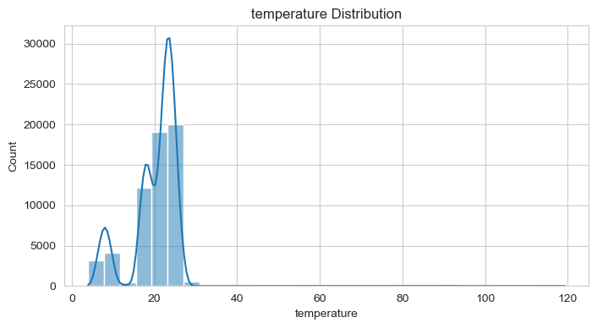
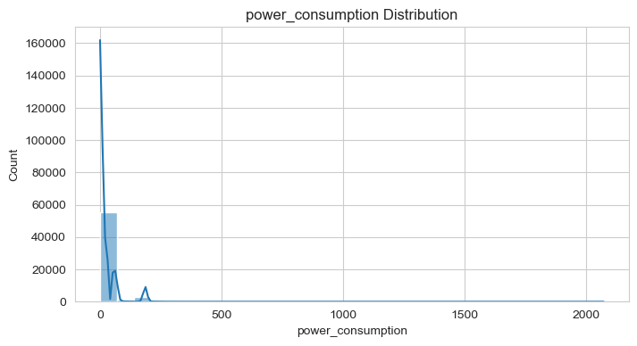

2.2 Fault Patterns
- Chillers, AHUs and Pumps account for roughly 99% of all faults, despite being only 3 of the 6 asset types.
- Chillers have close to 3x the fault rate of the next most reliable equipment — recommended for daily monitoring, with AHUs/Pumps weekly and the remaining types monthly.
- No single sensor reliably predicts a fault: correlation between any individual feature and fault_flag stays below |r| = 0.024. Faults appear to result from multi-feature interactions rather than simple thresholds.
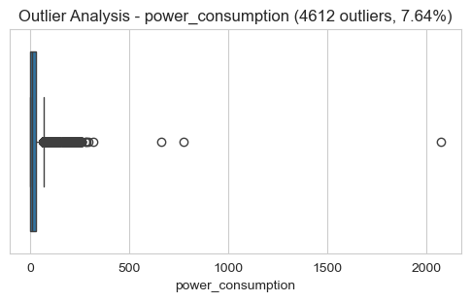
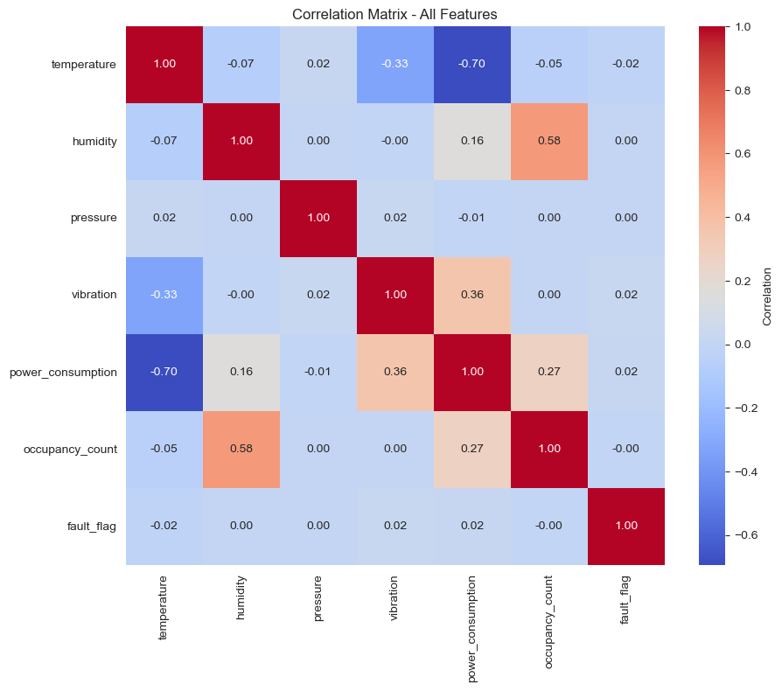

2.3 Temporal & Correlation Patterns
Pattern | Finding
Weekday vs weekend power | ~25-27 kWh weekdays vs ~13-15 kWh weekends (occupancy-driven)
Peak fault hours | 5 PM and 8 PM (7 faults each)
Peak fault days | Friday (20 faults) and Saturday (18 faults)
45-day trend | Stable (+1.7% change first week vs last week)
Strongest sensor correlation | Temperature ↔ Power, r = -0.70
Occupancy ↔ Power | No significant correlation despite both being reliably captured

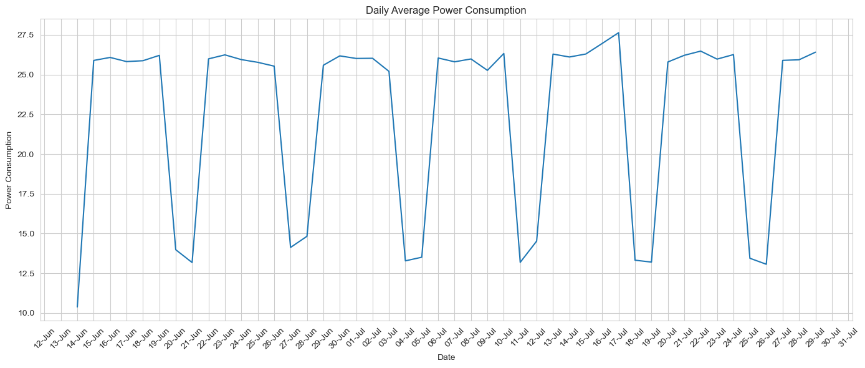
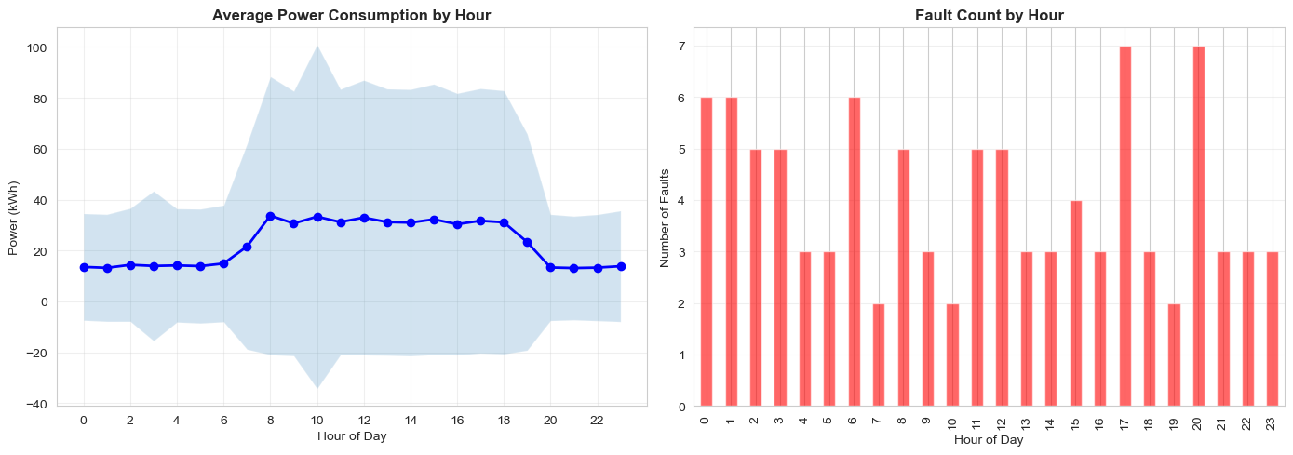
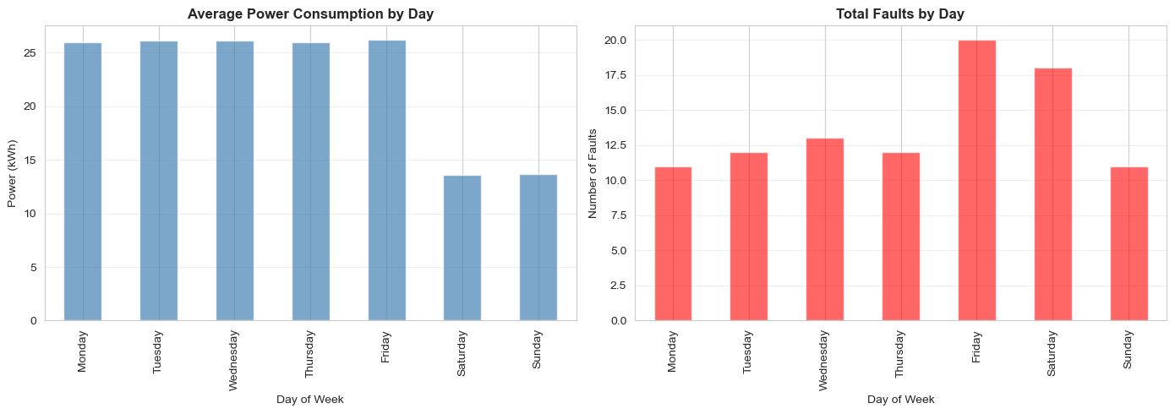

Overall recommendation from the EDA: standard accuracy is a misleading metric given the 99.84%/0.16% class imbalance, and predictive work should lean on ensemble methods (Random Forest, XGBoost) with SMOTE or class weighting rather than rule-based sensor thresholds.

3. Predictive Maintenance (Task 2)
Objective: predict whether an asset will experience a failure within the next 24 hours, using only information available before that failure.

3.1 Approach
- Target: failure_next_24h, built by looking ahead to each asset's next fault and flagging the 24 hours preceding it (1,145 positive rows out of 60,308, ~1.9%).
- Feature engineering: 34 features selected from 50+ candidates — lag features (1h/6h/24h), rolling mean/std/max, 6h/12h trend slopes, temporal features, and power/occupancy interaction ratios.
- Chronological 70/30 train-test split with a 24-hour embargo to avoid look-ahead leakage; missing sensor values filled using training-only medians per asset.
- Class imbalance handled with SMOTE on the training set only, balancing ~40,093 vs 782 minority samples up to 80,186 total training rows.

3.2 Models & Results
Model | Precision | Recall | F1-Score | ROC-AUC
Random Forest (300 trees, depth 8) | 0.520 | 0.646 | 0.576 | 0.933
XGBoost (300 est., depth 5, lr 0.05) | 0.638 | 0.718 | 0.676 | 0.950

XGBoost was selected as the best model (highest F1 and ROC-AUC), correctly flagging roughly 72% of true failures while keeping false alarms manageable.
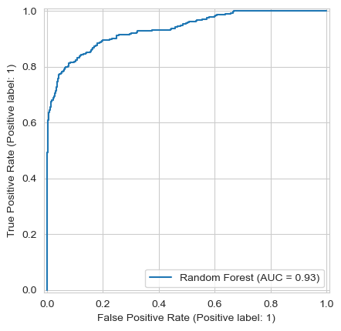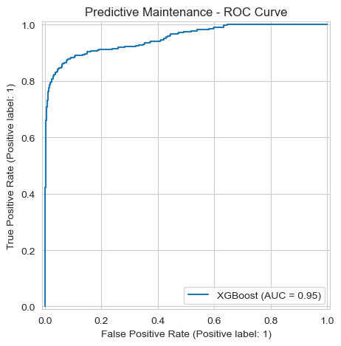

3.3 Top Predictive Features
- vibration_slope_6 (6-hour vibration trend) dominates, with an importance of 0.43 — far ahead of any other feature.
- Rolling temperature means (24h and 6h) and operating-mode indicators (Idle, Heating) are the next strongest signals.
- This is consistent with different fault types having different lead indicators — refrigerant leaks trend on temperature, bearing wear on vibration, electrical issues on power.
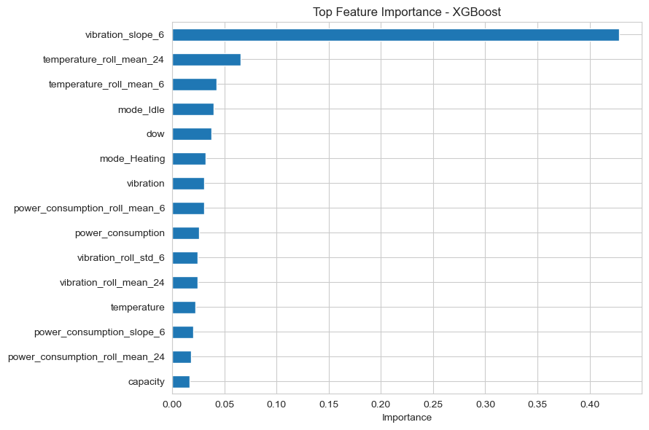
Business Impact
• The model catches the majority of failures while keeping the false-alarm rate low enough to be operationally useful for a maintenance team.
• Recommended threshold: 0.50 probability, saved alongside the model for production scoring.

4. Anomaly Detection (Task 4)
Objective: flag abnormal equipment behavior — spikes, excessive vibration, unusual temperature, or gradual sensor drift — independent of the labeled fault flag, to support earlier intervention.

4.1 Three Complementary Methods
Method | Technique | Anomalies Found
Isolation Forest | Multivariate outlier detection, fit per asset type (1% contamination) | 607 (1.00%)
Rolling Z-Score | Flags values >3.5 std devs from a 48-hour rolling baseline | 1,210 (2.00%)
Drift / Change-Point | Flags a 6h mean shifting far from the 72h mean (99.5th pct threshold) | 588 (0.97%)

- Combined coverage: 2,172 of 60,405 readings (3.60%) were flagged by at least one method.
- Severity scoring sums the three flags: Critical (all 3 methods agree, 10 rows), High (2 methods, 213 rows), Warning (1 method, 1,949 rows).
- Only 1.2% of flagged anomalies coincide with an already-labeled fault — the rest are early-warning signals or non-fault outliers (e.g. sensor spikes), which is the intended behavior of an anomaly detector.
- The drift method contributes 379 rows across 37 assets that neither of the other two methods catch, confirming it acts as a genuinely separate check rather than a redundant one.

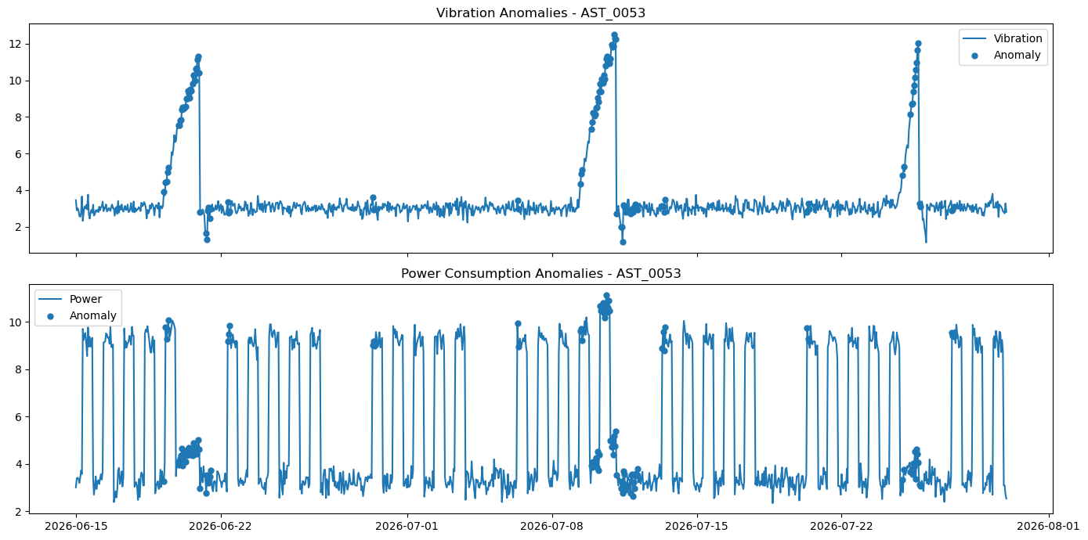

4.2 Anomaly Rate by Asset Type
Asset Type | Anomaly Rate
Pump | 5.03%
Chiller | 4.50%
AHU | 3.57%
EnergyMeter | 3.18%
EnvSensor | 3.04%
HVAC | 2.85%

5. Power Consumption Forecasting (Task 3)
Objective: forecast each building's hourly power consumption 24 hours ahead, using the previous 7 days of history.

5.1 Approach
- Asset-level readings were aggregated to hourly, building-level totals (7,560 building-hour records across 7 buildings) and aligned onto a complete hourly timeline per building.
- Calendar features (hour, day-of-week, weekend flag) were added using sine/cosine cyclic encoding, so that, e.g., 23:00 and 00:00 are treated as adjacent rather than far apart.
- An encoder-decoder LSTM was built: an LSTM encoder reads 168 hours of history (power + calendar features) into a context vector; an LSTM decoder combines that context with the known future calendar features to directly output all 24 forecasted hours at once.
- The model has 119,873 trainable parameters and was trained with early stopping and learning-rate reduction on validation loss (up to 100 epochs, batch size 32).
- Evaluation used the final 7 days of the dataset as a held-out test period: 5,215 training sequences and 1,008 test sequences.
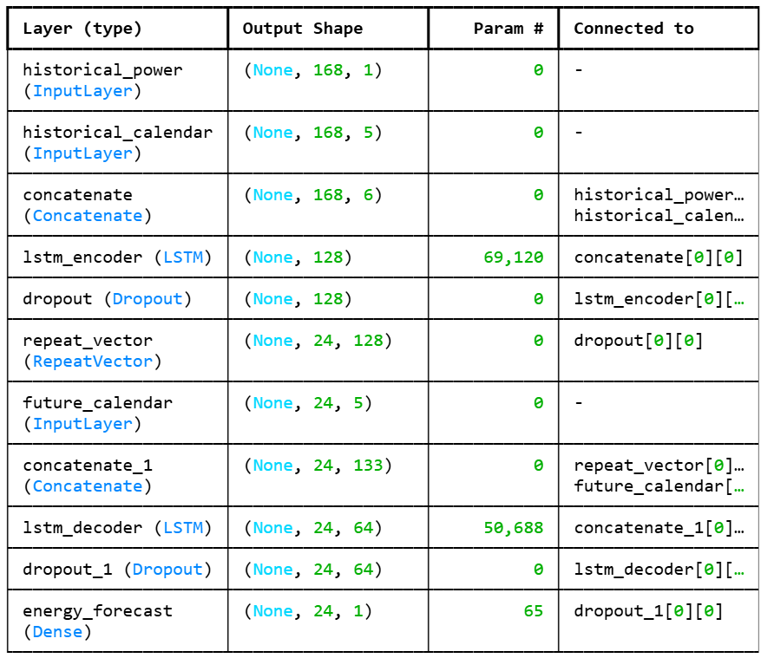

5.2 Results
Model | MAE | RMSE | MAPE
LSTM (encoder-decoder) | 9.03 | 17.05 | 7.51%
Naive baseline ("same hour last week") | 43.93 | 85.67 | 30.36%

The LSTM improves mean absolute error by 79.4% over the naive baseline, with a healthy training curve showing no over- or under-fitting and validation loss stabilizing early.
Takeaway
• A 7.5% MAPE on 24-hour-ahead forecasts is strong for building-level energy data and is suitable for operational load planning.
• The model is saved and considered ready for production forecasting.

6. Asset Connectivity Analysis (Task 5)
Objective: map how assets are physically and logically connected, identify data-quality gaps in that structure, and estimate the operational blast radius if a given asset fails.

6.1 Data Quality Findings
Check | Count
Missing parent relationships | 22
Duplicate connection records | 2
Orphan assets (no parent, no connection) | 1
Invalid parent-child mappings | 1

6.2 Graph Structure
- Asset hierarchy (parent-child only): 56 nodes, 33 relationships.
- Combined dependency graph (hierarchy + explicit connections): 56 assets, 40 relationships, with 1 fully isolated asset.
- Chillers are the most connected asset type, typically with 2-3 direct connections each, consistent with their role as a central mechanical hub.
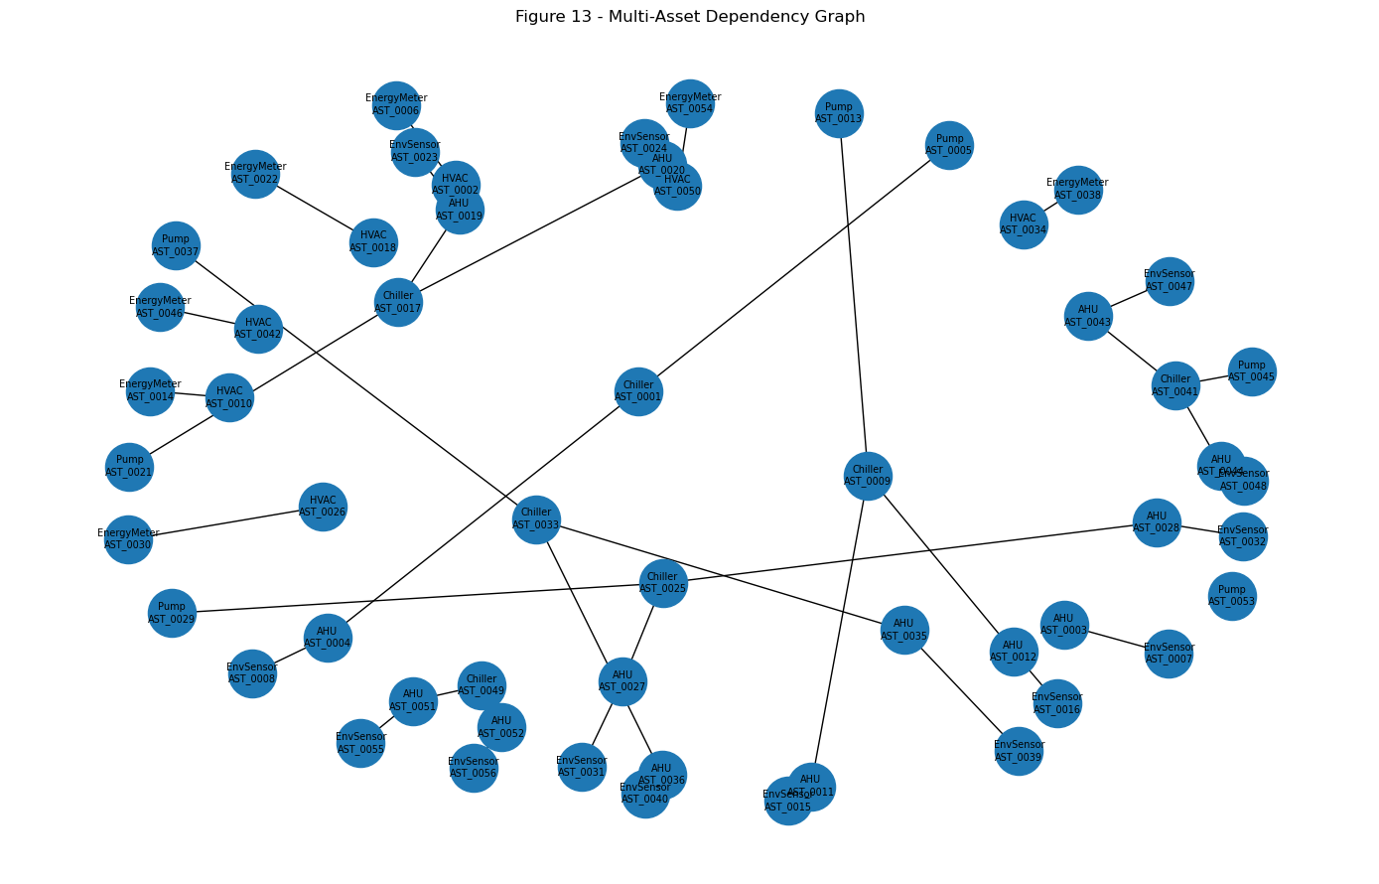

6.3 Failure Impact Examples
Scenario | Downstream Impact | Operational Impact | Recommended Action
Chiller (AST_0001) fails | 3 assets (1 AHU, 1 Pump, 1 EnvSensor) | Localized impact to dependents | Isolate the failed asset, inspect downstream equipment, switch to backup systems
Pump (AST_0005) fails | 0 assets | Limited direct downstream impact | Monitor and schedule maintenance or replacement
This confirms that Chillers sit higher in the dependency chain and therefore warrant closer monitoring — reinforcing the fault-rate finding from the EDA that Chillers should be checked daily.

7. Conclusions & Recommendations

7.1 Conclusions
All five notebooks point to the same operational picture: Chillers (and to a lesser extent AHUs and Pumps) are the highest-risk, most-connected, and most fault-prone assets in the portfolio, and failures build up gradually (drift, rising vibration trend) before they trip a hard fault flag.

7.2 Recommendations
- Prioritize monitoring by asset type: Chillers daily, AHUs/Pumps weekly, remaining types monthly — supported by both the EDA fault rates and the connectivity failure-impact analysis.
- Deploy the XGBoost predictive-maintenance model (F1 = 0.676, ROC-AUC = 0.950) as an early-warning layer, watching vibration trend and rolling temperature features most closely.
- Use the anomaly detection layer for signals the fault-history model can't see yet — particularly the drift check, which catches slow calibration/degradation issues 24 days out from labeled faults.
- Feed the LSTM forecasts (7.5% MAPE) into operational load planning; investigate the small number of high-error building-hours as candidates for further feature work.
- Fix the connectivity data gaps (22 missing parent links, 1 orphan asset, 2 duplicate records) so failure-impact analysis stays accurate as the network grows.

