Nectar Intelligent Facilities Platform

Data Scientist Challenge — Technical Report
Reproducible report generated from the current model/metric artifacts. Data is synthetic because no challenge dataset was attached.

1. Problem Understanding
The solution converts connected-building telemetry into four operational capabilities: proactive equipment-failure prediction, building energy forecasting, unsupervised anomaly detection, and multi-asset failure-impact analysis. A reproducible synthetic IoT fleet was generated because the supplied challenge package did not include telemetry files.
The generated fleet contains 56 assets across 3 sites and 7 buildings, with 60,453 telemetry rows. The generator intentionally includes clock jitter, communication gaps, missing sensor values, duplicate publications, multiple physically plausible fault signatures, independent sensor drift, and connectivity data-quality defects.

2. Exploratory Data Analysis
The raw-data audit identifies 48 duplicate (asset_id, timestamp) rows, irregular sampling caused by device clock jitter and communication outages, and approximately 1.3% missingness in key sensor fields. Duplicate rows are retained for the audit but deduplicated before modeling. The highest average energy draw is from chillers; business-hours energy is approximately 2.57x the trough-hour level.
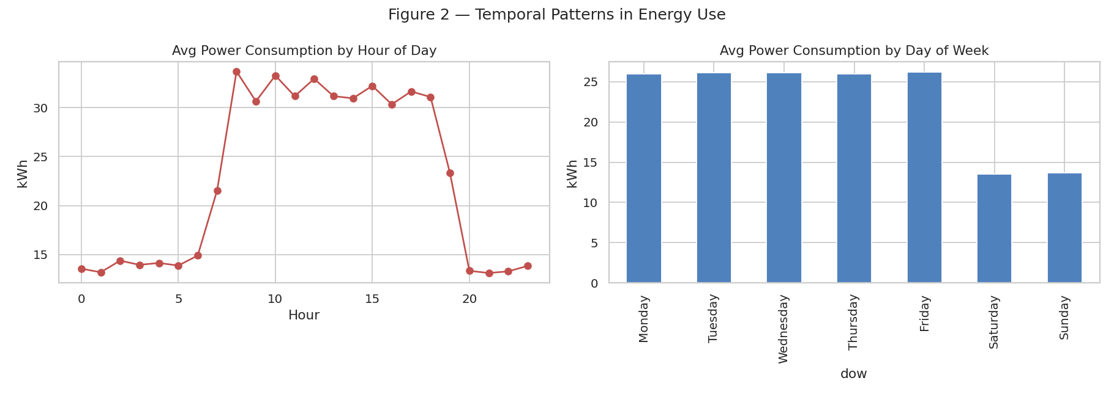
- Chillers are the dominant energy-consuming asset type.
- Faults are intentionally heterogeneous: belt slippage, filter fouling, refrigerant leak, electrical fault, bearing wear and cavitation use different sensor signatures.
- Pre-fault behaviour shows useful separation in vibration, temperature and power, motivating multivariate predictive features.
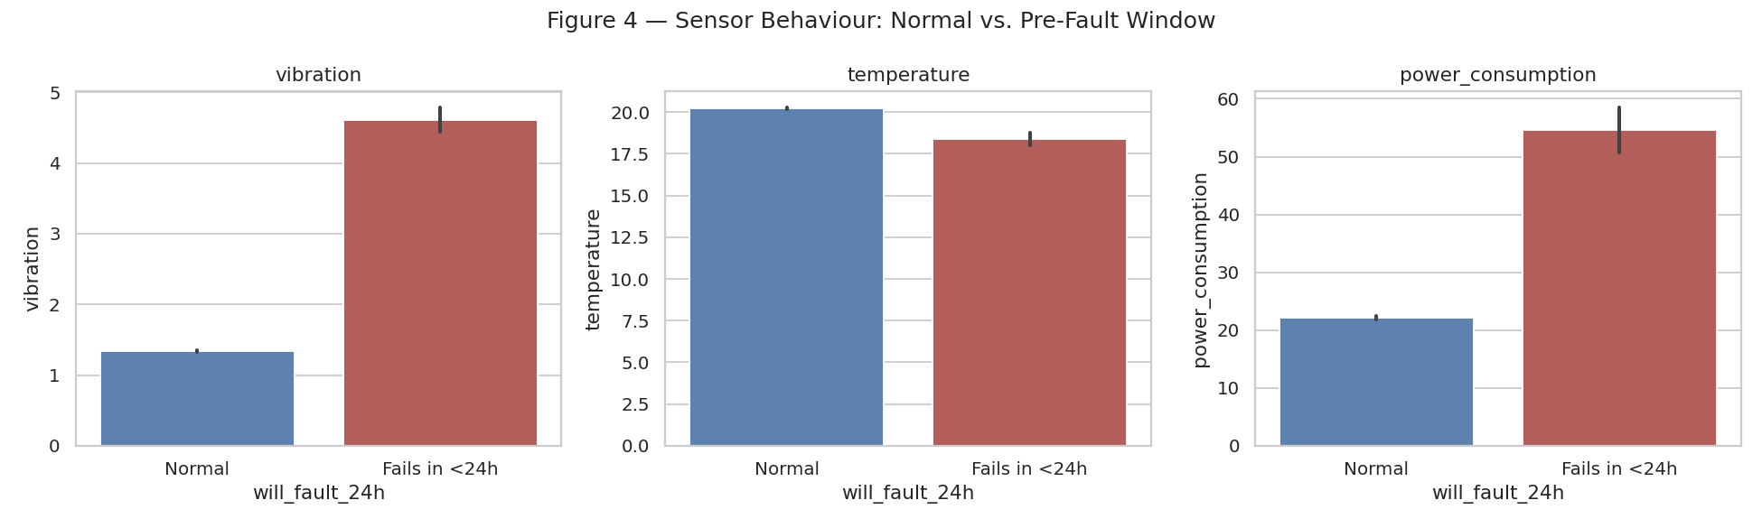

3. Predictive Maintenance
Objective: predict whether a non-faulting asset will experience its next observed fault within the next 24 clock hours. The target is timestamp-based rather than 'next 24 rows', so communication gaps cannot silently stretch or compress the prediction horizon. Rows already in an active fault are excluded.
- Causal feature engineering: current values, timestamp-aware 6h/24h rolling statistics, first differences, short-vs-long trend, asset type, operating mode and calendar features.
- Missing values are forward-filled only; remaining values are imputed with statistics learned from the training period. No future-value backfill is used.
- The split is chronological. A 24-hour embargo is applied before the test period so a training label cannot look into the evaluation window.
- The alert threshold (0.65) is tuned on a chronological validation slice inside training data and then frozen for test evaluation.
Model | Precision | Recall | F1 | ROC-AUC
RandomForest | 0.790 | 0.602 | 0.683 | 0.921
XGBoost | 0.689 | 0.708 | 0.699 | 0.952
XGBoost is selected by held-out F1. On the untouched test period it achieves 68.9% precision, 70.8% recall, 0.699 F1 and 0.952 ROC-AUC. These figures are materially more conservative than the previous stale report and are the numbers reproduced by the current code.
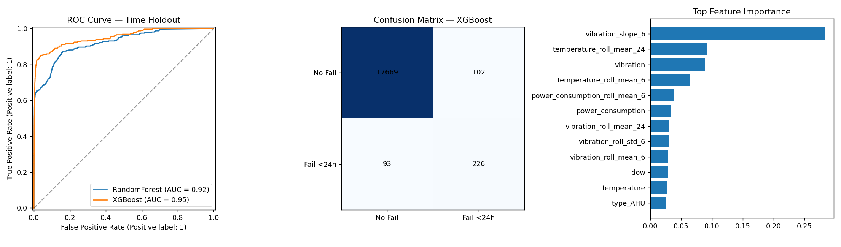

4. Energy Consumption Forecasting
The forecasting task is implemented as a direct multi-horizon model: every forecast origin produces 24 separate predictions for horizons 1 through 24 hours. Only information available at the origin is used for lag/rolling features; target-time calendar fields are known in advance. The final seven days of forecast origins form the holdout.
- Building-hour energy is created after deduplicating and nearest-hour bucketing of jittered asset telemetry.
- Lag features: 1h, 2h, 3h, 24h, 48h and 168h; causal rolling mean/std; origin and target calendar features; building identifier.
- No future interpolation/backfill is used for the target. Samples with missing target or baseline values are excluded from evaluation.
Metric | Model | Naive same-hour-yesterday
MAE (kWh) | 11.57 | 41.68
RMSE (kWh) | 21.00 | 82.88
MAPE | 9.34% | —
The direct multi-horizon model reduces MAE by 72.2% versus the seasonal baseline. This result should be described as a genuine 1–24h multi-horizon holdout, not as a one-step-ahead model.
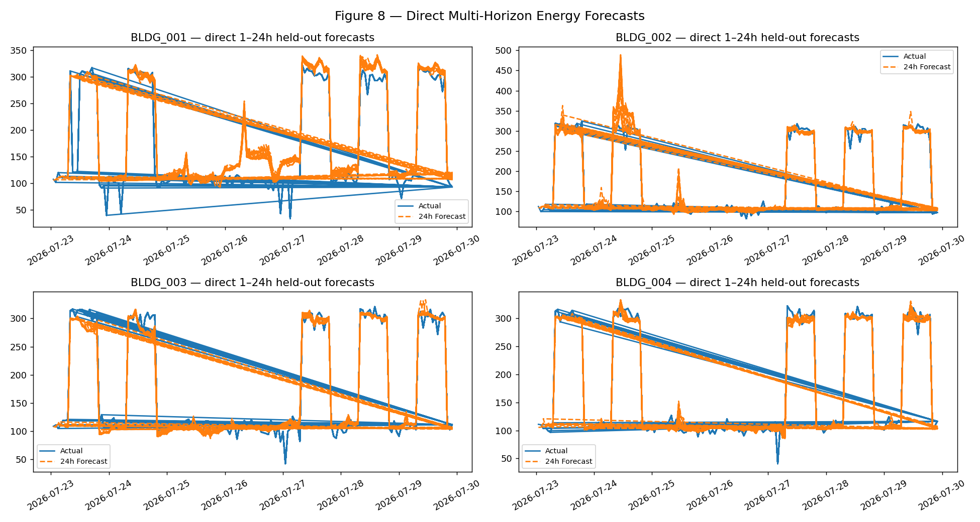

5. Anomaly Detection
Three complementary unsupervised checks are retained: per-asset-type Isolation Forest for multivariate outliers, a 48-hour rolling z-score for explainable point anomalies, and a short-vs-long rolling-mean drift detector. Sensor imputation is causal.
Method | Flagged
Isolation Forest | 607
Rolling z-score | 1210
Drift/change-point | 588
Union | 2172
The union contains 2172 readings (3.59% of telemetry). Only 1.2% overlap a labeled fault event; this is not treated as accuracy because anomaly detection is intentionally designed to surface non-fault outliers and early warnings as well.
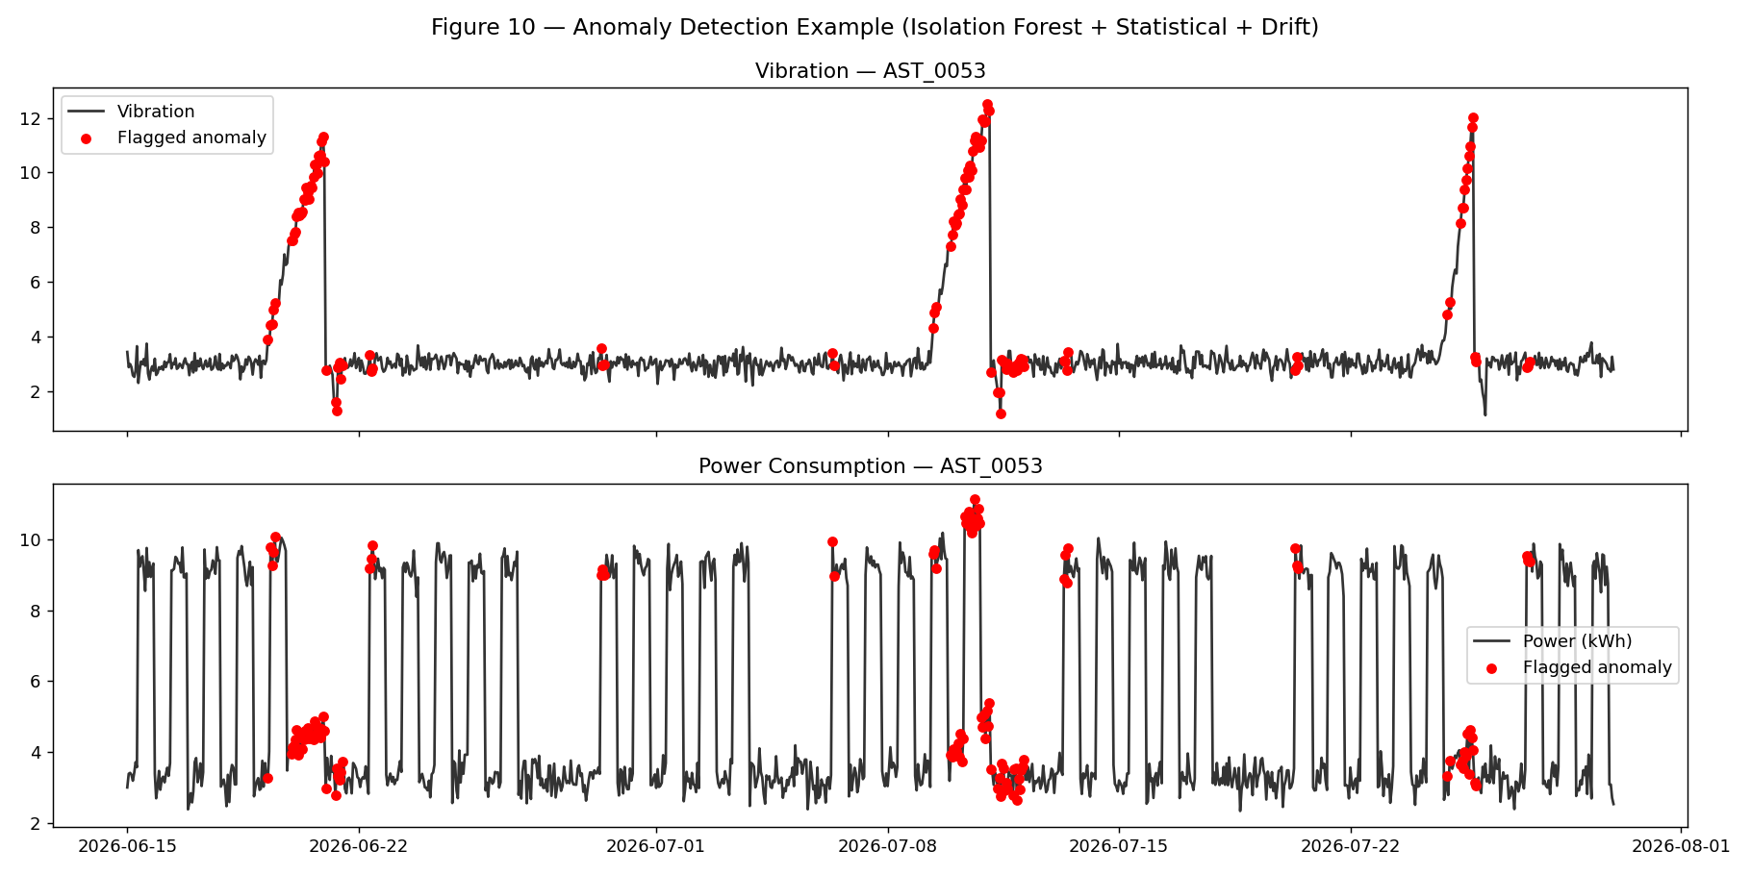

6. Multi-Asset Connectivity
A directed graph combines parent_asset_id hierarchy with explicit connectivity edges. The current analysis is correctly framed as downstream failure-impact/reachability analysis rather than a probabilistic failure-propagation model.
Example: failure of AST_0001 impacts 3 downstream assets: AST_0004, AST_0005, AST_0008.
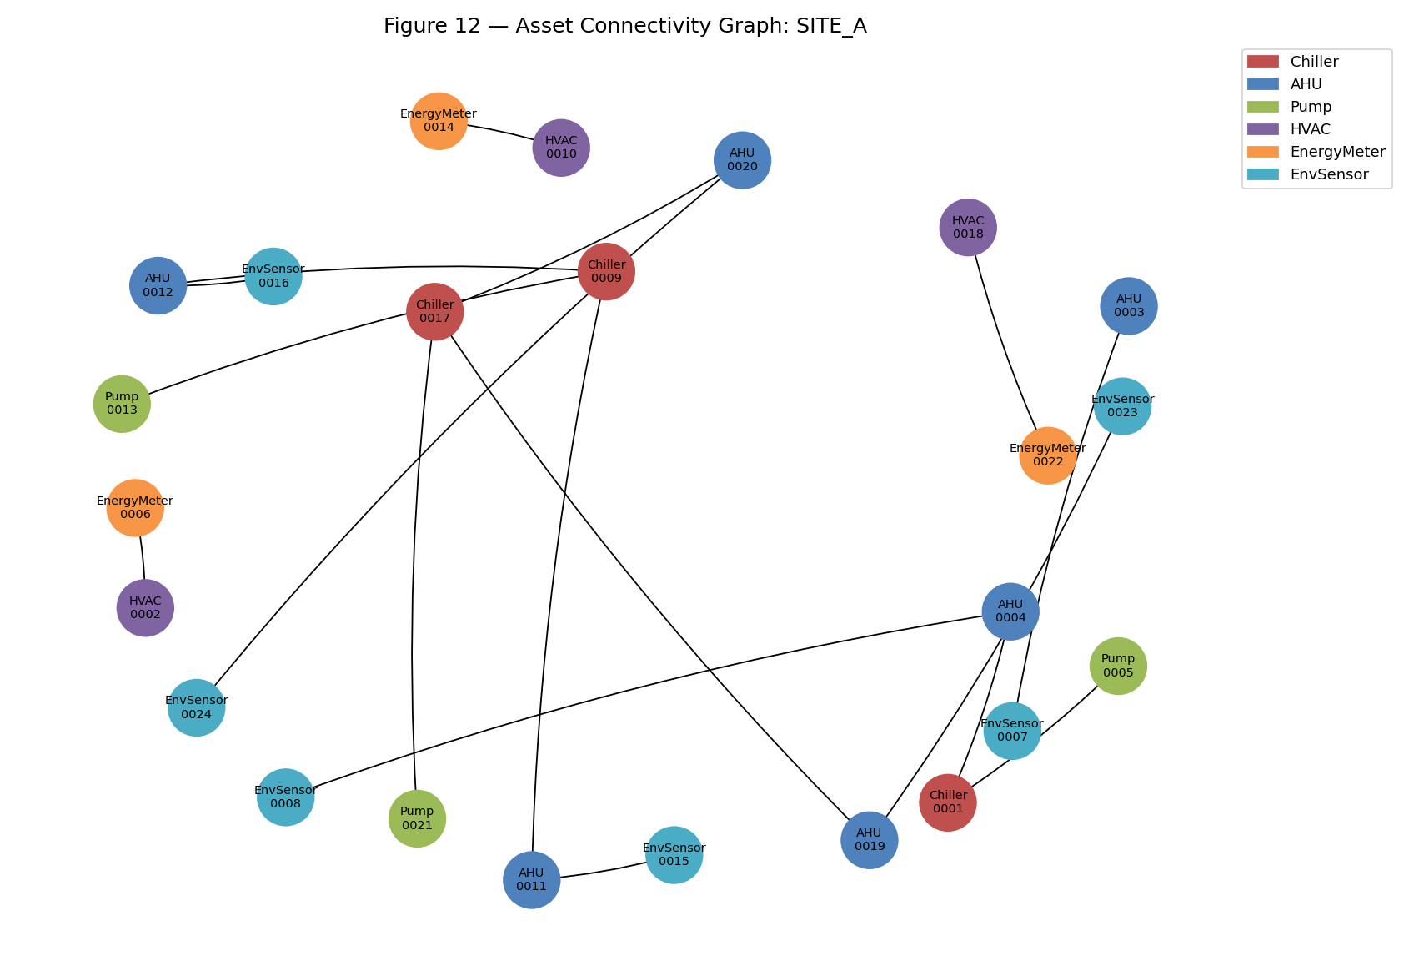
Data-quality issue | Count
Duplicate connectivity edges | 1
Invalid parent references | 1
Orphan assets | 1
Missing relationships | 1

7. Deployment & Engineering
- FastAPI exposes /predict_failure and uses the same shared causal feature-engineering module as the training pipeline.
- The API loads the persisted alert threshold and training-only imputation medians, eliminating the previous train/serve preprocessing mismatch.
- The Streamlit dashboard scores each asset using its available historical telemetry rather than fabricated rolling statistics.
- Project paths are derived from the repository root, so the package is portable across machines and execution directories.
- Kafka remains a scoped ingestion demo: producer → broker → consumer/SQLite, with live model scoring deliberately outside the demo boundary.

8. Limitations & Next Steps
- The data is synthetic; metrics must be revalidated on real telemetry.
- The predictive model's alert threshold should ultimately be tuned using the business cost of false negatives versus false positives.
- Anomaly thresholds should be calibrated with technician feedback and known incident labels.
- Connectivity impact is deterministic reachability. A production version could add edge probabilities and Monte Carlo propagation if probabilistic cascading-risk estimates are required.
- Forecasting can be improved with exogenous variables such as weather, tariffs, occupancy forecasts and planned equipment schedules.

