**ICP3**

**NAME: Gowtham Sai Reddy Maddireddy**

**ID:700759075**

**GIT HUB LINK:** [**https://github.com/Gowthamsai08/ICP3**](https://github.com/Gowthamsai08/ICP3)

**VIDEO LINK:** [**https://drive.google.com/file/d/1QAsWwbM1_JejlkVwoX-pStvlxYSbUQw2/view?usp=drive_link**](https://drive.google.com/file/d/1QAsWwbM1_JejlkVwoX-pStvlxYSbUQw2/view?usp=drive_link)

1. **Data Manipulation**

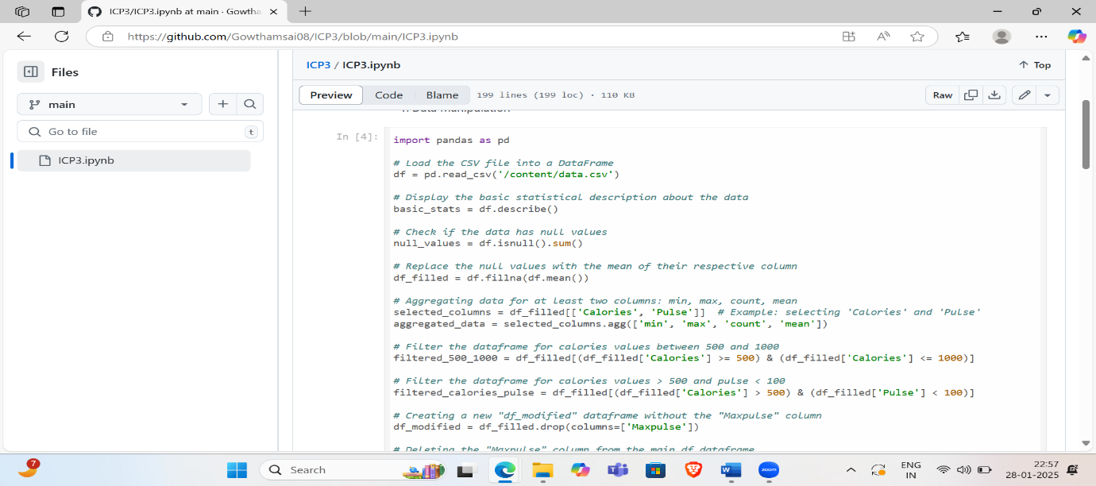

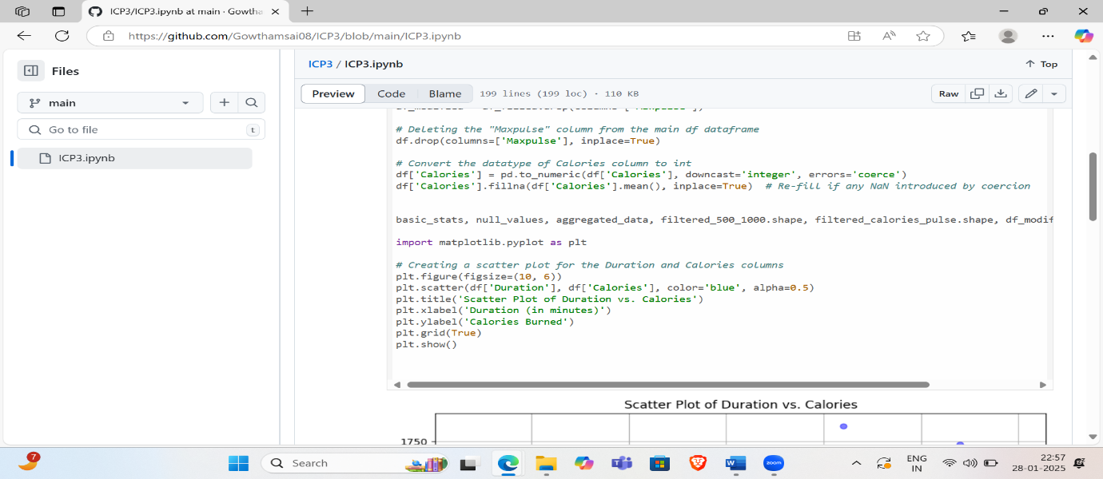

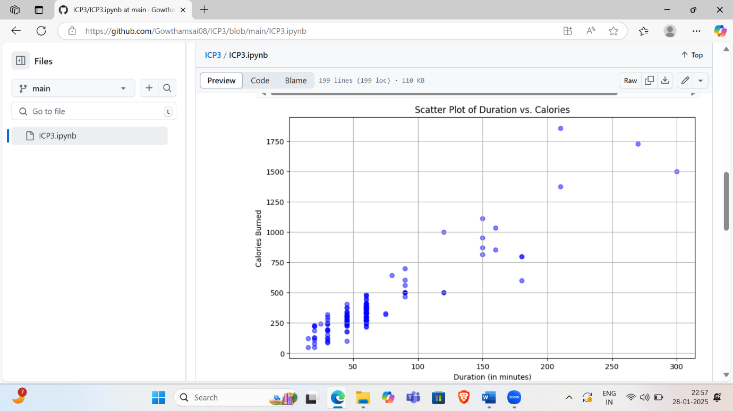

1. **Linear Regression**

