**MINI PROJECT**

**Name: GOWTHAM SAI REDDY MADDIREDDY**

**Student ID: 700759075**

**GITHUB Link:**  [**https://github.com/Gowthamsai08/Project-NNDL**](https://github.com/Gowthamsai08/Project-NNDL)

# Results

The result here explains how the model is evaluated by calculating various metrics like accuracy, precision, recall and f1 score. It also shows a graphical representation of accuracy vs loss which illustrates the accuracy of our model.

## PREDICTING THE MRI

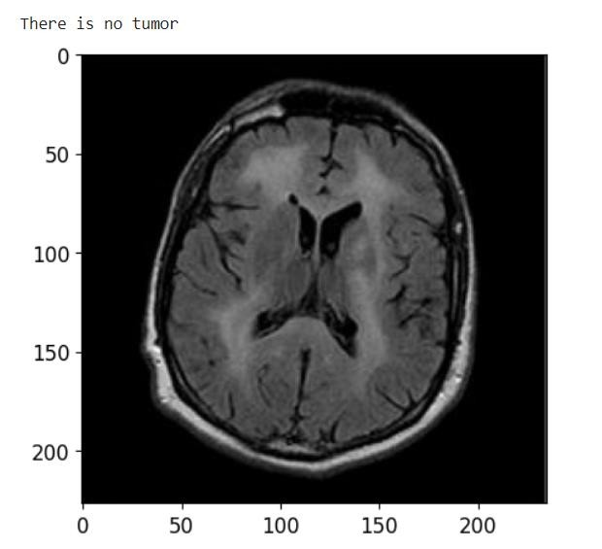

Fig 1 MR Image predicted as no tumor

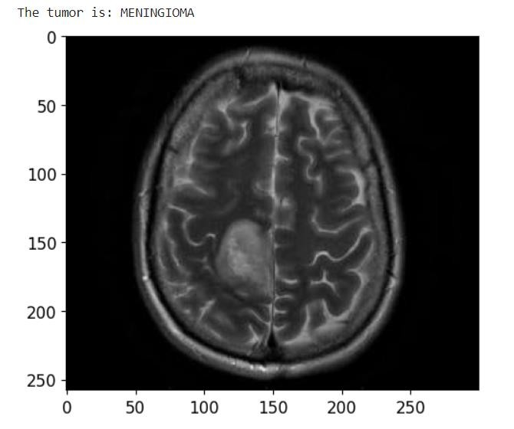

Fig 2 MR Image predicted as Meningioma

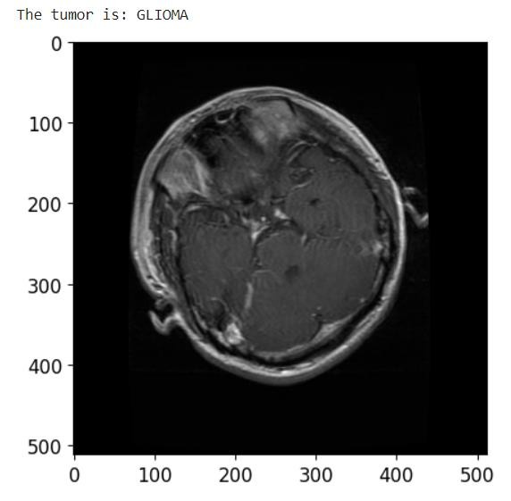

Fig 3 MR Image predicted as Glioma

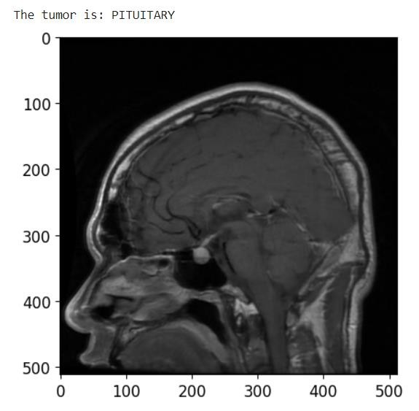

Fig 4 MR Image predicted as Pituitary

The MR image is predicted correctly as expected. The image is displayed after the prediction with the label on the top of the image as result.

## MODEL TRAINING HISTORY

This is the graph displaying the Accuracy and loss of the model with the red colored curve for loss and green colored graph for the accuracy. Our model achieved a high accuracy compared to other models.

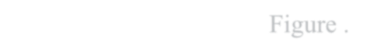

Figure

.

CNN

Model Training

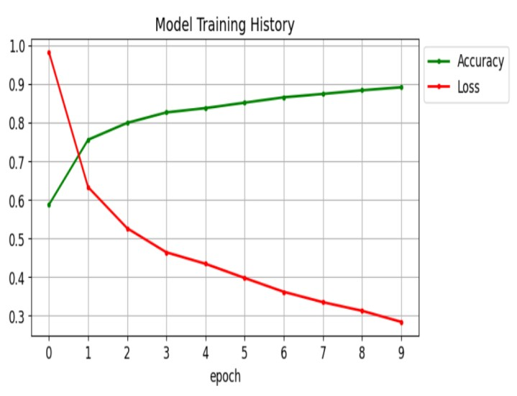

Figure

Inception V3 Model Training



Figure

VGG

-

16

Model Training

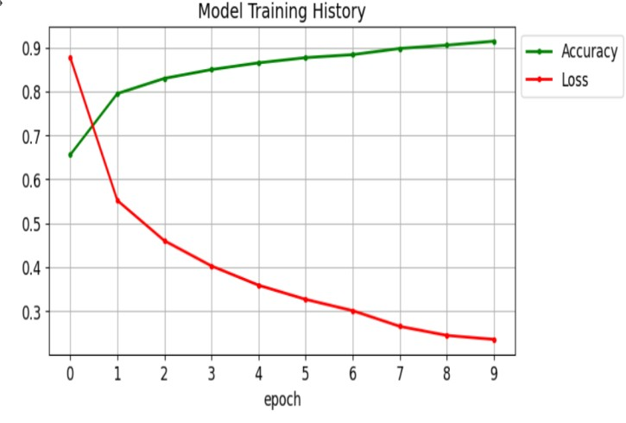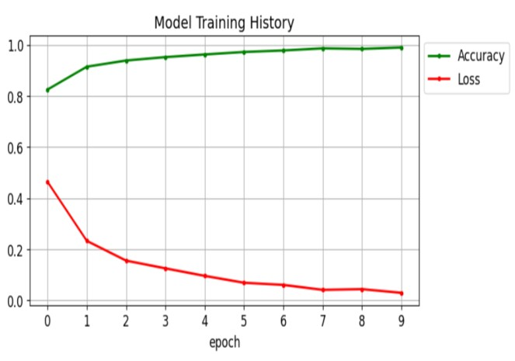

Here, in our system ,we trained the model using 10 epochs and achieved an overall accuracy of 98% on testing 1311 MR Images, i.e., 300 glioma MR images,306 meningioma MR images,405 no tumor images and 300 pituitary images. We got the highest accuracy for pituitary which is 100%.



## CLASSIFICATION REPORT

Here, in our system ,we trained the models using 10 epochs and achieved an overall accuracy of 98% for VGG16 on testing 1311 MR Images, i.e., 300 glioma MR images,306 meningioma MR images,405 no tumor images and 300 pituitary images. We got the highest accuracy for pituitary which is 100%.

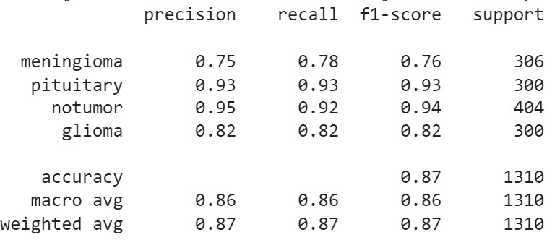

Fig 7.8 CNN Classification Report

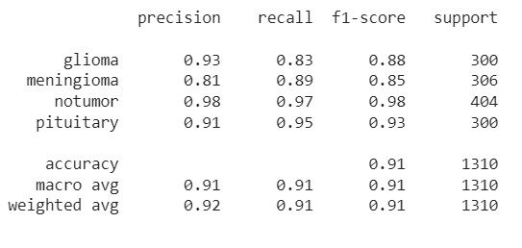

Fig 7.9 InceptionV3 Classification Report

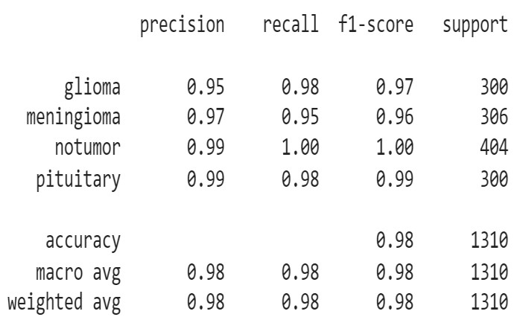

Fig 7.10 VGG16 Classification Report