1. show dbs

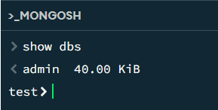

1. use zen_class

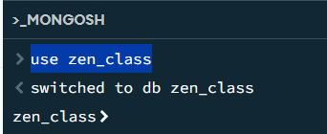

1. db.createCollection("users")

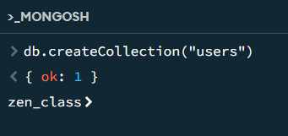

1. db.createCollection("codekata")

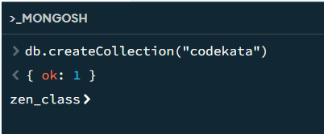

1. db.createCollection("attendance")

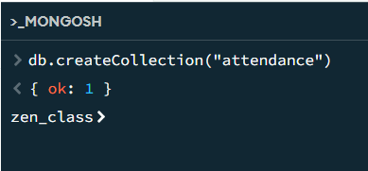

1. db.createCollection("topics")

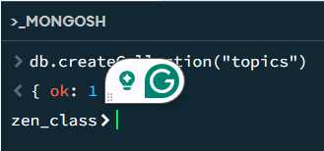

1. db.createCollection("tasks")

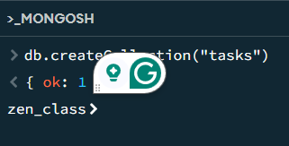

1. db.createCollection("company_drives")

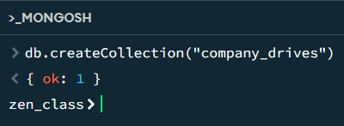

1. db.createCollection("mentors")

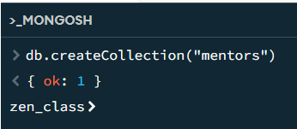

1. show collections

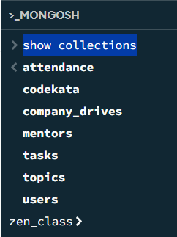

1. db.users.insertMany([

{

"name": "John Doe",

"email": "john@example.com",

"attendance": [

{"date": ISODate("2023-10-10T00:00:00Z"), "status": "Present"},

{"date": ISODate("2023-10-15T00:00:00Z"), "status": "Absent"}

],

"tasks": [

{"task_id": ObjectId(), "submission_date": ISODate("2023-10-12T00:00:00Z"), "status": "Submitted"},

{"task_id": ObjectId(), "submission_date": ISODate("2023-10-18T00:00:00Z"), "status": "Not Submitted"}

],

"codekata": {"solved_problems": 20},

"mentor_id": ObjectId()

},

{

"name": "Jane Smith",

"email": "jane@example.com",

"attendance": [

{"date": ISODate("2023-10-15T00:00:00Z"), "status": "Absent"},

{"date": ISODate("2023-10-20T00:00:00Z"), "status": "Present"}

],

"tasks": [

{"task_id": ObjectId(), "submission_date": ISODate("2023-10-18T00:00:00Z"), "status": "Submitted"}

],

"codekata": {"solved_problems": 30},

"mentor_id": ObjectId()

}

])

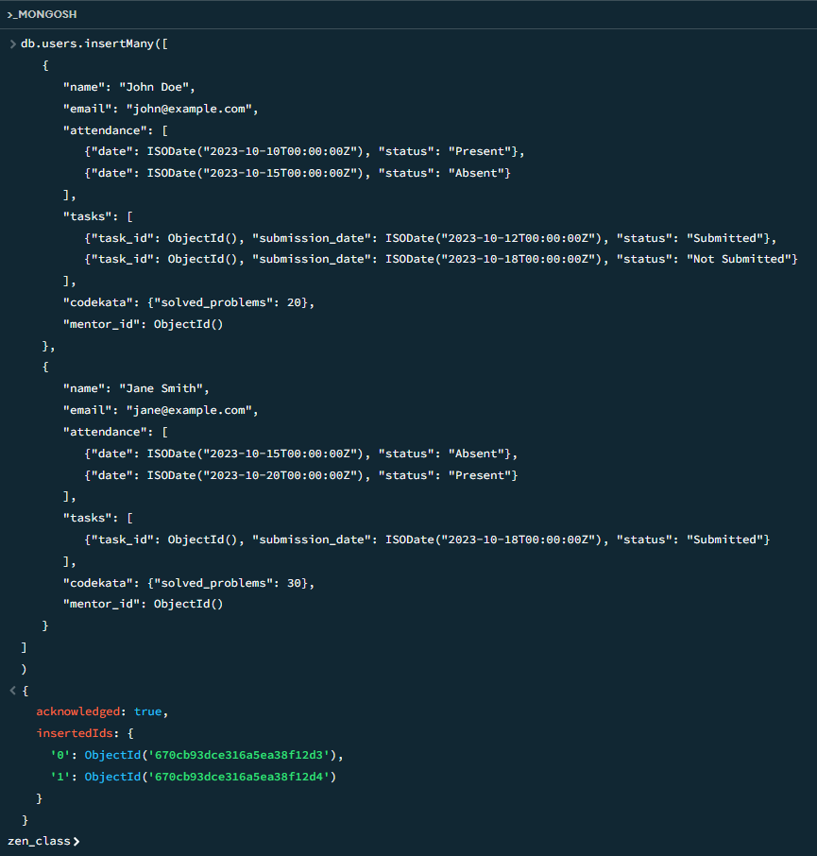

1. db.codekata.insertMany([

{

"user_id": ObjectId("670cb93dce316a5ea38f12d3"),

"problems_solved": 20

},

{

"user_id": ObjectId("670cb93dce316a5ea38f12d4"),

"problems_solved": 30

}

])

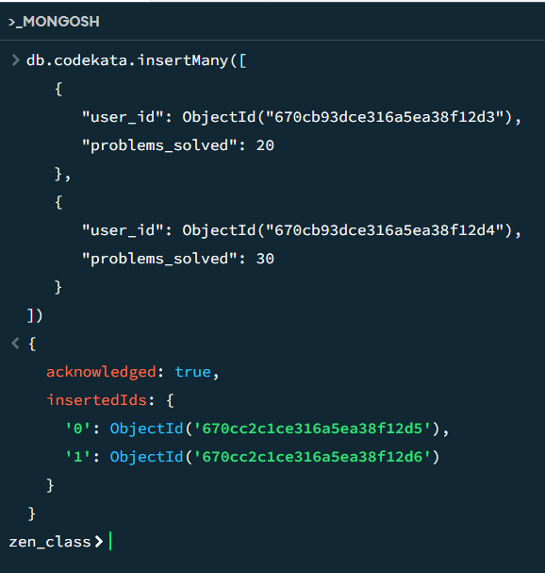

1. db.attendance.insertMany([

{

"user_id": ObjectId("670cb93dce316a5ea38f12d3"),

"date": ISODate("2023-10-15T00:00:00Z"),

"status": "Absent"

},

{

"user_id": ObjectId("670cb93dce316a5ea38f12d4"),

"date": ISODate("2023-10-15T00:00:00Z"),

"status": "Absent"

}

])

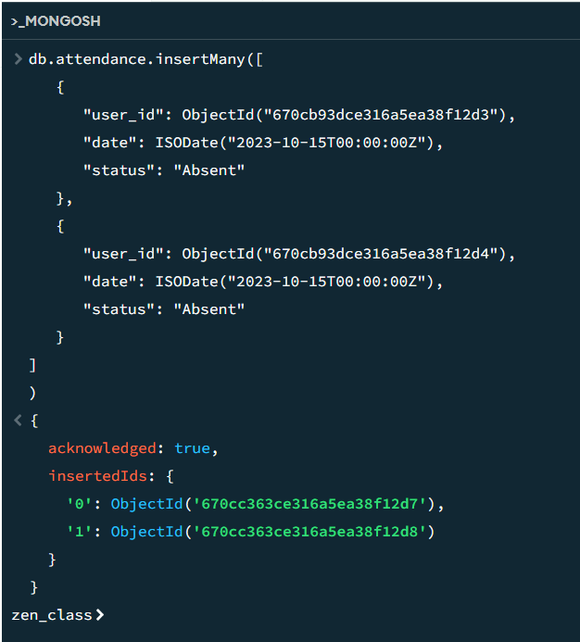

1. db.topics.insertMany([

{

"topic_name": "JavaScript Basics",

"date": ISODate("2023-10-05T00:00:00Z"),

"tasks": [

{"task_name": "JS Variables", "due_date": ISODate("2023-10-07T00:00:00Z")},

{"task_name": "JS Functions", "due_date": ISODate("2023-10-09T00:00:00Z")}

]

},

{

"topic_name": "Node.js Introduction",

"date": ISODate("2023-10-15T00:00:00Z"),

"tasks": [

{"task_name": "Node.js Setup", "due_date": ISODate("2023-10-17T00:00:00Z")},

{"task_name": "Node.js Routing", "due_date": ISODate("2023-10-18T00:00:00Z")}

]

}

])

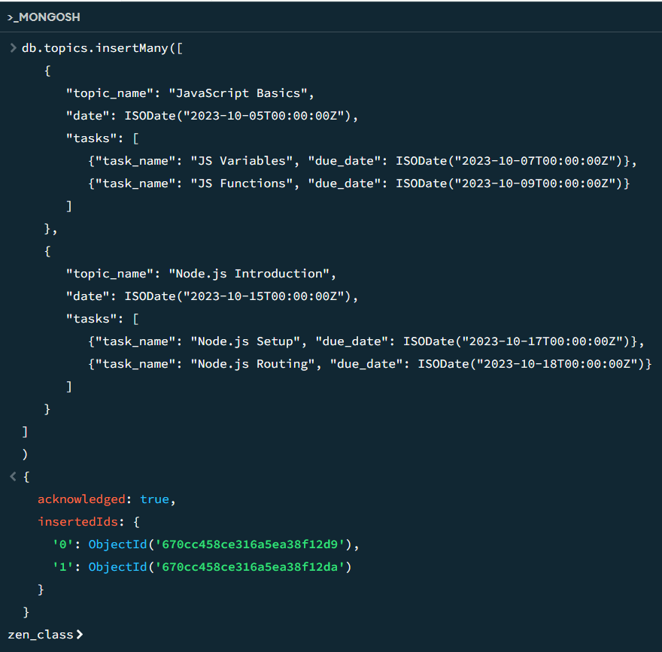

1. db.tasks.insertMany([

{

"task_name": "JS Variables",

"assigned_date": ISODate("2023-10-05T00:00:00Z"),

"due_date": ISODate("2023-10-07T00:00:00Z"),

"status": "Completed"

},

{

"task_name": "JS Functions",

"assigned_date": ISODate("2023-10-06T00:00:00Z"),

"due_date": ISODate("2023-10-09T00:00:00Z"),

"status": "Completed"

},

{

"task_name": "Node.js Setup",

"assigned_date": ISODate("2023-10-15T00:00:00Z"),

"due_date": ISODate("2023-10-17T00:00:00Z"),

"status": "Not Submitted"

},

{

"task_name": "Node.js Routing",

"assigned_date": ISODate("2023-10-15T00:00:00Z"),

"due_date": ISODate("2023-10-18T00:00:00Z"),

"status": "Submitted"

}

])

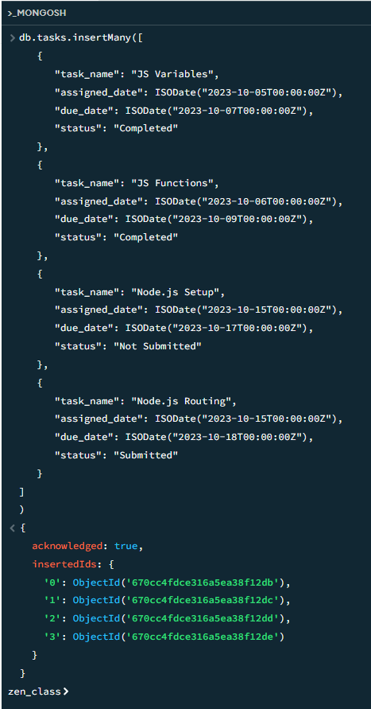

1. db.company_drives.insertMany([

{

"company_name": "Google",

"drive_date": ISODate("2020-10-20T00:00:00Z"),

"attendees": [

{"user_id": ObjectId("670cb93dce316a5ea38f12d3"), "status": "Appeared"},

{"user_id": ObjectId("670cb93dce316a5ea38f12d4"), "status": "Appeared"}

]

},

{

"company_name": "Microsoft",

"drive_date": ISODate("2020-10-25T00:00:00Z"),

"attendees": [

{"user_id": ObjectId("670cb93dce316a5ea38f12d3"), "status": "Appeared"}

]

}

]

)

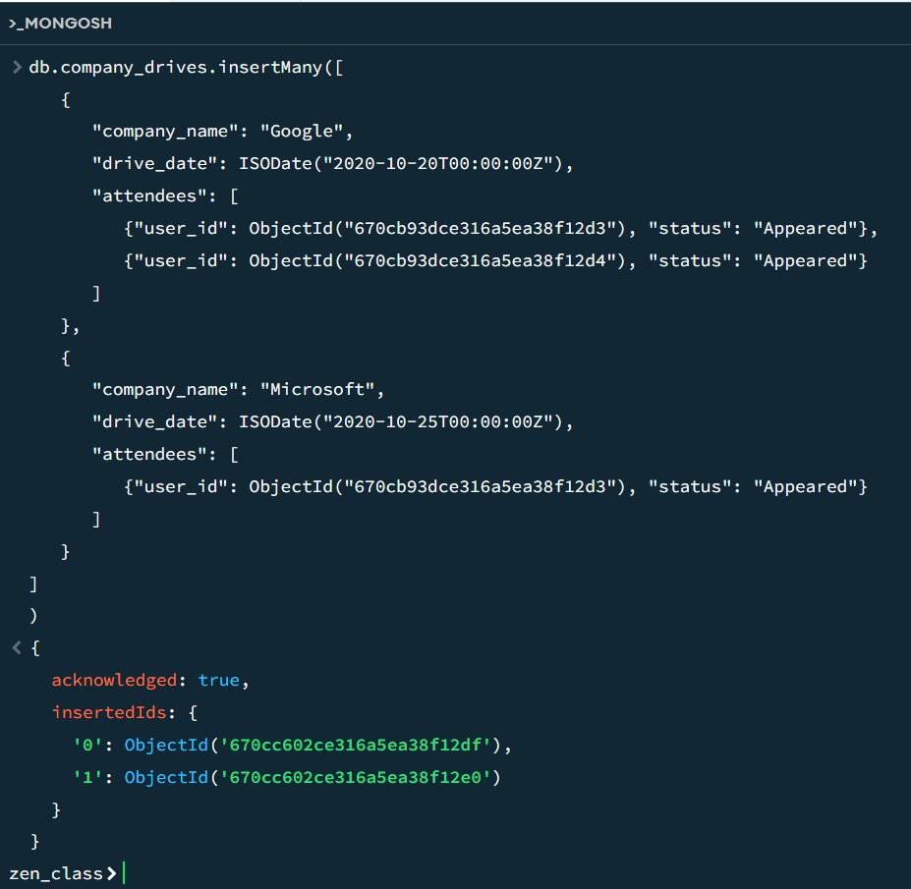

1. db.createCollection("mentees")

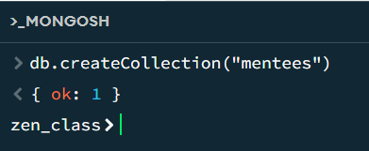

1. db.mentees.insertMany([

{

"name": "John",

"course": "FSD"

},

{

"name": "Jose",

"course": "FSD"

},

{

"name": "Rose",

"course": "FSD"

}

])

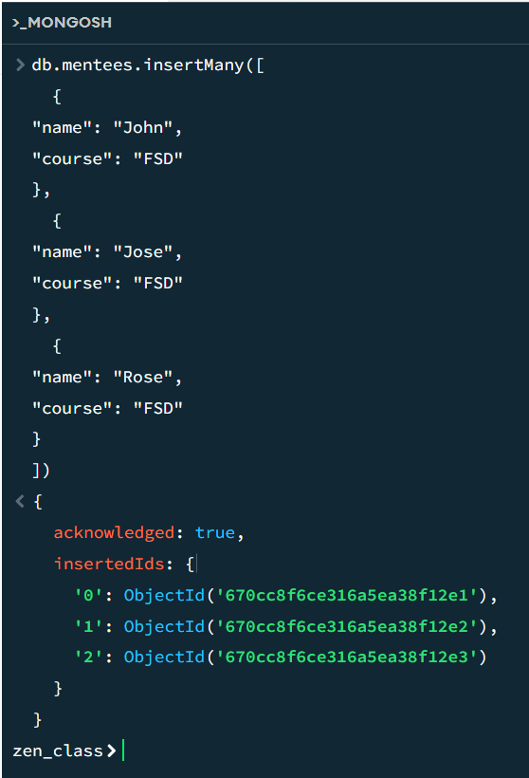

1. db.mentors.insertOne([

{

"name": "Mr. Raj",

"mentees": [

ObjectId("670cc8f6ce316a5ea38f12e1"),

ObjectId("670cc8f6ce316a5ea38f12e2"),

ObjectId("670cc8f6ce316a5ea38f12e3")

]

}

])

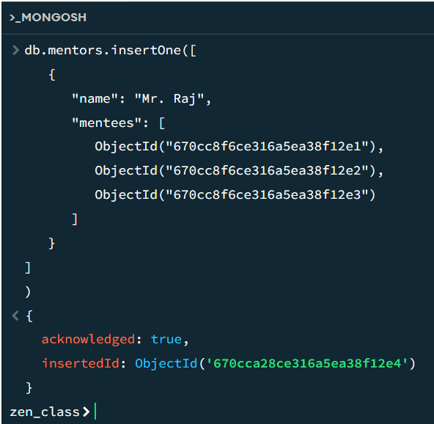

MongoDB Queries:

1. Find all the topics and tasks which are thought in the month of October

db.topics.aggregate([

{

$match: {

date: {

$gte: ISODate("2023-10-01T00:00:00Z"),

$lt: ISODate("2023-11-01T00:00:00Z")

}

}

},

{

$project: {

topic_name: 1,

tasks: 1

}

}

])

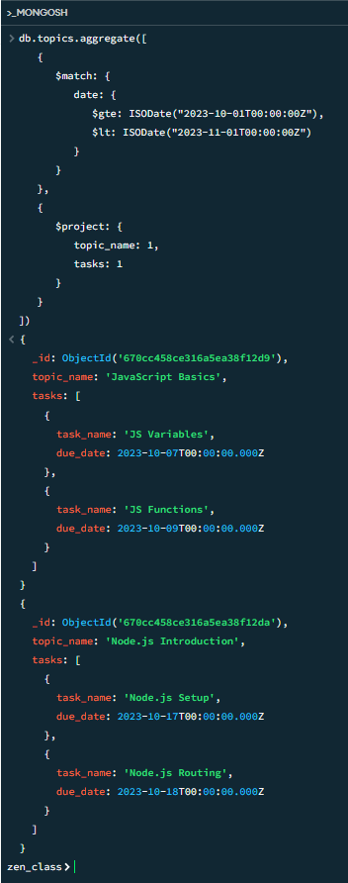

1. Find all the company drives which appeared between 15 oct-2020 and 31-oct-2020

db.company_drives.find({

drive_date: {

$gte: ISODate("2020-10-15T00:00:00Z"),

$lt: ISODate("2020-11-01T00:00:00Z")

}

})  
  
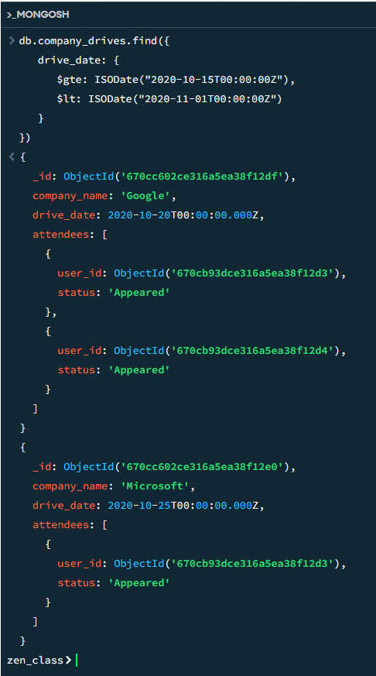

1. Find all the company drives and students who are appeared for the placement.  
   db.company_drives.aggregate([

{

$match: {

"attendees.status": "Appeared"

}

},

{

$lookup: {

from: "users",

localField: "attendees.user_id",

foreignField: "_id",

as: "student_info"

}

}

])

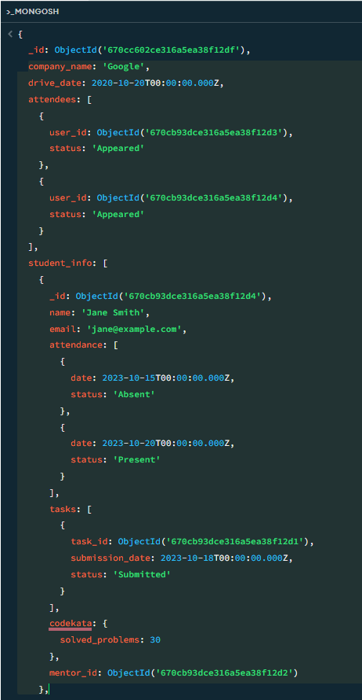

1. Find the number of problems solved by the user in codekata  
   db.codekata.findOne({ user_id: ObjectId("670cb93dce316a5ea38f12d3") }, { problems_solved: 1 })

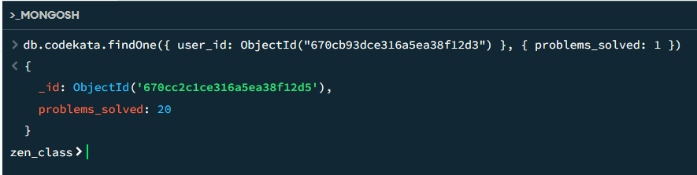

1. Find all the mentors with who has the mentee's count more than 15  
   db.mentors.aggregate([

{

$project: {

name: 1,

mentee_count: { $size: { $ifNull: ["$mentees", []] } }

}

},

{

$match: {

mentee_count: { $gt: 3 }

}

}

])

1. Find the number of users who are absent and task is not submitted  between 15 oct-2020 and 31-oct-2020

db.users.aggregate([

{

$match: {

"attendance": {

$elemMatch: {

date: {

$gte: ISODate("2020-10-15T00:00:00Z"),

$lt: ISODate("2020-11-01T00:00:00Z")

},

status: "Absent"

}

},

"tasks": {

$elemMatch: {

submission_date: {

$gte: ISODate("2020-10-15T00:00:00Z"),

$lt: ISODate("2020-11-01T00:00:00Z")

},

status: "Not Submitted"

}

}

}

},

{

$count: "absent_users_with_unsubmitted_tasks"

}

])