Gozde BARAN
101515982
LAB1
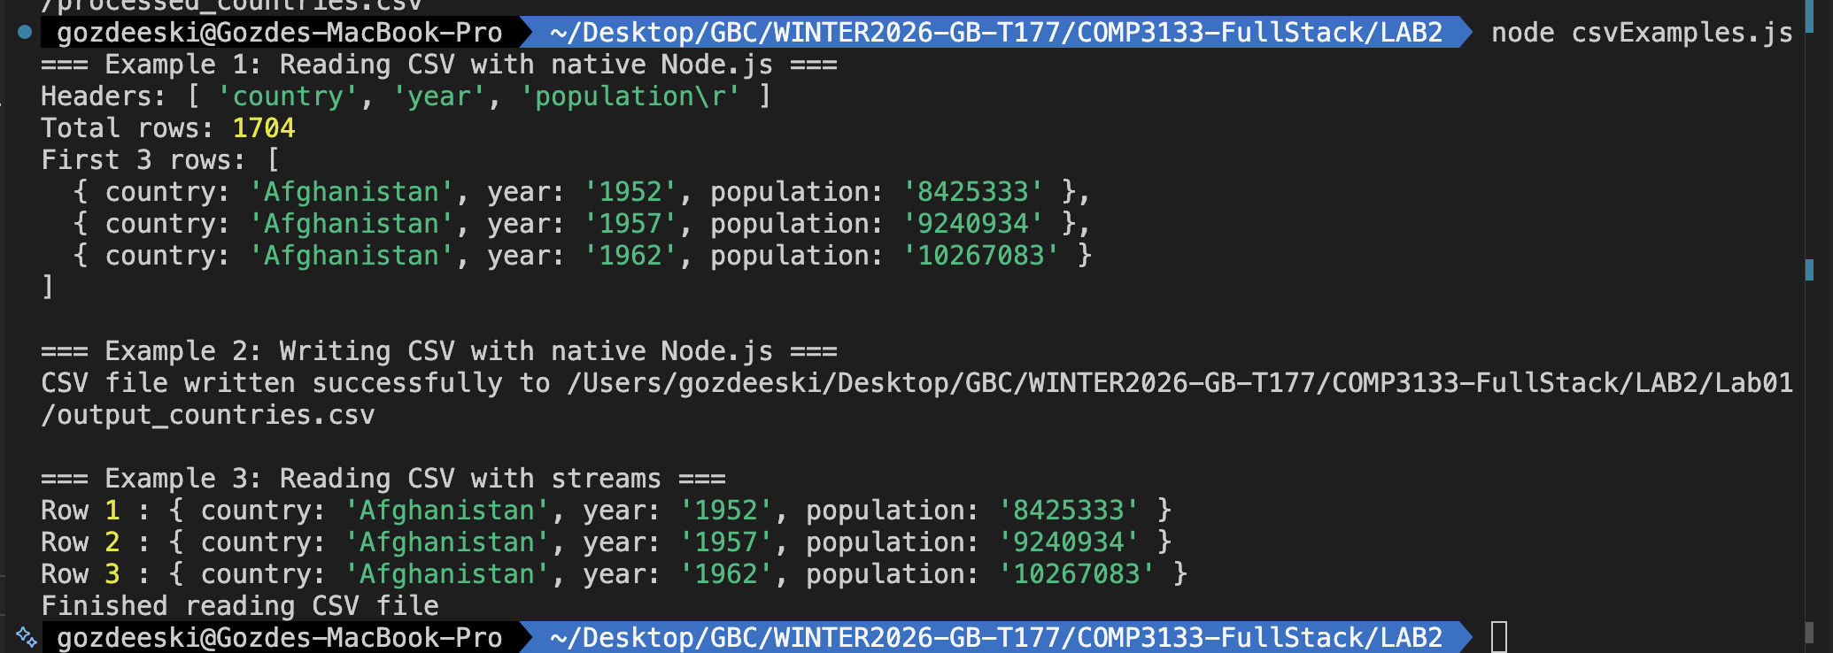
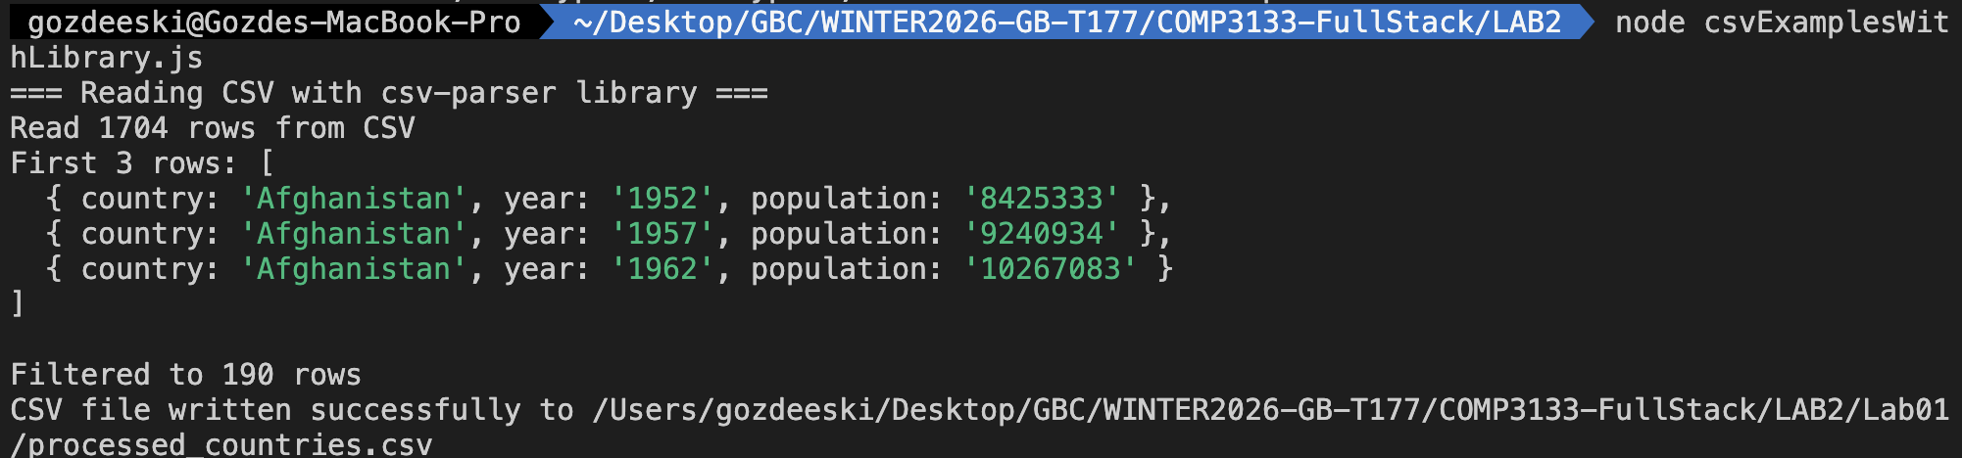
const fs = require("fs");
const path = require("path");

// manual parsing
function readCSVNative(filePath) {
try {
const data = fs.readFileSync(filePath, "utf8");
const lines = data.split("\n").filter((line) => line.trim() !== "");
const headers = lines[0].split(",");
const rows = [];

for (let i = 1; i < lines.length; i++) {
const values = lines[i].split(",");
const row = {};
headers.forEach((header, index) => {
row[header.trim()] = values[index]?.trim() || "";
});
rows.push(row);
}

return { headers, rows };
} catch (err) {
console.error("Error reading CSV file:", err);
return null;
}
}

// Writing CSV
function writeCSVNative(filePath, headers, rows) {
try {
// Create header row
let csvContent = headers.join(",") + "\n";

// Create data rows
rows.forEach((row) => {
const values = headers.map((header) => row[header] || "");
csvContent += values.join(",") + "\n";
});

fs.writeFileSync(filePath, csvContent, "utf8");
console.log(`CSV file written successfully to ${filePath}`);
return true;
} catch (err) {
console.error("Error writing CSV file:", err);
return false;
}
}

// Reading CSV
function readCSVStream(filePath, callback) {
const readStream = fs.createReadStream(filePath, { encoding: "utf8" });
let headers = [];
let isFirstLine = true;
let buffer = "";

readStream.on("data", (chunk) => {
buffer += chunk;
const lines = buffer.split("\n");
buffer = lines.pop() || "";

lines.forEach((line) => {
if (line.trim() === "") return;

if (isFirstLine) {
headers = line.split(",").map((h) => h.trim());
isFirstLine = false;
} else {
const values = line.split(",").map((v) => v.trim());
const row = {};
headers.forEach((header, index) => {
row[header] = values[index] || "";
});
callback(row);
}
});
});

readStream.on("end", () => {

if (buffer.trim() && !isFirstLine) {
const values = buffer.split(",").map((v) => v.trim());
const row = {};
headers.forEach((header, index) => {
row[header] = values[index] || "";
});
callback(row);
}
console.log("Finished reading CSV file");
});

readStream.on("error", (err) => {
console.error("Error reading CSV file:", err);
});
}

const inputPath = path.join(__dirname, "input_countries.csv");
const outputPath = path.join(__dirname, "output_countries.csv");

console.log("=== Example 1: Reading CSV with native Node.js ===");
const csvData = readCSVNative(inputPath);
if (csvData) {
console.log("Headers:", csvData.headers);
console.log("Total rows:", csvData.rows.length);
console.log("First 3 rows:", csvData.rows.slice(0, 3));
}

console.log("\n=== Example 2: Writing CSV with native Node.js ===");
if (csvData) {
const filteredRows = csvData.rows.filter(
(row) => parseInt(row.population) > 100000000,
);
writeCSVNative(outputPath, csvData.headers, filteredRows);
}

console.log("\n=== Example 3: Reading CSV with streams ===");
let rowCount = 0;
readCSVStream(inputPath, (row) => {
rowCount++;
if (rowCount <= 3) {
console.log("Row", rowCount, ":", row);
}
});

