ShopNest Store
Sales Analysis Dashboard

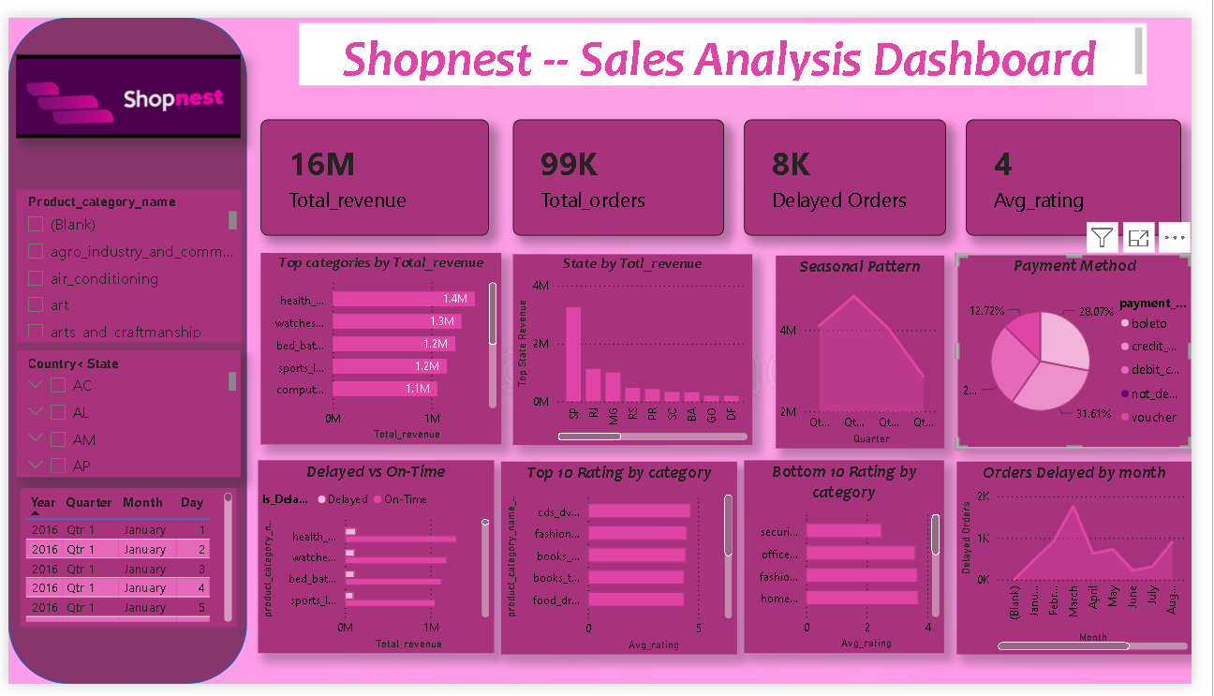

Project Overview
Dataset: Nexusgoods / ShopNest e-commerce store — Brazilian online marketplace data
Records: 99,441 orders spanning 2016–2018
Tables Used: Orders, Order Items, Products, Customers, Payments, Reviews, Geolocation, Category Translation
Objective: Build an interactive Power BI dashboard answering 7 business questions on sales, delivery, ratings and payments

Cleaned the data in power Query editor replaced empty , changed Data type , put first row as header and created extra conditional columns , new measures, manged relationship .

Q1. Top 10 Product Categories by Total Revenue
Question Statement: Identify and visually represent the top 10 product categories by total sales revenue across the entire dataset.
Visualization Used: Horizontal Bar Chart — sorted descending by Total Revenue
DAX Measure: Total Revenue = SUM(order_items[price])
Key Insights:
- health_beauty — R$ 1.4M, highest-selling category
- watches_gifts — R$ 1.3M, strong gifting demand
- bed_bath_table — R$ 1.2M, essential home goods
- sports_leisure — R$ 1.2M, growing lifestyle segment
- computers_accessories — R$ 1.1M, high-value tech items

Q2. Delayed Orders Analysis by Category
Question Statement: Determine the number of delayed orders in each category.
Visualization Used: Horizontal Bar Chart — showing count of delayed orders per product category
Calculated Column:
Is_Delayed = IF(orders[order_delivered_customer_date] > orders[order_estimated_delivery_date], "Delayed", "On-Time")
Key Insights:
Total delayed orders: 8,117 . The top-selling categories also have the most delays — suggesting high-demand categories face the most fulfilment pressure.

Q3. Monthly Comparison — Delayed vs On-Time Orders
Question Statement: Create a dynamic visual comparing delayed vs on-time orders for each month, with drillthrough cross-report functionality.
Visualization Used: Clustered Bar Chart (monthly) with Line Chart
Drillthrough Setup: Created a new report page 'Delivery Detail' with order-level breakdown
Key Insights:
On-time orders consistently dominate across all months. November 2017 showed the highest spike in delayed orders (1,043), coinciding with Black Friday demand surge. Overall volume grew significantly from mid-2017 onwards.

Q4. Payment Method Analysis
Question Statement: Analyze the most frequently used payment methods.
Visualization Used: Donut / Pie Chart

Key Insights:
- Credit Card — (73.9%) dominant
- Boleto — (19.0%), popular Brazilian bank slip method
- Voucher — (5.6%), discounts
- Debit Card — (1.5%), least used method

Q5. Product Rating Analysis — Top 10 & Bottom 10
Question Statement: Determine the top 10 highest-rated and bottom 10 lowest-rated product categories.
Visualization Used: Two separate Horizontal Bar Charts

DAX Measure: Avg Rating = AVERAGE(order_reviews[review_score])

Key Insights — Top 10 Highest Rated:
- cds_dvds_musicals — 4 avg
Key Insights — Bottom 10 Lowest Rated:
- security_services — 2 avg

Q6. State-wise Sales Analysis
Question Statement: Identify states with high and low sales.
Visualization Used: Stacked/Grouped Bar Chart + Map Visual

Key Insights:
- SP (São Paulo) — R$ 5.2M , dominant market
- RJ (Rio de Janeiro) — R$ 1.8M, 2nd largest
- MG (Minas Gerais) — R$ 1.6M, 3rd largest
- RS / PR / SC — R$ 0.5M–0.75M, southern states performing well
- AP / RR / AC — < R$ 16K, remote northern states with very low sales

Q7. Seasonal Sales Patterns (Quarterly)
Question Statement: Investigate seasonal patterns in sales.
Visualization Used: Line Chart / Area Chart

Quarterly Revenue Breakdown:
- 2016-Q4 — R$ 49,518
- 2017-Q1 — R$ 741,960
- 2017-Q2 — R$ 1.30M
Key Insights:
Clear upward growth trend from 2016 Q4 through 2018 Q2 — revenue grew 57x in under 2 years.
Q4 consistently shows higher revenue, driven by holiday shopping.
Q1 2018 and Q2 2018 are peak quarters.
Drop in Q3 2018 is due to dataset ending in August 2018.

Summary & Conclusion
The ShopNest Sales Analysis Dashboard successfully addresses all 7 business questions using Power BI. Key takeaways:
- Health & Beauty and Watches/Gifts are top revenue categories; CDs/DVDs are highest-rated.
- 8,117 orders delayed (8.2%), concentrated in high-volume categories.
- Credit card dominates payments (73.9%), followed by Boleto.
- São Paulo leads regional sales at R$ 5.2M — 3x more than Rio.
- Revenue grew 57x from Q4 2016 to Q2 2018, showing rapid expansion.
- Drillthrough feature enables managers to investigate delayed orders at order-level detail.
- Used Slicer for locating through states , cities , by product_category , by date.
- Created KPI of Total_revenue , Total_order , Average_rating, Delayed_shipping

