**Recommended Action: Neo Cloud Cockpit Compound Monitor Alert**

|  |  |  |
| --- | --- | --- |
| **Service** | **RA ID** | **RA Name** |
| [NEO]  Cloud Cockpit  [SERVICE-](https://jtrack.wdf.sap.corp/browse/SERVICE-13)13 | RA_xxxx | Neo Cloud Cockpit Compound Monitor Alert |

**Description**: This alert is raised if Cloud Cockpit application is not working correctly.

Note: Some hyperlinks in this document may not function correctly when clicked – please copy the

URLs to your browser if you encounter this problem!

**Steps to resolve the incident:**

* 1. Check if the issue is still present and open the respective monitor for which an SPC ticket is received

[NEO-ALL Cloud Cockpit - Database](https://availability.cfapps.us10.hana.ondemand.com/login" \l "/evaluation/324894/?tab=status)

[NEO-ALL Cloud Cockpit - DomainDB](https://availability.cfapps.us10.hana.ondemand.com/login#/evaluation/324797/?tab=status)

[NEO-ALL Cloud Cockpit - Global CIS](https://availability.cfapps.us10.hana.ondemand.com/login#/evaluation/324933/?tab=status)

[NEO-ALL Cloud Cockpit - Instances](https://availability.cfapps.us10.hana.ondemand.com/login#/evaluation/325112/?tab=status)

* 1. If the status is UP then the incident is resolved.   
     If the status is DOWN, proceed with next step.

For **“Instances”** proceed with step 2.

For **“Domain DB”** proceed with step 3.

For **“Global CIS”** proceed with step 4.

For **“Database”** proceed with step 5.

If current **Monitor Down Alert** is not listed above, then directly proceed with handover step 6.

1. Instances monitor failed.  
   Check if Database monitor **“NEO-<landscape> Cloud Cockpit Database”** also fails.  
   If so then proceed with database step 5. Otherwise continue here.  
      
   Check number of instances in monitoring cockpit for this landscape  
   1. Open NEO Monitoring Cockpithttps://monitoring.<landscape>.hana.ondemand.com/cockpit  
      Once the monitoring cockpit is opened - > Click on “All” and search for “account”.

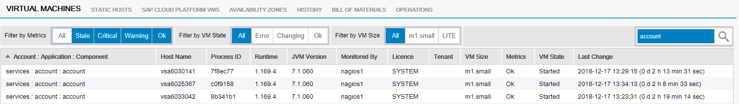

* 1. Look for application **services:account:account** in first displayed column Account : Application : Component  
     check number of instances and VM State of this application
  2. Stop (see appendix) all instances with status: VM_Failed, Error. Wait until those are stopped.
  3. If there are less than 3 instances remaining, then start new instances according appendix.
  4. If there are more than 4 instances running, then stop the oldest instances according appendix.
  5. Wait until remaining 3 instances are in running status.
  6. Check again monitor **“NEO-<landscape> Cloud Cockpit Instances”.**If the status is UP then incident is resolved.  
     Otherwise proceed with handover step 6.

1. Domain DB monitor failed, which means cockpit misses important data, e.g. neo java application status.  
   Check this monitor once again. If the status is still “failed” then proceed with handover step 6.
2. Global CIS monitor failed, which means cockpit misses important data, e.g. information about global accounts.  
   Check this monitor once again. If the status is still “failed” then proceed with handover step 6.
3. Database monitor failed, which means cockpit cannot access its database (This will also cause Instances monitor to fail).  
   In general cockpit can still be used, if the database is not accessible. Therefore just open a CRITICAL jira ticket for the Cloud Cockpit Team using this link: <https://jtrack/secure/CreateIssueDetails!init.jspa?pid=10099&issuetype=1&components=11915&priority=3>
4. Handover this Incident
   1. Inform [CE On Duty](https://wiki.wdf.sap.corp/wiki/display/EngSrv/30+CE+Engineer+on+Duty) with the relevant details like Landscape and Service name that is impacted.
   2. Update the SPC with relevant findings while executing the RA

**Appendix:**

Use the neo SDK command line for following actions.

**How to stop a Cloud Cockpit instance**

* List number of current instances  
  **neo status -h <landscape> -application account --account services –component account**  
  this command lists all known instances with their ID, State and latest change
* Before stopping an instance take a thread and heap dump as described below.
* Stop a single instance by ID  
  **neo stop -h <landscape> -application account --account services –component account -I <ID>**

**How to start a Cloud Cockpit instance**

* **neo start -h <landscape> -application account --account services –component account**  
  This command starts at least the minimal configured instance count

# How to take a heap and thread dump

* From monitor cockpit



* Get the hostname of the VM. Connect to the VM via putty from **WTS**.
* Execute following commands

**sudo su**

**jvmmon** (find the ljs PID)

**PID->** from the above step

**dump heap**

**The heap dump will be available in the monitoring cockpit Logs for the application.**

In order to take a thread dump while still on the VM :

jvmmon

dump stacktrace

Print to file /xxxxx/xxxxx/xx

Print stack trace