**Recommended Action: File System Service is not working**

|  |  |  |  |  |
| --- | --- | --- | --- | --- |
| **Service** | **RA ID** | **RA Name** | **RA Owner** | **Contacts** |
| [File System Service](https://jtrack.wdf.sap.corp/browse/SERVICE-205) |  | File System Service for Cloud Foundry (CF) - AWS only | Georgi Georgiev | [DL CP File System Service](mailto:DL_58789A447BCF84580A00002C@exchange.sap.corp) |

**Description**: This alert is raised if some/all of the File System Service broker application instances are not working.

**Check Status of Broker via Cockpit UI**

1. Log on to corresponding landscape

Navigate to SAPCF_xsa->SAP_xsa->nfs-filesystem->service and check “[filesystem-service-broker](https://account.int.sap.eu2.hana.ondemand.com/cockpit#/globalaccount/278d3ddd-c3b2-a5cc-f0b9-35405e327b6a/subaccount/sap-xsa/org/56379cc9-c832-48f5-920d-67a600aaca5b/space/ded08777-4db7-44d6-9e0e-6f080d3221c8/app/c72eb95b-0c63-49c6-a9ee-00816ee8531e/overview)” application. It must be in “Started” State and all <n> instances running.

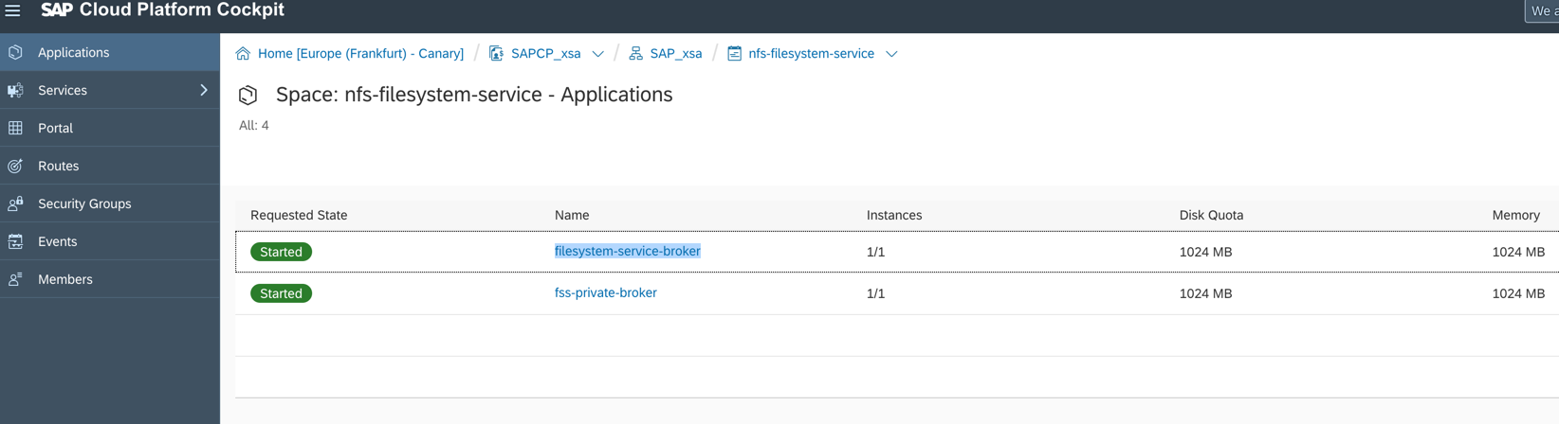

**Check Status of Broker via CF CLI**

1. Login with CF CLI client to the corresponding landscape:
   1. Specify landscape API endpoint

**$** cf api api.cf.<landscape API endpoint> List of APIs

1. Login with your credentials, which you will be interactively asked to provide

**$** cf login https://api.cf.<landscape domain> List of APIs

1. Navigate to “*SAP_xsa* org” and “*nfs-filesystem-service” space*

**$** cf target -o SAP_xsa -s nfs-filesystem-service

1. Check the “[filesystem-service-broker](https://account.int.sap.eu2.hana.ondemand.com/cockpit#/globalaccount/278d3ddd-c3b2-a5cc-f0b9-35405e327b6a/subaccount/sap-xsa/org/56379cc9-c832-48f5-920d-67a600aaca5b/space/ded08777-4db7-44d6-9e0e-6f080d3221c8/app/c72eb95b-0c63-49c6-a9ee-00816ee8531e/overview)” application
   1. List applications and check “requested state” column

**$** cf apps

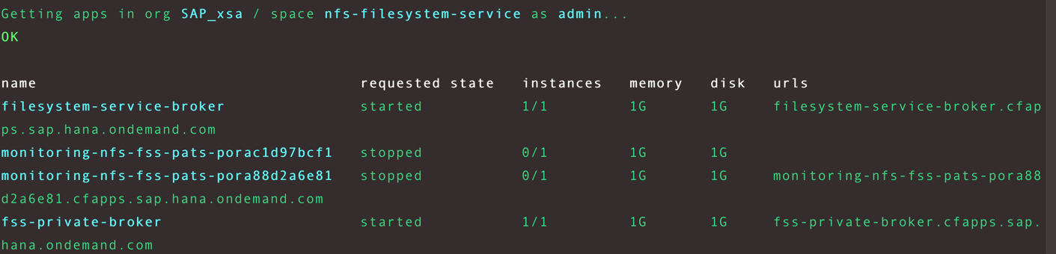

1. Logout from cf

**$** cf logout

# **Steps to resolve the incident (using CF CLI):**

1. Login with CF CLI client to the corresponding landscape:
   1. Specify landscape API endpoint

**$** cf api api.cf.<landscape API endpoint> List of APIs

1. Login with your credentials, which you will be interactively asked to provide

**$** cf login https://api.cf.<landscape domain> List of APIs

1. Navigate to “SAP_xsa org” and “nfs-filesystem-service” space

**$** cf target -o SAP_xsa -s nfs-filesystem-service

1. Find the “filesystem-service-broker” application and restart it, if its state is still not “started”

**$** cf apps



**$** cf restart <app name>

* 1. If an “filesystem-service-broker” application was not in started *requested state,* check its logs for the reason and store it for analysis.

**$** cf logs --recent <app name>

1. Logout from cf
   1. cf logout

Handover the accident.

# **Steps to resolve the incident (using Cockpit UI):**

1. Open landscape relevant cockpit for global account “SAPCP_xsa”, subaccount “SAP_xsa” and space “nfs-filesystem-service”

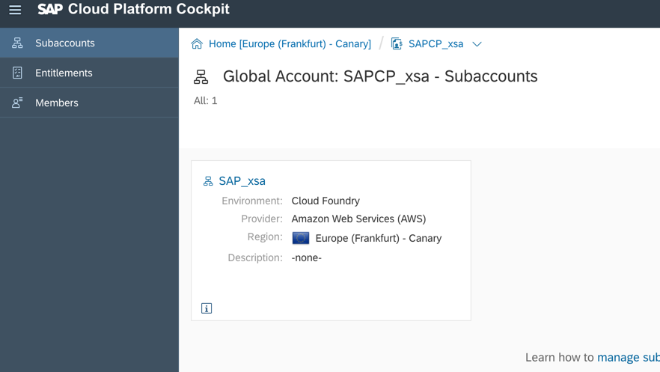

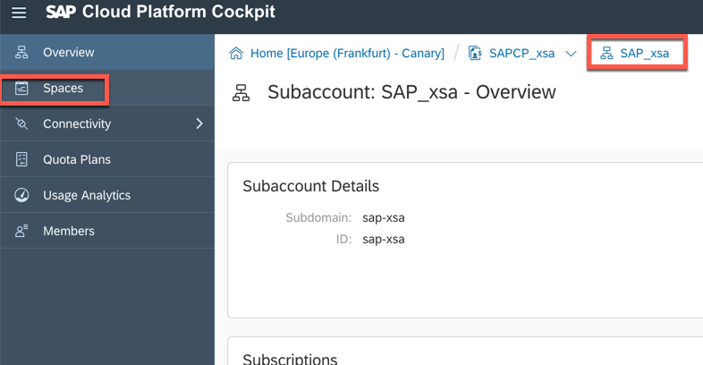*

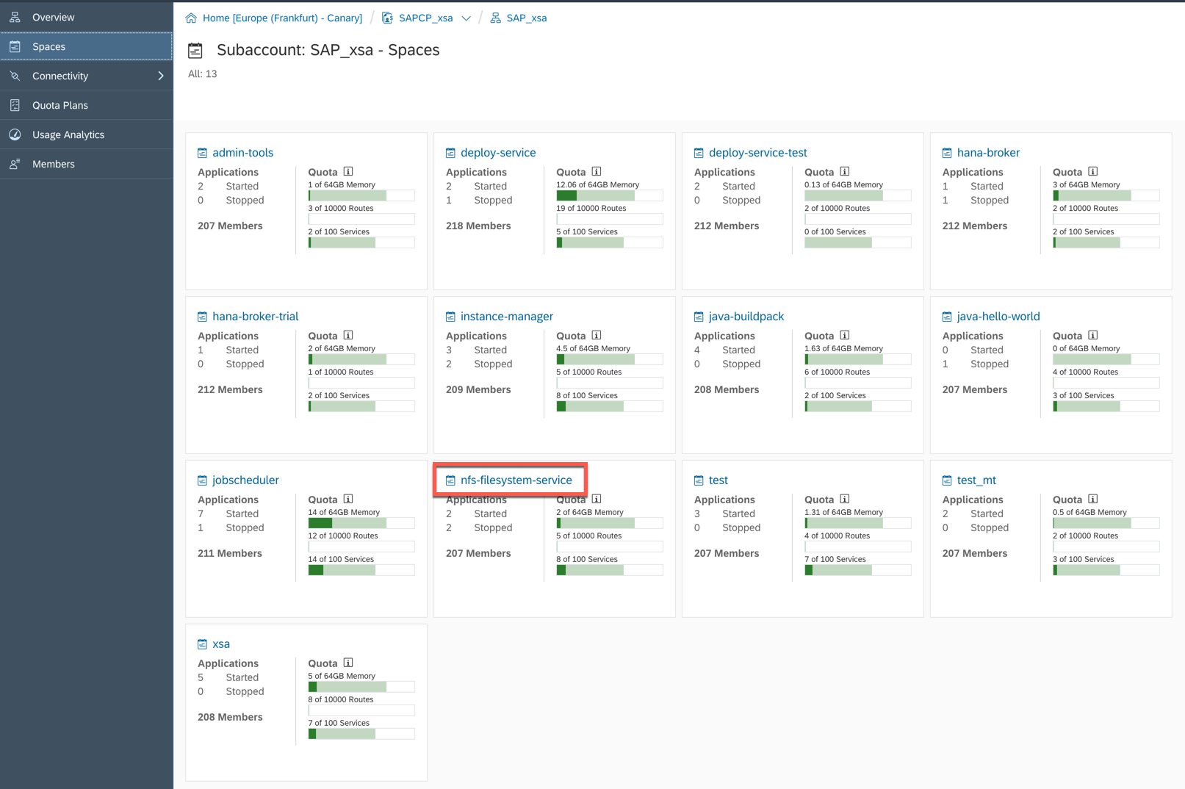

1. Navigate to *nfs-filesystem-service* space

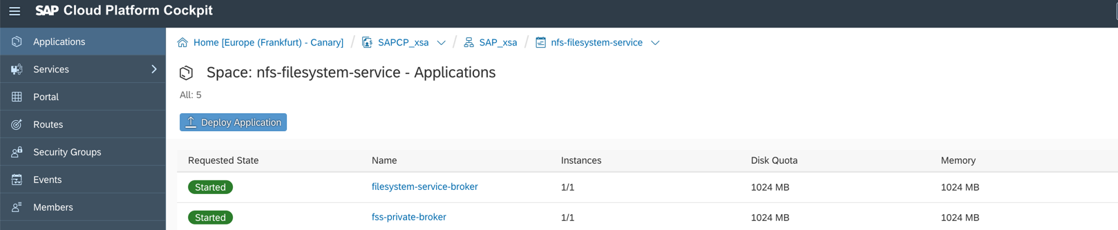

1. Check “**filesystem-service-broker**” application State. This can be observed in the *Requested State* Column

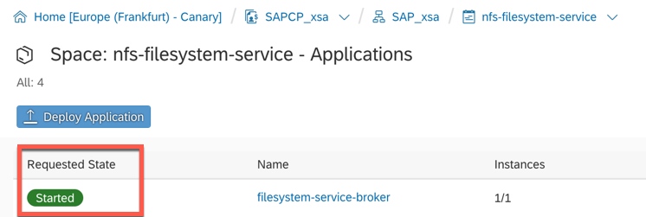

* 1. If the app is not in “Started” State, click on application name and try to restart it via the *Restart* action button

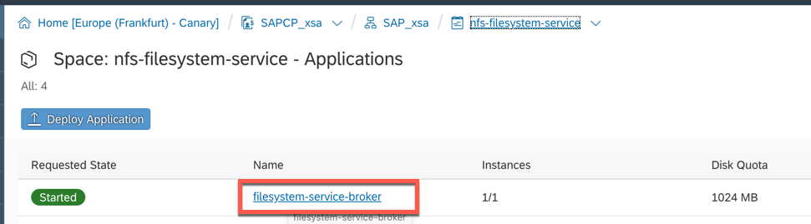

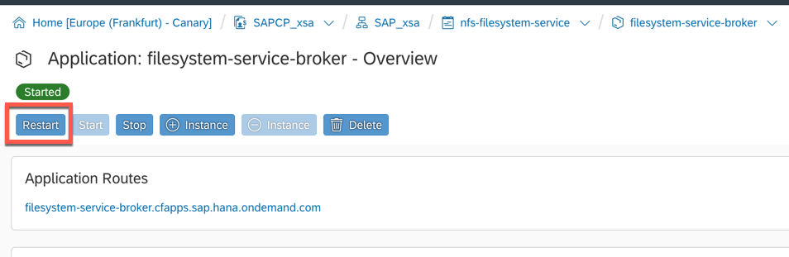

* 1. If an app is still not in “Started” State afterwards, check its logs for the reason and store it for analysis.
     1. Click on the application name – this will open the following screen:

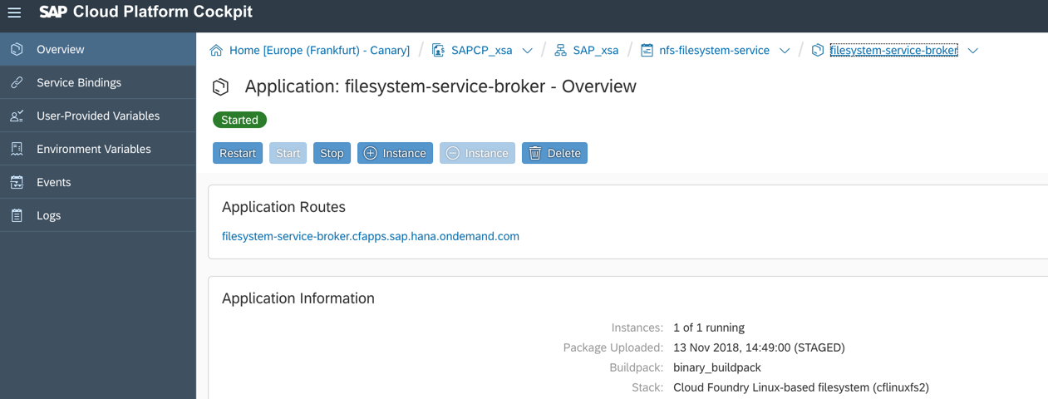

* + 1. Go to *Logs* and then download them (right part of the screen) and attach them to the incident ticket for analysis

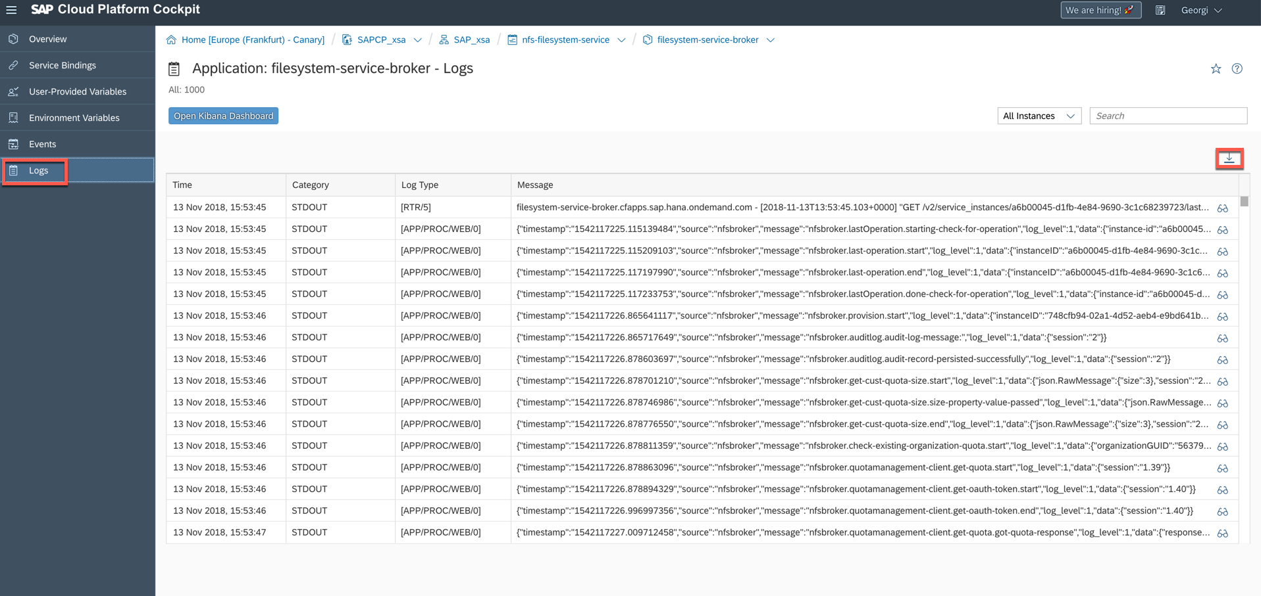

1. Handover the accident.

# **Steps to handover the Incident:**

1. Inform [[CE On Duty](https://wiki.wdf.sap.corp/wiki/x/th_Uag)](https://wiki.wdf.sap.corp/wiki/display/EngSrv/30+CE+Engineer+on+Duty) with the relevant details like Landscape and Service name that is impacted.
2. Update the SPC with relevant findings while executing the RA

# List of CF API’s

|  |  |  |  |  |  |  |  |  |  |  |
| --- | --- | --- | --- | --- | --- | --- | --- | --- | --- | --- |
| LANDSCAPE-ID | TYPE | DESCRIPTION | OWNER | JUMPBOX IP | DOMAIN |  |  |  |  |  |
| +--------------------+-------+--------------------------------+---------------+-----------------+----------------------------------------+ | | | | | | | | | | |
| | cf-ap10            | aws   | Asia Pacific (Sydney)          | sic@sap.com   | 13.55.57.30     |ap10.hana.ondemand.com | | | | | | | | | | |
| | cf-ap11            | aws   | Asia Pacific (Singapore)       | sic@sap.com   | 13.251.74.52    | ap11.hana.ondemand.com | | | | | | | | | | |
| | cf-br10            | aws   | Brazil (São Paulo)             | sic@sap.com   | 18.231.67.130   |br10.hana.ondemand.com | | | | | | | | | | |
| | cf-ca10            | aws   | Canada (Montreal)              | sic@sap.com   | 35.183.216.196  | ca10.hana.ondemand.com | | | | | | | | | | |
| | cf-eu10            | aws   | Europe (Frankfurt)             | sic@sap.com   | 18.195.99.177   | eu10.hana.ondemand.com | | | | | | | | | | |
| | cf-eu10-canary     | aws   | Europe (Frankfurt) - Canary    | all           | 35.158.149.138  | sap.hana.ondemand.com | | | | | | | | | | |
| | cf-jp10            | aws   | Japan (Tokyo)                  | sic@sap.com   | 54.95.90.37     | jp10.hana.ondemand.com | | | | | | | | | | |
| | cf-us10            | aws   | US East (VA)                   | sic@sap.com   | 34.227.144.30   | us10.hana.ondemand.com | | | | | | | | | | |
|  | | | | | | | | | | |
|  | | | | | | | | | | |
|  | | | | | | | | | | |