

Ministry of Education and Science of Ukraine

National Technical University of Ukraine “Igor Sikorsky Kyiv Polytechnic Institute” Faculty of Informatics and Computer Engineering Department of Information Systems and Technologies

Lab №6

**Theory of algorithms**

**“Search data structures - 1. Binary search trees”**

Team 2

Made by

Students of ІА-11:

Kovtun N.O.

Svirghevskiy N. L.

Berkovskiy D.R.

Ivannikov M.T.

Checked by:

as.dep.IST

as. Tsymbal S. I.

Kyiv 2022

*Lab goal*: Learn how to implement both unbalanced and balanced binary search trees as well as discover pros and cons for each algorithm.

*Lab progress:*

**Code source:** https://github.com/Gr1ngoire/TA_Lab_06

*Problem Formulation:*

*-Task1:* Implement unbalanced and balanced binary search tree.

*-Task2:* Measure:

*- elapsed time for filling different trees with elements (1000+ elements):*

*a. Consecutive elements;*

b. Random elements (wide range, not from 0 to 100 but with larger numbers);

- balancing time:

a. Consecutive numbers;

b. Random numbers;

- search time in:

a. Unbalanced binary tree;

b. Balanced binary tree;

- delete time:

a. with overbalancing;

b. without overbalancing;

|  |  |  |  |  |  |  |
| --- | --- | --- | --- | --- | --- | --- |
|  | Insertion | | Balancing | | Search | Deletion |
| r/e | c/e | r/e | c/e |
| Balanced BST | 6.501 | 10.119 | 0.003 | 0.002 | 0.025 |  |
| Unbalanced BST | 2.423 | 90.053 |  |  | 0.088 | 0.011 |
|  | Time elapsed, ms(ns/mcs/s) | | | | | |

Screenshots: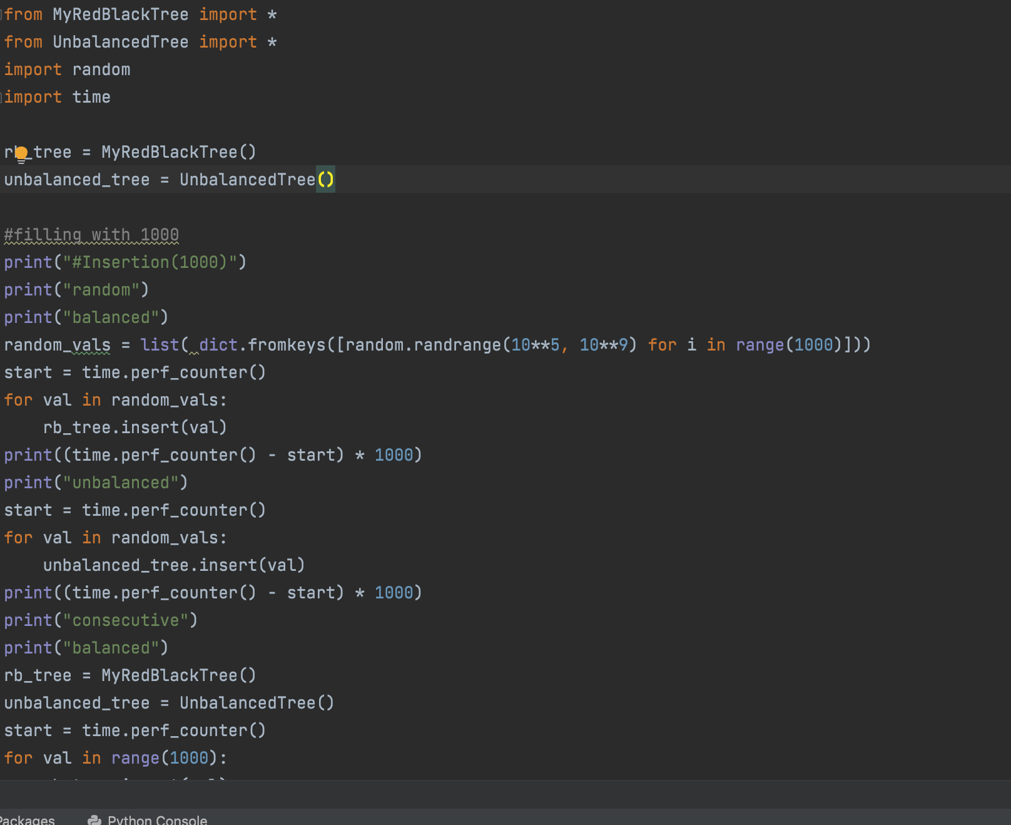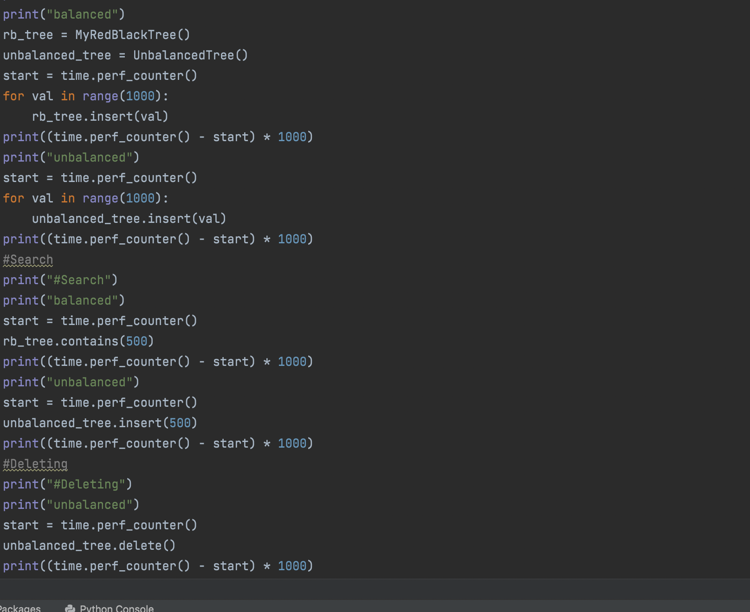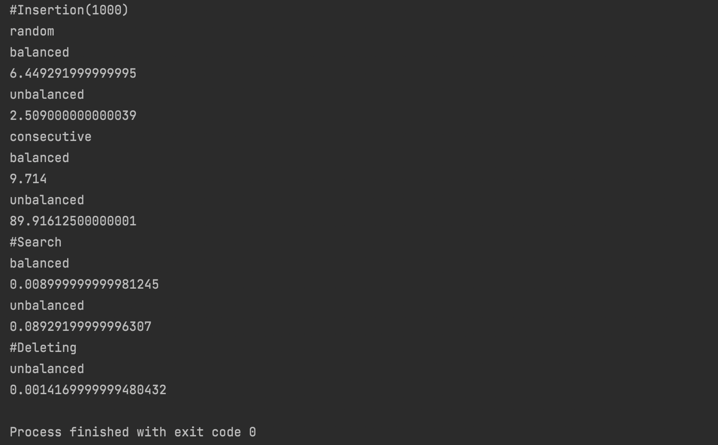

Conclusions: During this lab we discovered pros and cons of our binary search tree implementations.