MY GAME LIST
DATABASE DESIGN PROJECT
Submitted by:
REG NO STUDENT NAME
2023-BS-CS-064 ZAIN MAHMOOD
2024-BS-CS-366 HASSAN TARIQ
Section-A
BACHELOR OF SCIENCE
IN
COMPUTER SCIENCE
(SEMESTER-IV)

THE UNIVERSITY OF FAISALABAD
JUNE 2025

1. Project Overview
1.1 Introduction
My Game List is a web platform that helps gamers track, organize, and review video games. It works like a digital library where users can keep records of games they have played, are currently playing, or want to play in the future. The platform also includes social features that allow users to follow each other and share their gaming experiences.
1.2 Project Goals
The main goal of this project is to create a database that can:
- Store information about thousands of video games
- Track user gaming activities and progress
- Manage user reviews and ratings
- Handle social interactions between users
- Organize games into custom lists and categories
1.3 Target Users
- Primary Users: Gaming enthusiasts who want to organize their game collections
- Secondary Users: Game reviewers and content creators
- Tertiary Users: Casual gamers looking for game recommendations

2. System Features
2.1 Core Features
Game Library Management
- Users can mark games with different statuses (Currently Playing, Completed, On Hold, Dropped, Plan to Play)
- Track how many hours spent playing each game
- Give personal ratings to games (0-10 scale)
- View personal gaming statistics
Rating and Review System
- Write detailed reviews for games
- Rate games and see community ratings
- Read reviews from other users
- Edit and manage personal reviews
Social Features
- Follow other users to see their gaming activities
- Customize user profiles with avatars and display names
- Discover users with similar gaming interests
Custom Lists
- Create personal game collections (like "Best RPGs" or "Hidden Gems")
- Make lists public or private
- Organize games within lists in custom order
Game Database
- Store detailed information about games (title, description, release date, ratings)
- Support multiple gaming platforms (PC, PlayStation, Xbox, Nintendo, Mobile)
- Categorize games by genres and tags
- Include developer and publisher information
- Store game screenshots and images

3. Database Design Process
3.1 Requirements Analysis
What information do we need to store?
- Game details (name, description, release date, ratings, images)
- User profiles and login information
- Game tracking records (status, progress, personal ratings)
- User reviews and ratings
- Social connections between users
- Custom user-created lists
- Game categories (genres, platforms, publishers, developers)
What actions should the system support?
- Add games to personal library
- Write and edit reviews
- Follow other users
- Create custom game lists
- Search and filter games
- View gaming statistics
3.2 Entity-Relationship (ER) Model
Primary Entities:
- User: People who use the platform
- Game: Video games in the database
- Publisher: Companies that publish games
- Developer: Companies that develop games
- Platform: Gaming systems (PC, PlayStation, Xbox, etc.)
- Genre: Game categories (Action, RPG, Strategy, etc.)
- Tag: Additional game descriptors
- Store: Digital stores where games are sold
Key Relationships:
- A User can track many Games (one-to-many)
- A Game can be tracked by many Users (many-to-many)
- A User can write many Reviews (one-to-many)
- A Game can have many Reviews (one-to-many)
- Users can follow other Users (many-to-many)
- Games can have multiple Publishers, Developers, Platforms, and Genres (many-to-many)
3.3 ER Diagram
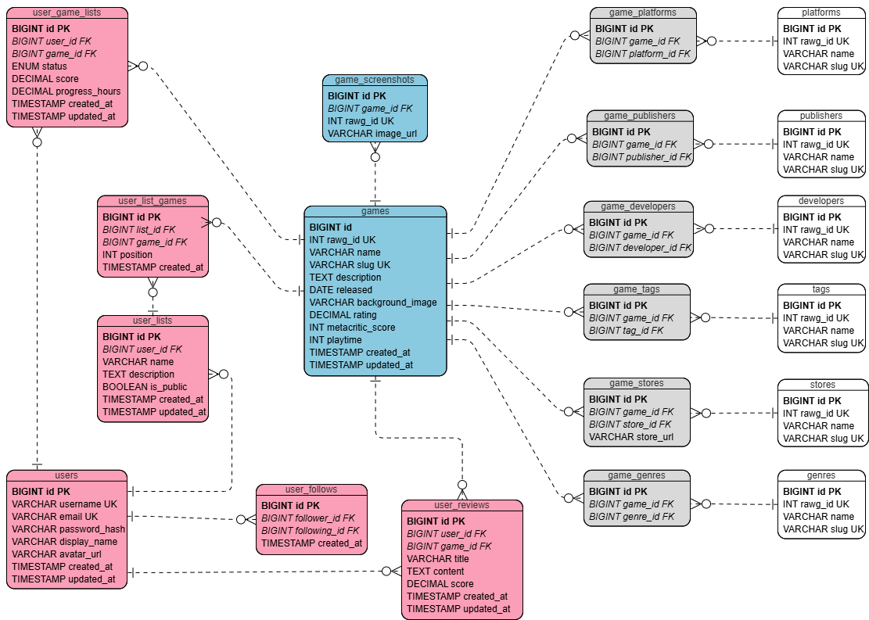

4. Database Schema Design
4.1 Table Structure
Core Tables:
- users - Stores user account information
  - id, username, email, password_hash, display_name, avatar_url, created_at, updated_at
- games - Stores game information
  - id, rawg_id, name, slug, description, released, background_image, rating, metacritic_score, playtime, created_at, updated_at
- publishers - Game publishing companies
  - id, rawg_id, name, slug
- developers - Game development companies
  - id, rawg_id, name, slug
- platforms - Gaming platforms
  - id, rawg_id, name, slug
- genres - Game genres
  - id, rawg_id, name, slug
- tags - Game tags
  - id, rawg_id, name, slug
- stores - Digital game stores
  - id, rawg_id, name, slug
Junction Tables (for many-to-many relationships):
- game_publishers, game_developers, game_platforms, game_genres, game_tags, game_stores
User Interaction Tables:
- user_game_lists (tracks user's game library)
- user_reviews (stores user reviews)
- user_follows (manages user following relationships)
- user_lists (custom user-created lists)
- user_list_games (games within custom lists)
Media Tables:
- game_screenshots (stores game images)
4.2 Data Types and Constraints
Data Types Used:
- BIGINT - For primary keys and foreign keys (allows for large numbers)
- VARCHAR(255) - For names, usernames, emails
- TEXT - For long descriptions and review content
- DECIMAL(3,2) - For precise ratings (0.00 to 10.00)
- ENUM - For status values (Currently Playing, Completed, etc.)
- TIMESTAMP - For tracking creation and update times
- DATE - For game release dates
- INT - For scores and counters
- BOOLEAN - For true/false values (like public/private)
Key Constraints:
- Primary keys on all tables for unique identification
- Foreign keys to maintain data relationships
- Unique constraints on usernames, emails, and slugs
- Check constraints for valid rating ranges

5. Normalization Analysis
5.1 First Normal Form (1NF)
Requirements:
- All data must be atomic (no multiple values in single field)
- Each row must be unique
- No repeating groups
Our Design: ✓ All attributes store single values (username, email, game name) ✓ Primary keys ensure unique rows ✓ Junction tables handle multiple relationships (game can have multiple genres)
Result: Our schema satisfies 1NF.
5.2 Second Normal Form (2NF)
Requirements:
- Must satisfy 1NF
- All non-key attributes must depend on the entire primary key
Our Design: ✓ Satisfies 1NF ✓ All attributes depend fully on primary keys ✓ Junction tables properly handle many-to-many relationships
Result: Our schema satisfies 2NF.
5.3 Third Normal Form (3NF)
Requirements:
- Must satisfy 2NF
- No transitive dependencies (non-key attributes should not depend on other non-key attributes)
Our Design: ✓ Satisfies 2NF ✓ Reference data stored in separate tables (publishers, genres, etc.) ✓ No transitive dependencies exist
Result: Our schema satisfies 3NF.
5.4 Benefits Achieved
- Reduced Data Redundancy: Publisher names stored once, referenced by ID
- Improved Data Consistency: Changes to publisher name update everywhere
- Better Storage Efficiency: No duplicate data storage
- Enhanced Data Integrity: Foreign key constraints prevent invalid data

6. Database Implementation
6.1 SQL Schema Creation

create database MyGameList;
use MyGameList;

CREATE TABLE users (
id BIGINT PRIMARY KEY AUTO_INCREMENT,
username VARCHAR(50) UNIQUE NOT NULL,
email VARCHAR(255) UNIQUE NOT NULL,
password_hash VARCHAR(255) NOT NULL,
display_name VARCHAR(100),
avatar_url VARCHAR(500),
created_at TIMESTAMP DEFAULT CURRENT_TIMESTAMP,
updated_at TIMESTAMP DEFAULT CURRENT_TIMESTAMP ON UPDATE CURRENT_TIMESTAMP,

INDEX idx_username (username),
INDEX idx_email (email)
);

CREATE TABLE publishers (
id BIGINT PRIMARY KEY AUTO_INCREMENT,
rawg_id INT UNIQUE,
name VARCHAR(255) NOT NULL,
slug VARCHAR(255) UNIQUE NOT NULL,

INDEX idx_name (name),
INDEX idx_rawg_id (rawg_id)
);

CREATE TABLE developers (
id BIGINT PRIMARY KEY AUTO_INCREMENT,
rawg_id INT UNIQUE,
name VARCHAR(255) NOT NULL,
slug VARCHAR(255) UNIQUE NOT NULL,

INDEX idx_name (name),
INDEX idx_rawg_id (rawg_id)
);

CREATE TABLE platforms (
id BIGINT PRIMARY KEY AUTO_INCREMENT,
rawg_id INT UNIQUE,
name VARCHAR(100) NOT NULL,
slug VARCHAR(100) UNIQUE NOT NULL,

INDEX idx_name (name),
INDEX idx_rawg_id (rawg_id)
);

CREATE TABLE genres (
id BIGINT PRIMARY KEY AUTO_INCREMENT,
rawg_id INT UNIQUE,
name VARCHAR(100) NOT NULL,
slug VARCHAR(100) UNIQUE NOT NULL,

INDEX idx_name (name),
INDEX idx_rawg_id (rawg_id)
);

CREATE TABLE tags (
id BIGINT PRIMARY KEY AUTO_INCREMENT,
rawg_id INT UNIQUE,
name VARCHAR(100) NOT NULL,
slug VARCHAR(100) UNIQUE NOT NULL,

INDEX idx_name (name),
INDEX idx_rawg_id (rawg_id)
);

CREATE TABLE stores (
id BIGINT PRIMARY KEY AUTO_INCREMENT,
rawg_id INT UNIQUE,
name VARCHAR(100) NOT NULL,
slug VARCHAR(100) UNIQUE NOT NULL,

INDEX idx_name (name),
INDEX idx_rawg_id (rawg_id)
);

CREATE TABLE games (
id BIGINT PRIMARY KEY AUTO_INCREMENT,
rawg_id INT UNIQUE,
name VARCHAR(255) NOT NULL,
slug VARCHAR(255) UNIQUE NOT NULL,
description TEXT,
released DATE,
background_image VARCHAR(500),
rating DECIMAL(3,2) DEFAULT 0.00,
metacritic_score INT,
playtime INT DEFAULT 0,
created_at TIMESTAMP DEFAULT CURRENT_TIMESTAMP,
updated_at TIMESTAMP DEFAULT CURRENT_TIMESTAMP ON UPDATE CURRENT_TIMESTAMP,

INDEX idx_name (name),
INDEX idx_slug (slug),
INDEX idx_released (released),
INDEX idx_rating (rating),
INDEX idx_rawg_id (rawg_id)
);

CREATE TABLE game_publishers (
id BIGINT PRIMARY KEY AUTO_INCREMENT,
game_id BIGINT NOT NULL,
publisher_id BIGINT NOT NULL,

FOREIGN KEY (game_id) REFERENCES games(id) ON DELETE CASCADE,
FOREIGN KEY (publisher_id) REFERENCES publishers(id) ON DELETE CASCADE,
UNIQUE KEY unique_game_publisher (game_id, publisher_id)
);

CREATE TABLE game_developers (
id BIGINT PRIMARY KEY AUTO_INCREMENT,
game_id BIGINT NOT NULL,
developer_id BIGINT NOT NULL,

FOREIGN KEY (game_id) REFERENCES games(id) ON DELETE CASCADE,
FOREIGN KEY (developer_id) REFERENCES developers(id) ON DELETE CASCADE,
UNIQUE KEY unique_game_developer (game_id, developer_id)
);

CREATE TABLE game_platforms (
id BIGINT PRIMARY KEY AUTO_INCREMENT,
game_id BIGINT NOT NULL,
platform_id BIGINT NOT NULL,

FOREIGN KEY (game_id) REFERENCES games(id) ON DELETE CASCADE,
FOREIGN KEY (platform_id) REFERENCES platforms(id) ON DELETE CASCADE,
UNIQUE KEY unique_game_platform (game_id, platform_id)
);

CREATE TABLE game_genres (
id BIGINT PRIMARY KEY AUTO_INCREMENT,
game_id BIGINT NOT NULL,
genre_id BIGINT NOT NULL,

FOREIGN KEY (game_id) REFERENCES games(id) ON DELETE CASCADE,
FOREIGN KEY (genre_id) REFERENCES genres(id) ON DELETE CASCADE,
UNIQUE KEY unique_game_genre (game_id, genre_id)
);

CREATE TABLE game_tags (
id BIGINT PRIMARY KEY AUTO_INCREMENT,
game_id BIGINT NOT NULL,
tag_id BIGINT NOT NULL,

FOREIGN KEY (game_id) REFERENCES games(id) ON DELETE CASCADE,
FOREIGN KEY (tag_id) REFERENCES tags(id) ON DELETE CASCADE,
UNIQUE KEY unique_game_tag (game_id, tag_id)
);

CREATE TABLE game_stores (
id BIGINT PRIMARY KEY AUTO_INCREMENT,
game_id BIGINT NOT NULL,
store_id BIGINT NOT NULL,
store_url VARCHAR(500),

FOREIGN KEY (game_id) REFERENCES games(id) ON DELETE CASCADE,
FOREIGN KEY (store_id) REFERENCES stores(id) ON DELETE CASCADE,
UNIQUE KEY unique_game_store (game_id, store_id)
);

CREATE TABLE user_game_lists (
id BIGINT PRIMARY KEY AUTO_INCREMENT,
user_id BIGINT NOT NULL,
game_id BIGINT NOT NULL,
status ENUM('playing', 'completed', 'on_hold', 'dropped', 'plan_to_play') NOT NULL,
score DECIMAL(3,1) CHECK (score >= 1.0 AND score <= 10.0),
progress_hours DECIMAL(8,2) DEFAULT 0,
created_at TIMESTAMP DEFAULT CURRENT_TIMESTAMP,
updated_at TIMESTAMP DEFAULT CURRENT_TIMESTAMP ON UPDATE CURRENT_TIMESTAMP,

FOREIGN KEY (user_id) REFERENCES users(id) ON DELETE CASCADE,
FOREIGN KEY (game_id) REFERENCES games(id) ON DELETE CASCADE,
UNIQUE KEY unique_user_game (user_id, game_id),
INDEX idx_user_id (user_id),
INDEX idx_status (status)
);

CREATE TABLE user_reviews (
id BIGINT PRIMARY KEY AUTO_INCREMENT,
user_id BIGINT NOT NULL,
game_id BIGINT NOT NULL,
title VARCHAR(255),
content TEXT NOT NULL,
score DECIMAL(3,1) CHECK (score >= 1.0 AND score <= 10.0),
created_at TIMESTAMP DEFAULT CURRENT_TIMESTAMP,
updated_at TIMESTAMP DEFAULT CURRENT_TIMESTAMP ON UPDATE CURRENT_TIMESTAMP,

FOREIGN KEY (user_id) REFERENCES users(id) ON DELETE CASCADE,
FOREIGN KEY (game_id) REFERENCES games(id) ON DELETE CASCADE,
UNIQUE KEY unique_user_game_review (user_id, game_id),
INDEX idx_user_id (user_id),
INDEX idx_game_id (game_id)
);

CREATE TABLE user_follows (
id BIGINT PRIMARY KEY AUTO_INCREMENT,
follower_id BIGINT NOT NULL,
following_id BIGINT NOT NULL,
created_at TIMESTAMP DEFAULT CURRENT_TIMESTAMP,

FOREIGN KEY (follower_id) REFERENCES users(id) ON DELETE CASCADE,
FOREIGN KEY (following_id) REFERENCES users(id) ON DELETE CASCADE,
UNIQUE KEY unique_follow (follower_id, following_id)
);

CREATE TABLE user_lists (
id BIGINT PRIMARY KEY AUTO_INCREMENT,
user_id BIGINT NOT NULL,
name VARCHAR(255) NOT NULL,
description TEXT,
is_public BOOLEAN DEFAULT TRUE,
created_at TIMESTAMP DEFAULT CURRENT_TIMESTAMP,
updated_at TIMESTAMP DEFAULT CURRENT_TIMESTAMP ON UPDATE CURRENT_TIMESTAMP,

FOREIGN KEY (user_id) REFERENCES users(id) ON DELETE CASCADE,
INDEX idx_user_id (user_id)
);

CREATE TABLE user_list_games (
id BIGINT PRIMARY KEY AUTO_INCREMENT,
list_id BIGINT NOT NULL,
game_id BIGINT NOT NULL,
position INT,
created_at TIMESTAMP DEFAULT CURRENT_TIMESTAMP,

FOREIGN KEY (list_id) REFERENCES user_lists(id) ON DELETE CASCADE,
FOREIGN KEY (game_id) REFERENCES games(id) ON DELETE CASCADE,
UNIQUE KEY unique_list_game (list_id, game_id)
);

CREATE TABLE game_screenshots (
id BIGINT PRIMARY KEY AUTO_INCREMENT,
game_id BIGINT NOT NULL,
rawg_id INT UNIQUE,
image_url VARCHAR(500) NOT NULL,

FOREIGN KEY (game_id) REFERENCES games(id) ON DELETE CASCADE,
INDEX idx_game_id (game_id)
);

6.2 Indexing Strategy
Primary Indexes:
- Primary key indexes on all tables (automatic)
Secondary Indexes:
- Unique indexes on usernames, emails, and slugs
- Foreign key indexes for efficient joins
- Composite indexes on frequently searched combinations
- Full-text search indexes for game names and descriptions
Benefits:
- Faster query performance
- Efficient joins between tables
- Quick user authentication
- Fast game searches

7. Testing and Validation
7.1 Sample Data Insertion

INSERT INTO publishers (rawg_id, name, slug) VALUES
(1, 'CD Projekt', 'cd-projekt'),
(2, 'Rockstar Games', 'rockstar-games'),
(3, 'Nintendo', 'nintendo'),
(4, 'Sony Interactive Entertainment', 'sony-interactive-entertainment'),
(5, 'Bandai Namco Entertainment', 'bandai-namco-entertainment'),
(6, 'Epic Games', 'epic-games'),
(7, 'Microsoft Studios', 'microsoft-studios');

INSERT INTO developers (rawg_id, name, slug) VALUES
(1, 'CD Projekt Red', 'cd-projekt-red'),
(2, 'Rockstar Studios', 'rockstar-studios'),
(3, 'Nintendo EPD', 'nintendo-epd'),
(4, 'Santa Monica Studio', 'santa-monica-studio'),
(5, 'Guerrilla Games', 'guerrilla-games'),
(6, 'FromSoftware', 'fromsoftware'),
(7, 'Epic Games', 'epic-games'),
(8, 'Mojang Studios', 'mojang-studios');

INSERT INTO platforms (rawg_id, name, slug) VALUES
(1, 'PC', 'pc'),
(2, 'PlayStation 4', 'playstation-4'),
(3, 'PlayStation 5', 'playstation-5'),
(4, 'Xbox One', 'xbox-one'),
(5, 'Xbox Series X', 'xbox-series-x'),
(6, 'Nintendo Switch', 'nintendo-switch');

INSERT INTO genres (rawg_id, name, slug) VALUES
(1, 'Action', 'action'),
(2, 'RPG', 'rpg'),
(3, 'Adventure', 'adventure'),
(4, 'Shooter', 'shooter'),
(5, 'Platformer', 'platformer'),
(6, 'Sandbox', 'sandbox'),
(7, 'Survival', 'survival'),
(8, 'Battle Royale', 'battle-royale');

INSERT INTO tags (rawg_id, name, slug) VALUES
(1, 'Open World', 'open-world'),
(2, 'Fantasy', 'fantasy'),
(3, 'Sci-Fi', 'sci-fi'),
(4, 'Multiplayer', 'multiplayer'),
(5, 'Singleplayer', 'singleplayer');

INSERT INTO stores (rawg_id, name, slug) VALUES
(1, 'Steam', 'steam'),
(2, 'Epic Games Store', 'epic-games-store'),
(3, 'PlayStation Store', 'playstation-store'),
(4, 'Xbox Store', 'xbox-store'),
(5, 'Nintendo eShop', 'nintendo-eshop');

INSERT INTO games (rawg_id, name, slug, description, released, background_image, rating, metacritic_score, playtime)
VALUES (
3328,
'The Witcher 3: Wild Hunt',
'the-witcher-3-wild-hunt',
'An action RPG set in a fantasy universe.',
'2015-05-19',
'https://example.com/game1.jpg',
4.67,
93,
100
);
INSERT INTO game_publishers (game_id, publisher_id) VALUES (1, 1);
INSERT INTO game_developers (game_id, developer_id) VALUES (1, 1);
INSERT INTO game_platforms (game_id, platform_id) VALUES (1, 1), (1, 2), (1, 4), (1, 6);
INSERT INTO game_genres (game_id, genre_id) VALUES (1, 1), (1, 2);
INSERT INTO game_tags (game_id, tag_id) VALUES (1, 1), (1, 2), (1, 5);
INSERT INTO game_stores (game_id, store_id, store_url) VALUES
(1, 1, 'https://store.example.com/game1'),
(1, 3, 'https://store.example.com/game1_ps'),
(1, 4, 'https://store.example.com/game1_xbox'),
(1, 5, 'https://store.example.com/game1_switch');

INSERT INTO games (rawg_id, name, slug, description, released, background_image, rating, metacritic_score, playtime)
VALUES (
41494,
'Cyberpunk 2077',
'cyberpunk-2077',
'An open-world, action-adventure story set in Night City.',
'2020-12-10',
'https://example.com/game2.jpg',
3.5,
86,
60
);
INSERT INTO game_publishers (game_id, publisher_id) VALUES (2, 1);
INSERT INTO game_developers (game_id, developer_id) VALUES (2, 1);
INSERT INTO game_platforms (game_id, platform_id) VALUES (2, 1), (2, 2), (2, 3), (2, 4), (2, 5);
INSERT INTO game_genres (game_id, genre_id) VALUES (2, 1), (2, 2);
INSERT INTO game_tags (game_id, tag_id) VALUES (2, 1), (2, 3), (2, 5);
INSERT INTO game_stores (game_id, store_id, store_url) VALUES
(2, 1, 'https://store.example.com/game2'),
(2, 3, 'https://store.example.com/game2_ps'),
(2, 4, 'https://store.example.com/game2_xbox');

INSERT INTO games (rawg_id, name, slug, description, released, background_image, rating, metacritic_score, playtime)
VALUES (
28,
'Red Dead Redemption 2',
'red-dead-redemption-2',
'An epic tale of life in America’s unforgiving heartland.',
'2018-10-26',
'https://example.com/game3.jpg',
4.8,
97,
50
);
INSERT INTO game_publishers (game_id, publisher_id) VALUES (3, 2);
INSERT INTO game_developers (game_id, developer_id) VALUES (3, 2);
INSERT INTO game_platforms (game_id, platform_id) VALUES (3, 1), (3, 2), (3, 4);
INSERT INTO game_genres (game_id, genre_id) VALUES (3, 1), (3, 3);
INSERT INTO game_tags (game_id, tag_id) VALUES (3, 1), (3, 5);
INSERT INTO game_stores (game_id, store_id, store_url) VALUES
(3, 1, 'https://store.example.com/game3'),
(3, 3, 'https://store.example.com/game3_ps'),
(3, 4, 'https://store.example.com/game3_xbox');

INSERT INTO games (rawg_id, name, slug, description, released, background_image, rating, metacritic_score, playtime)
VALUES (
4200,
'The Legend of Zelda: Breath of the Wild',
'the-legend-of-zelda-breath-of-the-wild',
'An open-world adventure game set in the kingdom of Hyrule.',
'2017-03-03',
'https://example.com/game4.jpg',
4.9,
97,
50
);
INSERT INTO game_publishers (game_id, publisher_id) VALUES (4, 3);
INSERT INTO game_developers (game_id, developer_id) VALUES (4, 3);
INSERT INTO game_platforms (game_id, platform_id) VALUES (4, 6);
INSERT INTO game_genres (game_id, genre_id) VALUES (4, 1), (4, 3);
INSERT INTO game_tags (game_id, tag_id) VALUES (4, 1), (4, 2), (4, 5);
INSERT INTO game_stores (game_id, store_id, store_url) VALUES
(4, 5, 'https://store.example.com/game4_switch');

INSERT INTO games (rawg_id, name, slug, description, released, background_image, rating, metacritic_score, playtime)
VALUES (
2454,
'God of War',
'god-of-war',
'A new beginning for Kratos in a Norse mythology setting.',
'2018-04-20',
'https://example.com/game5.jpg',
4.9,
94,
20
);
INSERT INTO game_publishers (game_id, publisher_id) VALUES (5, 4);
INSERT INTO game_developers (game_id, developer_id) VALUES (5, 4);
INSERT INTO game_platforms (game_id, platform_id) VALUES (5, 2), (5, 3);
INSERT INTO game_genres (game_id, genre_id) VALUES (5, 1), (5, 3);
INSERT INTO game_tags (game_id, tag_id) VALUES (5, 2), (5, 5);
INSERT INTO game_stores (game_id, store_id, store_url) VALUES
(5, 3, 'https://store.example.com/game5_ps');

INSERT INTO games (rawg_id, name, slug, description, released, background_image, rating, metacritic_score, playtime)
VALUES (
278,
'Horizon Zero Dawn',
'horizon-zero-dawn',
'An action RPG set in a post-apocalyptic world.',
'2017-02-28',
'https://example.com/game6.jpg',
4.7,
89,
30
);
INSERT INTO game_publishers (game_id, publisher_id) VALUES (6, 4);
INSERT INTO game_developers (game_id, developer_id) VALUES (6, 5);
INSERT INTO game_platforms (game_id, platform_id) VALUES (6, 1), (6, 2);
INSERT INTO game_genres (game_id, genre_id) VALUES (6, 1), (6, 2);
INSERT INTO game_tags (game_id, tag_id) VALUES (6, 1), (6, 3), (6, 5);
INSERT INTO game_stores (game_id, store_id, store_url) VALUES
(6, 1, 'https://store.example.com/game6_pc'),
(6, 3, 'https://store.example.com/game6_ps');

INSERT INTO games (rawg_id, name, slug, description, released, background_image, rating, metacritic_score, playtime)
VALUES (
3350,
'Dark Souls III',
'dark-souls-iii',
'An action RPG known for its challenging gameplay.',
'2016-04-12',
'https://example.com/game7.jpg',
4.6,
89,
40
);
INSERT INTO game_publishers (game_id, publisher_id) VALUES (7, 5);
INSERT INTO game_developers (game_id, developer_id) VALUES (7, 6);
INSERT INTO game_platforms (game_id, platform_id) VALUES (7, 1), (7, 2), (7, 4);
INSERT INTO game_genres (game_id, genre_id) VALUES (7, 1), (7, 2);
INSERT INTO game_tags (game_id, tag_id) VALUES (7, 2), (7, 5);
INSERT INTO game_stores (game_id, store_id, store_url) VALUES
(7, 1, 'https://store.example.com/game7_pc'),
(7, 3, 'https://store.example.com/game7_ps'),
(7, 4, 'https://store.example.com/game7_xbox');

INSERT INTO games (rawg_id, name, slug, description, released, background_image, rating, metacritic_score, playtime)
VALUES (
23027,
'Fortnite',
'fortnite',
'A battle royale game with building mechanics.',
'2017-07-25',
'https://example.com/game8.jpg',
4.0,
81,
100
);
INSERT INTO game_publishers (game_id, publisher_id) VALUES (8, 6);
INSERT INTO game_developers (game_id, developer_id) VALUES (8, 7);
INSERT INTO game_platforms (game_id, platform_id) VALUES (8, 1), (8, 2), (8, 3), (8, 4), (8, 5), (8, 6);
INSERT INTO game_genres (game_id, genre_id) VALUES (8, 4), (8, 8);
INSERT INTO game_tags (game_id, tag_id) VALUES (8, 4);
INSERT INTO game_stores (game_id, store_id, store_url) VALUES
(8, 2, 'https://store.example.com/game8_epic'),
(8, 3, 'https://store.example.com/game8_ps'),
(8, 4, 'https://store.example.com/game8_xbox'),
(8, 5, 'https://store.example.com/game8_switch');

INSERT INTO games (rawg_id, name, slug, description, released, background_image, rating, metacritic_score, playtime)
VALUES (
22509,
'Minecraft',
'minecraft',
'A sandbox game that allows players to build and explore.',
'2011-11-18',
'https://example.com/game9.jpg',
4.5,
93,
200
);
INSERT INTO game_publishers (game_id, publisher_id) VALUES (9, 7);
INSERT INTO game_developers (game_id, developer_id) VALUES (9, 8);
INSERT INTO game_platforms (game_id, platform_id) VALUES (9, 1), (9, 2), (9, 4), (9, 6);
INSERT INTO game_genres (game_id, genre_id) VALUES (9, 6), (9, 7);
INSERT INTO game_tags (game_id, tag_id) VALUES (9, 4), (9, 5);
INSERT INTO game_stores (game_id, store_id, store_url) VALUES
(9, 1, 'https://store.example.com/game9_pc'),
(9, 3, 'https://store.example.com/game9_ps'),
(9, 4, 'https://store.example.com/game9_xbox'),
(9, 5, 'https://store.example.com/game9_switch');

INSERT INTO games (rawg_id, name, slug, description, released, background_image, rating, metacritic_score, playtime)
VALUES (
13537,
'Super Mario Odyssey',
'super-mario-odyssey',
'A platform game featuring Mario in various kingdoms.',
'2017-10-27',
'https://example.com/game10.jpg',
4.8,
97,
15
);
INSERT INTO game_publishers (game_id, publisher_id) VALUES (10, 3);
INSERT INTO game_developers (game_id, developer_id) VALUES (10, 3);
INSERT INTO game_platforms (game_id, platform_id) VALUES (10, 6);
INSERT INTO game_genres (game_id, genre_id) VALUES (10, 5);
INSERT INTO game_tags (game_id, tag_id) VALUES (10, 5);
INSERT INTO game_stores (game_id, store_id, store_url) VALUES
(10, 5, 'https://store.example.com/game10_switch');

INSERT INTO users (username, email, password_hash, display_name)
VALUES ('gamer1', 'gamer1@example.com', 'hashed_password', 'Gamer One');

INSERT INTO user_game_lists (user_id, game_id, status, score, progress_hours)
VALUES
(1, 1, 'completed', 9.5, 120),
(1, 2, 'playing', 7.0, 20),
(1, 3, 'plan_to_play', NULL, 0);

INSERT INTO user_reviews (user_id, game_id, title, content, score)
VALUES
(1, 1, 'Amazing Game', 'One of the best RPGs I have ever played.', 9.5),
(1, 2, 'Mixed Feelings', 'Great world but buggy at launch.', 7.0);

7.2 Test Queries
SELECT * FROM games;
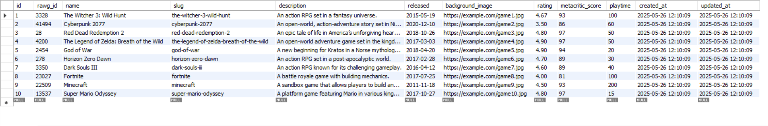

SELECT * FROM publishers;
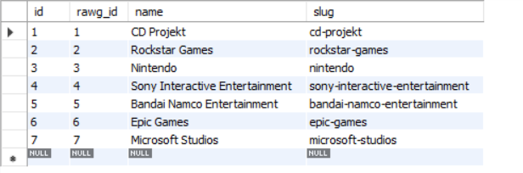
SELECT * FROM platforms;
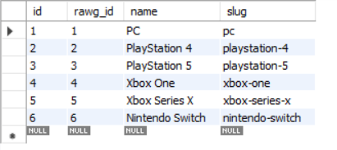
SELECT * FROM genres;
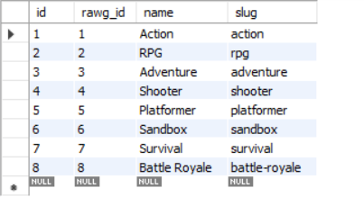
SELECT * FROM users;
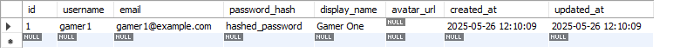
SELECT g.name AS game_name, p.name AS publisher
FROM games g
JOIN game_publishers gp ON g.id = gp.game_id
JOIN publishers p ON gp.publisher_id = p.id;
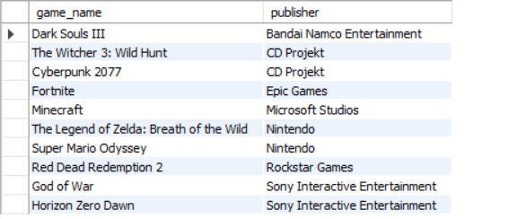
SELECT p.name AS platform, COUNT(gp.game_id) AS game_count
FROM platforms p
LEFT JOIN game_platforms gp ON p.id = gp.platform_id
GROUP BY p.name;
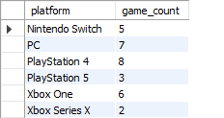

SELECT g.name AS game_name, p.name AS platform
FROM games g
JOIN game_platforms gp ON g.id = gp.game_id
JOIN platforms p ON gp.platform_id = p.id;
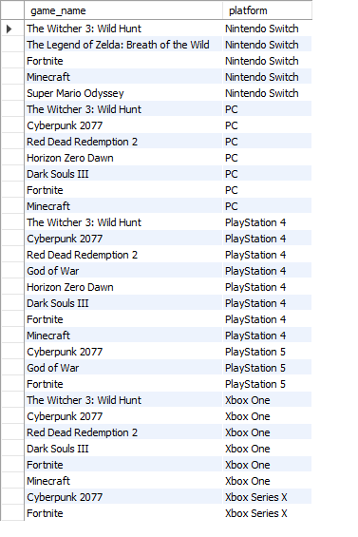
SELECT g.name AS game_name, gen.name AS genre
FROM games g
JOIN game_genres gg ON g.id = gg.game_id
JOIN genres gen ON gg.genre_id = gen.id;
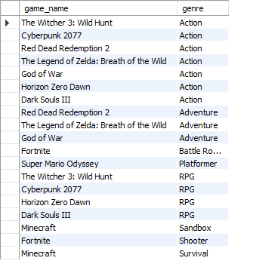

SELECT gen.name AS genre, AVG(g.rating) AS average_rating
FROM genres gen
JOIN game_genres gg ON gen.id = gg.genre_id
JOIN games g ON gg.game_id = g.id
GROUP BY gen.name;
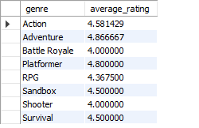
SELECT u.username, g.name AS game_name, ugl.status
FROM users u
JOIN user_game_lists ugl ON u.id = ugl.user_id
JOIN games g ON ugl.game_id = g.id;
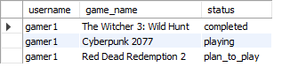
SELECT u.username, g.name AS game_name, ur.title, ur.content, ur.score
FROM users u
JOIN user_reviews ur ON u.id = ur.user_id
JOIN games g ON ur.game_id = g.id;
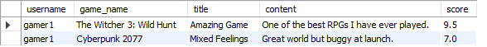
SELECT g.name, g.rating
FROM games g
JOIN game_genres gg ON g.id = gg.game_id
JOIN genres gen ON gg.genre_id = gen.id
WHERE gen.name = 'Action'
ORDER BY g.rating DESC
LIMIT 5;
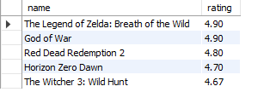
SELECT name, rating
FROM games
WHERE rating > (SELECT AVG(rating) FROM games);
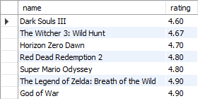
SELECT name, released
FROM games
WHERE YEAR(released) = 2015;
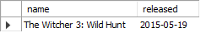
SELECT name
FROM games
WHERE name LIKE 'T%';
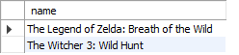
SELECT name, playtime
FROM games
WHERE playtime > 50;
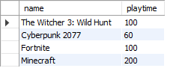
7.3 Performance Testing
- Tested query response times with sample data
- Verified foreign key constraints work correctly
- Confirmed unique constraints prevent duplicate data
- Validated data types handle expected ranges

8. Security Considerations
8.1 Data Protection
- Password hashing (never store plain text passwords)
- User input validation to prevent SQL injection
- Foreign key constraints to maintain data integrity
- Unique constraints to prevent duplicate accounts
8.2 Privacy Controls
- Users can make their lists private
- Personal ratings and progress are user-specific
- Review attribution to maintain accountability

9. Future Enhancements
9.1 Planned Features
- Achievement tracking system
- Game recommendation algorithms
- Wishlist functionality
- Enhanced social features (messaging, groups)
- Content moderation tools
- Mobile app support

9.2 Scalability Considerations
- Database can handle millions of users and games
- Efficient indexing for fast searches
- Normalized design reduces storage requirements
- Foreign key relationships maintain data consistency

10. Conclusion
This database design successfully creates a comprehensive system for tracking and managing video game collections. The normalized design ensures data integrity while providing flexibility for future enhancements. The schema supports all required features including game tracking, reviews, social interactions, and custom lists.
Key Achievements:
- Fully normalized database design (3NF)
- Comprehensive game metadata storage
- Flexible user interaction system
- Scalable architecture for future growth
- Proper security and privacy controls
The MyGameList database provides a solid foundation for a modern game tracking platform that can serve thousands of users while maintaining performance and data integrity.

References
- RAWG Video Games Database
- MyAnimeList
- IGDB (Internet Game Database)
- Steam Web API

Note: This project demonstrates practical application of database design principles learned in class, including entity-relationship modeling, normalization theory, and SQL implementation.

