

Advanced Software Engineering

Luca Di Gregorio

Git-hub: https://github.com/Gr3gbug/ASE-19.git

# Report

The specification required us to manage some cases which are intentionally left empty or partially. Let’s move on the analysis of these cases commenting the solution approach.

About the decoration methods, sometimes it was required to complete the latter. I’ve personally solved this task considering that as suggested by Flask the map class by default already accept the *GET, OPTIONS,* and *HEAD* calls, so for this reason I’ve simply removed when not necessary or added other methods (like *DELETE, PUT*) when required to properly accomplish the calls.

About the return value of each method, I’ve made sure to return json objects (where requested). Finally, for what concern the creation of a quiz, retrieve information and check if is available or not, I’ve exploited the suggested methods presents in the “*quizzes.py*” file. Finally, the most interesting part was the that involved me in using the test file (“*test_quiz.py*”) in order to correct the output values so that I could get the corrected outputs.

## Screen-shot “pytest”

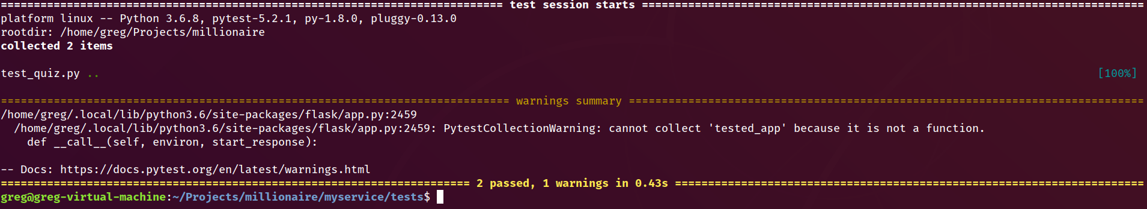

## screenshots of the tests performed with PostMan

Screenshots follow the same order whose has been executed in the “test.py” file to make it easy and understandable for the reader. To better understand the comment on each image, consult the following legend:

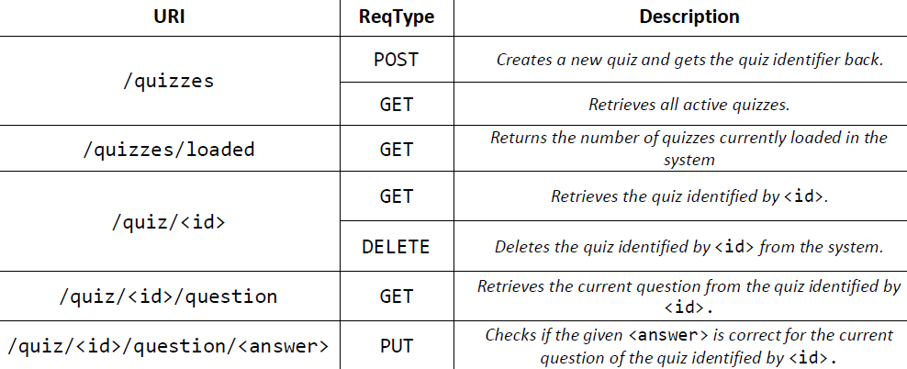

**N.B:** in order to avoid repetitions, images that follow one another with equal calls will be commented with "—”

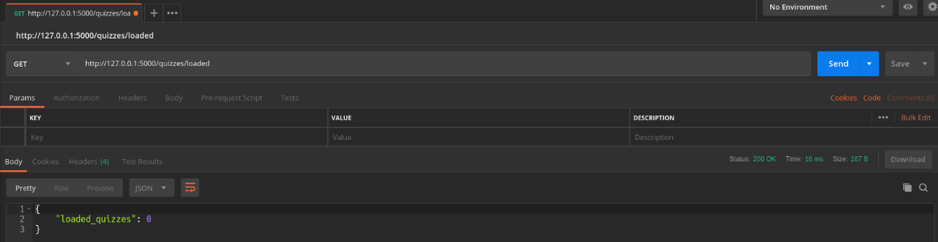 no loaded quiz

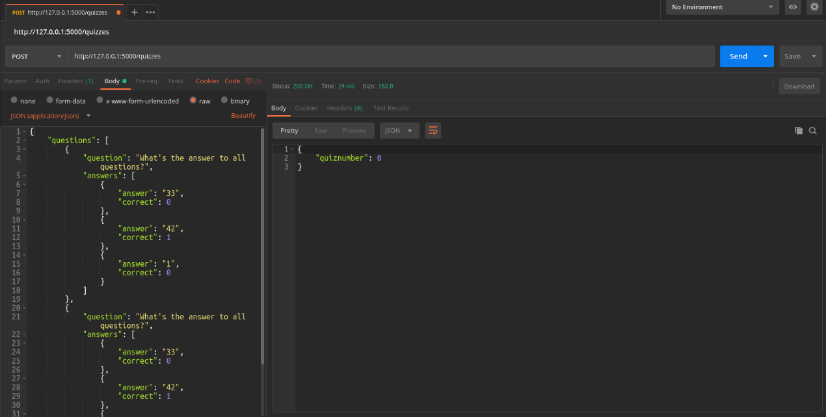create quiz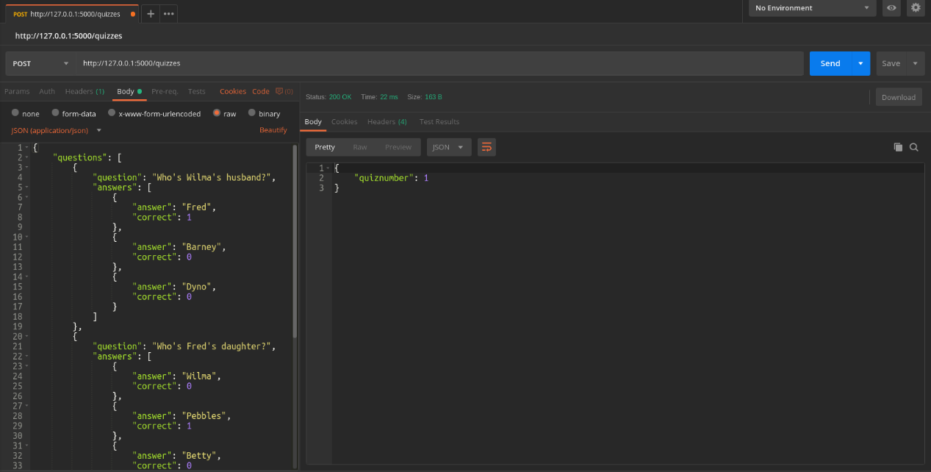--

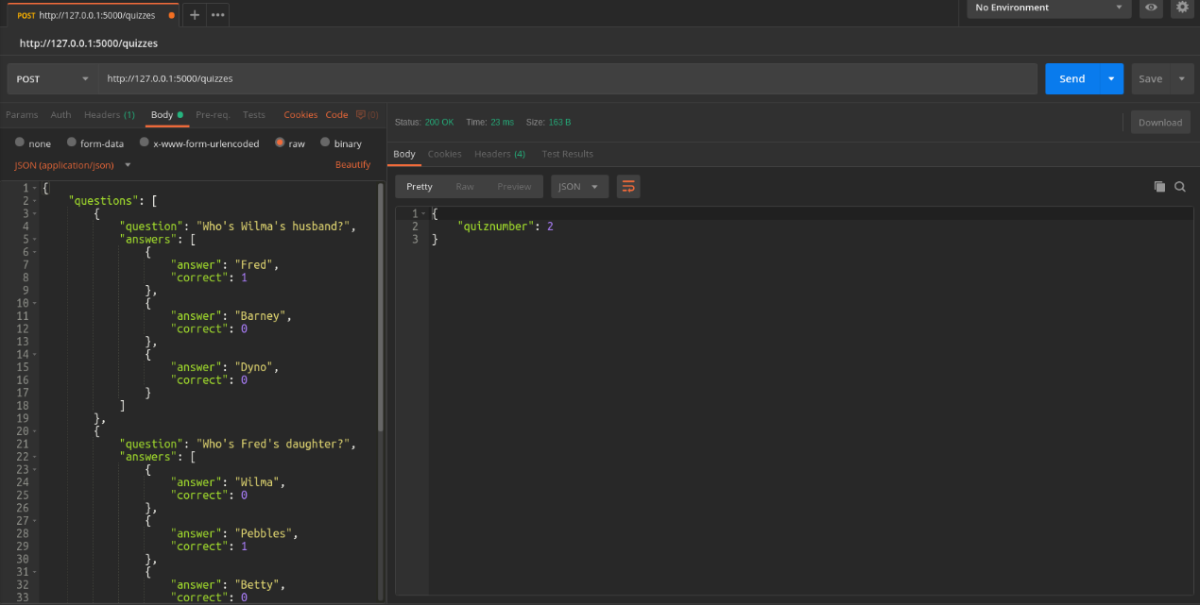--

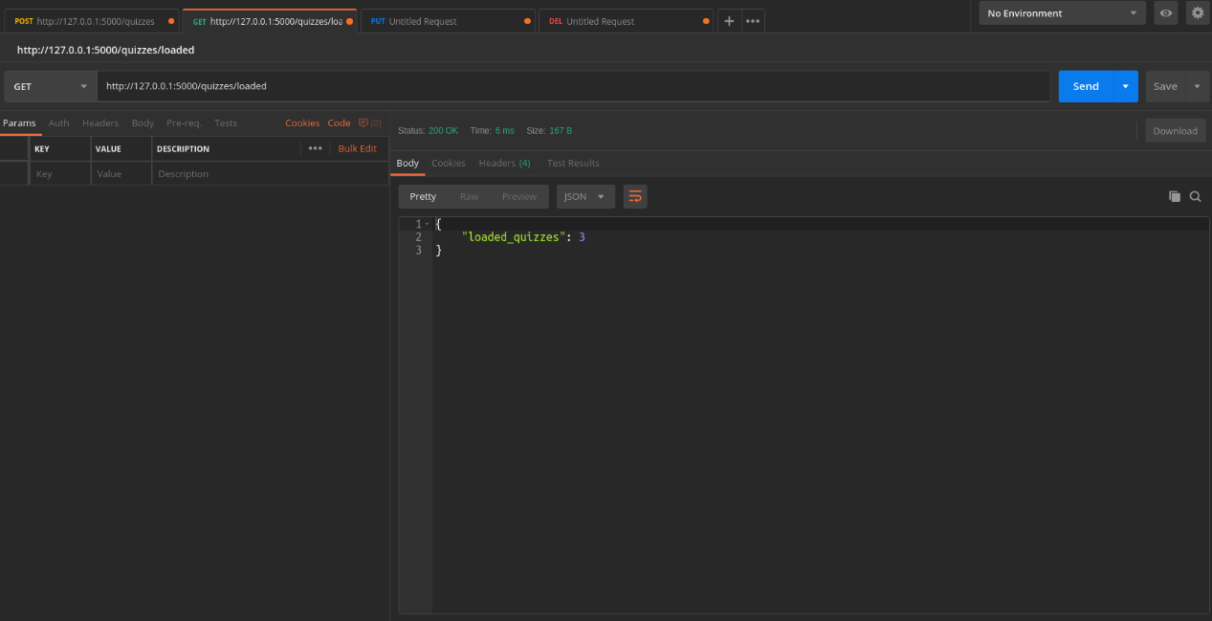Get number of created quizzes

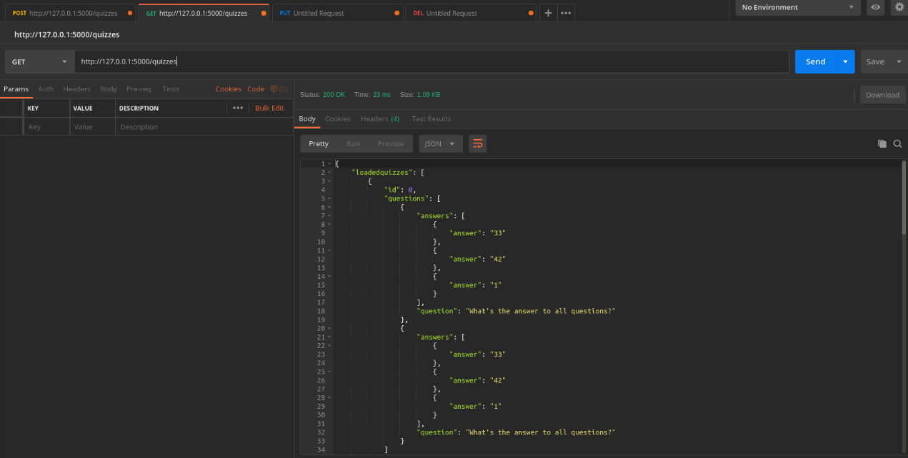Get created quizzes

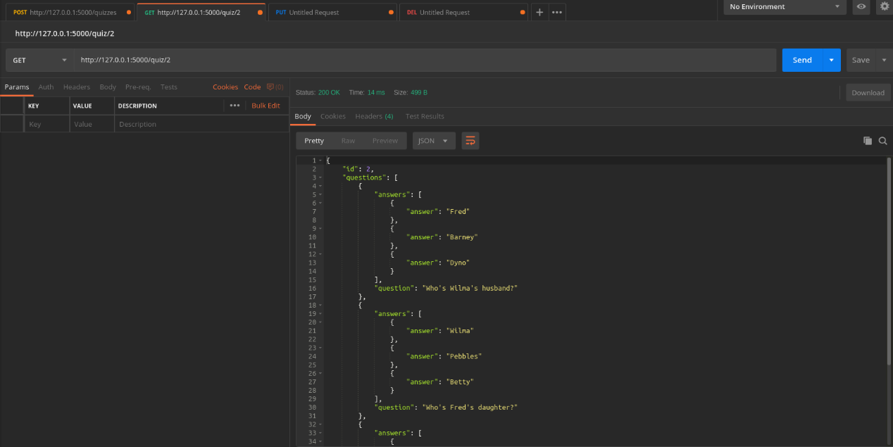Retrieve existing one

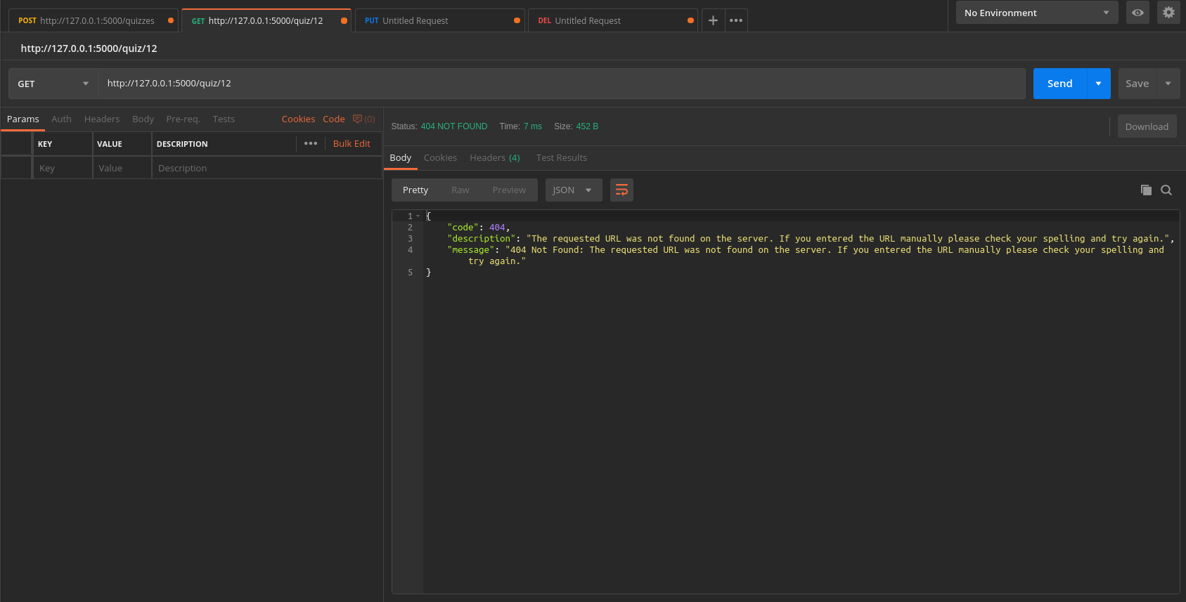-- non existing

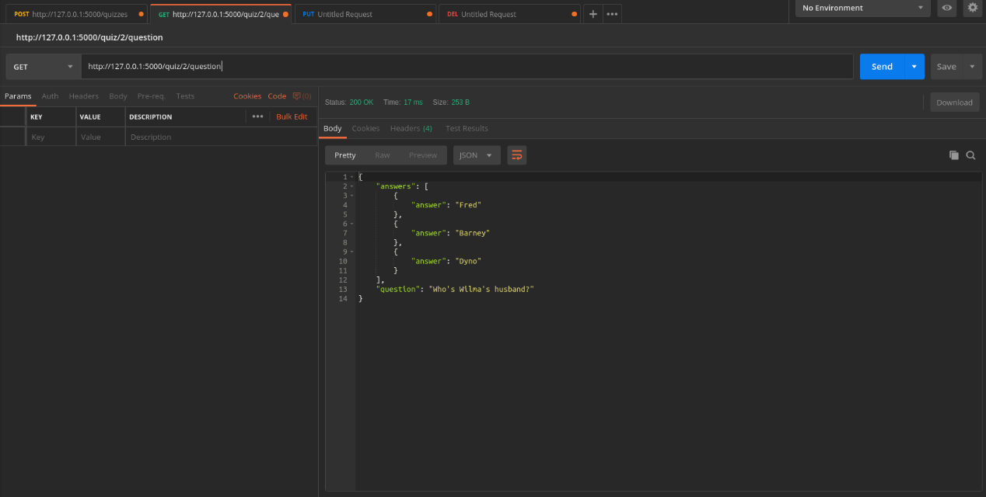Get <id> question

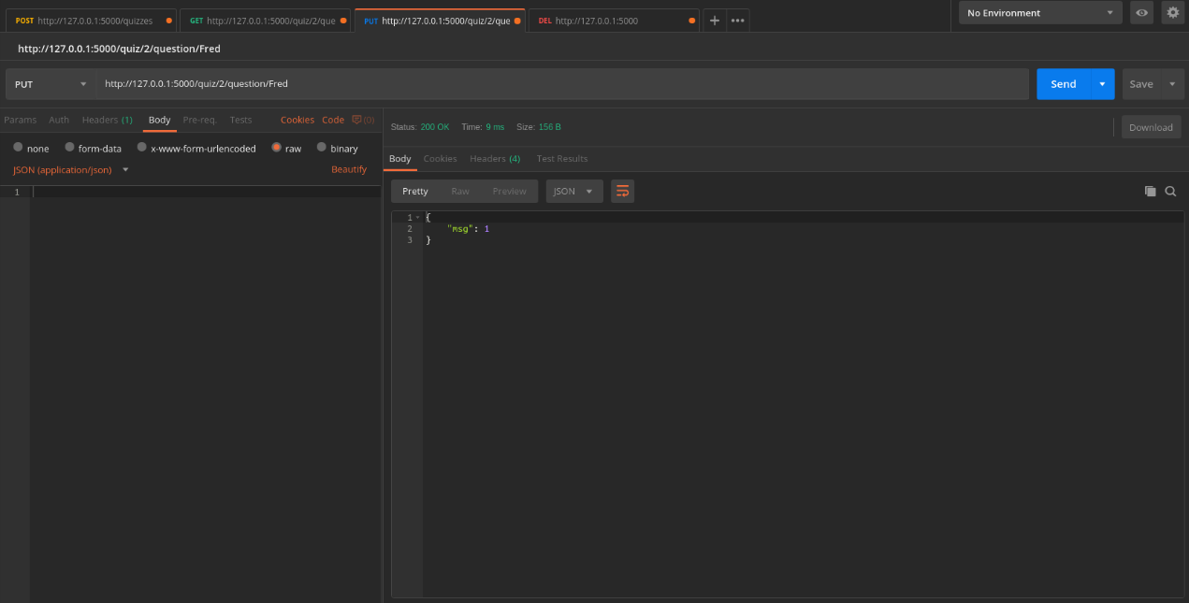correct answer

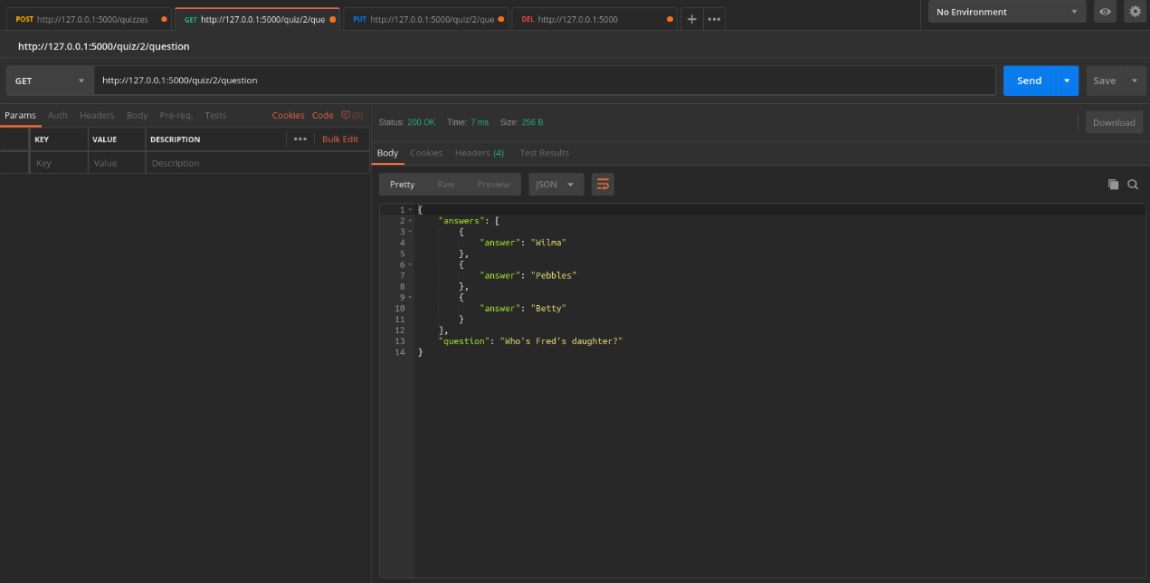--

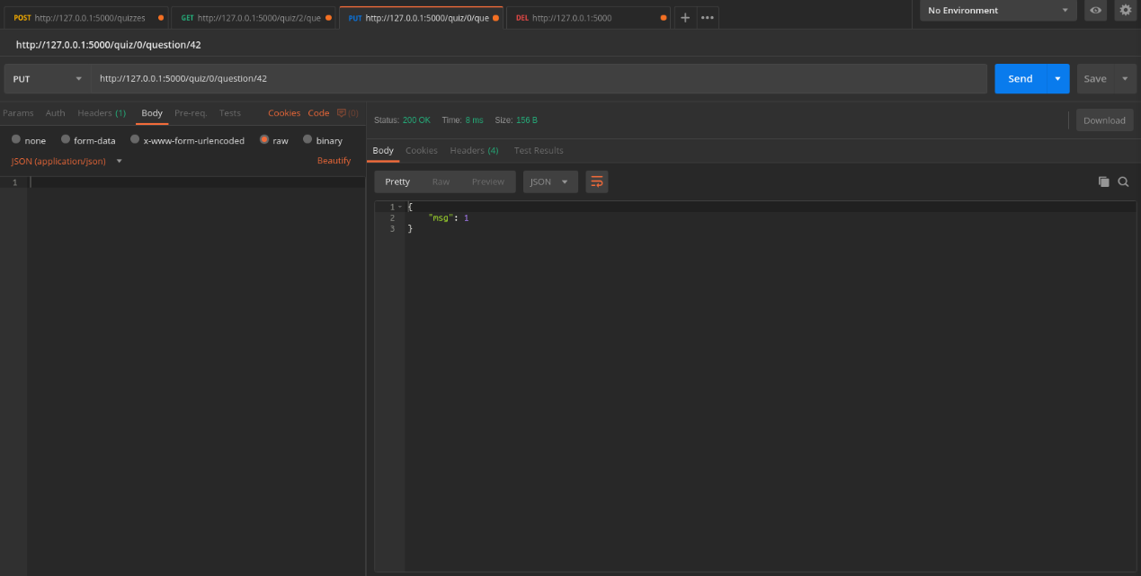--

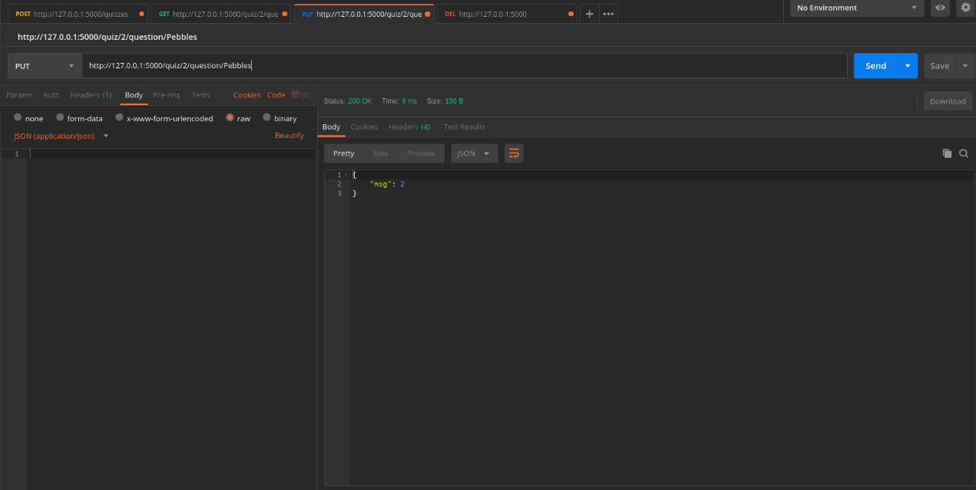answer ok

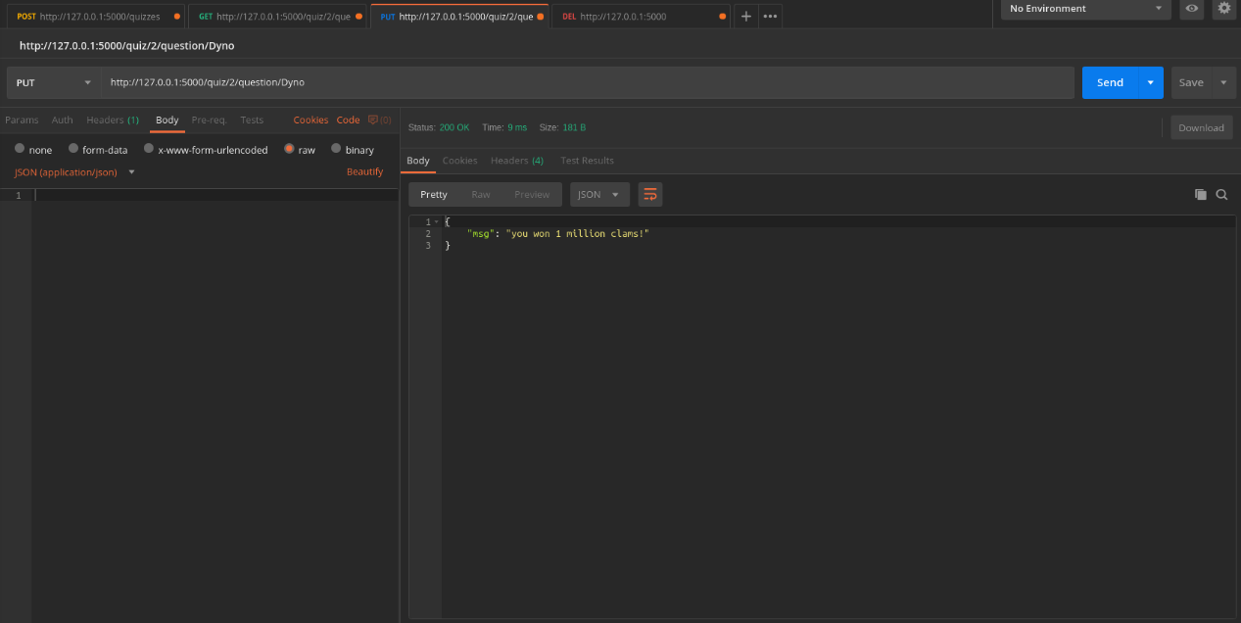answer 1 million

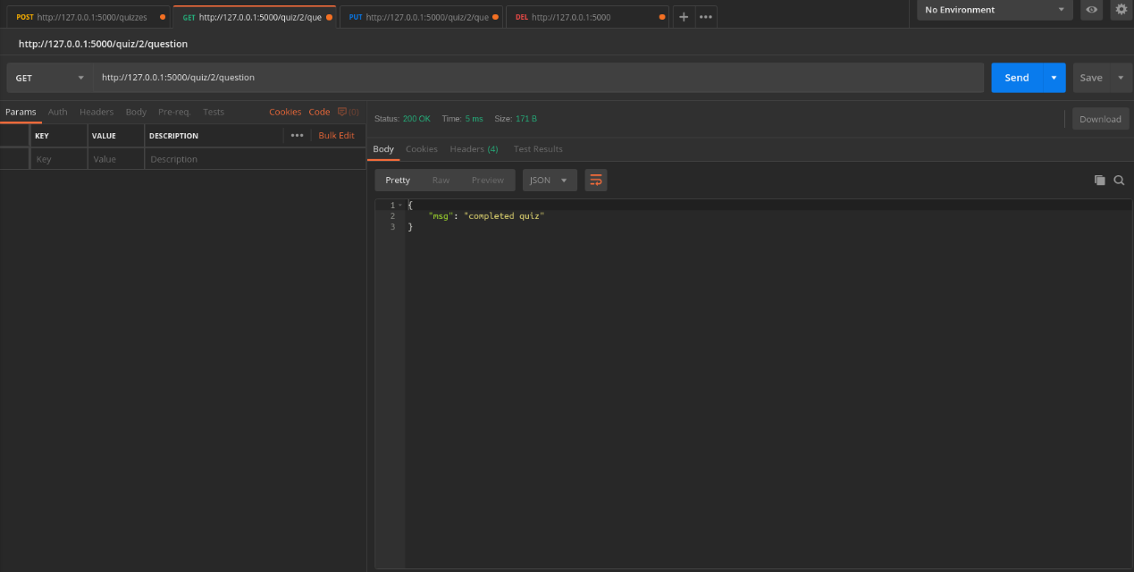double call to complete quiz

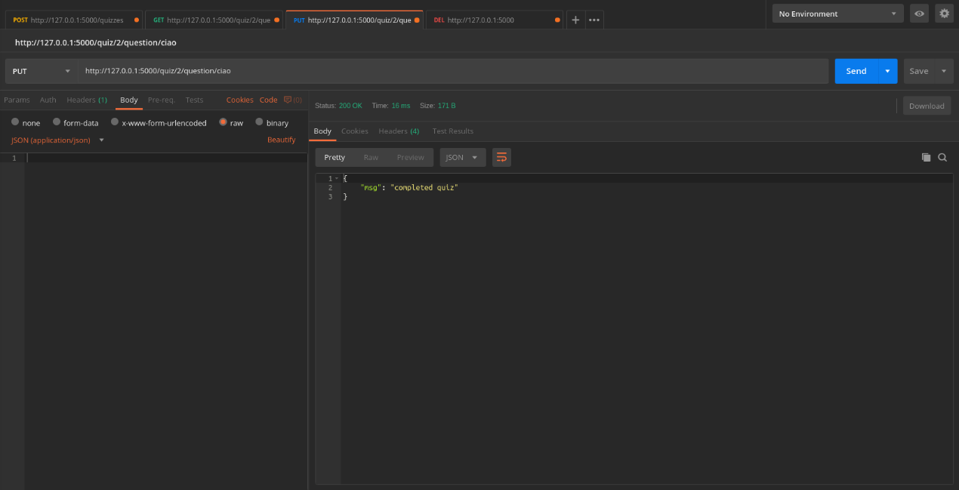--

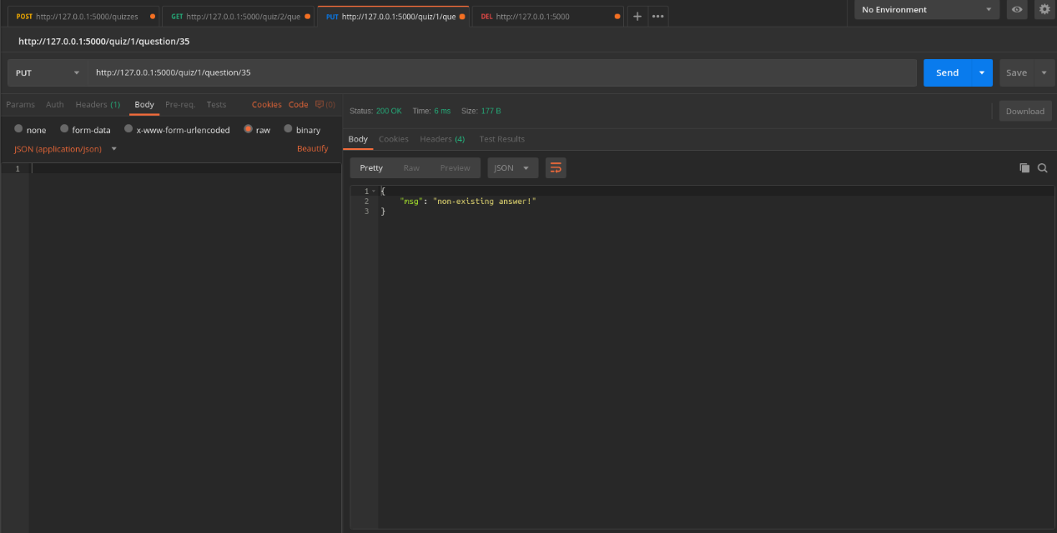non-existing-answer

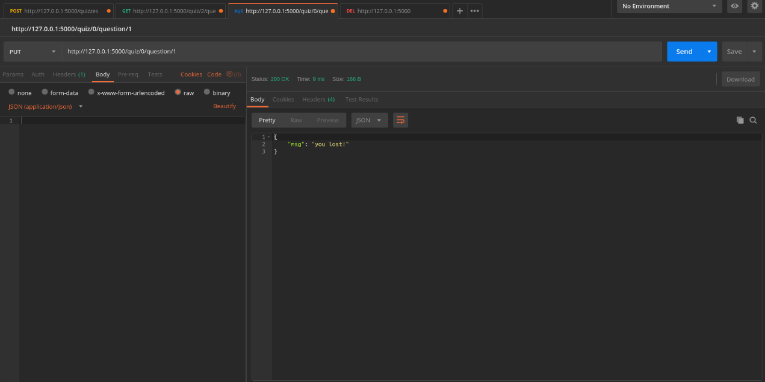 wrong answer

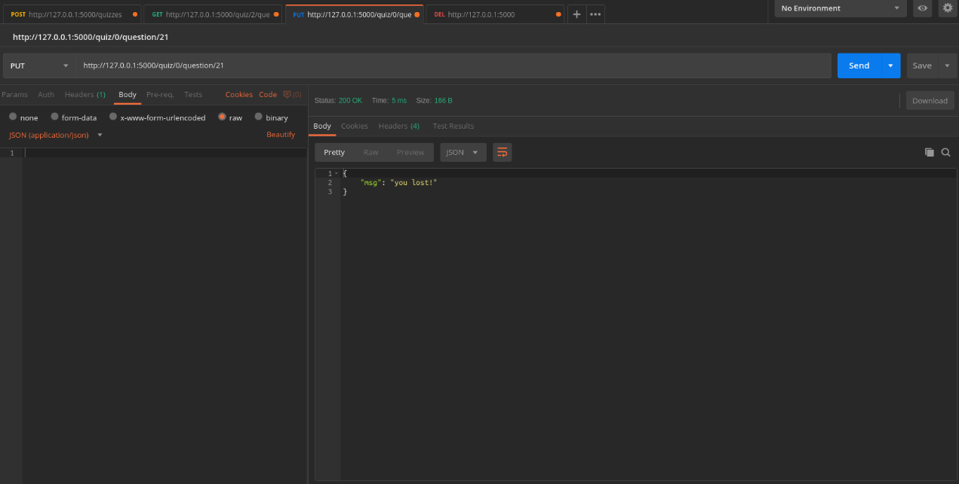--

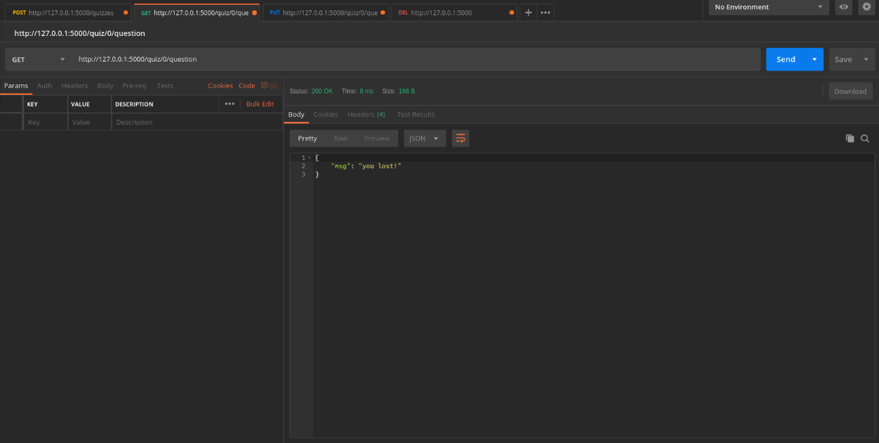--

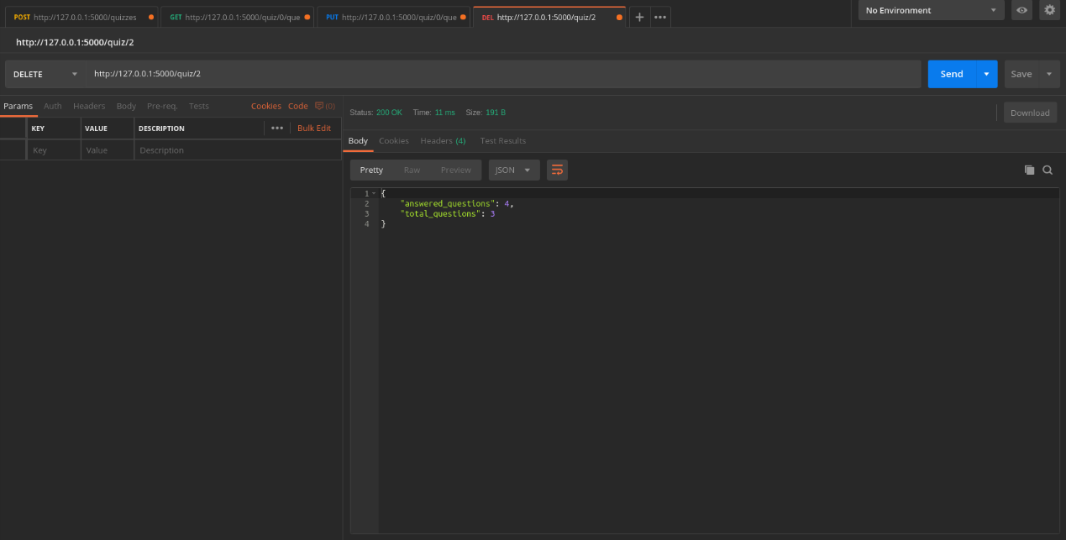delete quiz

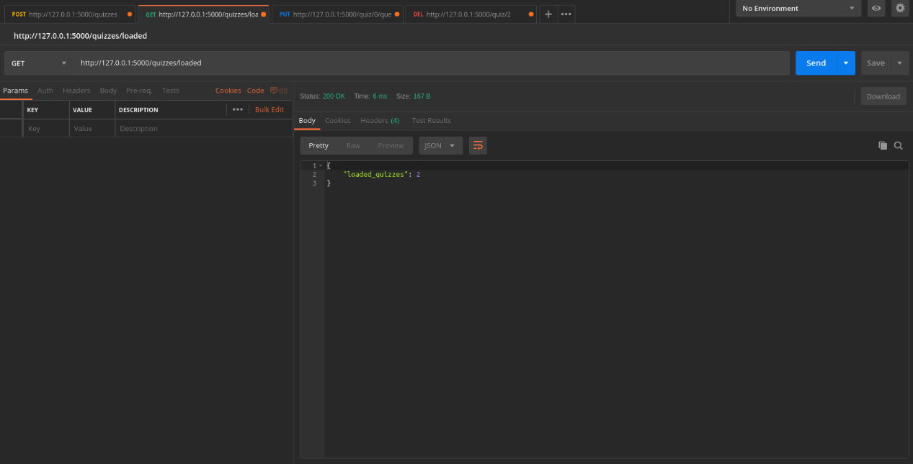--

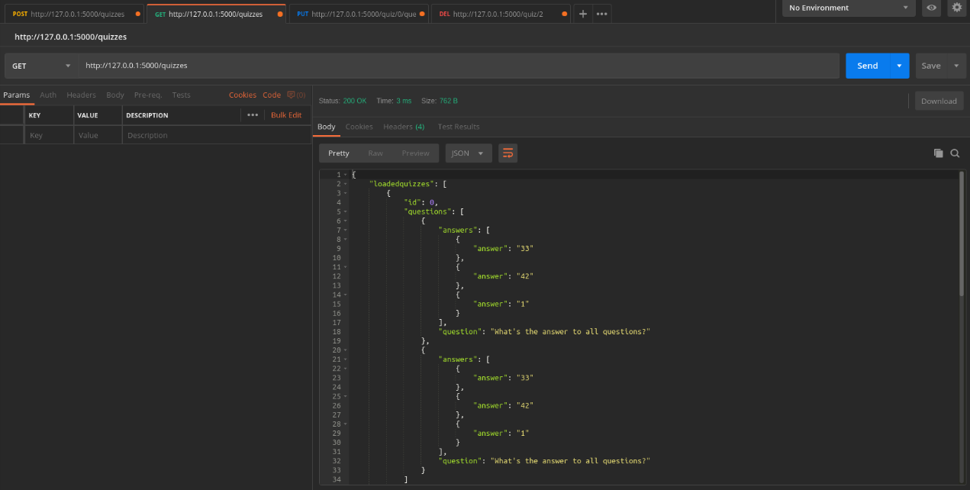--

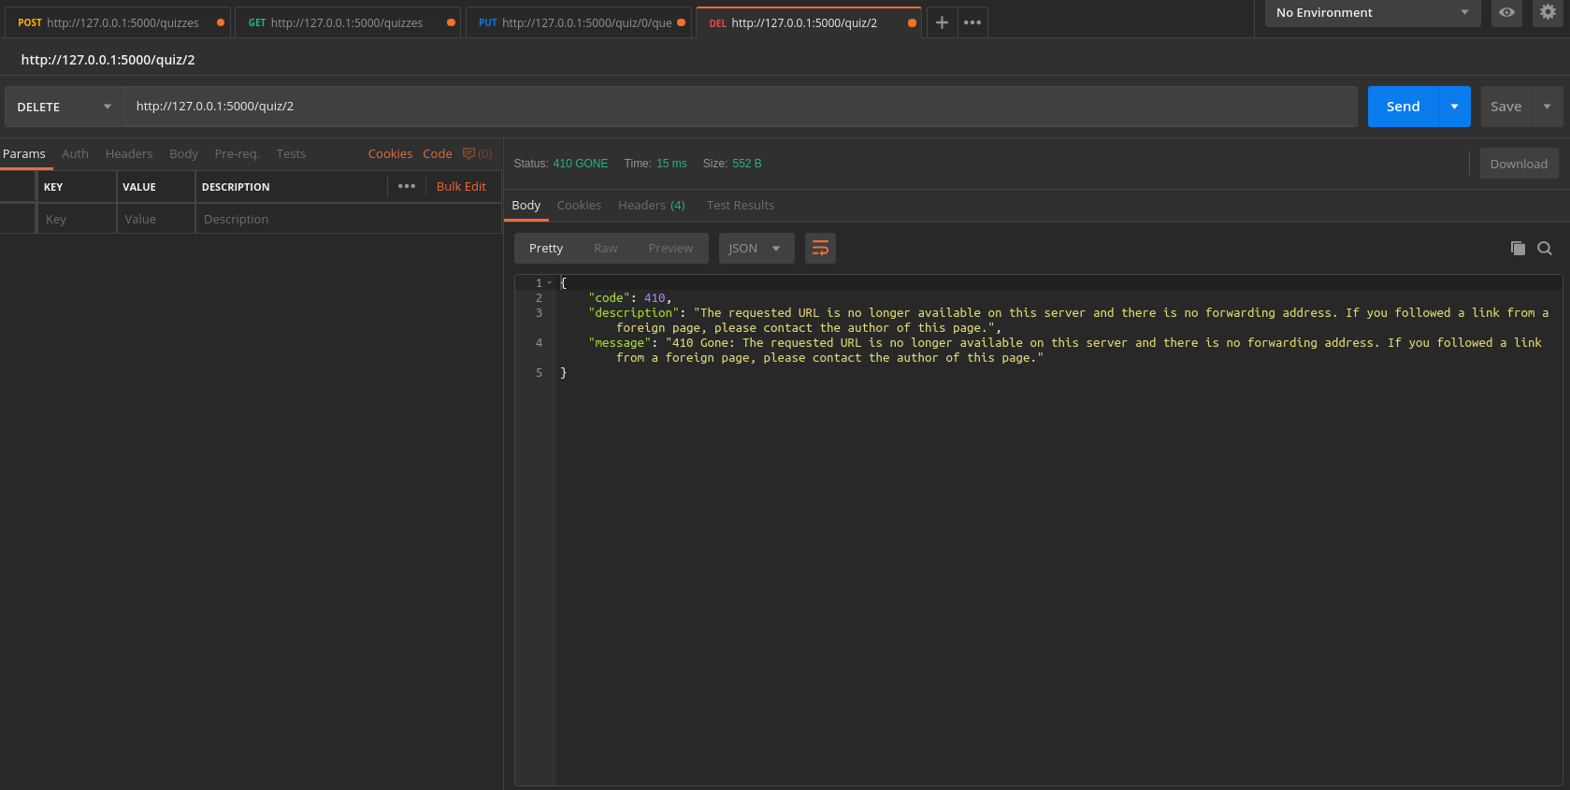delete previously deleted

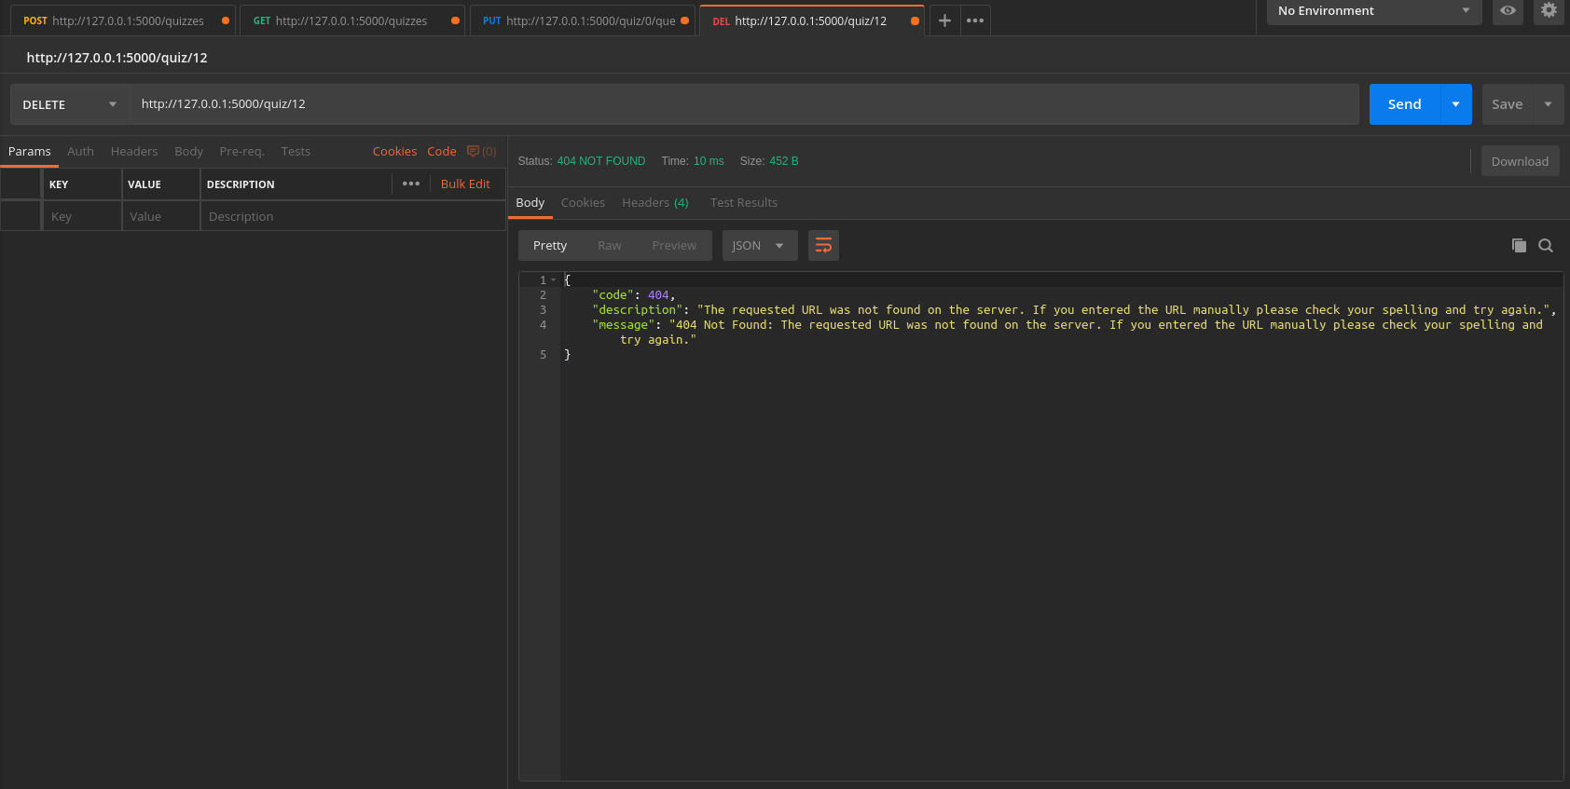delete non existing quiz

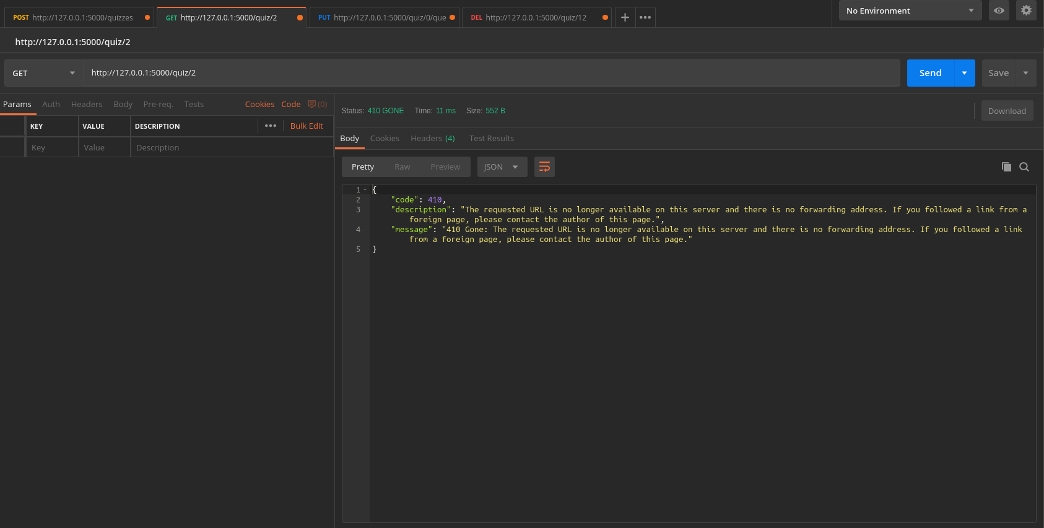get non existing quiz

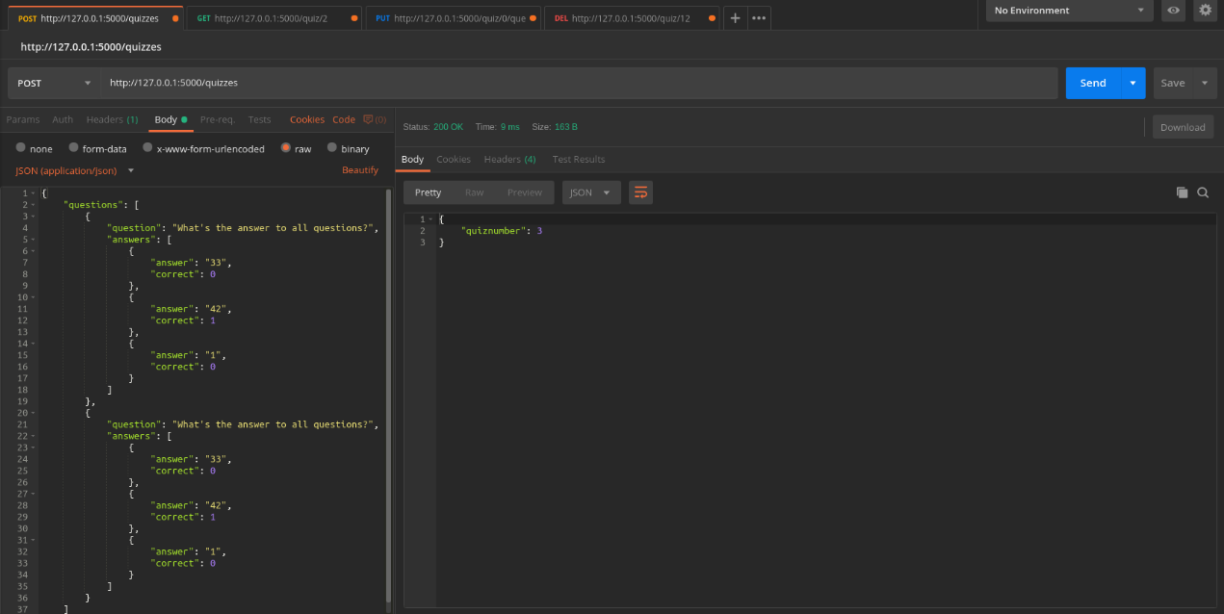create after delete

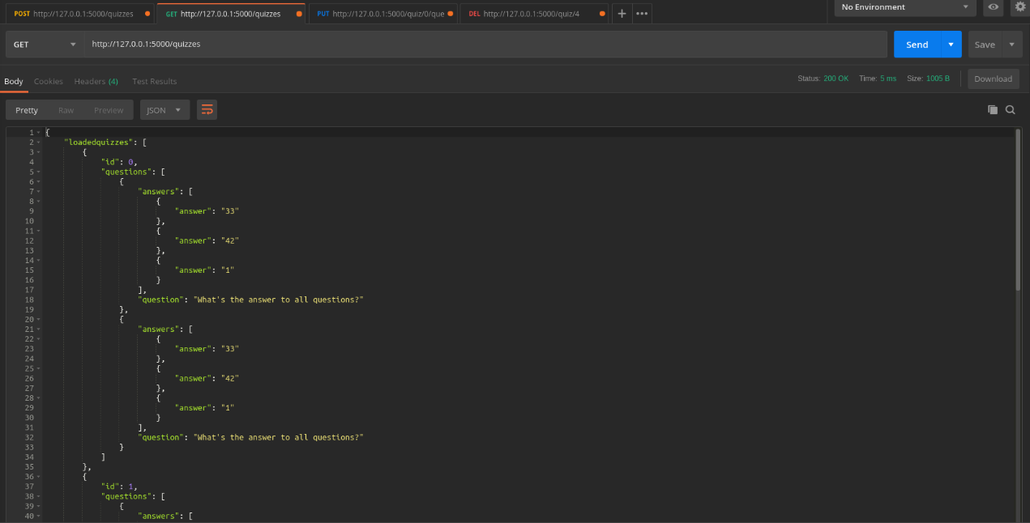get quizzes

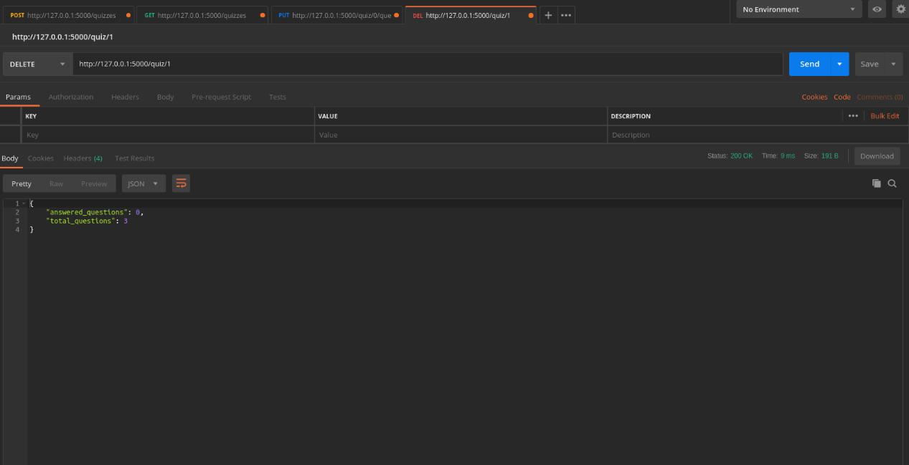delete quiz <1>