TASK 2 Content Assets Log
ASSETS TABLE
Log No. | Asset (name, image, website) | Source Link | Rationale/Purpose | Date
1. | W3Schools Template | https://www.w3schools.com/w3css/tryit.asp?filename=tryw3css_templates_black&stacked=h | I’ve decided to use this template as a means to start off my project as it is well designed with it having visually appealing and responsive layout. In addition, I can also save a lot of time as the project is just 30 hours, so building a website from scratch will seem redundant, when I can edit the source code and make tweaks that align with the aesthetic of my website. | 24/03/25
2. | 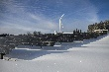 | Photo by Pixabay: https://www.pexels.com/photo/solar-panels-on-snow-with-windmill-under-clear-day-sky-433308/ | This Image will be used as the homepage banner and will be placed near the call-to-action button | 24/03/25
3. | from flask import Flask  app = Flask(__name__)  @app.route("/")  Routing:  @app.route('/')  def index():  return 'Index Page'  @app.route('/hello')  def hello():  return 'Hello, World' | https://flask.palletsprojects.com/en/stable/quickstart/#a-minimal-application | To allow the HTML templates to be rendered via flask. This code will also allow the user to reference or route any other pages from a particular page | 24/03/25
 | from flask import request  @app.route('/login', methods=['GET', 'POST'])  def login():  if request.method == 'POST':  return do_the_login()  else:  return show_the_login_form() |  | POST will be used to send data to a server to create/update a resource(this should allow the developer to render the HTML pages).
4. |  | Photo by Andrea Piacquadio: https://www.pexels.com/photo/man-sitting-on-chair-beside-table-834863/ | This is an image that will be used for the CEO profile in the ‘Meet our Team’ in the About Us Page. | 24/03/25
5. |  | Photo by Christina Morillo: https://www.pexels.com/photo/man-wearing-blue-button-up-sweater-1181391/ | This is the image of the CTO that will be used in the ‘Meet our Team’ Section of the about us page | 24/03/25
6. |  | Photo by Christina Morillo: https://www.pexels.com/photo/woman-wearing-white-shirt-1181690/ | This is the image of the Chief Engineering that will be used in the ‘Meet our Team’ section o the About Us Page | 24/03/25
7. | 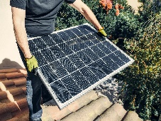 | Photo by Kindel Media: https://www.pexels.com/photo/a-person-in-black-shirt-holding-a-solar-panel-while-standing-on-the-roof-9875441/ | Image of Solar panel that will be used next to the solar panel installation description in the ‘Services’ page. | 24/03/25
8. |  | https://www.design.com/maker/logo/9b99b4a7-e37f-4bb6-8dd0-d0f8bd7b4195/draft/a70165ad-68f7-4fb5-bb20-467f4cbe1b10?savedDraft=True | Logo(I took a screenshot of the logo; this was because I needed to sign up to the design website in order to download the design, but the exam prohibits that) | 24/03/25
9. |  | Photo by Kindel Media: https://www.pexels.com/photo/industry-charging-vehicle-technology-9800009/ | Image of an EV charging vehicle that will be used next too the EV Charging description in the ‘Services’ Page | 24/03/25
10. | 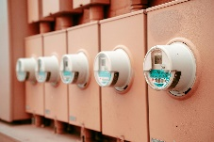 | Photo by Connor McManus: https://www.pexels.com/photo/row-of-electricity-meters-11924298/ | Image of a smart meter that will be used next to the Smart home management description in the ‘Services’ page | 24/03/25
11. | <div class="hero-image">  <div class="hero-text">  <h1>I am John Doe</h1>  <p>And I'm a Photographer</p>  <button>Hire me</button>  </div>  </div> | How To Create a Hero Image  W3Schools | This bloc of code allowed me to insert a hero image for my homepage
12. | 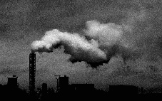 | Photo by Elīna Arāja: https://www.pexels.com/photo/monochrome-photo-of-industrial-plant-3401354/ | Image of carbon emissions that will be used in the Blog Page.
13. | How to embed Google Map | How to Embed Google Map in HTML [Step-By-Step Guide] | This website provided me to with a step by step guide on how to Embed a map on my contact us page.

Sources Table
Link | Where the link goes to

