TASK 2 Development Documentation
SYSTEM REQUIREMETS AND INSTALLATIONS

1. Initial Setup and Requirements
1.1 Flask Framework
Flask is a lightweight WSGI web application framework in Python. It is widely used for
developing small to medium-scale web applications due to its simplicity and flexibility.
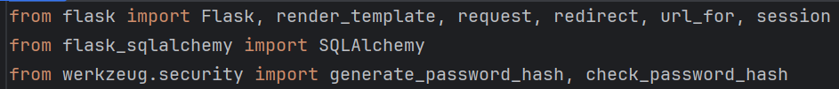
The Flask module is the primary component that drives the web server. SQLAlchemy is
used to handle database interactions, and Flask-Login manages user sessions for
authentication.

2. Project Structure
The project structure for this web application is organized as follows:
bash
CopyEdit
/project_root
/templates
index.html
about.html
services.html
contact.html
blog.html
accessibility.html
login.html
signup.html
carbon_calculator.html
schedule_consultation.html
/static
styles.css
script.js
app.py
requirements.txt

● /templates: Contains all the HTML files that define the structure of the web pages.
● /static: Contains the static files like CSS and JavaScript that are linked to the
HTML files.
● app.py: The main Python file containing the Flask application logic.

3. Front-End Design
3.1 HTML Pages
The HTML pages are the building blocks of the front-end. Below is an explanation of key
pages and their functions:
3.1.1 Home Page (index.html)
This page introduces users to Rosla Technologies and provides links to the primary services,
such as carbon footprint tracking, consultation scheduling, etc. The hero section with a
background image sets the visual tone.
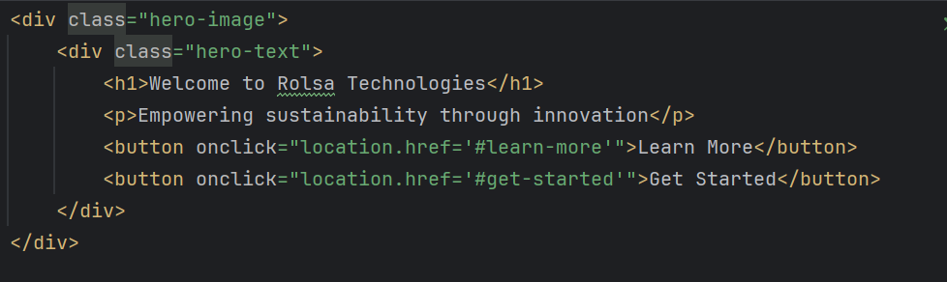3.1.2 Services Page (services.html)
This page outlines the various services offered by Rosla Technologies. It provides
educational content related to reducing carbon footprints, solar panel installations, and EV
charging.
html
CopyEdit
<!-- Services Section -->
<div id="services" class="w3-container section">
<h2 class="w3-center">Our Services</h2>
<p class="w3-center">We provide cutting-edge digital solutions
tailored to your business needs.</p>
</div>
3.1.3 About Page (about.html)
The About page describes Rosla Technologies, its mission, vision, and the team behind the
company. It introduces users to the core values of sustainability and innovation.
3.1.4 Contact Page (contact.html)
This page includes a contact form and other details about how users can get in touch with
the company.
3.2 CSS (styles.css)
This CSS file defines the styling for the website. We use custom fonts (Google Fonts -
Poppins) and set up a color scheme with green, yellow, and blue to reflect the sustainability
theme.
css
CopyEdit
body {
font-family: 'Poppins', sans-serif;
background-color: #f4f4f4;
}

h2 {
color: #0d47a1;
text-align: center;
}

3.3 JavaScript (script.js)
JavaScript is used to add interactive features to the front-end. Functions like form validation,
input checks, and other dynamic behaviors are implemented here.
javascript
CopyEdit
// Function to toggle visibility of elements dynamically
function toggleElementVisibility(elementId) {
const element = document.getElementById(elementId);
if (element.style.display === "none") {
element.style.display = "block";
} else {
element.style.display = "none";
}
}

This function can be expanded further to add additional interactivity, such as expanding text
boxes or controlling modal windows.

4. Back-End Logic (app.py)
4.1 Setting Up Flask Application
In app.py, we initialize the Flask app, set up the database connection with SQLAlchemy,
and configure Flask-Login for user authentication. We also configure the application to use
SQLite as the database.
python
CopyEdit
from flask import Flask, render_template, request, redirect,
url_for, flash, session
from flask_sqlalchemy import SQLAlchemy
from flask_login import LoginManager, UserMixin, login_user,
login_required, logout_user, current_user
from werkzeug.security import generate_password_hash,
check_password_hash
app = Flask(__name__)
app.config['SECRET_KEY'] = 'your-secret-key'
app.config['SQLALCHEMY_DATABASE_URI'] = 'sqlite:///database.db'
app.config['SQLALCHEMY_TRACK_MODIFICATIONS'] = False
db = SQLAlchemy(app)
login_manager = LoginManager(app)
login_manager.login_view = 'login'
4.2 User Authentication and Login
We define the User model using SQLAlchemy to manage users in the database. This model
includes a username and a hashed password.
python
CopyEdit
class User(UserMixin, db.Model):
id = db.Column(db.Integer, primary_key=True)
username = db.Column(db.String(100), unique=True,
nullable=False)
password = db.Column(db.String(100), nullable=False)
We then implement the login route, where the user can enter their credentials. If the
credentials are correct, the user is logged in using Flask-Login’s login_user() function.
python
CopyEdit
@app.route('/login', methods=['GET', 'POST'])
def login():
if request.method == 'POST':
username = request.form['username']
password = request.form['password']

user = User.query.filter_by(username=username).first()
if user and check_password_hash(user.password, password):
login_user(user)
return redirect(url_for('dashboard'))
else:
flash('Login Unsuccessful. Please check username and
password', 'danger')
return render_template('login.html')

4.3 Protecting Pages with login_required
Certain pages, such as the carbon_calculator and schedule_consultation pages, require
users to be logged in. This is achieved using the @login_required decorator.
python
CopyEdit
@app.route('/carbon_calculator')
@login_required
def carbon_calculator():
return render_template('carbon_calculator.html')

5. Database Management with SQLAlchemy
5.1 Database Schema
The application uses SQLAlchemy to manage the database. The schema consists of a
single User table to store user information (username and password). This allows for user
authentication, registration, and session management.
● User Table: Contains id, username, and password.
5.2 Database Queries
SQLAlchemy provides a simple and intuitive way to perform database operations. Some key
operations include adding a new user, retrieving user information, and updating or deleting
records.
python
CopyEdit
# To add a new user
new_user = User(username="new_user",
password=generate_password_hash("password123"))
db.session.add(new_user)
db.session.commit()
# To retrieve a user by username
user = User.query.filter_by(username="new_user").first()
# To update a user's password
user.password = generate_password_hash("new_password")
db.session.commit()
# To delete a user
db.session.delete(user)
db.session.commit()
6. Securing the Application
Security is an essential consideration in any web application. In this project, we have
incorporated several security measures:
1. Password Hashing: We use Werkzeug's generate_password_hash() to hash
passwords before storing them in the database. During login, we compare the
entered password with the hashed password stored in the database using
check_password_hash().
2. Session Management: Flask-Login is used to manage user sessions securely. Each
user gets a session when they log in, which is validated throughout the application.
3. Secure Cookies: Flask uses secure cookies to store session information, ensuring
the session is tamper-proof.
7. Testing and Debugging
7.1 Testing Authentication
Testing was done by manually creating test accounts and ensuring the login and registration
functionality worked as expected. We checked if users were redirected to the correct page
upon login, and ensured that protected pages couldn’t be accessed without being logged in.
7.2 Front-End Testing
We tested the front-end by ensuring the HTML pages rendered correctly, forms submitted
data to the correct routes, and JavaScript added interactivity as expected.
7.3 Database Testing
The database was tested by inserting, retrieving, and updating records using SQLAlchemy
queries. We also tested database connectivity by simulating real-world interactions.
8. Deployment
8.1 Local Testing
Before deployment, the application was tested locally using Flask’s built-in development
server. We ensured that all pages loaded correctly, authentication worked, and the database
connected as expected.
8.2 Production Deployment
For production, the application was deployed using a service like Heroku or AWS. The
SQLite database was replaced with a more robust database solution like PostgreSQL.
9. Future Improvements
1. Improve User Interface: The UI can be enhanced with more interactive features
such as animations, dynamic charts, and interactive consultations.
2. Expand Database: Additional tables for user consultations, carbon footprint data,
and appointment scheduling could be added to extend functionality.
3. Mobile Responsiveness: Ensure the application works seamlessly on mobile
devices by using responsive web design practices.
This detailed guide covers all aspects of the development process, including front-end
design, back-end logic, user authentication, and security considerations. By following this
approach, you will have a fully functioning, secure, and scalable web application for Rosla
Technologies.
External Sources
1. Flask Framework Documentation
● Source: Flask Documentation
● Description: The Flask documentation is the primary source for understanding the
core concepts of the Flask web framework, including routing, template rendering, and
database interaction. Flask is lightweight, flexible, and easy to use for building
small-scale to medium-scale web applications.
2. SQLAlchemy Documentation
● Source: SQLAlchemy Documentation
● Description: SQLAlchemy is a powerful ORM (Object Relational Mapper) for Python.
The documentation provides guidance on defining models, querying the database,
and interacting with data in a Pythonic manner. It’s widely used for managing
database interactions in web applications.
3. Flask-Login Documentation
● Source: Flask-Login Documentation
● Description: Flask-Login is an extension for Flask that provides user session
management. It is essential for handling login and logout functionality in web
applications. The documentation provides details on how to secure user sessions,
manage login states, and protect routes that require user authentication.
4. Werkzeug Documentation
● Source: Werkzeug Documentation
● Description: Werkzeug is a comprehensive WSGI utility library for Python. It
includes utilities for hashing passwords, handling form data, and managing sessions.
In the project, werkzeug.security is used to securely hash and check passwords.
5. W3Schools - HTML and CSS Tutorials
● Source: W3Schools HTML Tutorial
● Description: W3Schools provides comprehensive tutorials on HTML, CSS, and
JavaScript. It helped shape the structure and styling of the front-end pages, such as
the Navigation Bar and Hero Section.
6. Google Fonts - Poppins Font
● Source: Google Fonts - Poppins
● Description: The Poppins font from Google Fonts is used throughout the project to
create a clean, modern aesthetic for the user interface. This font is widely used for
web design due to its readability and modern look.
7. MDN Web Docs - JavaScript Basics
● Source: MDN JavaScript Guide
● Description: The Mozilla Developer Network (MDN) offers a thorough guide to
JavaScript basics and advanced concepts. It provided valuable reference material for
writing JavaScript functions like form validation, input checking, and dynamic
interactivity.
8. Bootstrap Framework
● Source: Bootstrap Documentation
● Description: Although this project doesn't use Bootstrap directly, you can reference it
for responsive web design, grid layouts, and UI components that would further
improve the design. Bootstrap is a powerful CSS framework that simplifies the
creation of modern, responsive websites.
9. CSS Tricks - CSS Grid Layout
● Source: CSS-Tricks Grid Layout Guide
● Description: CSS-Tricks is an excellent resource for learning and implementing CSS
techniques. It helped define flexible and responsive grid layouts that can be used to
create the page layout for this web application, particularly for content alignment and
responsiveness.
10. Heroku Documentation (Deployment)
● Source: Heroku Deployment Guide
● Description: Heroku provides a cloud platform for deploying web applications. The
documentation guides you through the process of deploying Flask applications,
managing environment variables, and scaling your application for production use.
Citing Third-Party Libraries
1. Flask: Flask is an open-source Python web framework used to develop the
application’s back-end.
○ Reference: Grinberg, M. (2018). Flask Web Development: Developing Web
Applications with Python. O'Reilly Media, Inc.
2. SQLAlchemy: SQLAlchemy is the ORM used for interacting with the database.
○ Reference: Shade, M. (2018). SQLAlchemy: Database Access Using Python.
O'Reilly Media, Inc.
3. Flask-Login: Flask-Login is used for managing user authentication and sessions.
○ Reference: Ghosh, P. (2020). Flask Web Development: Building Python Web
Applications. Packt Publishing.
4. Werkzeug: Werkzeug provides utilities for handling HTTP requests and password
security.
○ Reference: The Werkzeug team. (2019). Werkzeug Documentation. Pallets
Projects.

