Task 2: Test log
General Pages(without user log in)
Log No. | Testing Component | Test Data | Expected Outcome | Actual Outcome | Comments and intended actions
1 | Nav Bar Interaction; the user test if the nav bar is functioning |  | The user should be able to click all the webpage links on the navigation bar and redirect the user to those pages | The program works as intended  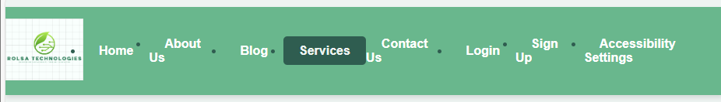
2. | Embedded Map; Test carried out to ensure that the embedded map displays on the ‘Contact Us’ page | 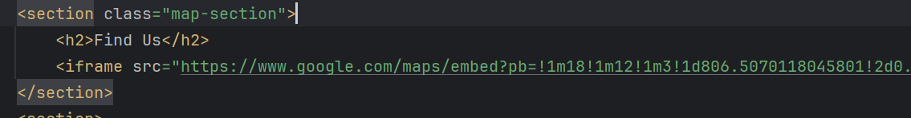 |  | 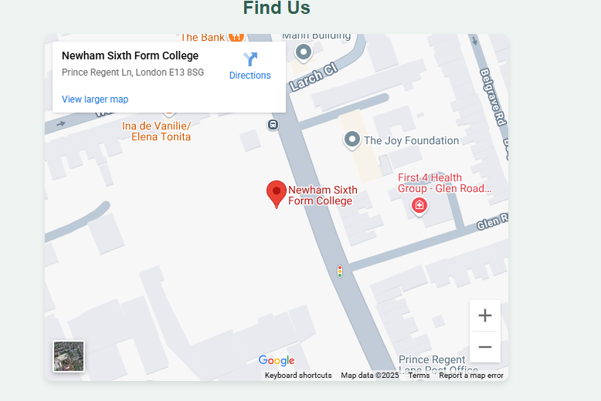

Testing Component | Description of test | Test data to be used (if required) | Expected outcome | Actual outcome | Comments and intended actions
1.
User Registration | Can the user Signup when using valid input data | Username: Great, Email: rolsa@rolsa.com, and Password: 1234  Password Confirmation: 1234 | Account created successfully | Account created successfully and user information has been stored in a database | N/A
Login Authentication | Can the user login when using valid input data | Username: Great  Password: 1234 | Account Logged in successfully
Incorrect Login Attempt | To see if user can login with incorrect credentials | Wrong Email and Password | Error message displayed | Error message displayed | Working as intended
Consultation Booking |  | User selects date/time | Appointment confirmed | Appointment saved in database | Ensure email confirmation works
Accessibility Features |  | User changes contrast mode | UI adapts to user change | Works as expected | Ensure setting is consistent throughout the website

