Add Formula to create .gexf file for all the Fan Mails as nodes.

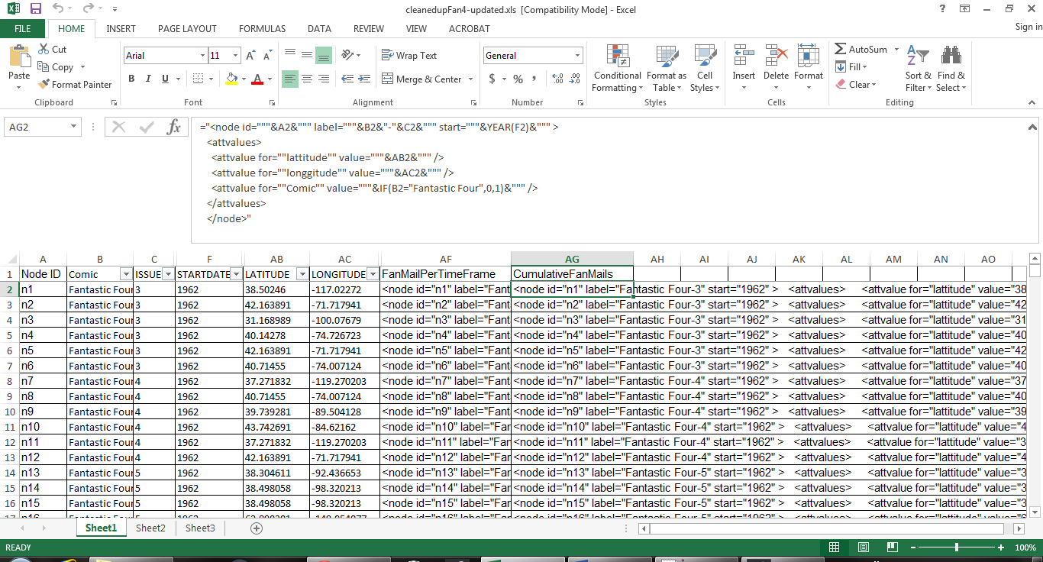

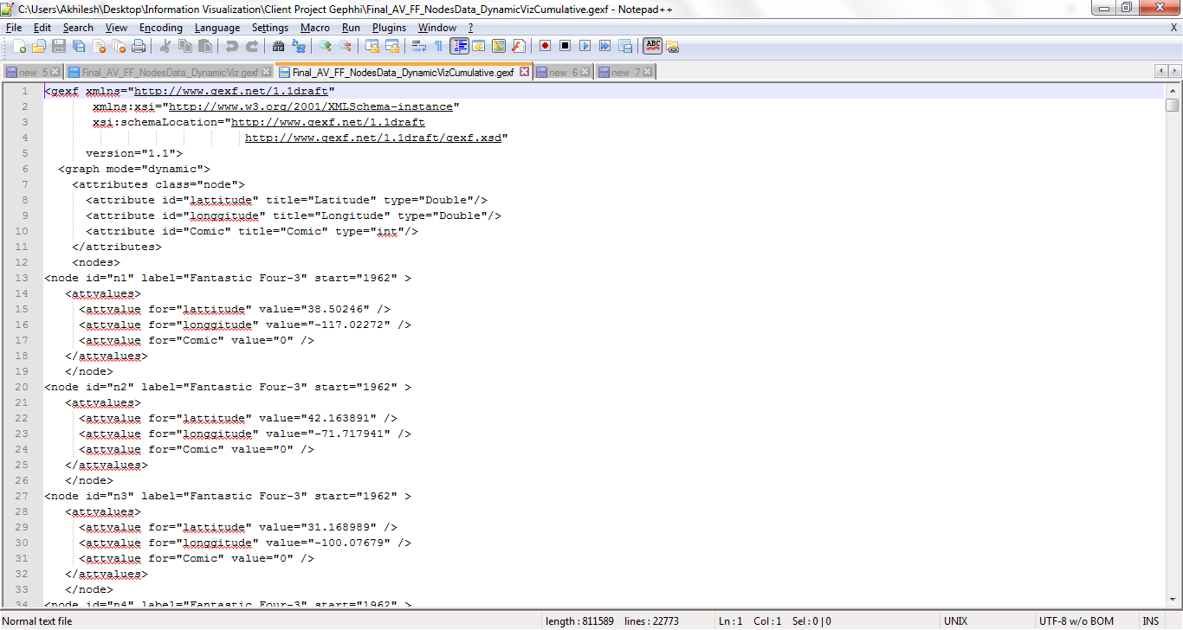

Open Gephi. Add and load plugin “Map of countries” from Layouts section.

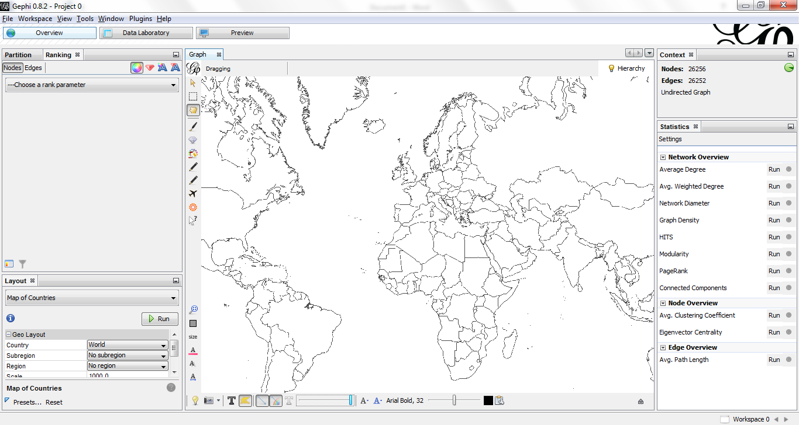

Load the .gexf file into Gephi and append to the graph.

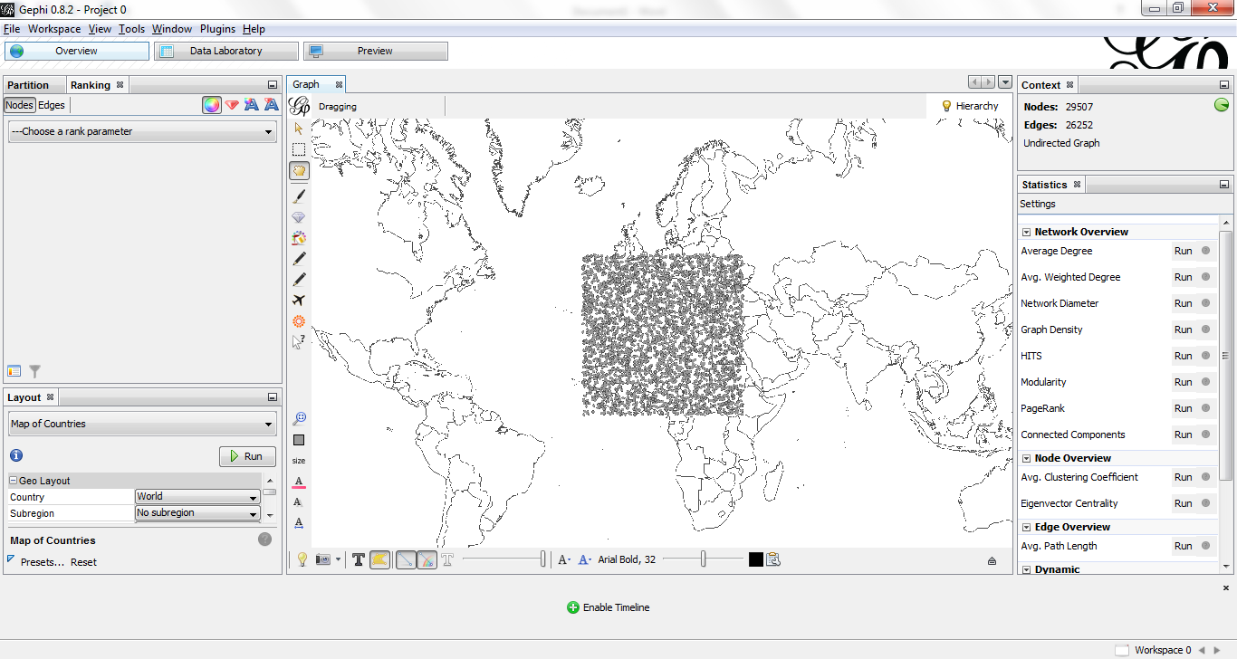

Navigate to Data Laboratory and merge Latitude/longitude columns from “Map of Countries” and .gexf files.

Then run plugin “Geo Layout”, Choose ranking parameter and color code “Fantastic Four”/”Avengers” mails.

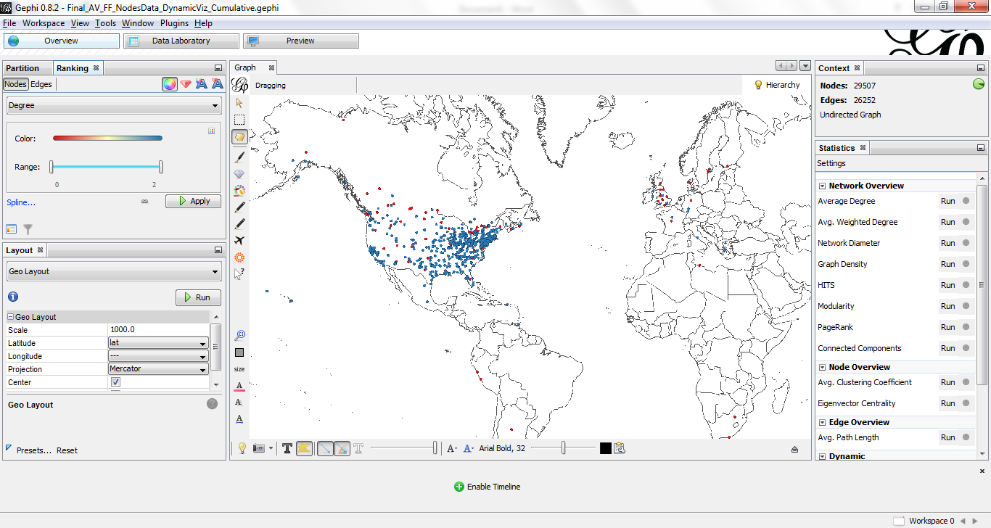

Click on “Enable Timeline” and choose run settings.

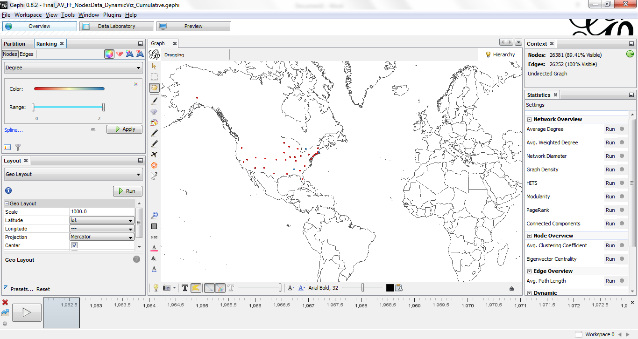

Run to see the dynamic visualization.