*A Project report*

*on*

# College Port

*Submitted* By

**Prathamesh Pai (20bcs103),**

**Dipesh Mishra (20bcs043),**

**Harshal Dube(20bcs052).**

*Under the guidance of*

**Dr. Shankar Biradar,  
Dr. Uma Sheshadri.**



INDIAN INSTITUTE OF INFORMATION TECHNOLOGY,

DHARWAD

Acknowledgments:

This project is a part of the Object-oriented programming course. We wholeheartedly express our sincere gratitude towards **Dr. Uma Sheshadri** and **Dr. Shankar Biradar** for their guidance and supervision. They guided and helped us complete this project. We also sincerely thank them for giving us this assignment and encouraging us to create this project.   
Introduction:

The name of our website is **“College Port”.** We made this website to connect various students from our college so that they can reach other students, share their concerns and ask queries for the problems that they face. They can also post any information that they find useful and want to share with others. Users can post something as text, image, or video file. If someone posts a query, other users who have the solution to the query can comment under the post and help each other with their problems.

## Key-features:

Only the users of our college (IIIT Dharwad) can make an account on this website so the users can feel free to share anything that may be useful to others. They can openly ask about their queries since only the students from their college are exposed to these posts. Users can upvote a post so more people will see the post. People will know that the post with a higher number of upvotes is more useful.

Users can comment under a post to provide a solution to a query or provide their views on the matter.

## Technologies Used :-

Frontend technologies :-

React.js

Javascript

HTML

CSS

Backend technologies :-

Node.js

MongoDB

Express.js

Middleware :-

Mongoose

## Data schemas :-

We have used three data schemas , they are :-

User Schema ;-

The below schema is the User schema, The user data is stored in the following way.

User {

username : String , email:String ,password :String , profilePicture:String

coverPicture:String , followers:Array ,following:Array , isAdmin:Boolean

city:String , from:String }

Post Schema :-

The below schema is the Post schema, The post data is stored in the following way.

Post {

userId:String,desc:String,img:String,likes:Array,comments:Array,bookmarks:Array}

Comment Schema:-

The below schema is the Comment schema, Comments are stored in the following way.

Comment {

userId:String , desc:String , img:String, likes:Array, posts:Array}

## Authenticate users with google OAuth :- ­­

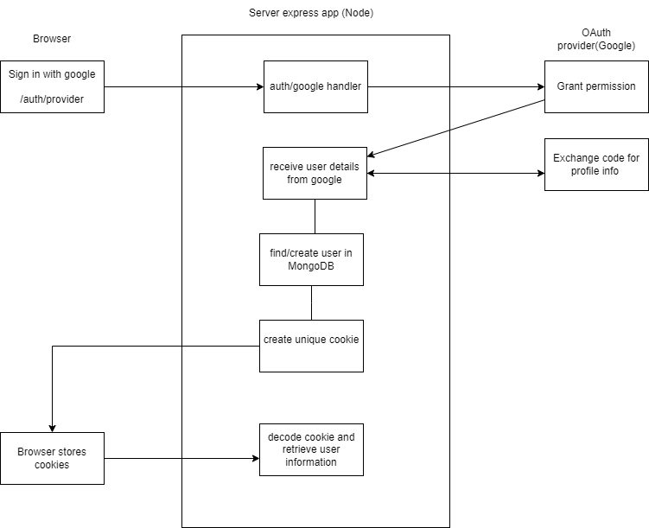

## React components flow – :-

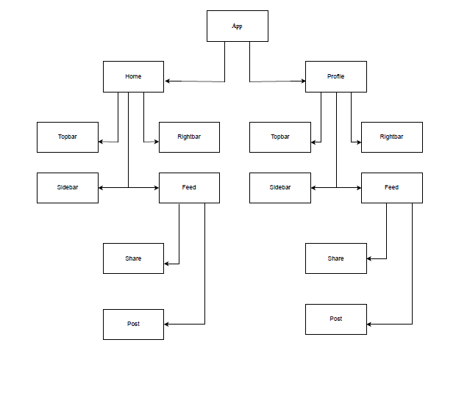

## Modules: