E-COMMERCE · LEADERSHIP PACK
Business Insights Report
Sales, profit, and product mix | January 2024 – December 2025
This pack is for a leadership review. Charts and tables use the cleaned sales model. Returns stay in as negative sales. Orders with a broken date or no product are left out.

1. Snapshot
Revenue | Profit | Margin | Orders / customers
29,449,585 | 6,748,690 | 22.9% | 24,955 / 2,000

- Two-year sales 29,449,585 and profit 6,748,690 — about 22.9% of each rupee of sales is profit.
- The company is steady, not seasonal. The problem is mix: a few high-volume products keep little profit.
- Regions look different in size, but they keep almost the same profit on each sale.

2. Top 10 products by revenue
These ten products bring in about one-fifth of product sales. Kids Product 98 leads on both sales and margin. Paper Product 94 is the weak name in this list: it ranks tenth but keeps much less profit than the rest.
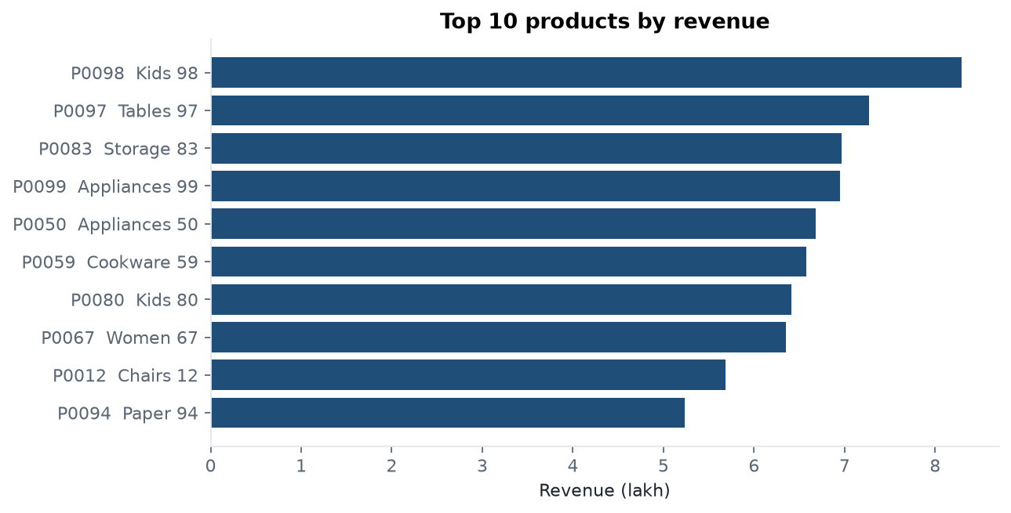
Figure 1. Revenue of the ten best-selling products (lakh).
Rank | Product | Category | Revenue | Profit | Margin
1 | P0098 Kids Product 98 | Clothing | 829,113 | 319,536 | 38.5%
2 | P0097 Tables Product 97 | Furniture | 727,002 | 210,808 | 29.0%
3 | P0083 Storage Product 83 | Furniture | 696,707 | 183,997 | 26.4%
4 | P0099 Appliances Product 99 | Home & Kitchen | 694,713 | 228,439 | 32.9%
5 | P0050 Appliances Product 50 | Home & Kitchen | 668,335 | 202,509 | 30.3%
6 | P0059 Cookware Product 59 | Home & Kitchen | 657,901 | 196,912 | 29.9%
7 | P0080 Kids Product 80 | Clothing | 641,467 | 161,426 | 25.2%
8 | P0067 Women Product 67 | Clothing | 634,806 | 144,817 | 22.8%
9 | P0012 Chairs Product 12 | Furniture | 568,745 | 196,533 | 34.6%
10 | P0094 Paper Product 94 | Office Supplies | 523,043 | 78,887 | 15.1%

3. Which regions make the most profit?
North makes the most profit, then East and South. West is a little behind because it has four states, not five. Central is only Madhya Pradesh, so its total is smaller. Margin is about 22–23% everywhere. North is not better at profit. It simply sells more.
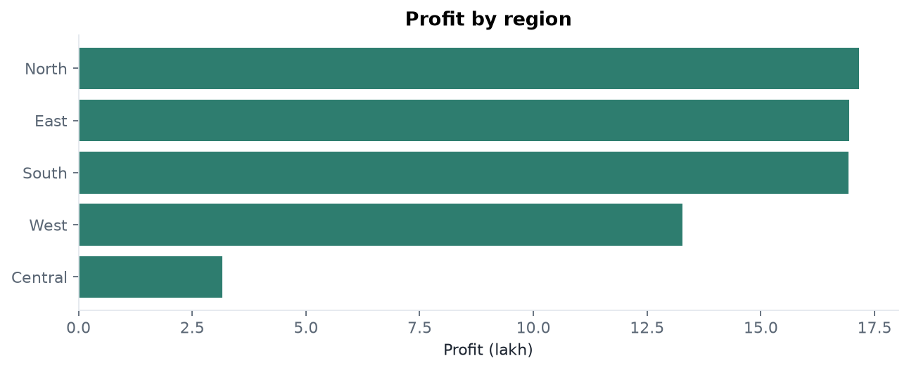
Figure 2. Total profit by region. Size follows coverage, not a better margin.
Region | Orders | Revenue | Profit | Margin
North | 6,335 | 7,557,756 | 1,716,419 | 22.7%
East | 6,266 | 7,344,953 | 1,694,936 | 23.1%
South | 6,202 | 7,358,637 | 1,692,440 | 23.0%
West | 4,932 | 5,770,698 | 1,328,446 | 23.0%
Central | 1,220 | 1,417,542 | 316,448 | 22.3%

4. Monthly revenue and profit
Sales stay in a narrow band. Best sales month: 2025-12 (1,326,222). Softest: 2025-02 (1,087,114). Best profit month: 2025-08 (302,863). There is no company-wide festival spike. February looks soft mainly because it has fewer days.
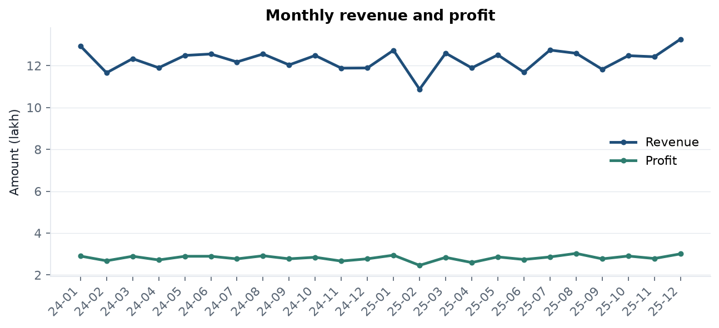
Figure 3. Monthly revenue and profit (lakh). The band is tight across 24 months.

5. High sales, low profit margin
These products sit in the top 25% of sales and the bottom 25% of margin. They move a lot of money but leave little behind. Company average margin is 22.9%.
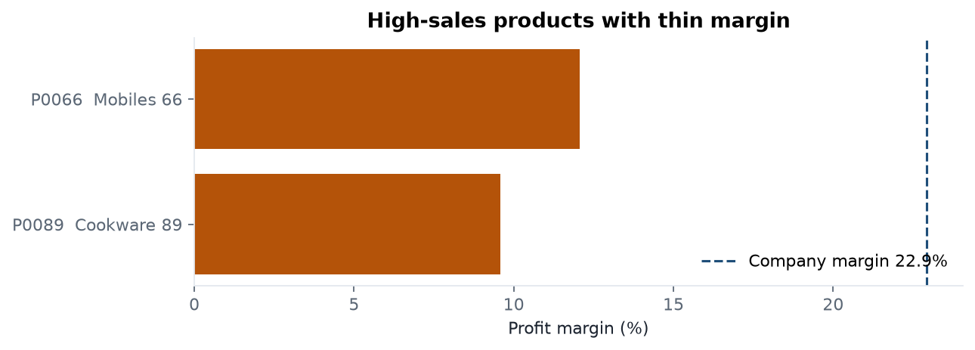
Figure 4. Margin of the high-sales, low-margin pair vs the company average (dashed).
Product | Category | Revenue | Profit | Margin
P0089 Cookware Product 89 | Home & Kitchen | 500,882 | 47,955 | 9.6%
P0066 Mobiles Product 66 | Electronics | 416,699 | 50,271 | 12.1%

Cookware Product 89 is the main concern (about 5.01 lakh sales at 9.6% margin). Mobiles Product 66 is next at 12.1%. Also watch Paper Product 94 (top 10, 15.1%) and Tables Product 84 (high sales, about 13.4%). Volume is not the same as a healthy mix.

6. What the company should do next

Fix the mix, not only the volume
Review price, discount, and cost on Cookware Product 89 and Mobiles Product 66. If the discount is too deep, cap it. If cost is high, talk to the supplier or raise the list price. Do not put extra ad spend on these two until margin improves.

Treat regions as volume, not as profit skill
Do not move budget away from South or East just because North is first. All three keep about the same profit on each sale. For growth, add coverage in West and Central rather than assuming those teams underperform.

Do not plan stock on a company-wide season
Total sales barely move from month to month. A big festival stock-up for the whole catalogue is not supported. If you season stock, do it for a few products only, after a category owner checks that the same month repeats next year.

Protect the winners
Kids Product 98, the top appliances, and Chairs Product 12 combine high sales with healthy margin. Keep them in stock and on the homepage. Do not discount them as hard as the weak-margin SKUs.

Clean the product list and the order file
Twelve products sit in the wrong category. Sixty orders have no customer, 35 have no product, and ten have no real date. Stop loading a sale until those fields are filled. Until sign-up dates are trustworthy, do not use ‘first purchase after sign-up’ for marketing.

7. Bottom line
The business is steady, not spiky. Profit is even across regions. The real opportunity is mix: keep pushing the high-margin bestsellers, and stop letting a few high-volume products quietly dilute company margin.
Source: cleaned star schema. Rebuild with python scripts/build_insights_report.py

