EXPERIMENT-6

NAME: GRACE JEYARANI P ROLLNO: 240701158
Simulate the life cycle stages for UI Design using the RAD model and develop a small interactive interface Axure.RP, Openproj
RAD MODEL Work Flow Diagram:
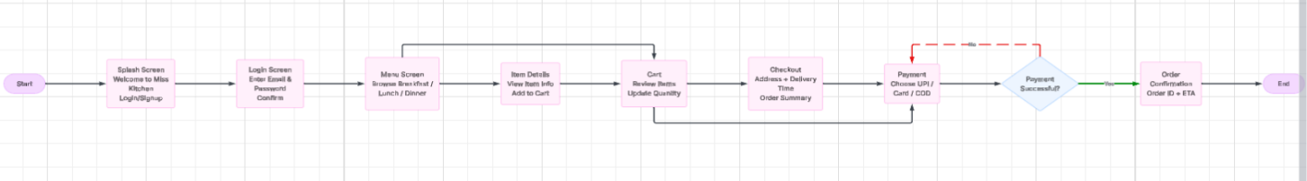
PROCEDURE:
Phase 1: Requirement Analysis
• Defined Application Objective:
Developed a mobile-based food ordering prototype named Miss Kitchen to simplify ordering meals digitally.
• Collected Functional Requirements:
o Welcome Screen: Intro page with application branding and entry button.
o Authentication Module: User login using registered Email ID and Password.
o Food Listing Screen: Dynamic menu showing meals with thumbnails, category names, and price values.
o Product Information Screen: Detailed preview of selected food item with ingredients/description.
o Shopping Cart Module: Displays chosen items before purchase confirmation.
o Address & Delivery Module: Shows customer location and estimated delivery schedule.
o Transaction Module: Enables user to choose preferred payment mode.
o Completion Screen: Final confirmation after successful order placement.
• Prepared Workflow:
Mapped the process from app launch to final delivery confirmation.
Phase 2: Interface Design
• Started Axure RP Project:
Created a prototype project titled Miss Kitchen Ordering System.
• Screen Design Activities:
o Designed all screens in mobile size format.
o Applied restaurant-style dark maroon color palette for premium branding.
o Inserted food images to improve product visibility.
o Positioned navigation icons at bottom for quick access.
o Used soft buttons and clean text arrangement for better usability.
• Usability Notes Added:
Added labels, placeholders, and screen instructions for smooth user interaction.
Phase 3: Prototype Development
• Built Interactive Navigation:
o Login button redirects to Menu page.
o Selecting food opens item details screen.
o Add to Cart button moves to cart page.
o Checkout redirects to payment section.
o Confirm Order displays success message.
• Improved User Experience:
o Tested clickable buttons and screen linking.
o Adjusted spacing, font size, and alignment.
o Ensured smooth mobile app simulation.
Phase 4: Implementation & Delivery
• Final Review:
Verified complete order flow, payment navigation, and confirmation output.
• Prototype Export:
Published the final clickable prototype through browser preview / Axure share link for presentation.
