EXPERIMENT – 7

NAME: GRACE JEYARANI P ROLLNO: 240701158

Experiment with different layouts and colour schemes for an app.

Collect user feedback on aesthetics and usability.
Prototype screen before feedback:
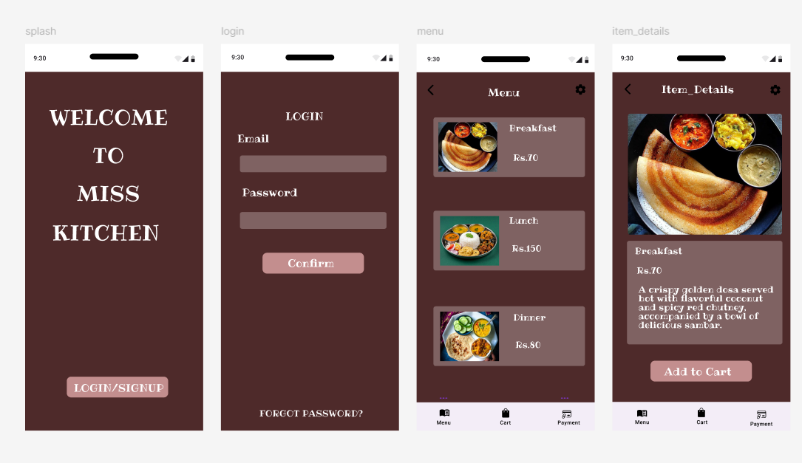
Prototype screen after feedback:
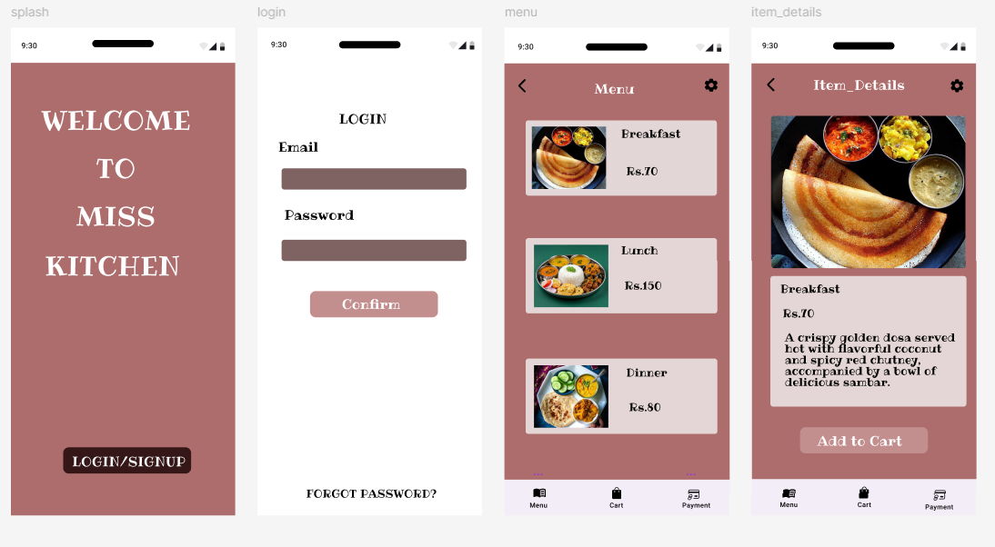
Analysis of Feedback
Most Preferred:
• Overall design (clean, classy, modern look) was highly appreciated
• Users liked the colour scheme and simplicity
Most Usable:
• App is described as easy to use, user-friendly, and intuitive
• Navigation felt smooth and accessible
Most Attractive:
• UI was considered visually appealing and well-designed
• Fonts and layout received positive comments
Common Observations
• Users prefer simple and clean layouts over cluttered screens
• Buttons and interactive elements should be more prominent
• Some users want more colour variations/themes
• Request for more dishes/options in the menu
• Suggestion to include bilingual support
• Minor improvements needed in spacing and alignment
• Fonts are good but can be further refined
Improvements Made
Based on feedback:
• Improved button visibility (better contrast, more prominent CTA)
• Enhanced color palette with softer background + accent colours
• Adjusted spacing and alignment for smoother content flow
• Maintained simple and clean UI structure
• Optimized typography for better readability
• Designed scope for adding more menu items
• Considered bilingual feature (e.g., English + Tamil)
• Ensured overall UI feels modern, clean, and user-friendly

