EXPERIMENT-9

NAME: GRACE JEYARANI P ROLLNO: 240701158
Design input forms that validate data (e.g., email, phone number) and display error messages using HTML/CSS, JavaScript.
AIM:
The aim is to design input forms that validate data, such as name, email, phone number and password, and display error messages using HTML/CSS and JavaScript with Validator.js.
Step 1:
Setting Up the HTML Form Start by creating an HTML form with input fields
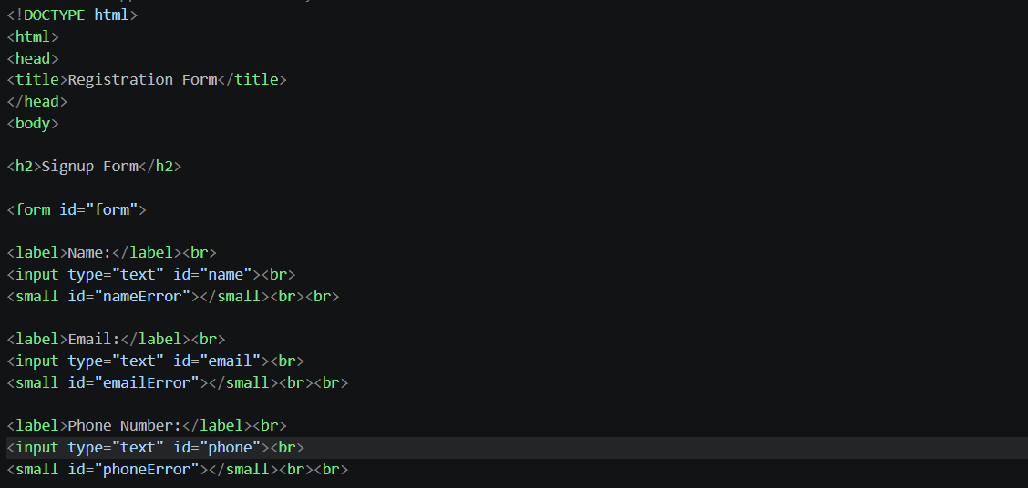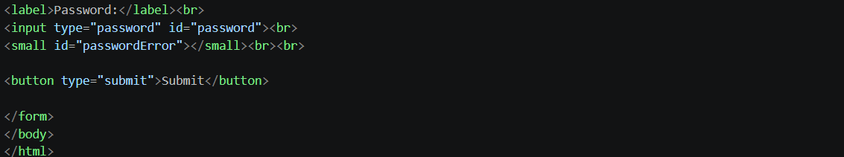
Output:
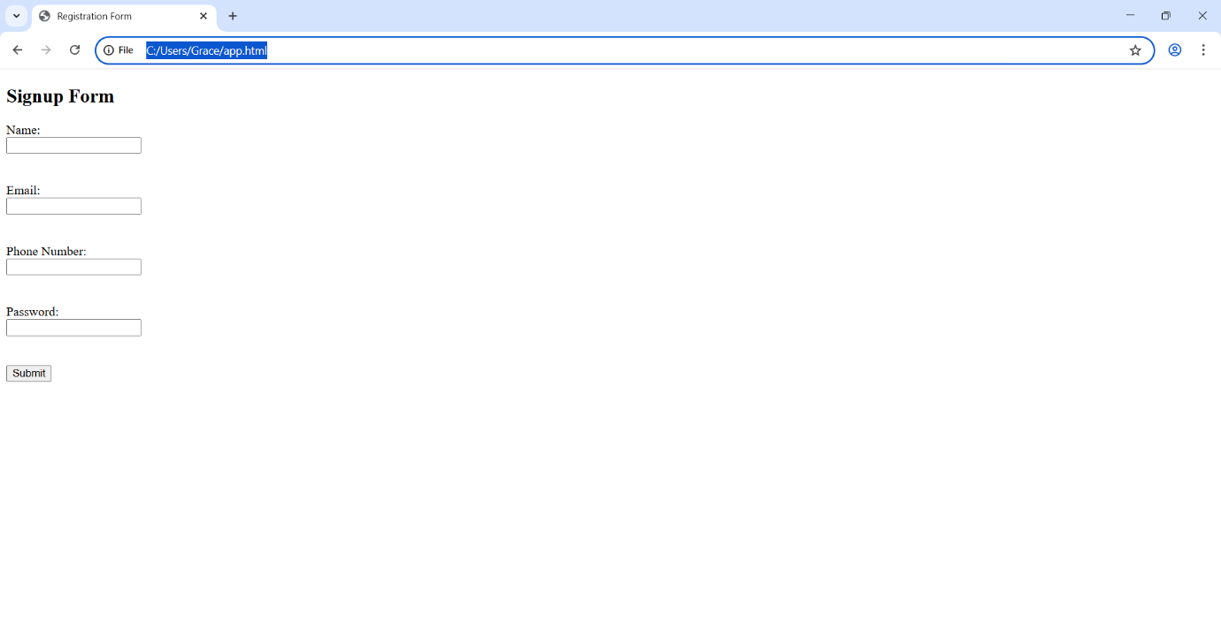
Step 2:
Styling the Form with CSS Next, add some basic styling to make the form look nice.
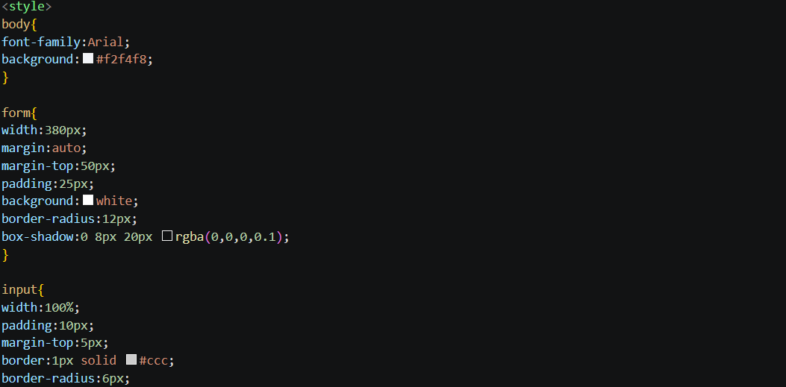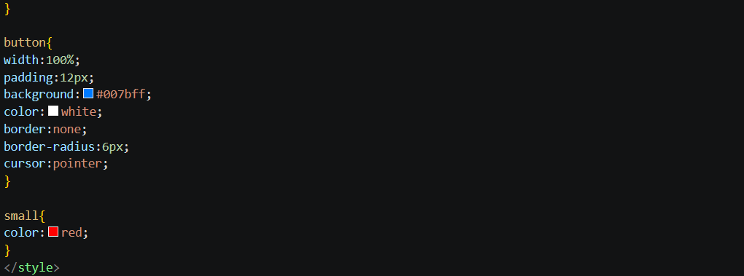
Output:
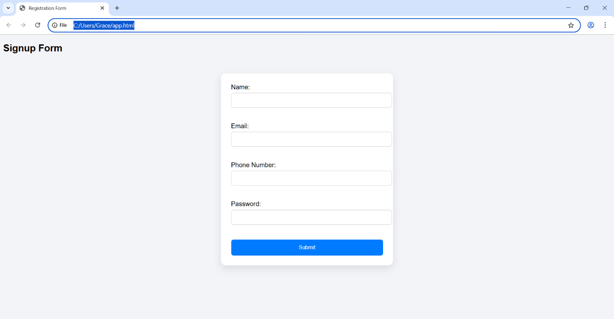
Step 3:
Adding JavaScript for Validation Finally, add JavaScript to validate the input fields using Validator.js and display error messages.
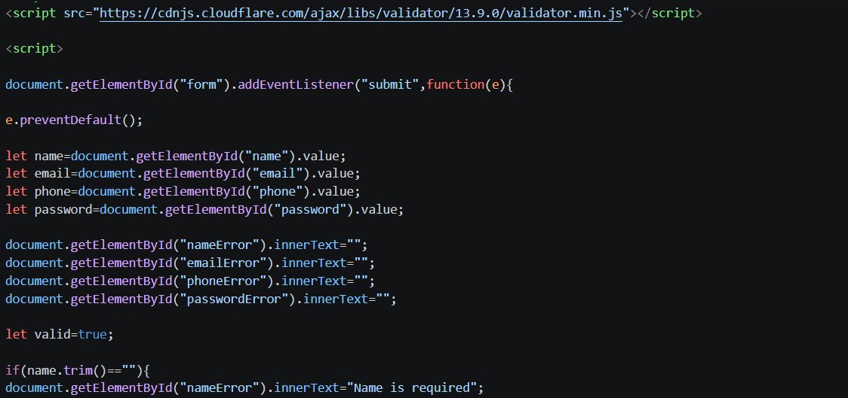
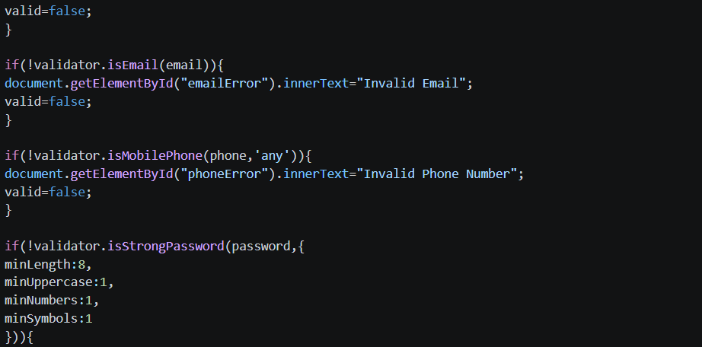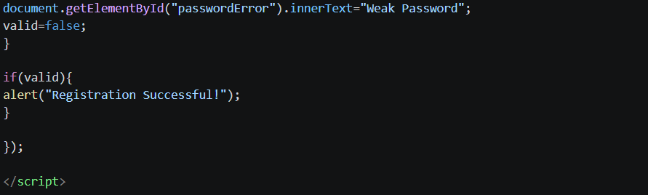
Output:
