Week 2 Documentation – Data Cleaning in Power BI

Introduction
Data cleaning is an essential step in the data analysis process. It ensures that the dataset is accurate, consistent, and ready for visualization and analysis. In Microsoft Power BI, data cleaning is mainly performed using the Power Query Editor, which provides several built-in tools to transform and clean data efficiently.

Common Data Cleaning Functions in Power BI

1. Replace Values
Replace Values is used to find and replace specific values in a column. It helps correct incorrect or inconsistent data entries.
Path: Home → Replace Values

2. Trim Data
The Trim function removes extra spaces from the beginning and end of text values. This helps ensure consistent formatting in text fields.
Path: Transform → Format → Trim

3. Clean Function
The Clean function removes non-printable characters from text values. This improves data quality by eliminating unwanted hidden characters.
Path: Transform → Format → Clean

4. Split Column
The Split Column feature divides one column into multiple columns based on a delimiter such as a comma, space, or dash.
Path: Home → Split Column

5. Remove Blank Rows
This option removes rows that contain empty or missing values, helping to maintain a clean and usable dataset.
Path: Home → Remove Rows → Remove Blank Rows

Power BI Interface Example
The following screenshot shows an example of the Power BI interface where data transformation and cleaning operations are typically performed.
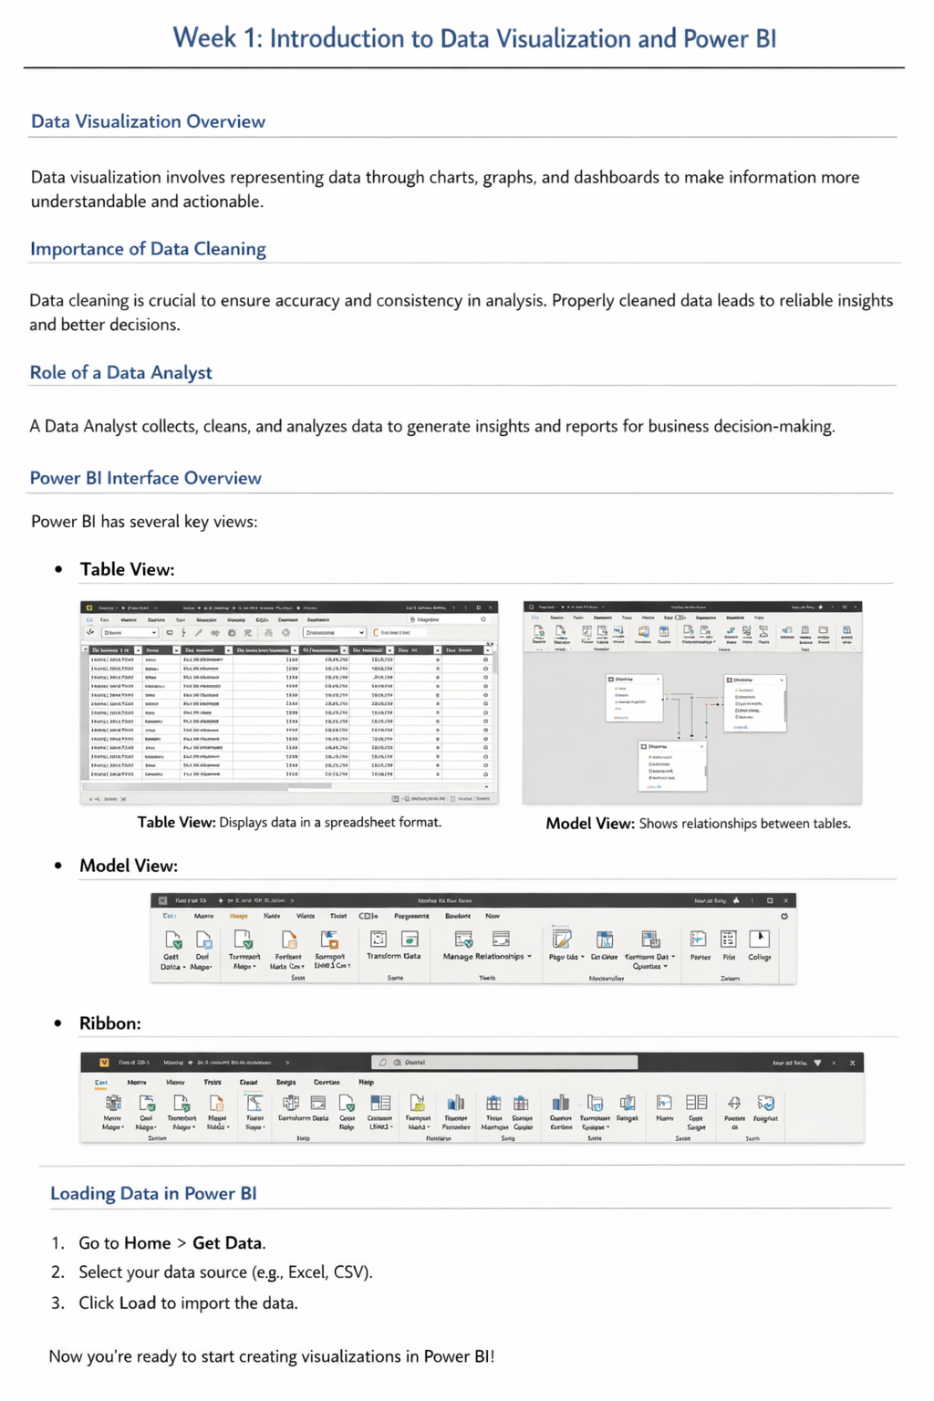

Conclusion
Using these data cleaning functions in Power BI helps improve data accuracy and ensures better analysis results. Clean and well-prepared data allows analysts to create meaningful visualizations and reliable insights.

