BIT 4107 – Mobile Application Development
ENHANCED PROFESSIONAL STUDENT LOGBOOK
Student Name: Grace Wairimu Njenga
Admission Number: BIT/2024/33362
School/Faculty: Computing and Informatics
Programme: information technology
Academic Year: fourth year
Semester: Second semester
Lecturer: Mr. Nyoro Micheal
Phone Number: ______________________________

Contents
Week 1: Introduction to Mobile Application Development 3
Practical Activities Undertaken 3
Tools/Software Used 3
Personal Reflection 5
Week 2: Mobile Development Environment 6
Personal Reflection 7
Week 3: User Interface Design 8
Personal Reflection 12

Week 1: Introduction to Mobile Application Development

Practical Activities Undertaken
only screenshots needed and labeling
Screenshots/Evidence Attached (Yes/No)

Tools/Software Used
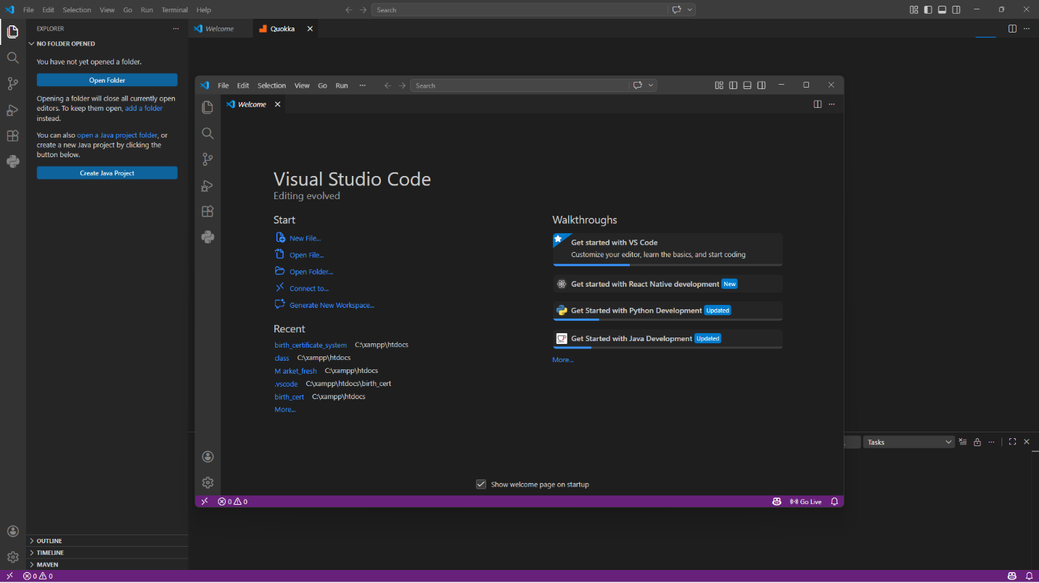
Figure 1 VS Code

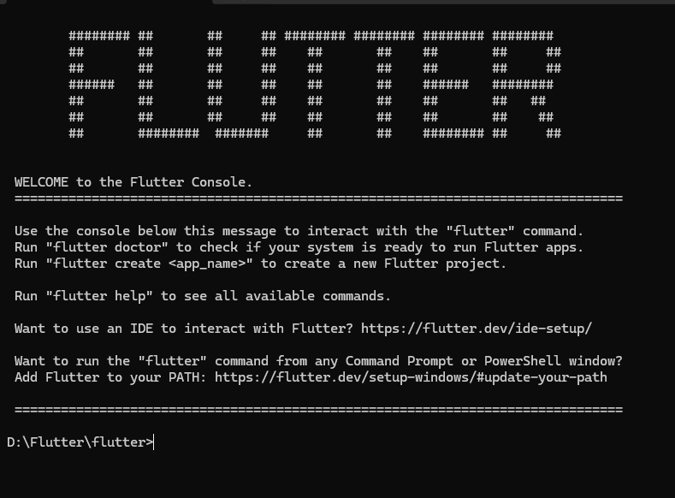
Figure 2 Flutter
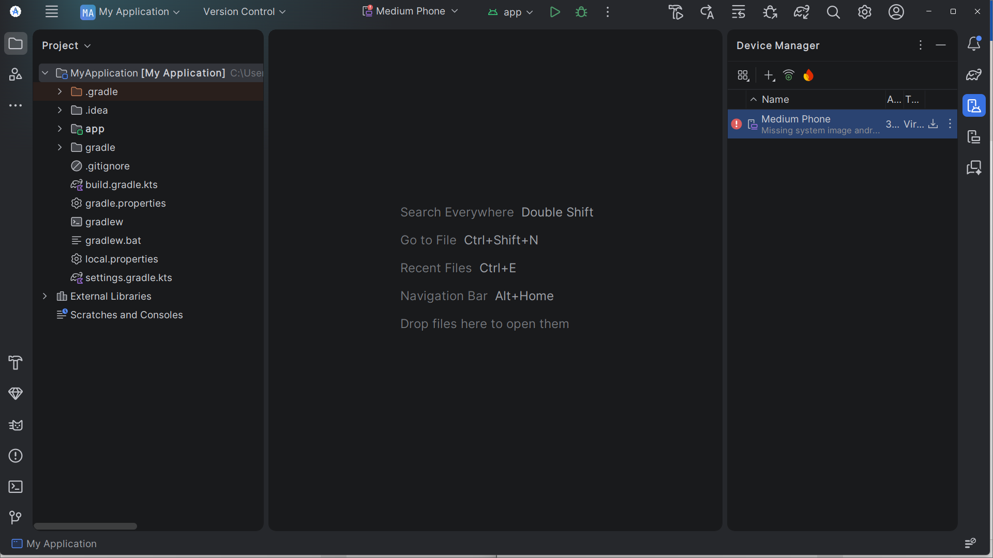
Figure 3 Android Studio

Personal Reflection
Setting up my mobile application development environment using VS Code, Flutter, and Android Studio has been an important first step in my project. Although I have not started designing the application yet, I have learned how to install and configure the required tools. This process has increased my understanding of mobile app development.

Week 2: Mobile Development Environment
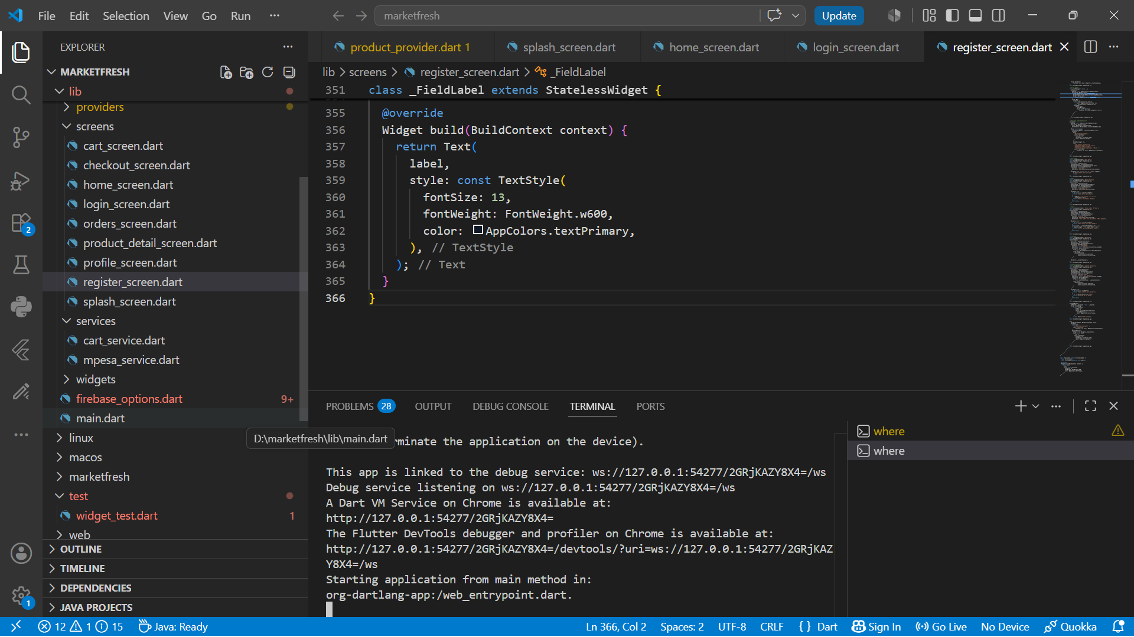
Figure 4 VS Code
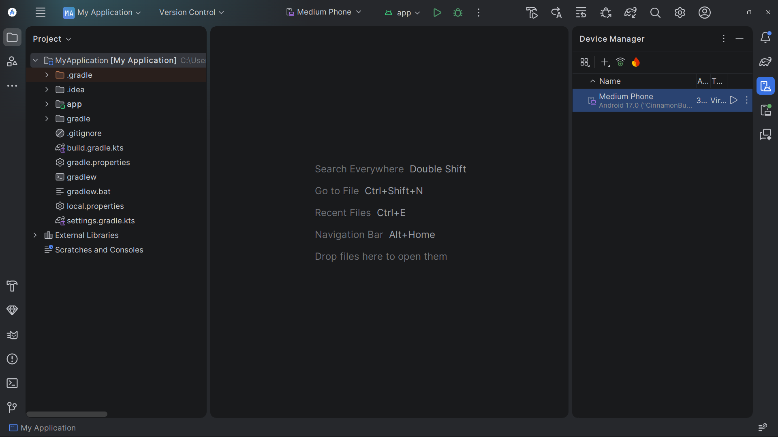
Figure 5 Android Studio

Personal Reflection
Setting up the development environment for my mobile application project was an essential step. I successfully installed and configured VS Code, Flutter, and Android Studio to support application development. The screenshots provided demonstrate that the required tools are ready for use, establishing a strong foundation for the design and implementation phases.

Week 3: User Interface Design
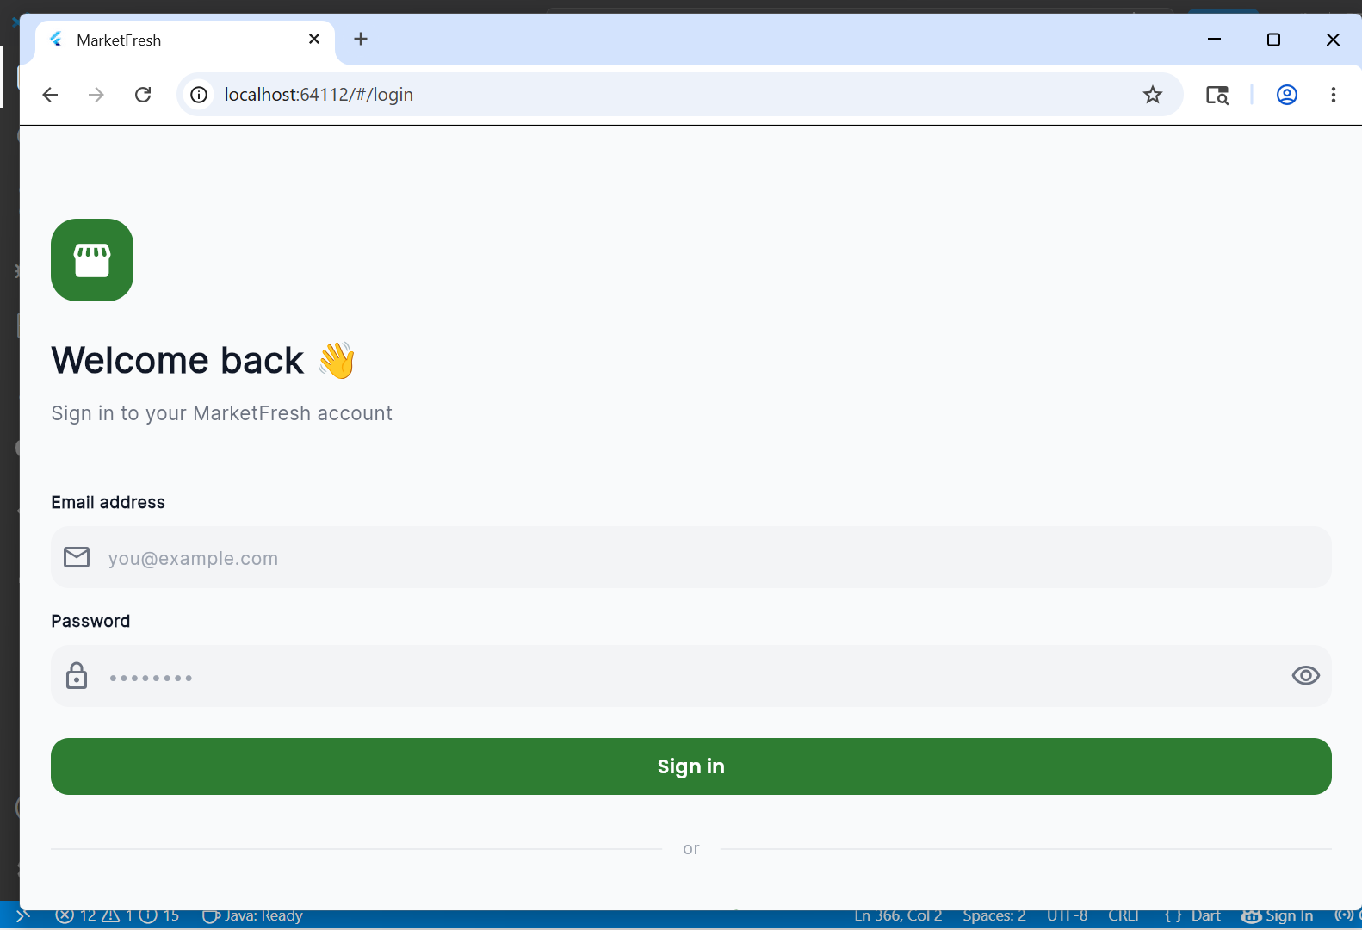
Figure 6 Login Screen
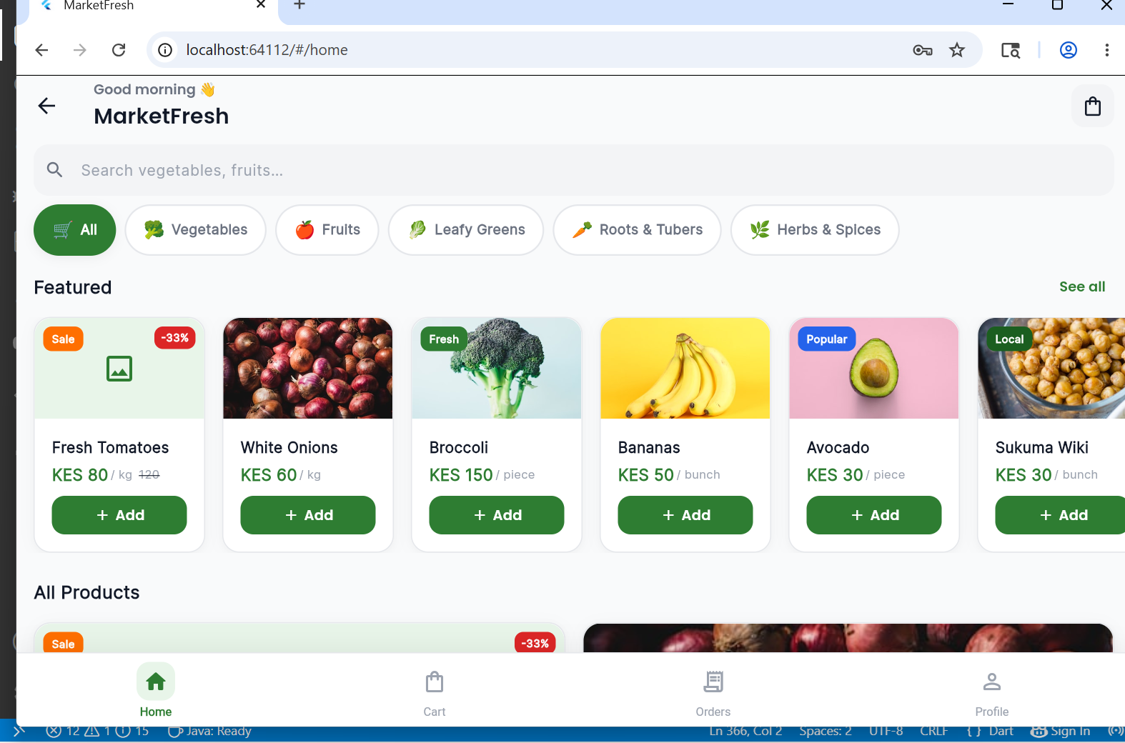
Figure 7 Home Screen
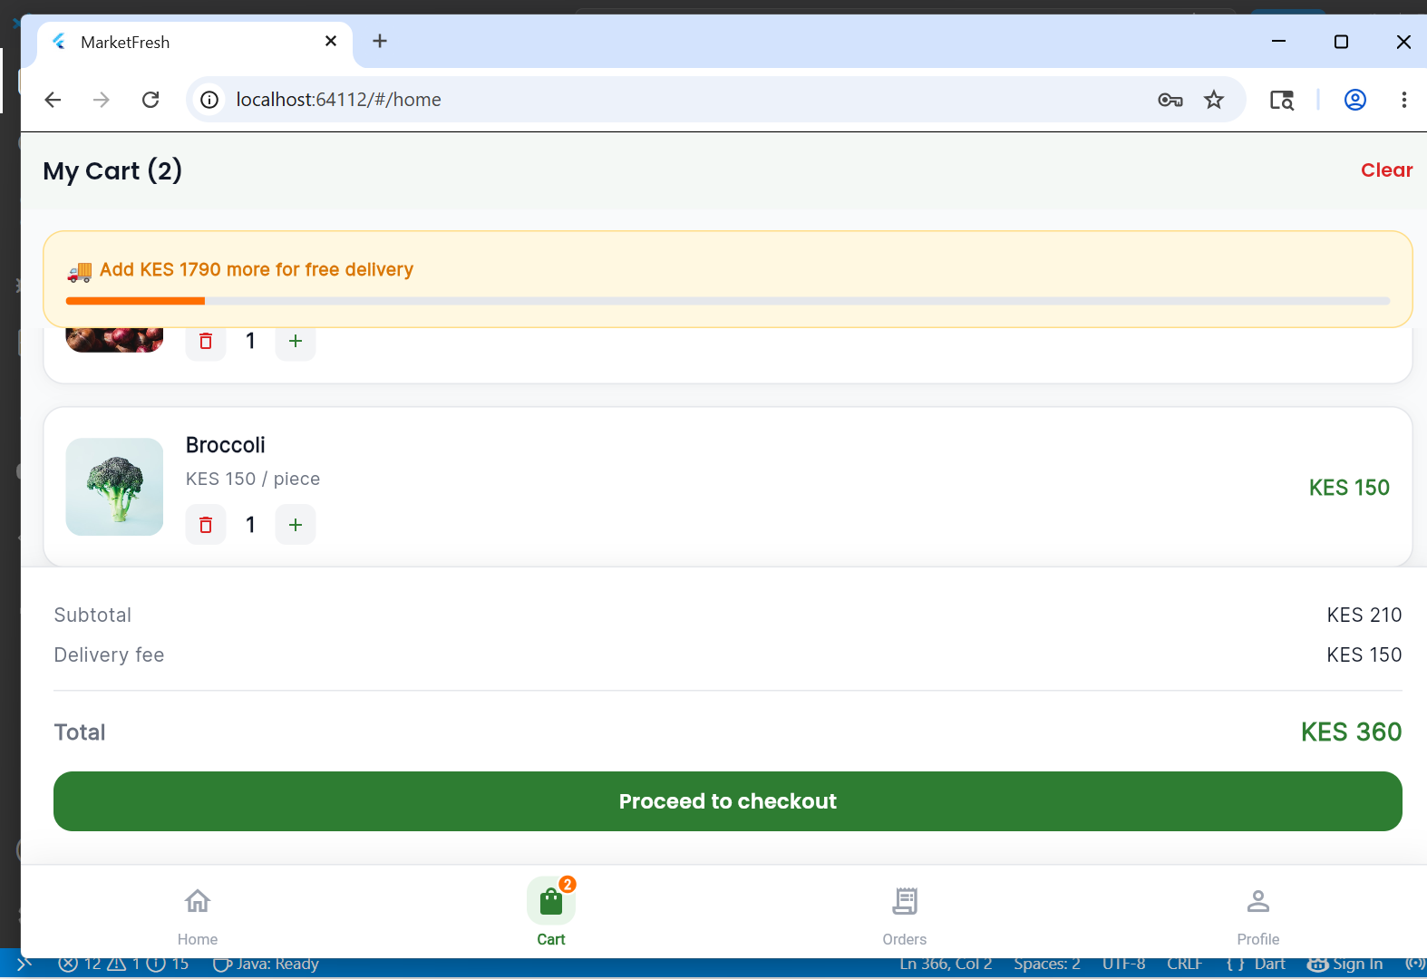
Figure 8 Cart Screen

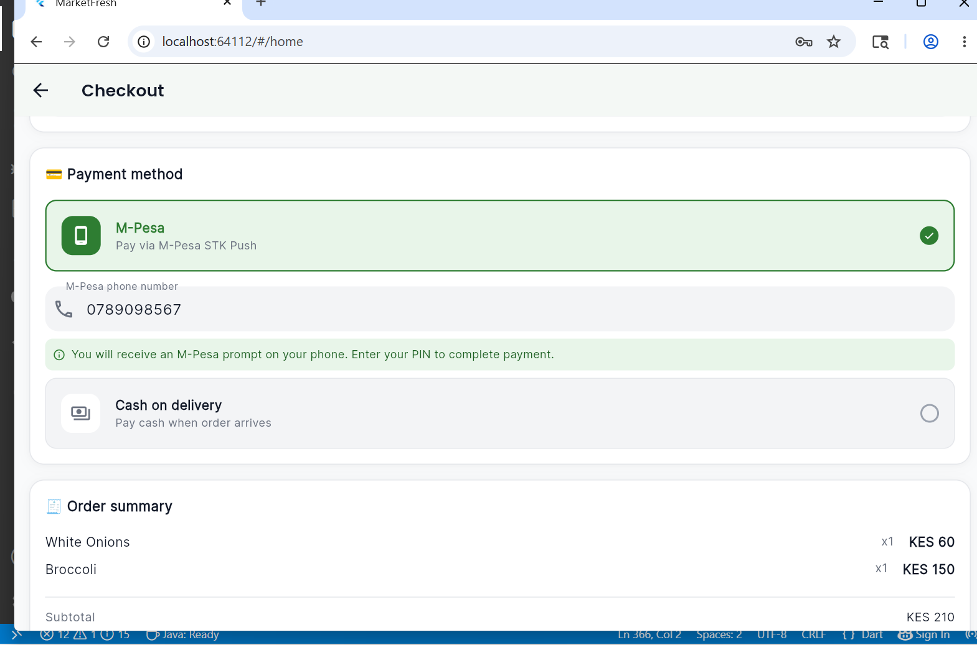
Figure 9 Checkout
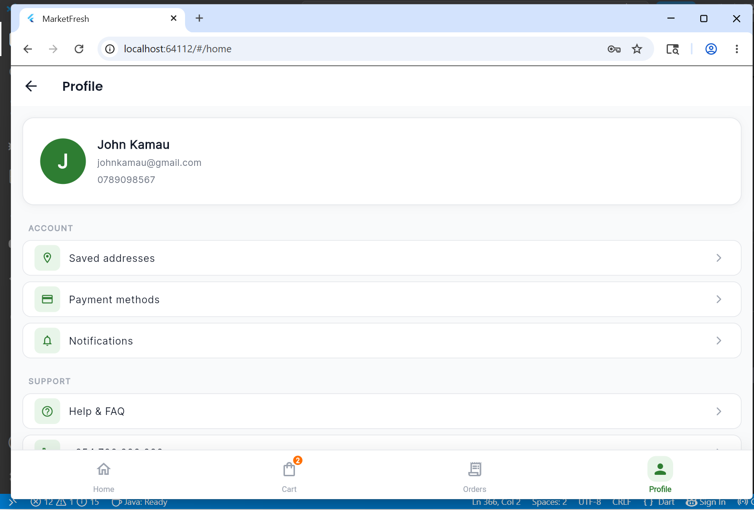
Figure 10 Profile Screen

Personal Reflection
Developing the login page and user interfaces for my mobile application has been a rewarding experience. Using VS Code, Flutter, and Android Studio, I created the initial screens that users will interact with. This stage helped me improve my design and development skills while gaining practical experience in mobile application development.

