The typical structure of a C programming textbook! Here are the major parts you'd usually find:
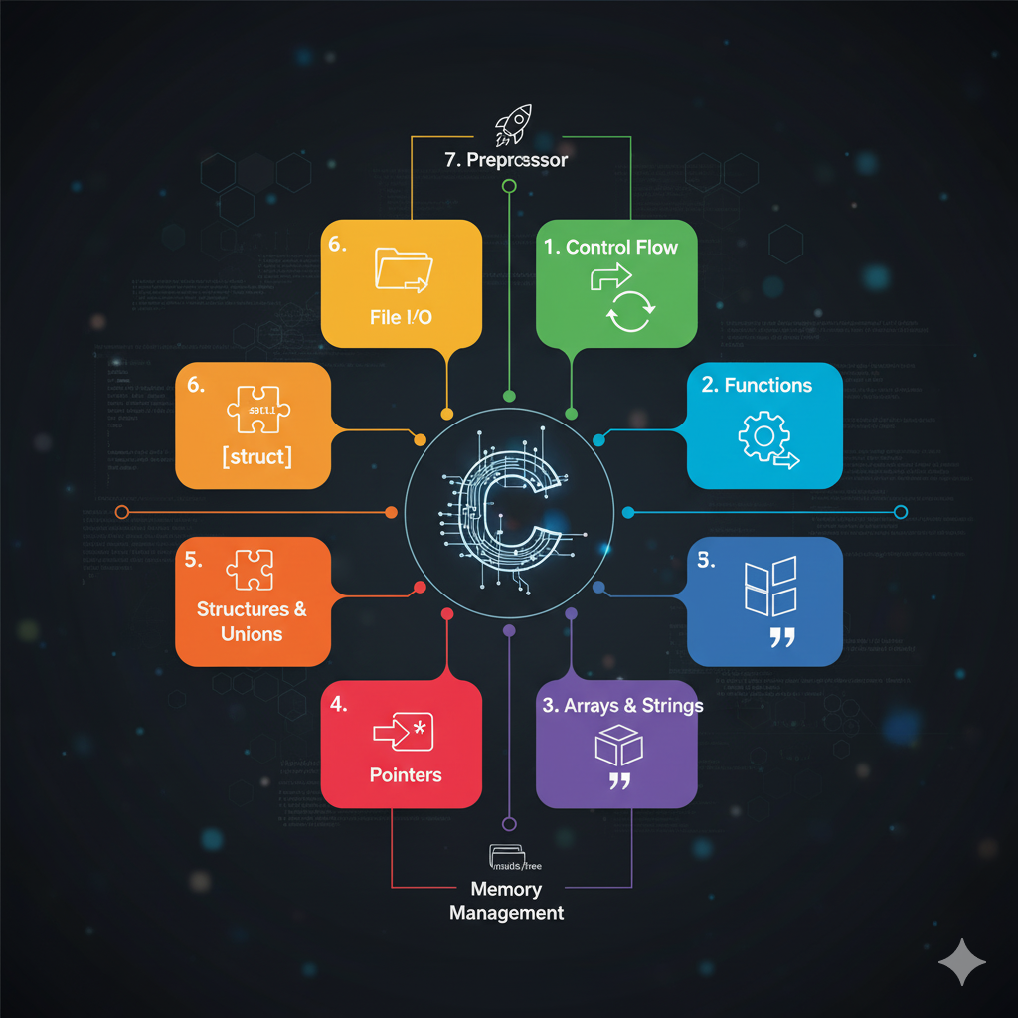

1. Introduction to C 📚
This section usually covers the history of C, its features, and how it compares to other programming languages. It also introduces the basic structure of a C program, how to compile and run it, and fundamental concepts like variables, data types, and operators.

2. Control Flow 🚦
Here, you'll learn about how to control the execution flow of your program. This includes:
- Conditional Statements: if, else if, else, switch for making decisions.
- Looping Constructs: for, while, do-while for repetitive tasks.

3. Functions ⚙️
Functions are the building blocks of C programs. This part focuses on:
- Defining and calling functions.
- Function parameters and return values.
- Scope of variables (local vs. global).
- Recursion.

4. Arrays and Strings 📝
These are crucial for handling collections of data:
- Arrays: Storing multiple values of the same type.
- Strings: Character arrays used to represent text. This often includes string manipulation functions.

5. Pointers 📍
Pointers are a powerful and sometimes challenging concept in C. This section delves into:
- What pointers are and how they work.
- Pointer arithmetic.
- Pointers and arrays.
- Dynamic memory allocation (malloc, calloc, realloc, free).

6. Structures and Unions 🧩
These allow you to create custom data types:
- Structures: Grouping different data types under a single name.
- Unions: Storing different data types in the same memory location.

7. File I/O 📂
Learning how to interact with files is essential for many applications:
- Opening, reading from, writing to, and closing files.
- Different file modes (text vs. binary).

8. Preprocessor Directives 🚀
These are instructions for the compiler that are processed before actual compilation:
- #include for including header files.
- #define for macros.
- Conditional compilation (#ifdef, #ifndef).

9. Advanced Topics (Optional, but common) 🌌
Many textbooks also include:
- Data Structures: Linked lists, stacks, queues, trees (often with C implementations).
- Command-Line Arguments: How to pass arguments to your program when it runs.
- Error Handling: Techniques for dealing with errors gracefully.
Here's an image that might represent the core concepts of C programming:

