# **My Deep Learning Blog**

# **Lesson 2**

* Used Bing API to search and download images
* Used **datablock** method to read and label the images based on category
* Used data augmentation to vary the data for the model
* Trained the model
* Used the **confusion matrix** to show mistakes the model made
* Cleaned data using **imageclassifiercleaner** utility
* Exported the model to pickel file
* Created a notebook that reads the pkl file
* Used Ipywidgets for creating an upload widget and a classify button
* Used Binder to deploy the notebook application so that other users can run it.
* The notebook will read the uploaded image and then the classify button will display the category and the probability of accuracy based on the trained model.
* I still got pretty good results even without cleaning any of the data!

[Bee Classifier Application](https://mybinder.org/v2/gh/Grace-bit-prog/deeplearning/master?urlpath=%2Fvoila%2Frender%2Fbeeapp.ipynb)

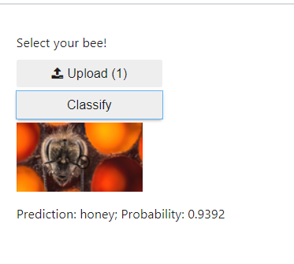

**Github Notes**

These notes are what I learned using the Paperspace Platform.

* Create a Repository in Github
* In Paperspace, open up a Jupyter terminal
* Make a new local repository for the files you want to push to your remote Github repository

1) make a test directory where you want to copy your files to.

mkdir test

# cd test

2) initialize the local repository

# git init

Initialized empty Git repository in /notebooks/test/.git/

3) copy the files you need to add to the test directory

4) push your files to your remote github repository

# git push --set-upstream <https://github.com/Grace-bit-prog/deeplearning> master

Merge made by the 'recursive' strategy.

README.md | 1 +

bee_classifier.ipynb | 883 +++++++++++++++++++++++++++++++++++++++++++++++++++

beeapp.ipynb | 109 +++++++

export.pkl | Bin 0 -> 47589446 bytes

requirements.txt | 5 +