SOFTWARE CONSTRUCTION REPORT
Name: GRACE KENNE TSAGUE
Matricule:CT25A452
course: Software Construction and Evolution

Learning Marketing Platform
(Website Application)
Applying the Five Processes of Software Construction

1. Introduction
The Learning Marketing Platform is a web-based application designed to bridge the gap between digital marketing education and practical application. The platform targets learners at all levels — from beginners exploring digital marketing fundamentals to experienced professionals seeking advanced certifications and analytics-driven insights. Built as a fully responsive website, it provides curated course content, AI-powered learning recommendations, progress tracking, and community engagement features.
This report details the application of the five core processes of software construction to the development of this platform. It also outlines the strategies employed to minimize complexity, the management approaches adopted, and the tools and technologies utilized throughout the project lifecycle.

2. The Five Processes of Software Construction

2.1 Software Requirements
The requirements phase laid the foundation for the entire project. Stakeholder interviews, competitor analysis, and user surveys were conducted to gather both functional and non-functional requirements for the Learning Marketing Platform.
Key functional requirements identified included:
- User registration, login, and profile management
- Course browsing, enrollment, and completion tracking
- AI-powered course and content recommendations
- Instructor dashboard for content upload and learner analytics
- Certification issuance upon course completion
- Discussion forums and peer-to-peer interaction
- Payment gateway integration for premium courses

Non-functional requirements included:
- Page load time of under 2 seconds for all core pages
- System availability of 99.9% uptime
- Full mobile responsiveness across all device sizes
- GDPR-compliant data handling and storage

A Software Requirements Specification (SRS) document was produced and reviewed with all stakeholders before development commenced. Use case diagrams and user story maps were created to visualize expected system behaviour and ensure the team had a shared understanding of scope.

2.2 Software Design
The design process translated the requirements into a concrete system architecture. The platform was designed using a three-tier architecture: a presentation layer (frontend), a business logic layer (backend API), and a data layer (database). This separation of concerns was critical in minimizing complexity and enabling parallel development across teams.
Design decisions included:
- Frontend: React.js was chosen for its component-based architecture, facilitating reusable UI elements across the platform.
- Backend: Node.js with Express was selected for the REST API, offering high throughput and a JavaScript-consistent full-stack environment.
- Database: MySQL was adopted for structured relational data storage, managing users, enrolments, and course records with robust query performance.
- Authentication: JSON Web Tokens (JWT) with OAuth 2.0 integration for social logins (Google, LinkedIn).
- Cloud Hosting: Railway was used as the deployment platform, providing seamless integration with GitHub for automated deployments and simple environment management.

The main design stack consisted of:
Layer | Technology | Purpose
Frontend | React.js | Component-based UI forms and views
Backend | Node.js (Express) | REST API and business logic layer
Database | MySQL | Relational data storage and management

Wireframes and high-fidelity prototypes were developed using Figma and reviewed iteratively with stakeholders. System interaction diagrams, entity-relationship diagrams (ERDs), and API contract documentation were produced during this phase to guide implementation.

2.3 Software Technology (AI, Machine Learning & Data Mining)
Technology selection was one of the most critical processes in the construction of the Learning Marketing Platform. Beyond the standard web technologies, the team strategically integrated Artificial Intelligence (AI), Machine Learning (ML), and Data Mining techniques to enhance learner engagement and platform intelligence.
AI and Machine Learning Integration:
A collaborative filtering recommendation engine was built and integrated into the platform. Using historical learner behaviour data — including courses viewed, time spent per module, quiz scores, and completion rates — the ML model predicts and recommends courses most relevant to each individual user. The model was developed using Python's Scikit-learn library and deployed as a microservice via a Flask API that the main Node.js backend communicates with.
Natural Language Processing (NLP) was also applied to power a smart search feature. Learners can search using conversational language (e.g., "I want to learn how to run Facebook ads for a small budget"), and the system uses TF-IDF vectorization and cosine similarity to match queries against course descriptions and tags, returning the most semantically relevant results.
Data Mining:
Data mining techniques were applied to the platform's usage logs and learner engagement data. Clustering algorithms (K-Means) were used to segment learners into groups such as 'casual browsers', 'active learners', and 'certification-seekers'. These segments informed the marketing messaging and course bundle recommendations displayed to different user groups on the platform dashboard.
Instructors benefit from a data mining dashboard that visualises learner drop-off points, most replayed video segments, and quiz difficulty analysis — enabling continuous course improvement. Apache Kafka was used for real-time data streaming from user activity, feeding a data pipeline that processes and stores event data in a data warehouse for periodic ML retraining.
Other Technologies Used:
- React.js — Frontend SPA framework
- Node.js / Express — Backend REST API
- Python / Flask — ML microservice
- MySQL — Relational database for all structured data
- AWS S3, EC2, RDS — Cloud infrastructure
- Redis — Session caching and performance optimization
- Stripe API — Payment processing
- Railway — Deployment and hosting platform

2.4 Software Construction Tools (DevOps)
Effective tooling was central to the team's ability to deliver a high-quality platform within schedule. Beyond development frameworks, the team adopted a DevOps culture, using a suite of tools to automate, monitor, and streamline the construction pipeline.
The following four DevOps tools were integral to the project:

i. Kubernetes (Container Orchestration & Scaling)
Kubernetes was used to deploy and scale containerised components of the platform in the production environment. Each service — the frontend, backend API, ML microservice, and database — was packaged as a container and managed through Kubernetes deployments and services. Kubernetes enabled automatic horizontal scaling during periods of high learner traffic, such as promotional course launches, ensuring consistent performance without manual intervention. Rolling updates and self-healing capabilities reduced downtime and improved platform resilience.

ii. Prometheus (Monitoring & Health Tracking)
Prometheus was integrated to collect real-time metrics from all running services, including API response times, error rates, database query durations, and server resource utilisation. It continuously scraped metrics from each Kubernetes pod, providing the operations team with a live feed of platform health. Custom alerting rules were defined to trigger notifications when critical thresholds were breached, such as error rate spikes or high memory consumption.

iii. Grafana (Visualisation & Alerting)
Grafana was connected to Prometheus as the visualisation layer, providing the development and operations team with live dashboards that tracked platform health at all times. Custom dashboards were built to display learner traffic trends, server load, and API performance. Alerts were configured to notify the team via Slack when error rates exceeded acceptable thresholds or when server CPU usage spiked above 80%. This monitoring stack allowed the team to proactively identify and resolve performance bottlenecks before they impacted learner experience.

iv. GitHub Actions (CI/CD Pipeline)
GitHub Actions was configured as the Continuous Integration and Continuous Deployment (CI/CD) tool for the project. Every code push to the repository triggered an automated workflow that ran unit tests, integration tests, and linting checks. Upon a successful merge to the main branch, the pipeline automatically built Docker containers and deployed the updated application to the Railway staging environment. Production deployments were triggered after QA sign-off, reducing the risk of untested code reaching end users. GitHub Actions significantly reduced manual deployment errors and shortened the release cycle from weeks to days.

2.5 Software Testing
A comprehensive testing strategy was implemented across all layers of the Learning Marketing Platform to ensure functionality, performance, security, and usability met the specified requirements.
Unit Testing:
Individual components and functions were tested in isolation using Jest (JavaScript) and PyTest (Python ML microservice). Over 85% code coverage was achieved across the backend API endpoints. Every pull request was blocked from merging if coverage dropped below this threshold, enforced automatically by the GitHub Actions CI pipeline.
Integration Testing:
Integration tests verified that system components worked correctly together — for instance, ensuring that the recommendation engine microservice correctly received user behaviour data from the main API and returned valid course IDs. Postman was used to test and document all REST API endpoints, with automated collection runs integrated into the CI pipeline.
User Acceptance Testing (UAT):
A beta cohort of 30 users — comprising both learners and instructors — participated in structured UAT sessions prior to launch. Feedback collected through structured forms and observation sessions was categorised and triaged, with critical issues resolved before the production release.
Performance & Security Testing:
Apache JMeter was used to simulate concurrent user loads of up to 2,000 simultaneous learners to verify that the platform met its performance SLAs. OWASP ZAP was run against the application to identify and remediate common web vulnerabilities including SQL injection, cross-site scripting (XSS), and insecure authentication flows before go-live.

3. Platform Analytics
The following analysis presents a quantitative overview of the Learning Marketing Platform's core data at the time of reporting. The bar chart below illustrates the distribution of platform entities — Users, Courses, Enrollments, and Assignments — providing a snapshot of the platform's current scale and engagement.

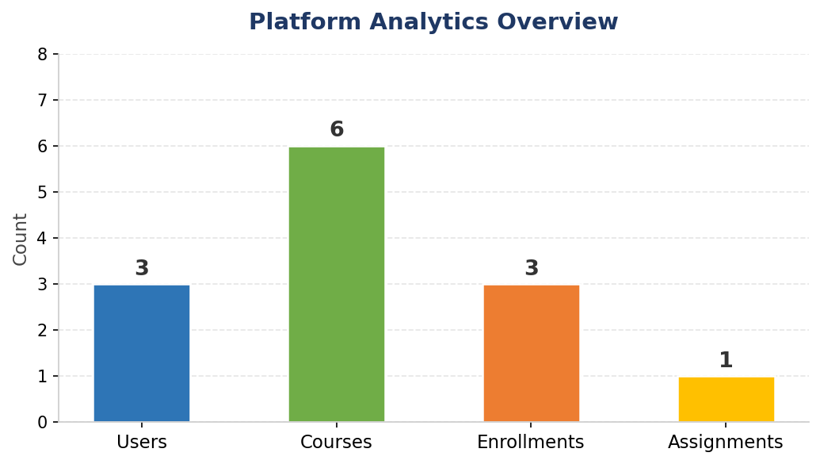
Figure 1: Platform Analytics Overview — Entity Count Distribution
Platform Entity | Count | Notes
Users | 3 | Registered platform users
Courses | 6 | Available courses
Enrollments | 3 | Active course enrollments
Assignments | 1 | Active assignments

The analytics highlight that Courses (6) represent the richest content area of the platform, while Enrollments (3) and Users (3) reflect the current early-stage adoption. The single active Assignment indicates that assignment-based learning is in its initial rollout phase. These metrics will be tracked continuously to measure platform growth and inform content strategy.

4. Minimizing Complexity
Managing and minimizing complexity was a deliberate focus throughout the development of the Learning Marketing Platform. Unchecked complexity is the primary driver of bugs, schedule overruns, and technical debt in software projects. The following strategies were employed:
Modular Architecture:
The platform was built using a microservices-inspired modular architecture where each major concern — user management, course delivery, payments, recommendations, and notifications — was developed as a largely independent module with clearly defined interfaces. This meant that a change in the payment module, for example, had no risk of breaking the course recommendation engine.
Component-Based Frontend:
React.js components were designed to be small, focused, and reusable. A shared component library was established early in the project containing buttons, form inputs, cards, and modals with consistent styling. This prevented duplicate code and ensured visual consistency across the platform with minimal effort.
Consistent Coding Standards:
ESLint and Prettier were enforced across all JavaScript codebases, and Black was used for Python code. These tools automatically flagged and corrected formatting inconsistencies, keeping the codebase clean and readable. Code reviews were mandatory before any merge, ensuring that complexity-introducing patterns such as deeply nested conditionals or oversized functions were caught early.
Clear Documentation:
All API endpoints were documented using Swagger/OpenAPI, providing a self-service reference for both frontend developers and external integration partners. An internal developer wiki on Confluence documented architecture decisions, onboarding guides, and module-level overviews.

5. Project Management
The project was managed using an Agile Scrum framework, with two-week sprint cycles. A cross-functional team of eight members — including frontend developers, backend developers, a UX designer, a data scientist, a QA engineer, and a project manager — collaborated throughout the project.
Management tools and practices included:
- Jira was used as the primary project management tool. The product backlog was maintained and prioritised in Jira, with all tasks, bugs, and user stories tracked through their complete lifecycle from 'To Do' to 'Done'.
- Daily standups were held every morning (15 minutes) to surface blockers and align the team on daily goals.
- Sprint planning and retrospective sessions were held at the start and end of each two-week sprint, enabling continuous process improvement.
- Confluence served as the team's knowledge management hub, hosting meeting notes, architecture documentation, and onboarding guides.
- Slack was used for day-to-day team communication, integrated with GitHub and Jira to receive real-time notifications on pull requests, build statuses, and issue updates.

Risk management was conducted at the beginning of the project and revisited each sprint. Key risks identified included API third-party dependency failures, data privacy compliance, and ML model accuracy. Mitigation plans were documented and assigned to responsible team members.

6. Conclusion
The development of the Learning Marketing Platform demonstrates how the systematic application of the five processes of software construction — requirements, design, technology selection, tooling, and testing — leads to a well-structured, scalable, and high-quality web application. By adopting a modular architecture, integrating AI and machine learning for intelligent personalisation, and implementing a robust DevOps pipeline with Kubernetes, GitHub Actions, Prometheus, and Grafana, the team was able to deliver a platform that is both technically sound and aligned with the needs of its users.
The platform's core design stack — React.js for the frontend, Node.js (Express) for the backend, and MySQL for the database — provided a reliable and maintainable foundation, with Railway handling seamless deployment to production. The analytics overview further confirms the platform's growing engagement, with 6 active courses and ongoing learner enrollments.
The project's success was equally dependent on disciplined project management through Agile Scrum, a conscious effort to minimize complexity at every stage, and a comprehensive testing strategy that gave stakeholders confidence in the product prior to launch. The Learning Marketing Platform stands as a practical example of how principled software construction practices translate directly into a better, more reliable product.

