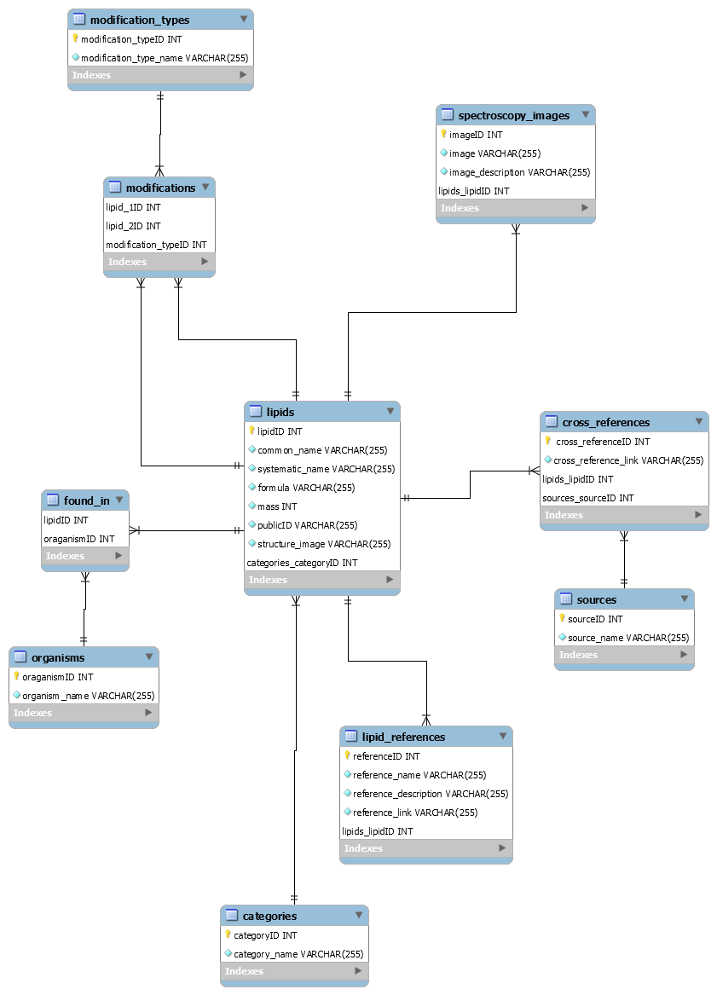

**Relational Schema**

lipids(lipidID INT, common_name VARCHAR(255), systematic_name VARCHAR(255), formula VARCHAR(255), mass INT, publicID VARCHAR(255), structure_image VARCHAR(255), categories_categoryID INT )

organisms(organismID INT, organism_name VARCHAR(255))

categories(categoryID INT, category_name VARCHAR(255))

lipid_references(referenceID INT, reference_name VARCHAR(255), reference _description VARCHAR(255), reference_link VARCHAR(255), lipids_lipidID INT)

cross_references(cross_referenceID INT, cross_reference_ link VARCHAR(255), lipids_lipidID INT, sources_sourceID INT)

sources(sourceID INT, source_name VARCHAR(255))

spectroscopy_images(imageID INT, image VARCHAR(255), image_description VARCHAR(255), lipids_lipidID INT)

modifications_lipids(lipids_1ID INT, lipids_2ID INT, modification_typeID INT)

modifications(modification_typeID INT, modification_type_name VARCHAR(255))

found_in(lipidID INT, organismID INT)

lipids

|  |  |  |  |  |  |  |  |
| --- | --- | --- | --- | --- | --- | --- | --- |
| lipidID | common_name | systematic_name | formula | mass | publicID | structure_image | categories_categoryID |

organisms

|  |  |
| --- | --- |
| organismID | organism_name |

categories

|  |  |
| --- | --- |
| categoryID | category_name |

lipid_references

|  |  |  |  |  |
| --- | --- | --- | --- | --- |
| referenceID | reference_name | reference _description | reference_link | lipids_lipidID |

cross_references

|  |  |  |  |
| --- | --- | --- | --- |
| cross_referenceID | cross_reference_ link | lipids_lipidID | sources_sourceID |

sources

|  |  |
| --- | --- |
| sourceID | source_name |

spectroscopy_images

|  |  |  |  |
| --- | --- | --- | --- |
| imageID | image | image_description | lipids_lipidID |

modifications_lipids

|  |  |  |
| --- | --- | --- |
| lipids_1ID | lipids_2ID | modification_typeID |

modifications

|  |  |
| --- | --- |
| modification_typeID | modification_type_name |

found_in

|  |  |
| --- | --- |
| lipidID | organismID |

**Functional Dependencies**

lipidID → common_name, systematic_name, formula, mass, publicID, structure_image, categories_categoryID

organisms → organismID, organism_name

categories → categoryID, category_name

lipid_references → referenceID, reference_name, reference _description, reference_link, lipids_lipidID

cross_references → cross_referenceID, cross_reference_ link, lipids_lipidID, sources_sourceID

sources → sourceID, source_name

spectroscopy_images → imageID, image, image_description, lipids_lipidID

modifications_lipids → lipids_1ID, lipids_2ID, modification_typeID

modifications → modification_typeID, modification_type_name

found_in → lipidID, organismID