**Lesson 14**

**The Last Years of the Apostle Paul**

**第十四课 使徒保罗的最后年日**

**OPENING PRAYER课前祷告**

**HOMEWORK ASSIGNMENT REVIEW 课后作业回顾**

**WHAT HAPPENS AFTER ACTS ENDS? 使徒行传之后发生了哪些事情？**

The book of Acts seems to end strangely. According to the last verses of Acts, Paul lived under house arrest in a rented house somewhere in Rome for two years (Acts 28:30). Then what happened? Was Paul released? Was he brought to trial before the emperor, convicted and martyred? We are not told. It seems like a strange way for Luke to end his historical record.

《使徒行传》的结尾似乎有些奇怪。根据使徒行传的最后几节，保罗在罗马一个租来的房子里住了两年(使徒行传28:30)。然后发生了什么?保罗被释放?他在皇帝面前受审，被定罪然后殉道了吗?我们无从知晓。路加结束他历史记录的方式似乎有些奇怪。

**AD 62 – IMPRISONED IN ROME 公元 62 年–在罗马监禁**

* two-year house arrest in Rome
* 在罗马被囚禁两年
* “bound with a chain” (Acts 28:20).
* “戴着锁链” (使徒行传28：20)
* wrote the four “imprisonment letters” of Ephesians, Philippians, Colossians, and Philemon
* 写了四封“监狱书信”：以弗所书，腓立比书，歌罗西书，腓利门书。

**AD 62 – IN SPAIN? 公元62年——在西班牙吗?**

* “I plan to do so when I go to Spain. (Romans 15:24).
* “我切心想望到西班牙的时候，可以到你们那里，盼望从你们那里经过，得见你们，先与你们彼此交往，”(罗马书15:24)。
* “I will go to Spain and visit you on the way.” (Romans 15:28).
* “等我办完了这事，把这善果向他们交付明白，我就要路过你们那里，往西班牙去。”（罗15:28）
* “Paul by his example pointed out the prize of patient endurance. After that he had been seven times in bonds, had been driven into exile, had been stoned, had preached in the East and in the West, he won the noble renown which was the reward of his faith, having taught righteousness unto the whole world and having reached the farthest bounds of the West; and when he had borne his testimony before the rulers, so he departed from the world and went unto the holy place.” (1 Clement 5:5-6)
* 保罗以他的榜样显明耐心忍耐的回赠。之后，他被捆绑七次，又被放逐，被用石头打，在东部和西部传扬福音。他赢得了崇高的声望，那是对他信心的回赠，因为他将公义之道传遍了整个世界，也传到了西方最远的边界；他在官长面前作见证，之后就离开了这个世界，去了圣洁之地。(克莱门特前5:5-6)
* “Luke compiled the individual events that took place in his presence as he plainly shows by omitting the martyrdom of Peter as well as the departure of Paul from the city [of Rome] when he journeyed to Spain.” (Muratorian Canon, lines 37-39, translation by Dr. Bruce Metzger)
* 路加整理了与保罗同在时保罗的个人事迹，这一点可以从他省略彼得殉道以及保罗离开罗马城的记叙清楚地看到，因为他自己去了西班牙。(Muratorian Canon，第37-39行，布鲁斯·梅茨格博士翻译)
* “For after he had been in Rome, he returned to Spain, but whether he came thence again into these parts, we know not” (Chrysostom, Homily on 2nd Timothy, part 10)
* “他离开罗马之后，又回到了西班牙，但他是否又回到这些地方，我们不知道。”(克里索斯顿，侯米利论提摩太后书，第10部分)
* “ … one, who from Jerusalem, and even unto Illyricum, fully preached the Gospel, and instructed even imperial Rome, and carried the earnestness of his preaching as far as Spain, undergoing conflicts innumerable, and performing signs and wonders” (Cyril of Jerusalem, Jerusalem Catecheses, Lecture 17.26).
* “……有一个人，从耶路撒冷，甚至到伊利里加，都在传福音，甚至在罗马帝国进行教导，并且带着他的虔诚传教直到西班牙，经历了无数的冲突，并行了神迹奇事(耶路撒冷的西里尔，耶路撒冷的Catecheses（口授经文教理），第17.26讲)。

**AD 63 – CRETE 公元63——克里特**

* Titus 1:5 “The reason I left you in Crete was that you might straighten out what was left unfinished and appoint elders in every town, as I directed you.”
* 提多书1:5“我从前留你在克里特，是要你将那没有办完的事都办齐了，又照我所吩咐你的，在各城设立长老。”

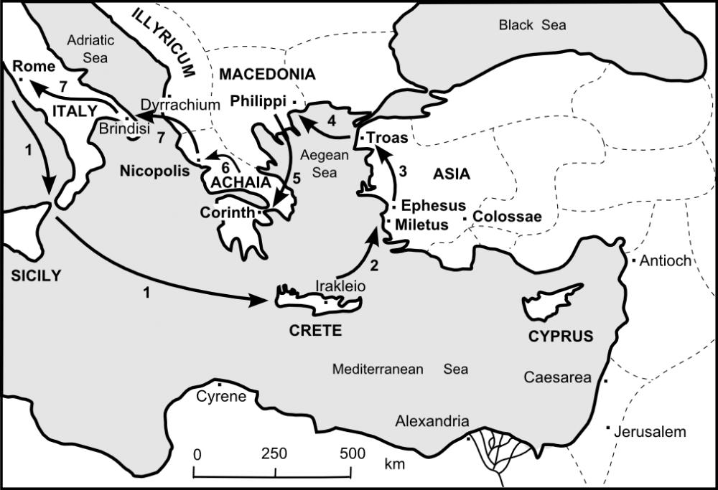

**AD 63 – MILETUS 公元63-米利都**

* 2 Timothy 4:20 - “I left Trophimus sick in Miletus.”
* 提摩太后书4:20- “特罗非摩病了， 我就留他在米利都。”

**AD 63 – COLOSSAE 公元63-歌罗西**

* “Prepare a guest room for me, because I hope to be restored to you in answer to your prayers.” (Philemon 22)
* “此外，你还要给我预备住处，因为我盼望藉着你们的祷告，必蒙恩到你们那里去。”（腓利门书22）

**AD 63 – TROAS 公元63-特罗亚**

* 2 Timothy 4:13 “When you come, bring the cloak that I left with Carpus at Troas, and my scrolls, especially the parchments.”
* 提摩太后书4:13“我在特罗亚留于加布的那件外衣，你来的时候可以带来，那些书也要带来，更要紧的是那些皮卷。”

**AD 64 – MACEDONIA 公元64-马其顿**

* “As I urged you when I went into Macedonia, stay there in Ephesus so that you may command certain men not to teach false doctrines any longer” (1 Timothy 1:3).
* “我 往 马 其 顿 去 的 时 候 ， 曾 劝 你 仍 住 在 以 弗 所 ， 好 嘱 咐 那 几 个 人 不 可 传 异 教 ，”（提摩太前书1:3）
* “I am confident in the Lord that I myself will come soon” (Philippians 2:24).
* “但 我 靠 着 主 自 信 我 也 必 快 去 。”（腓立比书2:24）

**AD 64 – CORINTH 公元64-哥林多**

* “Erastus stayed in Corinth…” (2 Timothy 4:20)
* “以 拉 都 在 哥 林 多 住 下 了 。 特 罗 非 摩 病 了 ， 我 就 留 他 在 米 利 都 。”（提摩太后书4:20）
* Titus 3:12 “As soon as I send Artemas or Tychicus to you, do your best to come to me at Nicopolis, because I have decided to winter there.”
* “我 打 发 亚 提 马 或 是 推 基 古 到 你 那 里 去 的 时 候 ， 你 要 赶 紧 往 尼 哥 波 **立 去 见 我 ， 因 为 我 已 经 定 意 在 那 里 过 冬 。”（提多书3:12）**

**AD 65-66 – IMPRISONMENT AND DEATH IN ROME**

**公元65-66-在罗马的监禁和死亡**

* see 2 Timothy 1:8, 16-17; 2:9 and 4:16
* 见提后1:8, 16-17; 2:9和4:16
* “FOR ME TO LIVE IS CHRIST AND TO DIE IS GAIN” St. Paul (Philippians 1:21)
* “因为我活着就是基督，死了就有益处。” 圣徒保罗(腓立比书1:21)