**THEOLOGY**

**A Study of God, the Author of Salvation**

**神论**

**神，救恩赐予者**

**Chapter 5 – The Triune God**

**第五章——三位一体的神**

**Lesson 11**

**ALS bilingual pdf file: Chapter 5, pages 1-11**

[NPH: pages 121-127]

**第十一课**

**ALS双语PDF文件：第五章，第1-11页**

[NPH: 第121-127页]

**Introduction简介**

In lesson 10 we saw how the glory of God involves many attributes or characteristics which belong to God. In this lesson #11 we begin a two-lesson unit on what we mean when we say that God is triune.

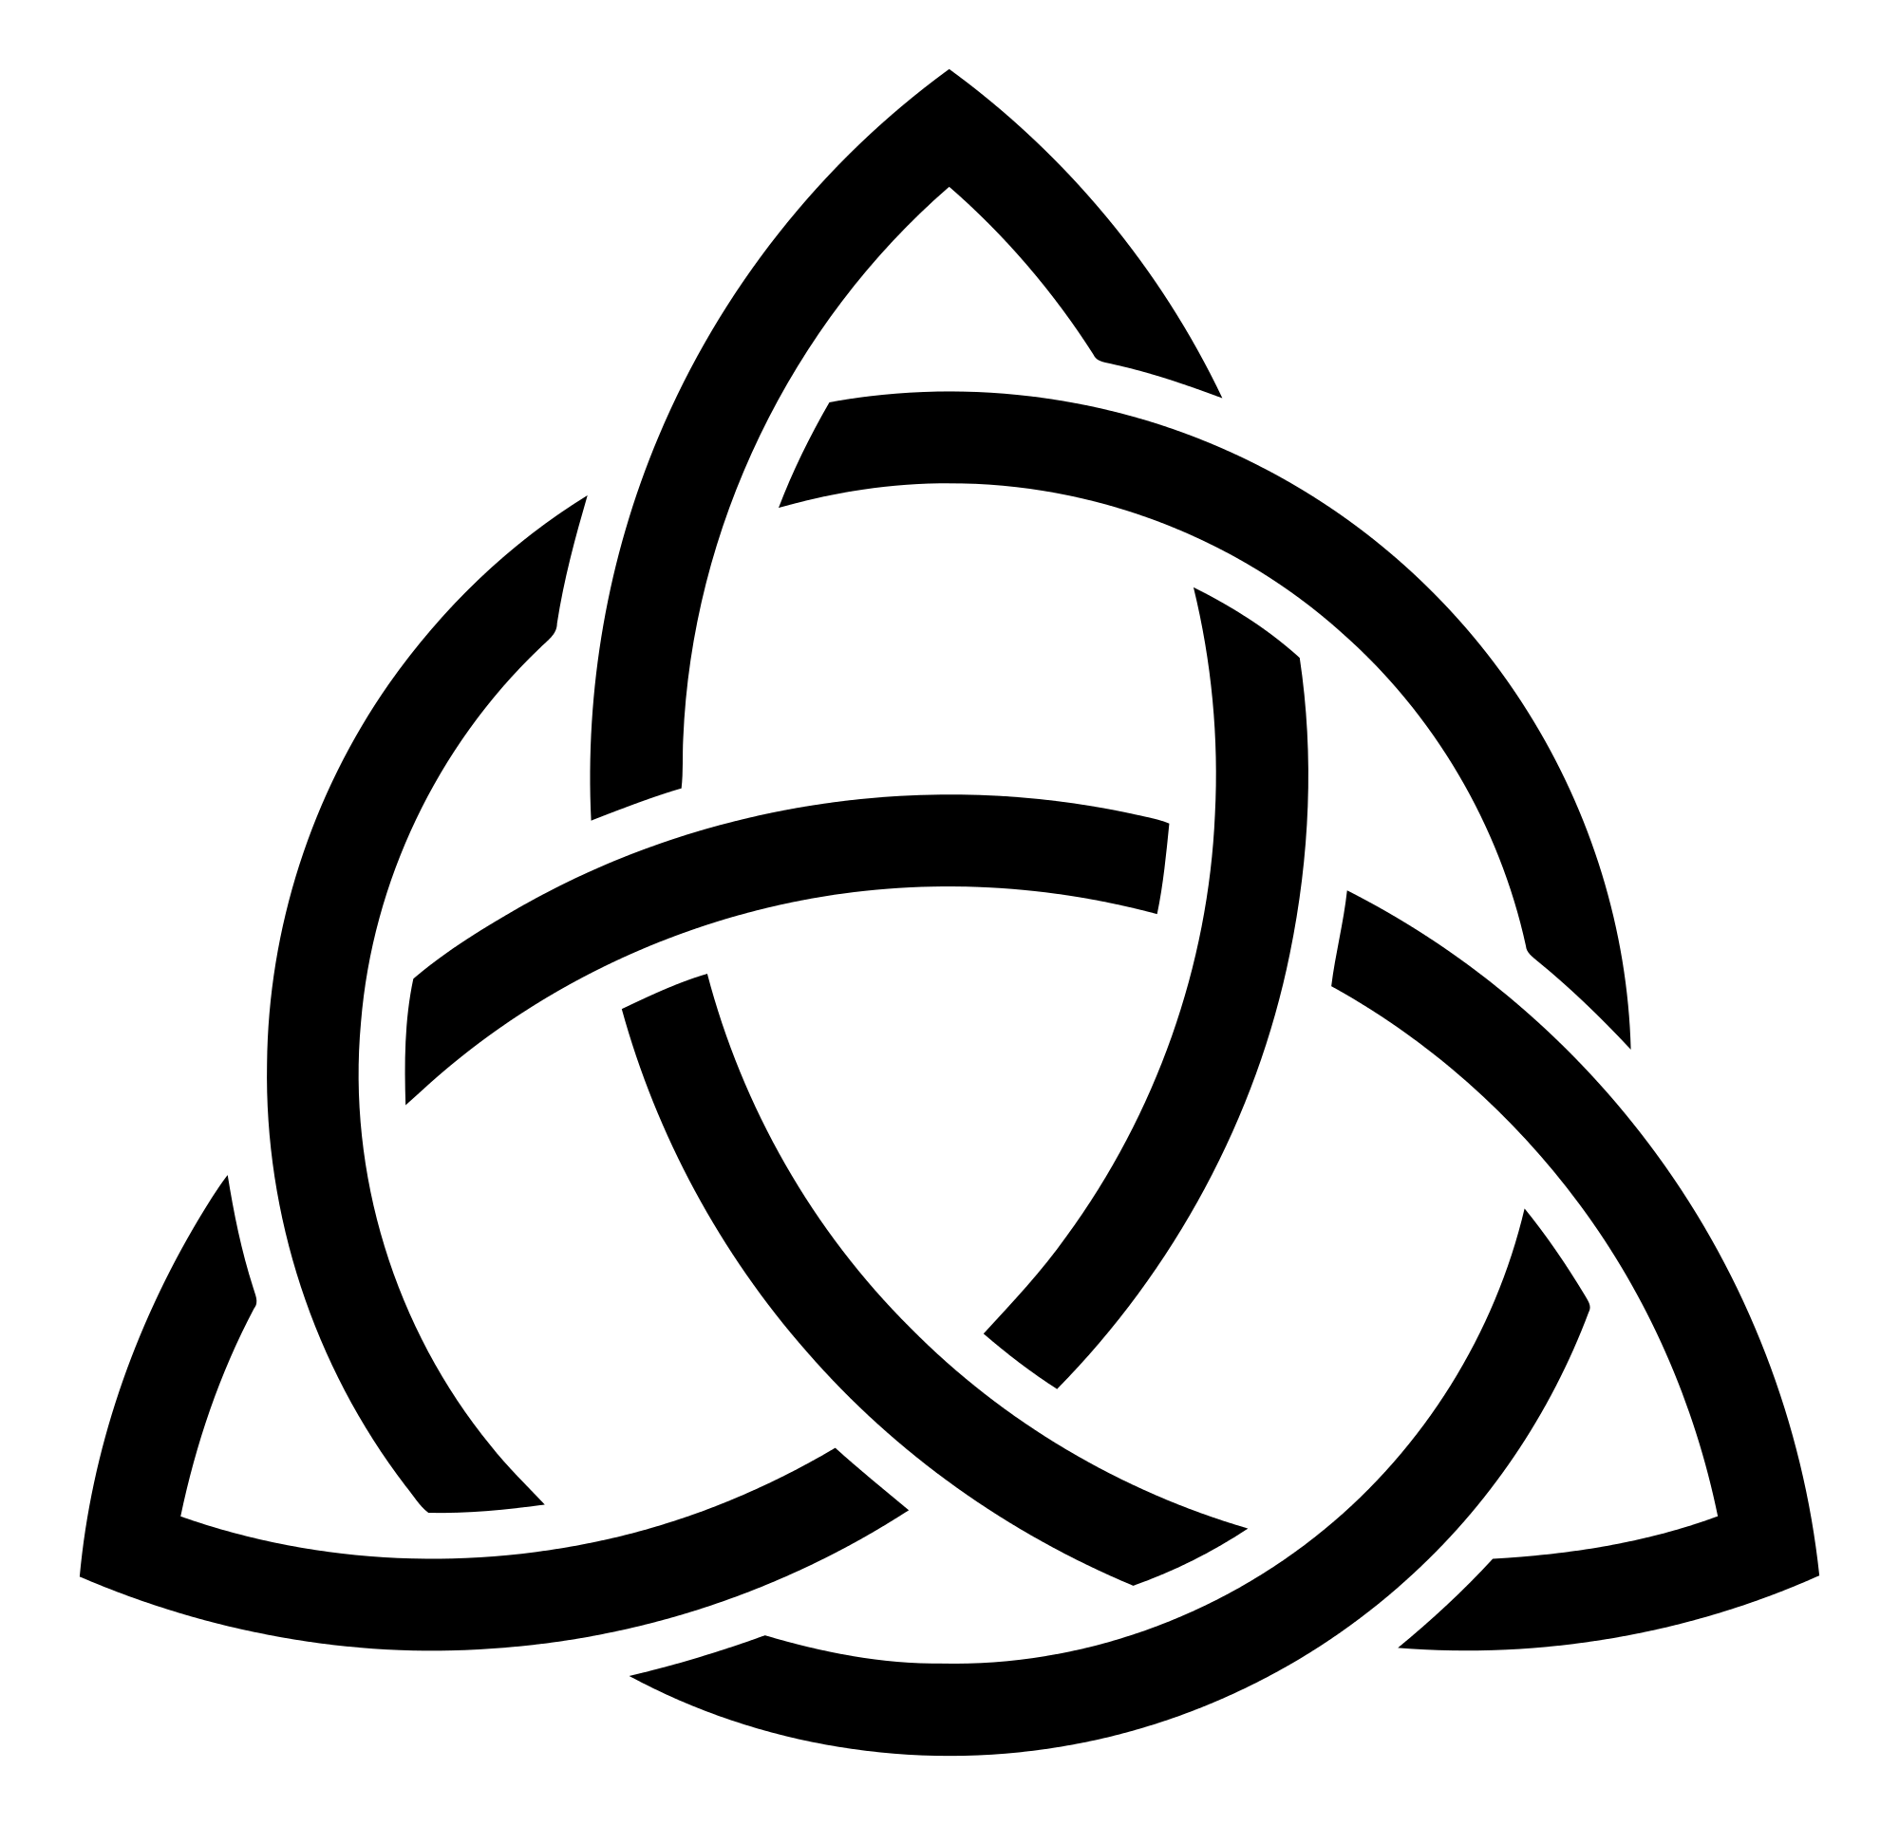

在第十课中，我们看到神的荣耀包括许多属于神的属性或者特征。本课我们将会开始一个两堂课的单元，来学习神是三位一体。

“Triune” is a word – coined by the ancient church – which summarizes what the Bible teaches when it presents the mystery of who God is. “Triune” is not a word which explains or makes sense of this mystery. Rather, “triune” is a term which summarizes the mystery which the Bible places before us. On the basis of faith in this revealed mystery, believers worship God – Father, Son and Holy Spirit.

“三位一体”是一个词——由早期教会造的词——该词总结了圣经所教导的关于神是谁的奥秘。“三位一体”并不是解释或者说明这个奥秘，而是总结了圣经关于这个奥秘对我们的教导。以启示的该奥秘为信心的根基，基督徒敬拜神——父，子和圣灵。

1. ***God is triune: one God in three persons and three persons in one God.***

***神是三位一体：一位神有三个位格，三个位格都是一位神***

1 Timothy 3:16*a提前3:16上*

Beyond all question, the mystery of godliness is great….

大哉，敬虔的奥秘……

The Church universal uses these terms to express what the Bible teaches about the mystery of the three-in-one nature of God. These terms were developed and agreed on during the early centuries of the Christian Church so that the people of God might “speak the same language” about God.

教会一般使用这些术语来表达圣经所教导的有关三位一体的神这一奥秘。这些术语都是基督教会最初几个世纪发展并且认同的，如此，神的子民可以在说到神的时候“用一种语言沟通”。

* + - 1. Definition of terms.术语定义
         1. Triune三位一体

Tri = 3; Une = 1 “**God is one God in three persons and three persons in one God”**

Tri = 3; Une = 1 “神是一位神三个位格、三个位格是同一位神”

* + - * 1. Essence / Being 本质/本体

**Consider these sentences from the Athanasian Creed:**

**请思想亚他那修信经当中的这几节：**

What the Father is, so is the Son, and so is the Holy Spirit.

父如何，子如何，圣灵也如何。

The Father is uncreated, the Son uncreated, the Holy Spirit uncreated;

父如何，子如何，圣灵也如何。

The Father is infinite, the Son infinite, the Holy Spirit infinite;

父无限，子无限，圣灵也无限。

The Father is eternal, the Son eternal, the Holy Spirit eternal;

yet they are not three who are eternal, but there is one who is eternal,

just as they are not three who are uncreated, nor three who are infinite,

but there is one who is uncreated and one who is infinite.

父永恒，子永恒，圣灵也永恒。

但非三永恒，乃是一永恒。

并非三位非受造，乃是一位非受造。

也非三无限，乃是一无限。

In the same way the Father is almighty, the Son is almighty, the Holy Spirit is almighty:

yet they are not three who are almighty, but there is one who is almighty.

So the Father is God, the Son is God, t he Holy Spirit is God;

yet they are not three Gods, but one God.

照样，父全能，子全能，圣灵也全能。

但非三全能，乃是一全能。

父是神，子是神，圣灵也是神。

但非三位神，乃是一位神。

So the Father is Lord, the Son is Lord, the Holy Spirit is Lord;

yet they are not three Lords, but one Lord.

父是主，子是主，圣灵也是主。

但非三位主，乃是一位主。

* + - * 1. *Person位格*

*There are three “persons” within the Trinity. Within the Trinity these three persons are distinct from each other and their actions are divisible.*

三位一体之内有三个“位格”。在三位一体之内，这三个位格彼此不同，他们的行为可以区分出来。

**Consider these sentences from the Athanasian Creed:**

**请思想亚他那修信经当中的这几节：**

The Father is neither made nor created nor begotten of anyone.

The Son is neither made nor created, ***but is begotten*** of the Father alone.

The Holy Spirit is neither made nor created nor begotten, ***but proceeds*** from the Father and the Son.

父非由谁作成：既非受造，亦非受生。

子独由于父：非作成，亦非受造；而为***受生***。

圣灵由于父与子：既非作成，亦非受造，亦非受生；而为***发出***。

And within this Trinity none comes before or after;

且此三位无分先后；

none is greater or inferior, but all three persons are coequal and coeternal,

so that in every way, as stated before, all three persons are to be worshiped as one God and one God worshiped as three persons.

无别尊卑。三位乃均永恒，而同等。

由是如前所言，我等当敬拜一体三位，而三位一体之神。

Creation of the world世界的受造

God the Father created all things.

父神创造了万物。

Genesis 1:1

In the beginning ***God*** created the heavens and the earth.

创1:1

起初***神***创造天地。

God the Holy Spirit imparted life to the world.

圣灵把生命赐给万物。

Genesis 1:2

**2**Now the earth was formless and empty, darkness was over the surface of the deep, and the ***Spirit of God*** was hovering over the waters.

创1:2

地是空虚混沌。渊面黑暗。***神的灵***运行在水面上。

God the Son spoke the world into existence

子神说话，世界得现

Genesis 1:3

**3**And ***God said***, “Let there be light,” and there was light.

创1:3

神说，要有光，就有了光。

John 1:1-3;14约1:1-3,14

In the beginning was the Word, and the Word was with God, and the Word was God. **2**He was with God in the beginning. **3**Through him all things were made; without him nothing was made that has been made.

太初有道，道与神同在，道就是神。这道太初与神同在。万物是借着他造的。凡被造的，没有一样不是借着他造的。

**14**The Word became flesh and made his dwelling among us. We have seen his glory, the glory of the one and only Son, who came from the Father, full of grace and truth.

道成了肉身住在我们中间，充充满满的有恩典有真理。我们也见过他的荣光，正是父独生子的荣光。

Salvation of sinners罪人的得救

The Father sent his Son.

父差遣子

Galatians 4:4

**4**But when the set time had fully come, God sent his Son to be born of a woman, so that he would be born under the law….

加4:4

及至时候满足，神就差遣他的儿子，为女子所生，且生在律法以下，

The Son suffered and died for our sins on the cross.

子为我们的罪受苦并死在十字架上

Galatians 3:13

**13**Christ redeemed us from the curse of the law by becoming a curse for us. As it is written, “Cursed is everyone who hangs on a tree.”

加3:13

基督既为我们受了咒诅，就赎出我们脱离律法的咒诅。因为经上记着，凡挂在木头上都是被咒诅的。

The Holy Spirit gave us faith in Jesus.

圣灵赐给我们信心相信耶稣

Galatians 3:2-3

**2**I just want to learn this from you: Did you receive the Spirit by the works of the law, or by the message that creates faith?  **3**Are you so foolish? Having begun by the Spirit, are you now trying to reach the goal by the flesh?

加3:2-3

我只要问你们这一件，你们受了圣灵，是因行律法呢？是因听信福音呢？你们既靠圣灵入门，如今还靠肉身成全吗？你们是这样的无知吗？

* + - 1. The Word of God makes it clear that each person of the Trinity is God.

神的话说得非常明确，三位一体的每个位格都是神

* + - * 1. Jesus tells us to bring our prayers to God the Father

耶稣告诉我们向父神祷告

Matthew 6:1-15 太6:1-15

* + - * 1. John the apostle calls Jesus the true God

使徒约翰称耶稣为真神

I John 5:19-20

**19**We know that we are from God and that the whole world lies in the grip of the Evil One.  **20**We know that the Son of God has come and has given us understanding so that we may know him who is true. And we are in him who is true, in his Son, Jesus Christ. He is the true God and eternal life.

约一5:19-20

我们知道我们是属神的，全世界都卧在那恶者手下。我们也知道神的儿子已经来到，且将智慧赐给我们，使我们认识那位真实的，我们也在那位真实的里面，就是在他儿子耶稣基督里面。这是真神，也是永生。

* + - * 1. Paul the apostle tells us the Holy Spirit is speaking God’s Word to us.

使徒保罗告诉我们圣灵把神的话告诉我们

1 Corinthians 2:9-10

**9**But as it is written: What no eye has seen and no ear has heard  
and no human mind has conceived—that is what God has prepared for those who love him.

**10**But God revealed it to us through his Spirit. For the Spirit searches all things, even the depths of God.

林前2:9-10

如经上所记，神为爱他的人所预备的，

是眼睛未曾看见，耳朵未曾听见，

人心也未曾想到的。

只有神借着圣灵向我们显明了。因为圣灵参透万事，就是神深奥的事也参透了。

* + - 1. Both the Old Testament and the New Testament reveal that God is triune.

旧约和新约都启示了神是三位一体

**Below are *some* of the scriptures which point to the mystery that God is Triune.**

**下面是*一些*指出神是三位一体这个奥秘的经文。**

Genesis 1:1-3创1:1-3

Genesis 1:26创1:26

Numbers 6:22-27民6:22-27

Deuteronomy 6:4申6:4

Psalm 2诗2

Psalm 110诗110

Proverbs 8箴8

Isaiah 11:1-2赛11:1-2

Isaiah 48:16赛48:16

Micah 7:18-19弥7:18-19

Zechariah 2:9-11亚2:9-11

Zechariah 3:8-9亚3:8-9

Matthew 3:13-17太3:13-17

Matthew 28:18-20太28:18-20

John 14:26约14:26

John 15:26约15:26

Acts 1:4-5徒1:4-5

Acts 5:3-5徒5:3-5

Romans 11:33-36罗11:33-36

2 Corinthians 13:14林后13:14

Ephesians 2:18 *(the mystery of the Trinity is mentioned in many places in Ephesians)*

弗2:18*（以弗所书中多处提到三位一体的奥秘）*

Hebrews 1:1-3来1:1-3

Revelation 1:4-6

启1:4-6

**Conclusion结语**

In this lesson we have gained confidence that the Bible truly teaches that the one true God is the Triune God. The Triune God is unique. There is no one like him. The doctrine of the Trinity is essential to the Christian faith. We accept this mystery, not because we understand it, but because this is how our God reveals himself to us in his Word, the Bible.

本课我们可以确信圣经真的教导独一真神是三位一体的神。三位一体的神是独特的。没有谁像他。三位一体的教义是基督信仰的核心。我们接受该奥秘，并非是由于我们理解，而是由于这是神在他的话语，即圣经当中向我们如此启示他自己。

In our next lesson (#12) we will conclude this unit [“Theology”] with a look at false teachings about the Triune God which have arisen through the centuries.

下一课（第十二课），我们会继续学习数个世纪以来所出现的关于三位一体之神的错误教导，来结束本单元[“神论”]。

**DISCUSSION TIME**

**STUDENTS’ QUESTIONS**

**INSTRUCTOR’S QUESTIONS**

**Homework**

Review your notes from this lesson. Give correct answers to the following questions. You may also find correct answers to these questions in the book “God So Loved the World” as indicated on page 1 of this lesson. Be ready to discuss these questions and your answers at the beginning of the next session.

*Your first exam will follow lesson 12 of this course.*

1. If someone said the word Trinity is not found in the Bible, what would you answer?

如果有人说，圣经当中并没有三位一体这个词，你会怎么回答？

2. Explain: God is one in essence.

请解释：神在本质上是一位

3. Why did the early church not use the word *prosopon* for the Persons of the Trinity?

为什么早期教会不使用*prosopon*来指三位一体的位格（Persons）?

4. What three things does the Bible ascribe to each person of the Trinity?

圣经中所说属于三位一体每个位格的是哪三样？

5. What ***personal*** characteristics does the Bible attribute to each person of the Trinity?

圣经教导三位一个每个位格所***特有的***属性是什么？

a. Mt 11:27太11:27

b. Jn 1:18约1:18

c. Jn 14:26约14:26

d. Jn 16:8约16:8

6. In what way does the Bible attribute ***distinctiveness*** to each person of the Trinity?

圣经教导三位一体每个位格的特殊性是什么？

a. Jn 5:32, 37约5:32,37

b . Isa 61:1 赛61:1

7. Which are the internal acts of the Trinity?

三位一体的内部行为是什么？

a. Ps 2:7; Jn 3:16诗2:7；约3:16

b. Ro 8:9; Ga 4:6罗8:9；加4:6

8. Explain the history of the addition of the *filioque* into the Nicene Creed.

请解释尼西亚信经增加*filioque* （“和子”）句的历史。

9. Distinguish the external acts of the Trinity from the internal acts. Gen 1:2; Jn 1:3.

区分三位一体的外部行为和内部行为。创1:2；约1:3

10. In what four ways does the Bible ascribe ***deity*** to each person of the Trinity?

圣经以哪四种方式承认三位一体每一位格的***神性***？

11. Identify how divine names are attributed to each person of the Trinity.

描述三位一体每一位格是如何被称为神的

a. Ro 1:7罗1:7

b. Isa 7:14赛7:14

c. Isa 9:6赛9:6

d. Jer 23:6耶23:6

e. Jn 1:1约1:1

f. Jn 8:58约8:58

g. Ac 5:3-5徒5:3-5

12. Identify how divine attributes are attributed to each person of the Trinity.

描述三位一体每一位格是如何被赋予神的属性的。

a. 1 K 8:39; Jn 21:17, 19王上8:39；约21:17，19

b. 1 Cor 2:11林前2:11

c. Jn 17:5; Heb 9:14约17：5；来9:14

d. Jer 23:24; Mt 18:20, Ps 139:7耶23:24；太18:24；诗139:7

13. Identify how divine works are attributed to each person of the Trinity.

描述三位一体每一位格所作是如何被认定为神的工的。

a. Gen 1:1,2; Jn 1:3; Job 33;4创1:1，2；约1:3；伯33:4

b. Col 1:16, 17西1:16,17

c. Jn 6:44约6:44

14. Identify how divine honor is attributed to each person of the Trinity.

描述三位一体的每个位格如何被赋予神的尊荣的。

a. Isa 42:8赛42:8

b. Jn 5:23约5:23

c. Isa 6:3赛6:3

15. Show that the Old Testament taught the doctrine of the Trinity.

说明旧约如何教导三位一体教义。

a. Isa 61:1赛61:1

b. Ps 2:7; 110:1诗2:7；110:1

c. Isa 63:10, 14赛63:10,14

d. Gen 1:26, 27; 3:22; Isa 6;8; Nu 6:23-27创1:26,27；3:22；赛6:8；民6:23-27

e. Jn 5:18约5:18

16. Show that the New Testament teaches the doctrine of the Trinity.

说明新约如何教导三位一体教义

a. Mt 28:19太28:19

b. 2 Cor 13:14林后13:14

c. Mt 3:16太3:16

d. Jn 14:26约14:26

e. Ac 10:38徒10:38