# Lab Assignment 1: Spinning Up React Native App

Date: 2024-10-08

Student: Bruketa, Grace

Instructor: Hassan, Natalia

## System Requirements:

CPU: Intel(R) Core(TM) Ultra 7 155U 2.10 GHz

RAM: 32.0 GB

Windows Version: 23H2

System Type: 64-bit operating system, x64-based processor

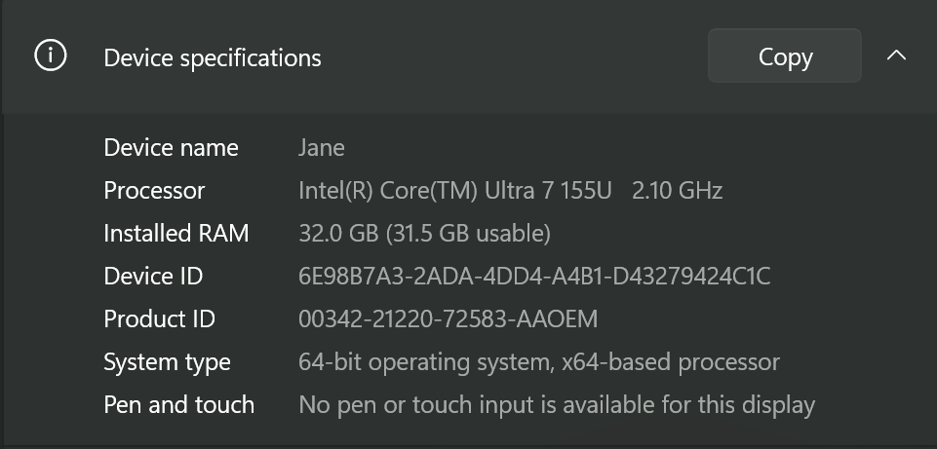

## Installation Instructions:

Install dependencies for React Native in this order;

1. Node: Terminal Interface
   * Install through Chocolatley
2. Java SE Development Kit (JDK)
3. Android Studio

Installing Node: With Chocolatey

1. Run Terminal as administrator
2. Run “*Get-ExecutionPolicy*”
   1. If it returns as ‘Restricted’ then run “*Set-ExecutionPolicy AllSigned”* or ”*Set-ExecutionPolicy Bypass -Scope Process*”.
3. Run the following command “*Set-ExecutionPolicy Bypass -Scope Process -Force; [System.Net.ServicePointManager]::SecurityProtocol = [System.Net.ServicePointManager]::SecurityProtocol -bor 3072; iex ((New-Object System.Net.WebClient).DownloadString('https://community.chocolatey.org/install.ps1'))*” .
4. If no errors, follow the previous command, then the Chocolatey is free to use and the command line can be closed.

Installing JDK:

1. Run Terminal as administrator.
2. Run “*choco install -y nodejs-lts microsoft-openjdk17" .*
3. If Node is already installed, ensure it is version 18.18 or newer. To check run the command “*node -v”.*

Installing Android Studio:

1. Install Android Studio from [https://developer.android.com/studio/install?_gl=1*zrvoe*_up*MQ..&gclid=CjwKCAjwjsi4BhB5EiwAFAL0YHs-Sq-3gETjCUqp_AQ8LgeLoV4TL2SmV6vQYaHOMueAJMHahz_VMxoC_d0QAvD_BwE&gclsrc=aw.ds](https://developer.android.com/studio/install?_gl=1*zrvoe*_up*MQ..&gclid=CjwKCAjwjsi4BhB5EiwAFAL0YHs-Sq-3gETjCUqp_AQ8LgeLoV4TL2SmV6vQYaHOMueAJMHahz_VMxoC_d0QAvD_BwE&gclsrc=aw.ds)
2. Within the Android Studio Installation Wizard, ensure the following boxes are checked:
   1. Android SDK
   2. Android SDK Platform
   3. Android Virtual Device
3. Install the selected components

Installing Android SDK:

1. Click the ‘More Actions’ dropdown and select SDK Manager
2. Click the “SDK Platforms” tab. The check the box “Show Package Details”.
3. Choose the “Android 14 (UpsideDownCake) entry to ensure the following items are checked
   1. Android SDK Platform 34
   2. Intel x86 Atom_64 System Image or Google APIs Intel x86 Atom System Image
4. Click “SDK Tools” tab and check the box “Show Package Details”.
5. Expand “Android SDK Build-Tools" and ensure that 34.0.0 is selected.
6. Finally click “Apply” to install the Android SDK and tools.

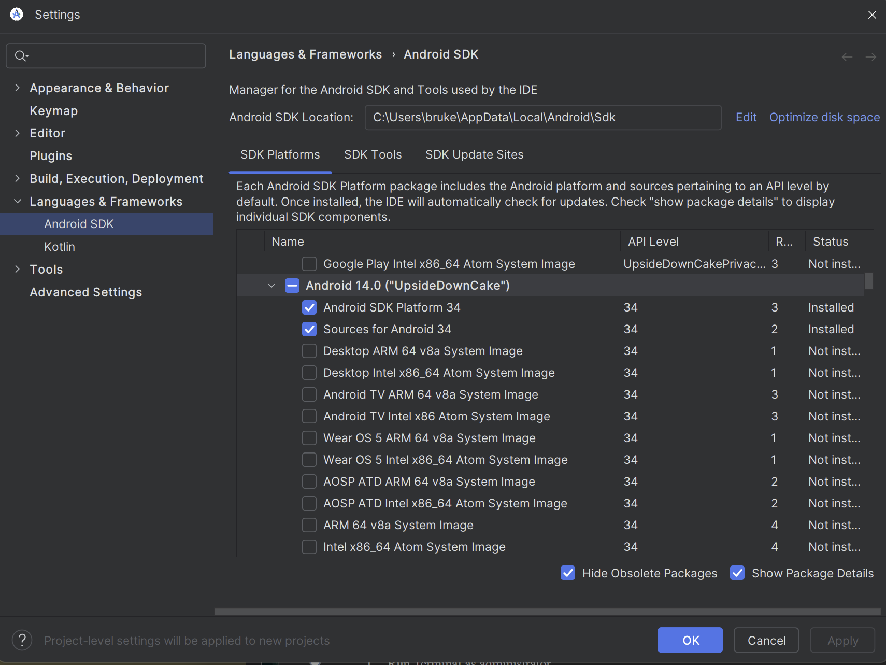

## Configuration Steps:

1. Open the **Windows Control Panel.**
2. Click **User Account**, then **User Accounts,** finally **Change my Environment variables.**
3. Click on **New...** to create a new user variable named **Android_Home** that is assigned to the value of the path to your Android SDK.
   1. Default path: %LOCALAPPDATA%\Android\Sdk
   2. Copy and paste **Get-ChildItem -Path Env:\** into terminal to verrify that Android_Home has been added

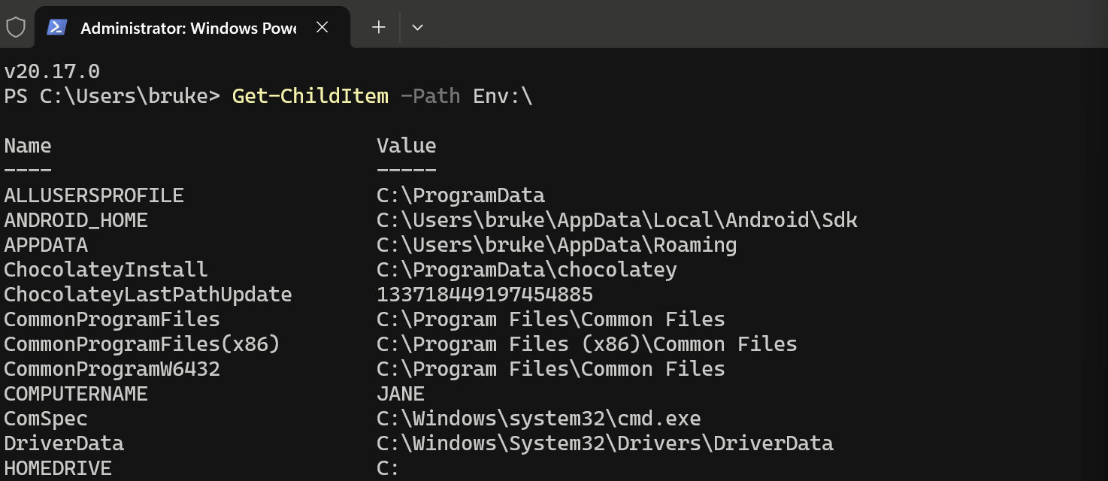

1. Add platform-tools to Path
   1. Open **Windows Control Panel.**
   2. Click **User Account**, then **User Accounts,** finally **Change my Environment variables.**
   3. Select and edit the **Path** variable. Then click **New** and add the path to platform-tools to the list. (Default path: %LOCALAPPDATA%\Android\Sdk\platform-tools)

## Create New Project:

Select "Create Virtual Device...", then pick any Phone from the list and click "Next", then select the **UpsideDownCake** API Level 34 image. (<https://reactnative.dev/docs/set-up-your-environment>)