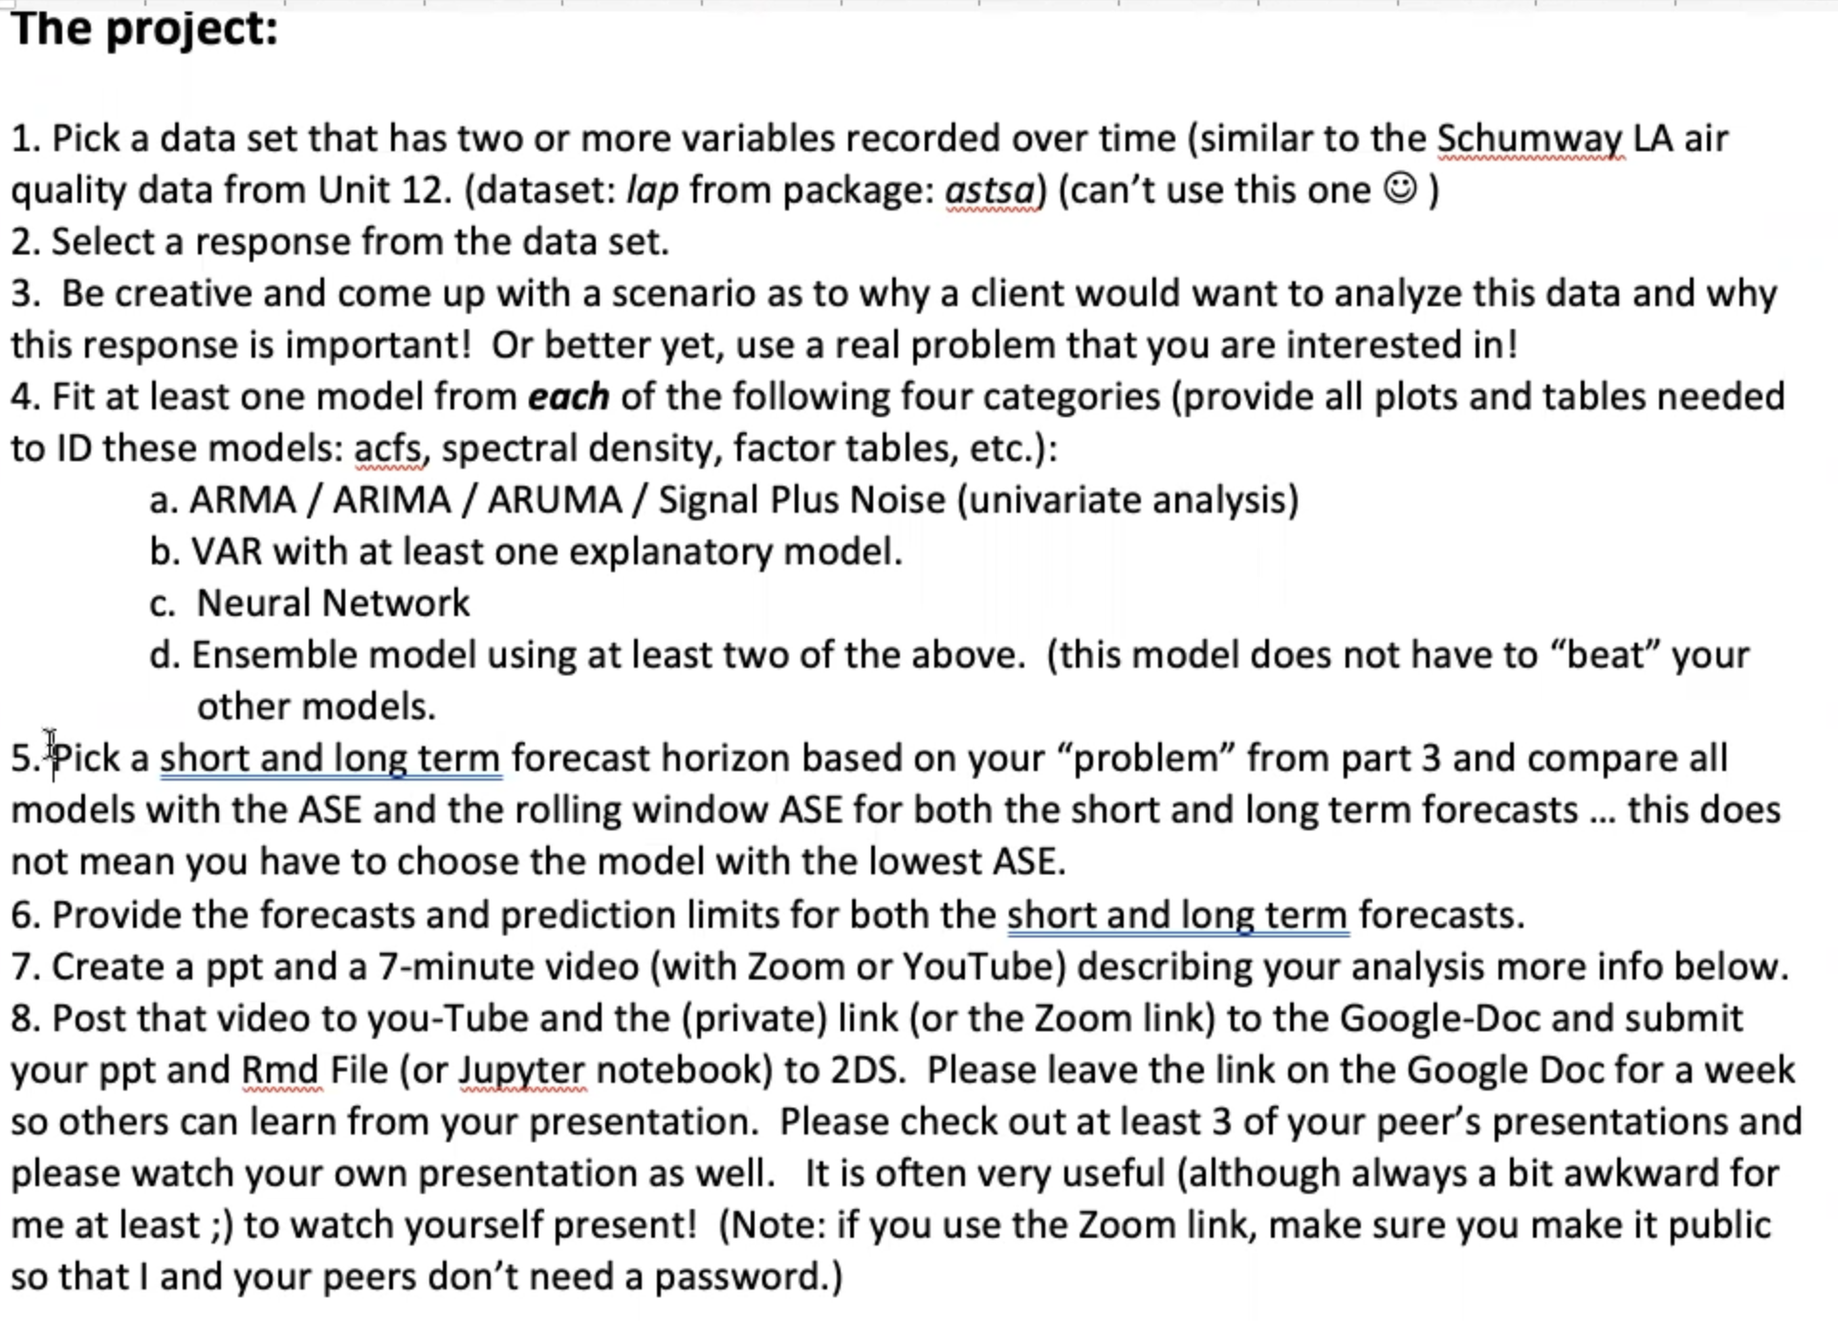

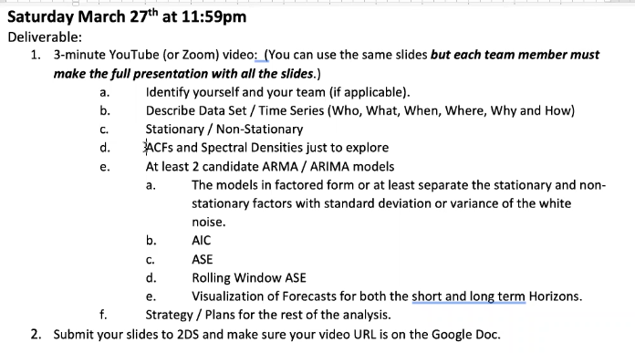

Rolling Window Code

Missing Data from windmills and car sales

Creatively or not at all

Throw away 60-79

Model with zeroes gives problems mathematically (artificially reduce SD)

Model assumes equal SD across time series