Grace Anne N. Matundan

ACMA191

**Flowcharts and Pseudocodes**

**Flowchart**

The flowchart presents how the process will work by explaining it in a step by step process to easily study and understand the diagrams.

We use flowcharts to even understand the process of presenting any project. Step by step we can easily understand it by using different symbols like arrows and shapes.

It is important to use in order for us people who work in a corporate world in this way we would be able to use it as a tool to communicate with other people or other business meetings to explain things easily by using flowcharts since it has own meaning with the use of different symbols like graphics.

**Different flowchart symbols**

rectangle - flowchart process stepOne step in the process. The step is written inside the box. Usually, only one arrow goes out of the box.

arrow - flowchart flow direction Direction of flow from one step or decision to another.

diamond - flowchart decision step Decision based on a question. The question is written in the diamond. More than one arrow goes out of the diamond, each one showing the direction the process takes for a given answer to the question. (Often the answers are "yes" and "no.")

semi-circle - flowchart delay or waitDelay or wait

circle - flowchart link to another page or flowchartLink to another page or another flowchart. The same symbol on the other page indicates that the flow continues there.

paralellogram - flowchart input or output Input or output

flowchart document symbolDocument

rounded rectangle or oval - flowchart start and end pointsAlternate symbols for start and end points

**Example of flowcharts**

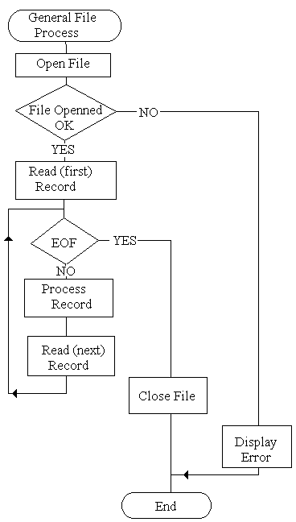

**Pseudocode**

According to Margaret Rouse in [Whatis.com](http://whatis.com/), Pseudocode is a detailed yet readable description of what a computer program or algorithm must do, expressed in a formally-styled natural language rather than in a programming language.

This would help us to read or recognize the program that we use like details but make sure that it can help to develop the program language properly to run your program.

This is important because it is readable in which the program language that you will use can easily run the computer because you use details and proper language of program.

**Example of Pseudocodes**

Start

Read Name, Age

IF Age= .99 then

Write “Error Empty.File”

ELSE

DOWHILE Name <>.99

Write Name, Age

Read Name, Age

ENDDO

ENDIF

Stop

References

<https://encrypted-tbn0.gstatic.com/images?q=tbn%3AANd9GcRVEh95ZSXI96zVCS2kNrWKc9RM4X3YqLQdoQfmQXZEpxb7qi-F>

[https://study.com](https://study.com/) › academy › pseu...Pseudocode: Definition & Examples Video with Lesson ...

<https://whatis.techtarget.com/definition/pseudocode>

https://asq.org/quality-resources/flowchart