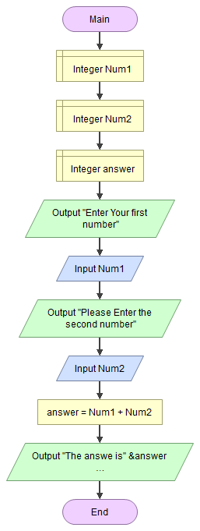

***M1 ADDING TWO NUMBERS***

**Function Main**

**Declare Integer Num1**

**Declare Integer Num2**

**Declare Integer answer**

**Output "Enter Your first number"**

**Input Num1**

**Output "Please Enter the second number"**

**Input Num2**

**Assign answer = Num1 + Num2**

**Output "The answe is" &answer**

**End**

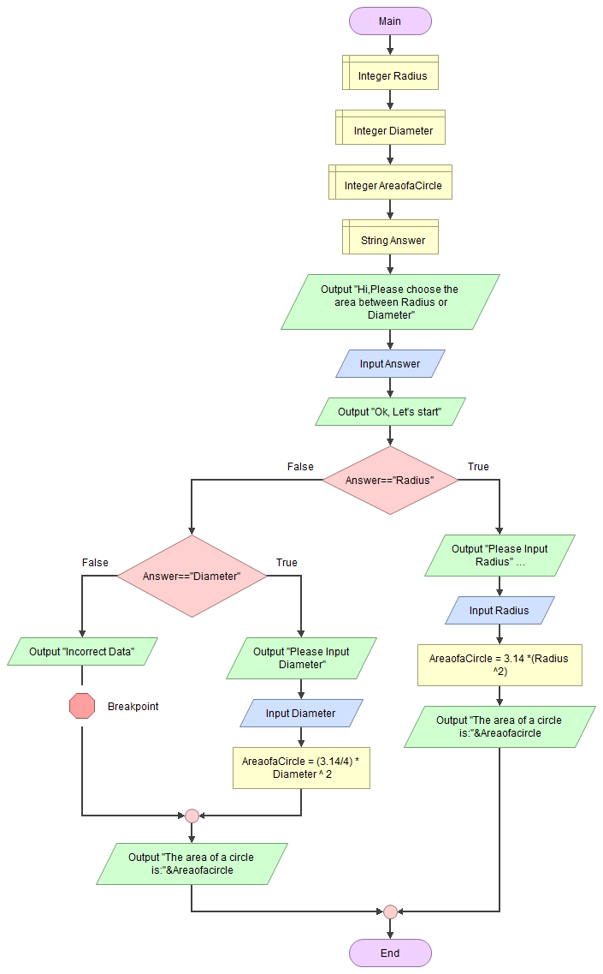

***M2 GETTING THE AREA OF A CIRCLE USING DIAMETER AND RADIUS***

**Function Main**

**Declare Integer Radius**

**Declare Integer Diameter**

**Declare Integer AreaofaCircle**

**Declare String Answer**

**Output "Hi,Please choose the area between Radius or Diameter"**

**Input Answer**

**Output "Ok, Let's start"**

**If Answer=="Radius"**

**Output "Please Input Radius"**

**Input Radius**

**Assign AreaofaCircle = 3.14 *(Radius ^2)**

**Output "The area of a circle is:"&Areaofacircle**

**False:**

**If Answer=="Diameter"**

**Output "Please Input Diameter"**

**Input Diameter**

**Assign AreaofaCircle = (3.14/4) * Diameter ^ 2**

**False:**

**Output "Incorrect Data"**

**End**

**Output "The area of a circle is:"&Areaofacircle**

**End**

**End**

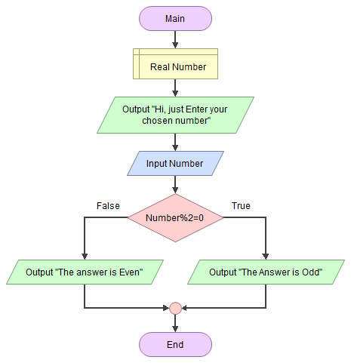

**M3 ODD AND EVEN NUMBER IDENTIFIER**

**Function Main**

**Declare Real Number**

**Output "Hi, just Enter your chosen number"**

**Input Number**

**If Number%2=0**

**Output "The Answer is Odd"**

**False:**

**Output "The answer is Even"**

**End**

**End**