**1)git init**

2)**nano number.py** - creates this file in a new window

add the folowing code:

for i in range(10):

print(i**2)

press **ctrl +X** to save then **Y** to confirm

3)Run the file by

**python numbers.py**

4)add and commit the file

5)create new branch cube **by 'git branch cube'**

or to create and checkout to it use

**git checkout -b cube**

6)**nano number.py** to edit the file:

edit to :(noticed changed from power 2 to power 3)

for i in range(10):

print(i**3)

Ctrl + X then Y

7)git add and commit

8)To merge we checkout to master and merge by:

**git merge cube -m 'merge branch cube and master'**

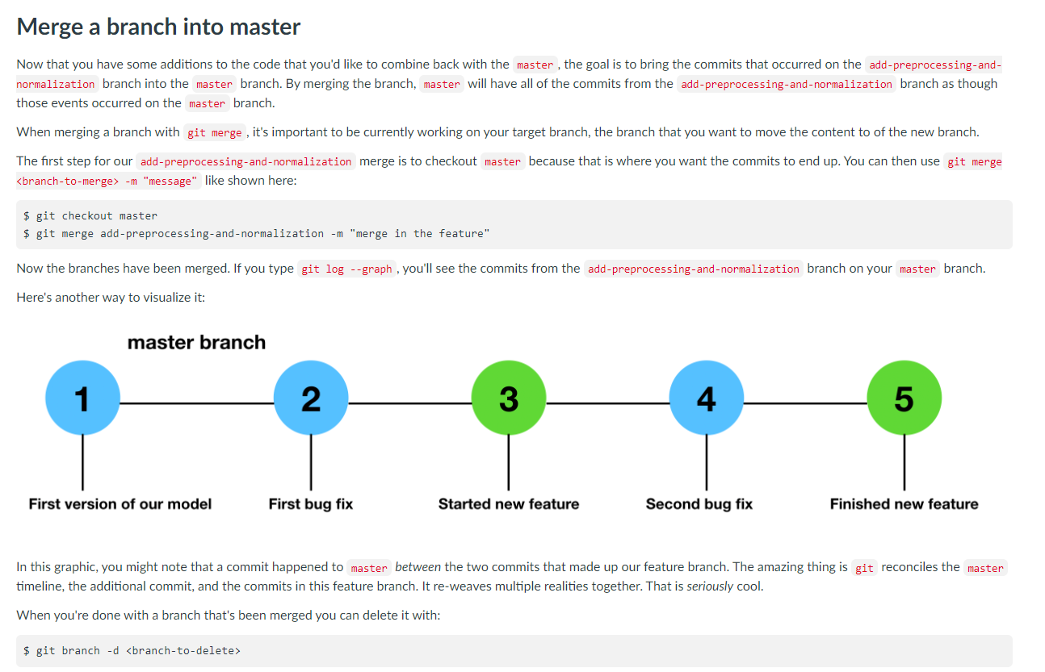

9)run python file again to see the modified changes

python numbers.py

10)Delete development branch cube

**git branch -d cube**

**10b**)  you can move back to master with **git checkout master**. You can also type [**git checkout –** ]in order to move back to the previous branch.

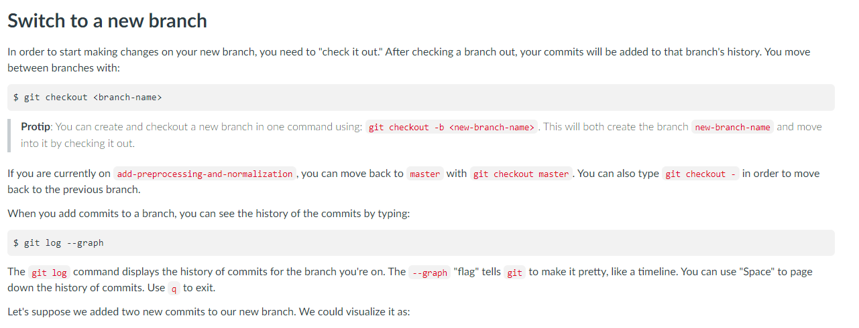

***Make sure all your changes are committed before you switch branches.***

11) git status to confirm everythings is fine

12)**git stash** - deletes all changes

13)cat numbers.py - check contents of your file

cat which will print the contents of a file to the command line,

14)Finally, if you want to re-implement your stashed changes you can use

git stash apply

brings back your changes

(**GIT CHEET SHEET)**

<https://rogerdudler.github.io/git-guide/>

git log --oneline

**git log one line**

git log --pretty=oneline

git log --pretty=oneline --max-count=2

git log --pretty=oneline --since='5 minutes ago'

git log --pretty=oneline --until='5 minutes ago'

git log --pretty=oneline --author=<your name>

git log --pretty=oneline --all