Improved Statistical Analysis Plan
Multiplex FISH Analysis of Post-Treatment Vaginal
Microbial Colonization in Bacterial Vaginosis

Based on the Masters Proposal by T.N. Mahlangu
CAPRISA Mucosal Immunology Laboratory
University of KwaZulu-Natal

Note: This document replaces Section 6 (Statistical Analysis) of the original proposal.
Each method is explained in plain language with justification.

1. Overview of Data Types
This study generates three types of data, each requiring a different statistical approach. These data types are not independent—for example, FISH spatial metrics at Day 8 may predict PMA-qPCR counts at Day 16. The statistical plan below treats them together in a unified framework.
Data Type | Source | What It Measures
Image-based (FISH) | Fluorescence microscopy | Bacterial abundance, fluorescence intensity, epithelial adherence, spatial organization
Quantitative (PMA-qPCR) | Viable bacterial counts | Number of live bacteria of each species present
Clinical / demographic | CAPRISA 098 cohort | Age, Nugent score, STI status, contraceptive use, etc.

2. Statistical Analysis Flow Diagram
The flowchart below shows the overall analytical pipeline. Start at the top with raw data, follow the path based on data type and research question, and arrive at the appropriate statistical method.
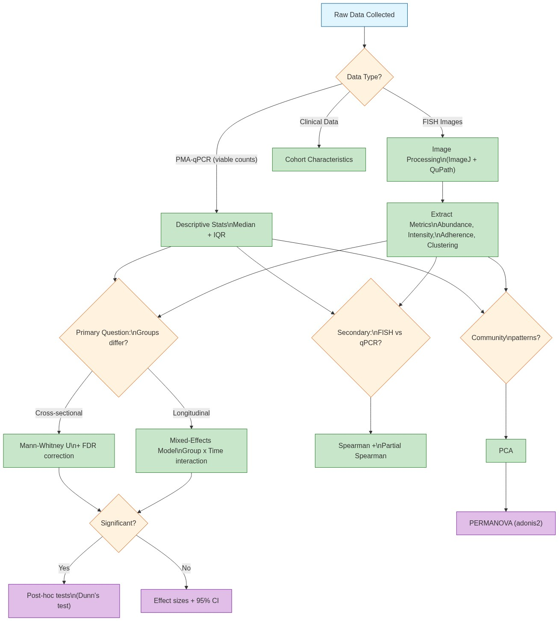

3. Detailed Methods — Explained and Justified

3.1 Sample Size Justification (New Addition)
What to do:
Conduct an a priori power analysis using pilot data or published studies (e.g., Hardy et al., 2015; Swidsinski et al., 2024). For a Mann-Whitney U test comparing two groups (antibiotic-responsive vs antibiotic-resistant) with a medium effect size (Cohens d = 0.6), alpha = 0.05, and power = 0.80, a minimum of approximately 20 participants per group is needed. This can be calculated using G*Power or the pwr package in R.
Why it was missing from the original proposal:
The original proposal mentions no sample size calculation. Reviewers will almost certainly ask: "How do you know the study has enough participants to detect a meaningful difference?"
Why this method:
A power analysis tells you how many samples you need to avoid a false negative—that is, missing a real difference because you simply did not have enough data. Without it, you risk wasting resources on an underpowered study or, worse, drawing incorrect conclusions from a study too small to detect the effect of interest.

3.2 Descriptive Statistics (Expanded from Original)
What to do:
For every variable (each bacterial taxon, each FISH metric, at each time point), report:
- Median and interquartile range (IQR)—not mean and standard deviation
- Minimum and maximum values
- Number of observations (especially important if data are missing)
Why these:
Microbial count data are almost never normally distributed. They are typically zero-inflated (many samples have zero counts for a given taxon) and right-skewed (a few samples have very high counts). Medians and IQRs are robust to outliers and do not assume a bell-shaped distribution.

3.3 Primary Analysis: Comparing Groups (Improved)
3.3.1 Cross-Sectional Comparisons (Single Visit)
Original approach: Mann-Whitney U test with no correction for multiple testing.
Improved approach:
1. Perform Mann-Whitney U tests for each bacterial taxon and each FISH metric at each time point.
2. Apply a Benjamini-Hochberg False Discovery Rate (FDR) correction to the resulting p-values.
Justification for FDR correction:
With approximately 7 bacterial targets, 4 time points, and multiple FISH metrics (abundance, adherence, clustering, etc.), you could easily run 50 or more separate statistical tests. At the standard p < 0.05 threshold, you would expect about 3 false positives by chance alone. The Benjamini-Hochberg method controls the proportion of false discoveries—meaning only 5% of the tests you call "significant" are expected to be false positives. This is the standard approach in microbiome research.
3.3.2 Longitudinal Analysis (Across Visits — New Addition)
The original proposal uses only the Mann-Whitney U test, which compares two groups at a single time point. This ignores the studys longitudinal design (visits at Days 0, 8, 16, and 24).
Improved approach:
Fit a mixed-effects model (also called a linear mixed model, LMM) for each outcome:
Value ~ Group + Time + Group x Time + (1 | Participant ID)
Where:
- Group = antibiotic-responsive vs antibiotic-resistant (fixed effect)
- Time = visit day (categorical: 0, 8, 16, 24)
- Group x Time = the interaction term—this tests whether the trajectory over time differs between groups
- (1 | Participant ID) = random intercept—accounts for the fact that repeated measurements from the same person are correlated
Why this is better:
Mixed-effects models: (1) Use all data efficiently, even if a participant misses a visit. (2) Handle uneven time spacing. (3) Tell you when groups diverge—for example, "by Day 16, the two groups are significantly different, but not before." (4) Are the gold standard for analysing longitudinal biomedical data.
What if normality assumptions are violated?
If the data remain non-normal after transformation, use the aligned rank transform or a generalised linear mixed model with a negative binomial distribution (appropriate for overdispersed count data from qPCR).

3.4 Secondary Analysis: Correlations (Improved)
Original approach: Spearman rank correlation between viable bacterial burden and FISH-derived spatial parameters.
Improved approach:
1. Spearman rank correlation—as originally proposed (this is a good choice for non-normal data).
2. Partial Spearman correlation (new)—controlling for potential confounders such as age, baseline Nugent score, and contraceptive use.
Justification:
A simple correlation between two variables can be misleading if a third variable affects both. For example, if older women tend to have both higher bacterial loads and more biofilm adherence, you would see a spurious correlation between bacterial load and adherence that is actually driven by age. Partial correlation removes the effect of these confounders, giving you the "direct" correlation between the two variables of interest.

3.5 Multivariate Exploration (New Addition)
The original proposal contains no multivariate analysis. This is a significant gap because microbiome data are inherently multivariate—bacteria do not exist in isolation, and community-level patterns may be missed by univariate tests.
Improved approach:
3.5.1 Principal Component Analysis (PCA)
Take all microbial variables (PMA-qPCR counts for each taxon and FISH metrics) and reduce them to a few summary axes. This helps visualise whether antibiotic-responsive and antibiotic-resistant samples form distinct clusters. PCA is an unsupervised method—it lets the data reveal patterns without any group labels.
3.5.2 Permutational MANOVA (adonis2)
Test whether the multivariate microbial community composition differs significantly between groups. Unlike PCA (which is visual), PERMANOVA provides a formal statistical test. It is implemented in the vegan R package and is the standard tool for testing group differences in microbial community data.

3.6 Multiple Comparison Correction (New Addition)
The table below summarises the available correction methods and when to use each:
Method | When to Use | Recommendation
Benjamini-Hochberg FDR | Primary group comparisons (many tests, exploratory context) | Recommended—balances discovery and rigour
Bonferroni | Only for a small set (<= 5) of pre-specified hypotheses | Too conservative for 50+ tests

3.7 Handling Missing Data (New Addition)
Problem:
In longitudinal studies, participants drop out or miss visits. This is especially relevant in cohorts of women at risk for BV, where loss to follow-up can be substantial.
What to do:
- Report why data are missing (e.g., loss to follow-up, poor sample quality, withdrawal of consent)
- Compare baseline characteristics of those who completed the study vs those who dropped out
- Use mixed-effects models (which handle missing-at-random data robustly) rather than deleting incomplete cases
Why this matters:
If women who dropped out had more severe BV or different microbial profiles, then analysing only the "completers" would bias the results. Mixed-effects models give unbiased estimates under the less strict "missing at random" assumption, meaning the probability of missing data can depend on observed variables (e.g., previous visits measurements) but not on unobserved outcomes.

3.8 Statistical Software
Task | Recommended Software | Why
Image analysis | ImageJ/Fiji + QuPath | Already proposed—good choices; QuPath excels at whole-slide quantification
PMA-qPCR analysis | R (v4.3+) with lme4, glmmTMB, emmeans | More flexible than GraphPad Prism for mixed models and custom contrasts
Multivariate analysis | R packages: vegan, ggplot2 | Industry standard for microbiome data analysis
Power analysis | G*Power or R package pwr | Free, widely accepted, easy to use
Graphs / figures | ggplot2 (R) or GraphPad Prism | Publication-quality figures

Note:
R is recommended alongside GraphPad Prism (not as a replacement) because Prism has limited support for mixed-effects models, partial correlations, and multivariate methods. GraphPad remains useful for the simpler Mann-Whitney U tests and Spearman correlations if preferred.

4. Summary of Changes from the Original Proposal
Aspect | Original Proposal | Improved Version
Sample size | Not mentioned | Power analysis described (G*Power or pwr)
Group comparison | Mann-Whitney U (single test) | Mixed-effects model (longitudinal) + Mann-Whitney with FDR correction
Multiple testing | None | Benjamini-Hochberg FDR correction
Correlations | Spearman (simple) | Spearman + partial Spearman (controlling for confounders)
Multivariate analysis | None | PCA + PERMANOVA (adonis2)
Missing data | None | Explicit handling: mixed models + attrition analysis
Software | GraphPad Prism only | R (lme4, vegan, emmeans) + GraphPad Prism

5. Plain-Language Summary
In simple terms:
The original proposal plans to compare two groups (women whose BV got better with antibiotics vs women whose BV did not) using a single type of test (Mann-Whitney). This is a good start, but it is like looking at only one piece of a puzzle.

The improved plan adds five key elements:

- A power analysis to make sure enough women are included to detect a meaningful difference.
- Longitudinal models that track the women over all four visits, not just one time point. This tells us not only if groups differ, but when they begin to differ.
- Correction for multiple testing (Benjamini-Hochberg) to avoid false alarms from running many statistical tests simultaneously.
- Multivariate methods (PCA + PERMANOVA) that look at the overall microbial community pattern rather than testing each bacterial species one at a time.
- A plan for missing data, since dropout is common in longitudinal studies and ignoring it can bias results.

Together, these additions make the study more rigorous, more transparent, and more likely to produce reliable, publishable results that can inform the development of improved BV treatments.

6. References (Statistical Methods)
Anderson, M.J. (2001). A new method for non-parametric multivariate analysis of variance. Austral Ecology, 26(1), 32–46.
Bates, D., Machler, M., Bolker, B., & Walker, S. (2015). Fitting linear mixed-effects models using lme4. Journal of Statistical Software, 67(1), 1–48.
Benjamini, Y., & Hochberg, Y. (1995). Controlling the false discovery rate: A practical and powerful approach to multiple testing. Journal of the Royal Statistical Society: Series B, 57(1), 289–300.
Faul, F., Erdfelder, E., Lang, A.-G., & Buchner, A. (2007). G*Power 3: A flexible statistical power analysis program for the social, behavioral, and biomedical sciences. Behavior Research Methods, 39(2), 175–191.
Oksanen, J., et al. (2022). vegan: Community Ecology Package. R package version 2.6-4.
R Core Team (2024). R: A language and environment for statistical computing. R Foundation for Statistical Computing, Vienna, Austria.
Therneau, T.M. (2024). lme4: Linear Mixed-Effects Models using Eigen and S4. R package version 1.1-35.

