Improved Statistical Analysis Plan
Characterising Microbial Community Shifts and Molecular Biomarkers
of Metronidazole and Clindamycin Treatment in an In Vitro Model of BV

Based on the Masters Proposal by Phiwokuhle B. Ntuntuza
CAPRISA Mucosal Immunology Laboratory
University of KwaZulu-Natal

Note: This document reviews and improves Section 3.4 of the original proposal.

1. Evaluation of the Original Section 3.4
The original proposal by Phiwokuhle B. Ntuntuza already has a substantially stronger statistical plan than is typical at the Masters level. It is commended for including:
- ANCOM-BC for differential abundance analysis (a modern, appropriate tool for microbiome compositional data)
- FDR-adjusted p-values for multiple testing correction
- Linear mixed models and repeated measures ANOVA for longitudinal data
- Bland-Altman analysis for method comparison (IAA vs qPCR)
- Both parametric and non-parametric alternatives (t-test vs Wilcoxon)
- R as the analysis platform
- Bioinformatics tools for metagenomic analysis (Kraken 2, Bracken, MetaSNV, etc.)

However, several gaps remain that, if addressed, would strengthen the proposal:
# | Gap | Why It Matters
1 | No sample size / power analysis | Reviewers will ask: how many replicates? How many samples?
2 | No alpha/beta diversity for 16S data | Standard in all microbiome studies and will be expected.
3 | Missing data not addressed | Contamination, failed sequencing, or dropout can occur.
4 | RM-ANOVA vs mixed models unclear | RM-ANOVA is restrictive; recommend mixed models as primary.
5 | No analysis hierarchy by objective | Which analysis answers which objective?
6 | Technical vs biological replicates unclear | Pseudo-replication must be avoided.
7 | No confounder plan for in vivo comparison | Age, STI status, etc. should be accounted for.
8 | No predictive modelling mentioned | Objective 2 needs formal classification (Random Forest, etc.).

2. Statistical Analysis Flow Diagram
The flowchart maps every data stream to its research question and the corresponding statistical method.
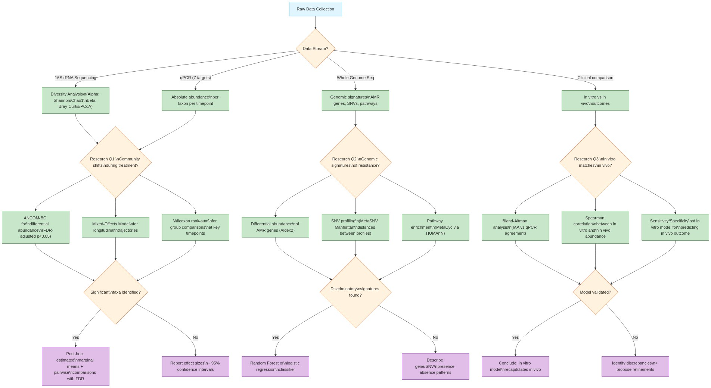

3. Detailed Methods - Explained and Justified

3.1 Sample Size and Replicate Justification (New)
Problem in original:
No sample size or replicate number is mentioned. This is critical for both the in vitro and in vivo components.
What to do:
In vitro experiments:
- Each treatment condition should have a minimum of 3 biological replicates (independent culture batches from different participant samples) with 2-3 technical replicates (same culture, separate qPCR/sequencing runs).
- For detecting a 2-fold change in bacterial abundance between treated and untreated controls with 80% power at alpha = 0.05, n = 3 biological replicates per condition is a reasonable minimum.
In vivo comparison (Objective 3):
- If using CAP098 cohort data, conduct a power analysis for a two-group comparison.
- For a Mann-Whitney U test with medium effect size (d = 0.6), alpha = 0.05, power = 0.80: approximately 20 participants per group.
Why this was added:
Without a power analysis, there is no way to know whether the study can detect the effects it is designed to find.

3.2 Microbial Community Analysis (16S rRNA) - Expanded
Original: ANCOM-BC, relative abundance, IAA, t-test/Wilcoxon.
Improved approach:
3.2.1 Alpha Diversity (New)
- Shannon diversity index and Chao1 richness estimator.
- Wilcoxon rank-sum test between cleared vs persistent groups.
- Why: Standard companion to differential abundance testing.
3.2.2 Beta Diversity (New)
- Bray-Curtis dissimilarity, visualised by Principal Coordinate Analysis (PCoA).
- PERMANOVA (adonis2 in vegan) to test group differences in community composition.
- Why: Captures whether overall community structure shifts during treatment.
3.2.3 Differential Abundance (Retained, refined)
- ANCOM-BC - keep as primary method (excellent choice).
- Sensitivity analysis: also run DESeq2 or MaAsLin2 to confirm results.
- Thresholds: FDR-adjusted p < 0.05 AND |log2 fold-change| >= 1 (standard and appropriate).
Why ANCOM-BC:
Standard tools (DESeq2, edgeR) assume most features do not change. In microbiome data, many taxa may shift, violating this. ANCOM-BC uses bias-correction that accounts for this.

3.3 Longitudinal Trajectories - Clarified
Original: RM-ANOVA and linear mixed models listed without specifying primary.
Recommendation:
- Primary: Linear mixed-effects model:
log10(abundance) ~ Treatment + Time + Treatment x Time + (1 | Culture_ID)
- Treatment = MTZ alone vs MTZ + clindamycin (fixed effect)
- Time = baseline, days 1-7, post-treatment, recovery (categorical)
- Treatment x Time = tests whether trajectory differs between regimens
- (1 | Culture_ID) = random intercept for each independent culture
Why mixed models over RM-ANOVA:
- Handle missing time points without dropping entire cultures.
- Do not require sphericity assumption.
- Handle uneven time spacing (e.g., daily samples then a recovery gap).
If residuals remain non-normal:
Use a generalised linear mixed model with negative binomial family.

3.4 Cross-Sectional Group Comparisons - Retained
Original: t-test or Wilcoxon; chi-square or Fisher's exact test.
Assessment: These are appropriate. The proposal correctly notes "as appropriate."
Refinement: Check normality via Shapiro-Wilk test and Q-Q plots. If n < 10 per group, default to non-parametric.

3.5 IAA vs qPCR Agreement - Retained and Justified
Original: Spearman/Pearson correlation + Bland-Altman analysis.
Assessment: Excellent addition. Bland-Altman is the correct method for assessing agreement.
Refinement:
- Default to Spearman (safer for microbial data).
- Report mean difference (bias) and 95% limits of agreement.
- Pre-define acceptable limits (e.g., bias within +/- 0.5 log10 copies/mL).

3.6 Genomic Signatures - Expanded
Original: FastQC, Kraken 2, Bracken, Metaphlan4, Humann3, Aldex2, Welch t-test, MetaSNV.
The bioinformatics pipeline is well described. Below are statistical refinements:
3.6.1 Differential Abundance of AMR Genes
- Aldex2 is appropriate (uses Monte Carlo approach for compositional data).
- Confirm FDR correction across all tested genes.
- Add effect size reporting alongside p-values.
3.6.2 Predictive Modelling (New)
Objective 2 aims to "identify signatures predictive of treatment success." Differential abundance alone does not address this fully.
- Random Forest classification: uses all genomic features to predict outcome.
- Logistic regression with elastic net regularisation: identifies most important individual features.
- 5-fold cross-validation repeated 10 times to avoid overfitting.
- Report AUC, sensitivity, specificity, positive/negative predictive values.
3.6.3 SNV Analysis
- MetaSNV + Manhattan distances - appropriate.
- Add: PERMANOVA on Manhattan distance matrices to formally test profile differences between groups.
- Add: PCoA visualisation of Manhattan distances.

3.7 In Vitro to In Vivo Comparison - Structured
Objective 3: compare biomarkers identified in vitro with those observed in vivo.
Original: mentions multivariate analyses but does not specify which.
Recommendation:
- Step 1: Spearman correlation for key taxa abundance between in vitro and matched clinical samples.
- Step 2: Concordance (percentage agreement) for AMR gene and SNV detection.
- Step 3: Sensitivity and specificity of the in vitro model for predicting in vivo outcome.
- Step 4: Logistic regression to identify which in vitro features best predict in vivo outcomes.

3.8 Multiple Comparison Correction
The original correctly uses FDR correction. Summary:
Analysis | Correction Method | Reason
Differential abundance (ANCOM-BC) | Benjamini-Hochberg FDR | Many taxa tested
Longitudinal mixed models | Tukey HSD or Bonferroni | Small number of pairwise comparisons
AMR genes (Aldex2) | Benjamini-Hochberg FDR | Many genes tested
In vitro vs in vivo correlations | Benjamini-Hochberg FDR | Multiple taxa vs outcomes

3.9 Handling Missing Data (New)
In vitro experiments:
- Technical failures - document and exclude only that measurement.
- Contamination - discard entire replicate and note in lab record.
- Mixed models handle missing time points without imputation.
In vivo comparisons:
- Report missingness by group and reason.
- Compare baseline characteristics of completers vs non-completers.
- If > 5% missing: consider multiple imputation (mice R package) as sensitivity analysis.

3.10 Statistical Software
Task | Software / Package | Notes
16S rRNA analysis | R: phyloseq, vegan, ANCOMBC | SILVA / Greengenes2 ref. db
Differential abundance | ANCOM-BC (primary), DESeq2 (sensitivity) | FDR-adjusted p < 0.05
Longitudinal modelling | R: lme4, glmmTMB, emmeans | Mixed-effects models
Metagenomics / AMR | Kraken2, Bracken, MetaPhlan4, HUMAnN, Aldex2, MetaSNV | As originally proposed
Predictive modelling | R: randomForest, glmnet | Cross-validated; report AUC
Graphs | R: ggplot2, pheatmap | Publication-quality figures

4. Summary of Changes
Aspect | Original Proposal | Improved Version
Sample size | Not mentioned | Power analysis + replicate plan
Alpha diversity | Not mentioned | Shannon + Chao1 + Wilcoxon
Beta diversity | Not mentioned | Bray-Curtis PCoA + PERMANOVA
Differential abundance | ANCOM-BC | ANCOM-BC + DESeq2 sensitivity
Longitudinal analysis | RM-ANOVA or LMM (unclear) | Mixed model primary, justified
Predictive modelling | Not mentioned | Random Forest + elastic net
IAA vs qPCR agreement | Bland-Altman | Refined with pre-specified limits
Missing data | Not mentioned | Documentation + sensitivity analysis
In vitro vs in vivo | Vague | Structured: correlation + concordance + sens/spec

5. Plain-Language Summary
The original Section 3.4 is significantly stronger than most Masters proposals, with modern methods (ANCOM-BC, FDR, Bland-Altman, mixed models) already included. The improvements focus on filling 8 specific gaps:
- Adding a power analysis so reviewers can see the study is adequately sized.
- Adding alpha and beta diversity analyses, which are standard in all 16S microbiome studies.
- Clarifying that the primary longitudinal method is mixed-effects models (more flexible than RM-ANOVA).
- Adding predictive modelling (Random Forest, elastic net) to formally address Objective 2.
- Structuring the in vitro vs in vivo comparison into clear steps with defined metrics.
- Adding a plan for missing data and replicate handling.
- Better distinguishing between Objectives 1, 2, and 3 in the analysis structure.

These additions transform the analysis from a collection of good methods into a coherent, justified statistical framework.

6. References (Statistical Methods)
Anderson, M.J. (2001). A new method for non-parametric multivariate analysis of variance. Austral Ecology, 26(1), 32-46.
Bates, D. et al. (2015). Fitting linear mixed-effects models using lme4. Journal of Statistical Software, 67(1), 1-48.
Benjamini, Y. & Hochberg, Y. (1995). Controlling the false discovery rate. Journal of the Royal Statistical Society: Series B, 57(1), 289-300.
Bland, J.M. & Altman, D.G. (1986). Statistical methods for assessing agreement between two methods of clinical measurement. The Lancet, 327(8476), 307-310.
Breiman, L. (2001). Random forests. Machine Learning, 45(1), 5-32.
Faul, F. et al. (2007). G*Power 3: A flexible statistical power analysis program. Behavior Research Methods, 39(2), 175-191.
Lin, H. & Peddada, S.D. (2020). Analysis of compositions of microbiomes with bias correction. Nature Communications, 11, 3514.
McMurdie, P.J. & Holmes, S. (2013). phyloseq: An R package for reproducible interactive analysis and graphics of microbiome census data. PLoS ONE, 8(4), e61217.
Oksanen, J. et al. (2022). vegan: Community Ecology Package. R package version 2.6-4.
Zou, H. & Hastie, T. (2005). Regularization and variable selection via the elastic net. Journal of the Royal Statistical Society: Series B, 67(2), 301-320.

