ISTE-608 Database Design and Implementation

## Homework #2 - Entity-Relationship Modeling

DUE: Sunday, September 10, 2023, by 11:59pm EDT

**Name: _Grace T Long Torales________________________________________**

**Submit this document, edited to include your answers, to the Homework #2 Assignment folder by the due date specified.**

**Part 1 – 20 points**

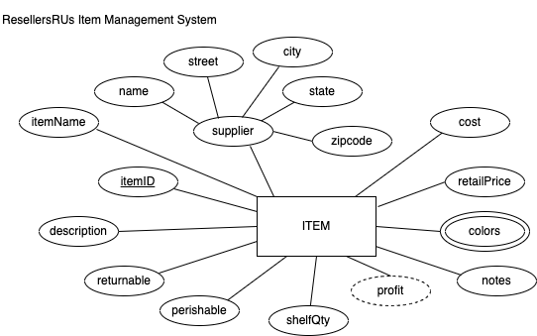

For the table below, please classify each attribute specified based on the E-R diagram above. Please place the best answer for each column that best describes the attribute.

|  |  |  |  |  |
| --- | --- | --- | --- | --- |
| Attribute | **Composite or Simple** | **Single-valued or Multi-valued** | **Stored or Derived** | **Identifier ? (Yes or No)** |
| profit | Simple | Single | Derived | No |
| street | Simple | Single | Stored | No |
| itemID | Simple | Single | Stored | Yes |
| supplier | Composite | Single | Stored | No |
| colors | Simple | Multi | Stored | No |

**Part 2 – 80 points**

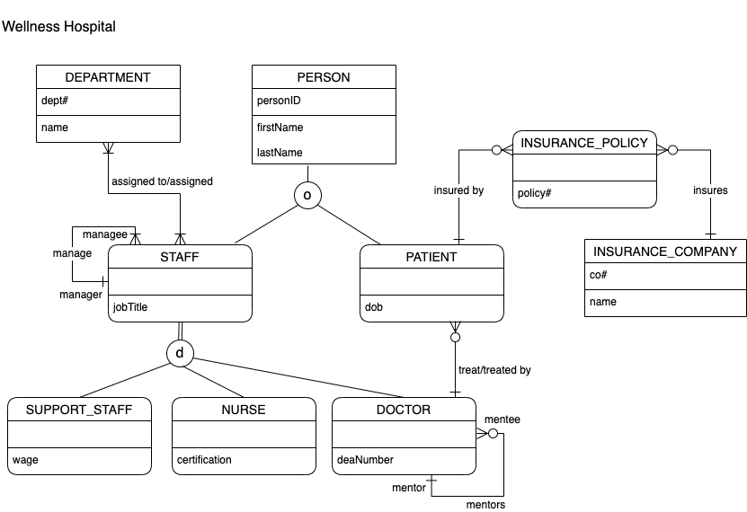

Using the E-R diagram for Wellness Hospital, please provide your answer to the following 22 questions.

1. (4 points) List the relationship verb phrase for each 'HAS-A' relationship that appears in the diagram.

**YOUR ANSWER:**

* DEPARTMENT assigned STAFF/STAFF assigned to DEPARTMENT
* STAFF:manager manages STAFF:managee/STAFF:managee managed by STAFF:manager
* PATIENT insured by INSURANCE_COMPANY(PATIENT insured by INSURANCE_POLICY)/INSURANCE_COMPANY insures PATIENT(INSURANCE_COMPANY insures INSURANCE_POLICY)
* DOCTOR treats PATIENT/PATIENT treated by DOCTOR
* DOCTOR:mentor mentors DOCTOR:mentee/DOCTOR:mentee mentored by DOCTOR:mentor

1. (3 points) List the relationship verb phrase for each binary relationship that appears in the diagram.

**YOUR ANSWER:**

* DEPARTMENT assigned STAFF/STAFF assigned to DEPARTMENT
* PATIENT insured by INSURANCE_COMPANY/INSURANCE_COMPANY insures PATIENT
* DOCTOR treats PATIENT/PATIENT treated by DOCTOR

1. (3 points) List the relationship verb phrase for each recursive relationship that appears in the diagram.

**YOUR ANSWER:**

* STAFF:manager manages STAFF:managee/STAFF:managee managed by STAFF:manager
* DOCTOR:mentor mentors DOCTOR:mentee/DOCTOR:mentee mentored by DOCTOR:mentor

1. (3 points) List the name of each supertype entity that appears in the diagram.

**YOUR ANSWER:** PERSON, STAFF

1. (4 points) List the name of each subtype entity that appears in the diagram.

**YOUR ANSWER:** STAFF, SUPPORT_STAFF, NURSE, DOCTOR, PATIENT

1. (3 points) List the name of each associative entity that appears in the diagram.

**YOUR ANSWER:** INSURANCE_POLICY

1. (3 points) Provide an example of an entity instance of PERSON.

**YOUR ANSWER:** personID = 1234, firstName = Grace, lastName = Long Torales

1. (3 points) List the relationship verb phrase for every 1:1 relationship that appears in the diagram.

**YOUR ANSWER:** There are no 1:1 relationships in the diagram

1. (3 points) List the relationship verb phrase for every 1:N (N:1) relationship that appears in the diagram.

**YOUR ANSWER:**

* STAFF:manager manages STAFF:manage
* PATIENT insured by INSURANCE_POLICY
* INSURANCE_COMPANY insures INSURANCE_POLICY
* DOCTOR treats PATIENT
* DOCTOR:mentor mentors DOCTOR:mentee

1. (3 points) List the relationship verb phrase for every M:N relationship that appears in the diagram.

**YOUR ANSWER:**

* DEPARTMENT assigned STAFF/STAFF assigned to DEPARTMENT
* PATIENT insured by INSURANCE_COMPANY/INSURANCE_COMPANY insures PATIENT

1. (3 points) List the name of each strong entity that appears in the diagram.

**YOUR ANSWER:** DEPARTMENT, PERSON, INSURANCE_COMPANY

1. (4 points) List the name of each weak entity that appears in the diagram.

**YOUR ANSWER:** STAFF, SUPPORT_STAFF, NURSE, DOCTOR, PATIENT, INSURANCE_POLICY

1. (4 points) Must a STAFF:managee be managed by a manager? Explain how you determined your answer from the E-R diagram provided.

**YOUR ANSWER:** A STAFF:managee must have 1 and only 1 STAFF:manager, as indicated by the line/plus next to manager in the recursive relationship describing managers and managees.

1. (4 points) Can there be an instance of DOCTOR that is not an instance of STAFF? Explain your answer.

**YOUR ANSWER:** Within this database, there cannot be an instance of DOCTOR that is not an instance of STAFF. DOCTOR is a weak entity, so it must have a related instance of STAFF. STAFF is also a weak entity, so it, in turn, must have a related instance of PERSON.

1. (4 points) Can a DOCTOR treat more than one PATIENT? Explain how you determined your answer from the E-R diagram provided.

**YOUR ANSWER:** Yes, a DOCTOR can treat more than one PATIENT, as indicated by the crow’s foot next to PATIENT in their connection.

1. (4 points) Must every instance of PERSON belong to a subtype? Fully explain how you determined your answer from the E-R diagram provided.

**YOUR ANSWER:** No, every instance of PERSON need not belong to a subtype, as indicated by the singular (as opposed to double) vertical line extending underneath PERSON to the supertype/subtype relationship indicator (partial specialization).

1. (4 points) Could an instance of PERSON be both a STAFF and a PATIENT? Fully explain how you determined your answer from the E-R diagram provided.

**YOUR ANSWER:** Yes, it is possible for a person to be a STAFF and a PATIENT, as indicated by the o in the supertype/subtype relationship indicator (overlap rule).

1. (4 points) Must every instance of STAFF belong to a subtype? Fully explain how you determined your answer from the E-R diagram provided.

**YOUR ANSWER:** Yes, every instance of STAFF must belong to a subtype, as indicated by the double (as opposed to singular) vertical line extending underneath STAFF to the supertype/subtype relationship indicator (total specialization).

1. (4 points) Could an instance of STAFF be both a SUPPORT_STAFF and a DOCTOR? Fully explain how you determined your answer from the E-R diagram provided.

**YOUR ANSWER:** No, a STAFF could not be both SUPPORT_STAFF and DOCTOR, as indicated by the d in the supertype/subtype relationship indicator (disjoint rule).

1. (4 points) If a discriminator were to be added to PERSON, fully explain what that would entail and why?

**YOUR ANSWER:** Because a PERSON need not be STAFF or PATIENT but could be both (partial specialization, overlap rule), an attribute would need to be added for each. Each attribute would need to be a Boolean to denote whether a PERSON is or is not categorized as that subtype.

1. (4 points) If a discriminator were to be added to STAFF, fully explain what that would entail and why?

**YOUR ANSWER:** Because a STAFF must be either a SUPPORT_STAFF, a NURSE, or a DOCTOR (total specialization, disjoint rule), an attribute would need to be added to denote which of those subtypes the STAFF is.

1. (5 points) Fully state the business rules for the **assigned to/assigned** relationship without using technical terms.

**YOUR ANSWER:** A DEPARTMENT may employ 1 or more STAFF members and a STAFF member may be assigned to 1 or more DEPARTMENTs. A DEPARTMENT *must* have at least 1 STAFF member and a STAFF member *must* be assigned to at least 1 DEPARTMENT.