## Homework # 3 - Transposing and E-R Diagram

DUE: Sunday, September 12, 2021 by 11:59pm EDT

**Name: __Grace T Long Torales__________________________**

**Submit this document edited to include your answers, for the two parts, to the HW#3 Assignment folder by the stated deadline.**

**Part #1 - 50 points**

1. (45 points) Transpose the E-R diagram below into relations, implementing all relationships. Denote primary keys and foreign keys appropriately. Use proper relation notation. You need to provide reference statements. There is a distinction between identifying and non-identifying relationships.

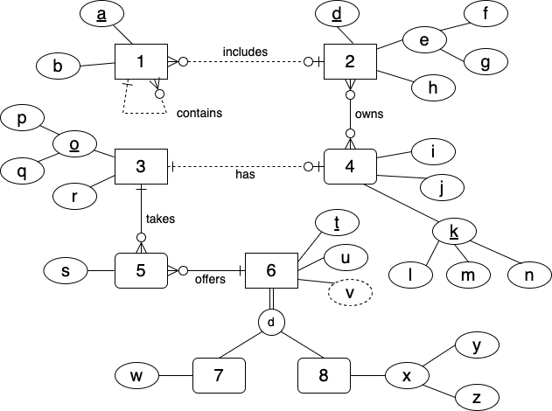

**YOUR TRANSPOSED RELATIONS:**

1(a, b, *a1, d*)

1(a1) mei 1(a)

1(d) mei 2(d)

2(d, f, g, h)

4(l, m, n, i, j, *p, q*)

4(p, q) mei 3(p, q)

2_4(*d, l, m, n*)

2_4(d) mei 2(d)

2_4(l, m, n) mei 4(l, m, n)

3(p, q, r)

5(*p, q, t,* s)

5(p, q) mei 3(p, q)

5(t) mei 6(t)

6(t, u)

7(*t,* w)

7(t) mei 6(t)

8(*t,* y, z)

8(t) mei 6(t)

2. (2 points) Using the E-R diagram above, please explain why entity 7 is weak and what the specific term for that type of entity is.

**REASON:** Entity 7 cannot exist without entity 6. There must be a corresponding entity 6 to describe entity 7.

**TERM:** subtype entity

3. (2 points) Using the E-R diagram above, please explain why entity 5 is weak and what the specific term for that type of entity is.

**REASON:** Entity 5 cannot exist without participating in the relationship between 3 and 6.

**TERM:** associative entity

4. ( 1 point) Using the E-R diagram above, please explain what relationship makes entity 4 weak and what about that relationship causes it to be weak.

**EXPLANATION:** The has relationship between 3 and 4 makes 4 weak. Total participation is required from 4.

**Part 2 - RIT Savings and Loan (50 points)**

1. (50 points) Transpose the E-R diagram below into relations, implementing all relationships. Denote primary keys and foreign keys appropriately. Use proper relation notation. You need to provide reference statements. There is a distinction between identifying and non-identifying relationships.

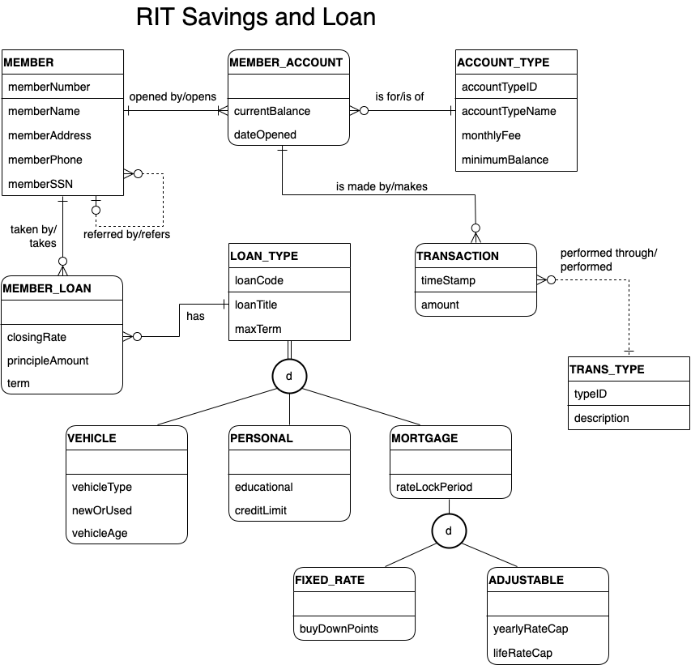

**YOUR TRANSPOSED RELATIONS:**

MEMBER(memberNumber, memberName, memberAddress, memberPhone, memberSSN, *referrerMemberNumber*)

MEMBER(referrerMemberNumber) mei MEMBER(memberNumber)

ACCOUNT_TYPE(accountTypeID, accountTypeName, monthlyFee, minimumBalance)

MEMBER_ACCOUNT(*memberNumber, accountTypeID,* currentBalance, dateOpened)

MEMBER_ACCOUNT(memberNumber) mei MEMBER(memberNumber)

MEMBER_ACCOUNT(accountTypeID) mei ACCOUNT_TYPE(accountTypeID)

TRANS_TYPE(typeID, description)

TRANSACTION(timestamp, amount, *memberNumber, accountTypeID, typeID*)

TRANSACTION(memberNumber, accountTypeID) mei MEMBER_ACCOUNT(memberNumber, accountTypeID)

TRANSACTION(typeID) mei TRANS_TYPE(typeID)

MEMBER_LOAN(*memberNumber, loanCode,* closingRate, principleAmount, term)

MEMBER_LOAN(memberNumber) mei MEMBER(memberNumber)

MEMBER_LOAN(loanCode) mei LOAN_TYPE(loanCode)

LOAN_TYPE(loanCode, loanTitle, maxTerm)

VEHICLE(*loanCode,* vehicleType, newOrUsed, vehicleAge)

VEHICLE(loanCode) mei LOAN_TYPE(loanCode)

PERSONAL(*loanCode,* educational, creditLimit)

PERSONAL(loanCode) mei LOAN_TYPE(loanCode)

MORTGAGE(*loanCode,* rateLockPeriod)

MORTGAGE(loanCode) mei LOAN_TYPE(loanCode)

FIXED_RATE(*loanCode,* buyDownPoints)

FIXED_RATE(loanCode) mei MORTGAGE(loanCode)

ADJUSTABLE(*loanCode,* yearlyRateCap, lifeRateCap)

ADJUSTABLE(loanCode) mei MORTGAGE(loanCode)