A Changing Waterscape

Grace T. Long Torales and Jessica Siskind

**Abstract**— The United States Environmental Protection Agency provided data on cyanobacteria growth in multiple reservoirs in the midwest. Cyanobacteria (sometimes known as blue-green algae) can be toxic to humans and animals. The original researchers found that water reservoirs in agricultural areas saw greater growth in cyanobacterial cell counts. We confirmed those findings here using interactive visual analytics techniques to study and understand the data. Agricultural areas are more susceptible to nutrient influxes due to rain runoff carrying animal waste and excess fertilizer into surrounding waterways.

**Index Terms**— Cyanobacteria, algal bloom, reservoir

# Introduction

We focused our final project on visualizing environmental data. The data in question was collected by Smucker et al. [1] across 20 different lakes from 1987 to 2018. In addition to analyzing the abiotic factors of the lakes, the researchers also collected information about the areas around the reservoirs and about the presence of cyanobacteria—a phylum of photoautotrophic prokaryotes primarily responsible for the phenomenon known as “algal blooms” or cyanobacterial blooms that can occur in bodies of water. These blooms can have dire consequences on ecological and human health in the surrounding area.

In their research, Smucker et al. [1] were hoping to identify trends in cyanobacterial presence in relation to mounting anthropomorphic pressures such as climate change and pollution. Our goal is similar. We would like to visualize this data so that it is accessible to a broader audience. According to their paper [1], Smucker et al. found increasing levels of cyanobacterial presence starting in approximately 2003 to 2005, especially in agriculturally dominated areas. We saw a more obvious increase in cyanobacterial presence starting in 2008, but still hope to impress upon viewers the severity of this issue.

Our data came from the United States Environmental Protection Agency [2]. We used several datasets, including one that described the Cyanobacteria present in each reservoir, data that described the reservoirs themselves, and data that described nutrient content within the reservoirs over time.

We used Tableau to visualize the data. Because interaction is an integral part of information inquiry [3], we made our visualizations as interactive as possible. Furthermore, we understood that our visualizations had to appeal to all levels of cognitive function: visceral, behavioral, and reflective [4], and reflected that in our visualizations.

*Grace T. Long Torales is with Rochester Institute of Technology. E-mail: gtl1500@g.rit.edu*

*Jessica Siskind is with Rochester Institute of Technology. E-mail: js9757@g.rit.edu.*

*Manuscript received 01 May. 2023; Date of Publication 01 May. 2023; date of current version 01 May. 2023.*

*For information on obtaining reprints of this article, please send*

*e-mail to: ykbics@rit.edu.*

# Data Collection and Preparation

The primary data for this project comes from the United States Environmental Protection Agency [2]. The datasets used were “Cyanobacteria_data.xlsx”, which described the cyanobacteria present in each reservoir. The dataset “Reservioir_information.xlsx”, contains the information on the reservoirs studied. The dataset “nutrient_trend_data.xlsx” has the information pertaining to the nutrients present in each reservoir.

Creating visualizations for this data was the best way to understand and interpret the data. The data was inserted into a [tableau workbook](https://public.tableau.com/app/profile/grace.t.long.torales/viz/GraceJessicaFinal/Final) to create graphs and charts. The visualizations created are all interactive, to have the user play around with the data and to see how the data has changed over time and to focus on one species of cyanobacteria or focus on a specific reservoir. The cyanobacteria dataset only had the names and abbreviations of each reservoir, and in order to get the locations of the reservoirs, the reservoir information data was joined to get the latitude and longitude of each reservoir. Having the locations helps to visualize where the reservoirs are located.

# 3 Visual Analysis of Data

To get information about the locations and amount of cyanobacteria, a visualization was created using a map in tableau. The maps in Figure 1 and Figure 2 show the locations and capacity of each reservoir and the amount of cyanobacteria present. The bubble graph in Figure 1 and Figure 2 display the amount of each species of cyanobacteria.

As seen in Figures 1 and 2, the amount of cyanobacteria present in the reservoirs changes between 1993 and 2017. The interactive graph can be used to see the changes in amounts throughout 1987-2018. There are multiple species of cyanobacteria present in the reservoirs.

The line graphs in Figure 3 shows the concentration of nutrients and cyanobacteria present in the reservoirs. The bar graph shows the change of each type of land cover. The graph shows an overall increase in agricultural land surrounding the reservoirs and that there are greater concentrations of cyanobacteria in reservoirs surrounded by agricultural land. Each reservoir can be selected and analyzed alone as well.

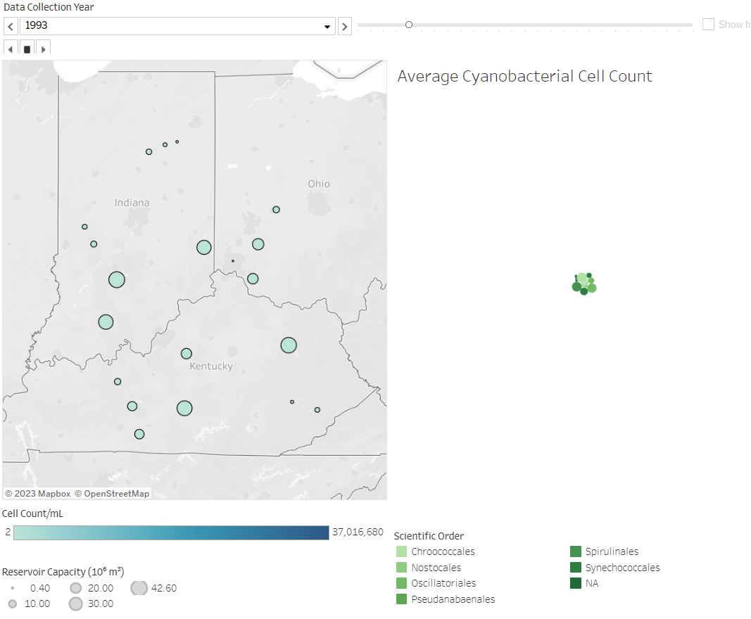

## Figure 1: Cyanobacteria presence in reservoirs in 1993

## Figure 2: Cyanobacteria presence in reservoirs in 2017

## Figure 3: Cyanobacteria vs Nutrient Concentration

# 4 Conclusion

By creating and analyzing Tableau visualizations, we successfully tracked the presence of cyanobacteria and reached conclusions that largely agree with those that the original researchers drew. Since approximately 2008, cyanobacterial cell counts appear to be increasing, which could pose a problem to human, animal, and ecological health in the future if trends continue. The greatest increases in cyanobacterial cell counts can be seen in reservoirs surrounded primarily by agricultural land. Increased cyanobacterial cell counts seem to be related to higher phosphorus concentrations. Phosphorous is a primary ingredient in agricultural fertilizers [5]. To a lesser extent, algal blooms appear to be related to the ammonia and Kjeldahl nitrogen concentrations in the reservoirs. These most likely come from both fertilizer and any animal waste in the vicinity (cattle, etc) [6].

**Acknowledgements**

The authors wish to thank Dr. Yusuf Bilgic for giving us the tools and skills necessary in implementing our visual analytical research.

**References**

1. N. J. Smucker, J. J. Beaulieu, C. T. Nietch, and J. L. Young, “Increasingly severe cyanobacterial blooms and deep water hypoxia coincide with warming water temperatures in reservoirs,” *Global Change Biology*, vol. 27, no. 11, pp. 2507–2519, 2021.
2. N. Smucker, “1987-2018 cyanobacteria and water quality data for 20 reservoirs,” *EPA*. [Online]. Available: https://edg.epa.gov/metadata/catalog/search/resource/details.page?uuid=https%3A%2F%2Fdoi.org%2F10.23719%2F1503175. [Accessed: 03-Apr-2023].
3. W. A. Pike, J. Stasko, R. Chang, and T. A. O'Connell, “The Science of Interaction,” *Information Visualization*, vol. 8, no. 4, pp. 263–274, Jul. 2009.
4. D. Norman, “Chapter 2: The Psychology of Everyday Actions,” in *The design of everyday things: Revised and expanded edition*, New York: Perseus Books L.L.C., 2013.
5. M. R. Hart, B. F. Quin, and M. L. Nguyen, “Phosphorus runoff from agricultural land and direct fertilizer effects: A Review,” *Journal of Environmental Quality*, vol. 33, no. 6, pp. 1954–1972, 2004.
6. D. Hill, W. Owens, and P. Tchounwou, “Impact of animal waste application on runoff water quality in field experimental plots,” *International Journal of Environmental Research and Public Health*, vol. 2, no. 2, pp. 314–321, 2005.

# Appendix

The cyanobacteria data used and other cyanobacteria data can be found here: <https://edg.epa.gov/metadata/catalog/search/resource/details.page?uuid=https://doi.org/10.23719/1503175>

The tableau workbook can be found here:

<https://public.tableau.com/app/profile/grace.t.long.torales/viz/GraceJessicaFinal/Final>