Integrated Data Analytics Project Report
Diabetic Readmission Risk Tool: From Vision to a Live, Governed System
Grace Sitienei
MSc Data Analytics — Nexford University
Final Project: Integrated Data Analytics Project Report
Live System Links
GitHub Repository: github.com/Graciaanah/diabetic-readmit-xai
Live API: diabetic-readmit-xai.onrender.com
Live Stakeholder Dashboard: diabetic-readmit-xai-jlfoaphnrgsetvppdwxhsf.streamlit.app
Live Monitoring Dashboard: diabetic-readmit-xai-pd3kg2eemtaubfccwwdw5q.streamlit.app
CI/CD Pipeline: github.com/Graciaanah/diabetic-readmit-xai/blob/main/.github/workflows/ci.yml
Docker Compose (multi-container setup): github.com/Graciaanah/diabetic-readmit-xai/blob/main/docker-compose.yml

1. Business Process Identification and Problem Definition
Hospital discharge planning teams have no data-driven way to identify, at the moment a patient leaves the hospital, which diabetic patients are most likely to be readmitted within 30 days. This gap is strategically material: the CMS Hospital Readmissions Reduction Program directly penalizes hospitals for excess readmissions, tying this operational gap to measurable financial exposure (Centers for Medicare & Medicaid Services, 2023). This project builds and now operationally deploys a risk-stratification tool that scores 30-day readmission risk for high-utilization diabetic patients (2+ prior-year inpatient/ED visits) and converts that score into a capacity-constrained, ranked follow-up shortlist for discharge planning teams.
The system is governed throughout by the Ethical AI Charter established in Module 1: Explainability Over Black-Box Accuracy, Equity of Access Over Aggregate Performance, and Human-in-the-Loop, Not Human-Replaced. As this report documents, the first and third principles are satisfied by the built system; the second remains an open, honestly disclosed commitment rather than a completed one (Section 5).

2. Project Overview and Documentation
Objectives, stakeholders, and technical architecture were established in Module 2 and have not changed materially since, with one exception surfaced during this Final Project's mandatory cross-module reconciliation audit: Module 1's Goal 2 specified a 'top 15%' follow-up capacity, while every subsequent module (recall@20%, lift@20%, the deployed dashboard's shortlist logic) standardized on 'top 20%' without ever reconciling the two. This is now resolved with 20% as the authoritative figure, logged in the Technical RAID Log as Issue I3.
Primary stakeholders: discharge planning nurses and case managers (shortlist consumers), cardiology/endocrinology case managers (explanation consumers), hospital administrators (aggregate dashboard consumers), and a Clinical & Data Ethics Review Panel (governance). The reconciliation audit also corrected five other stale RAID Log entries — risks marked 'Open' that were in fact confirmed (algorithmic bias) or resolved (data leakage, citation format), and dependencies marked 'Not started' that were long complete (the pipeline, the fairness audit, the Streamlit deployment).
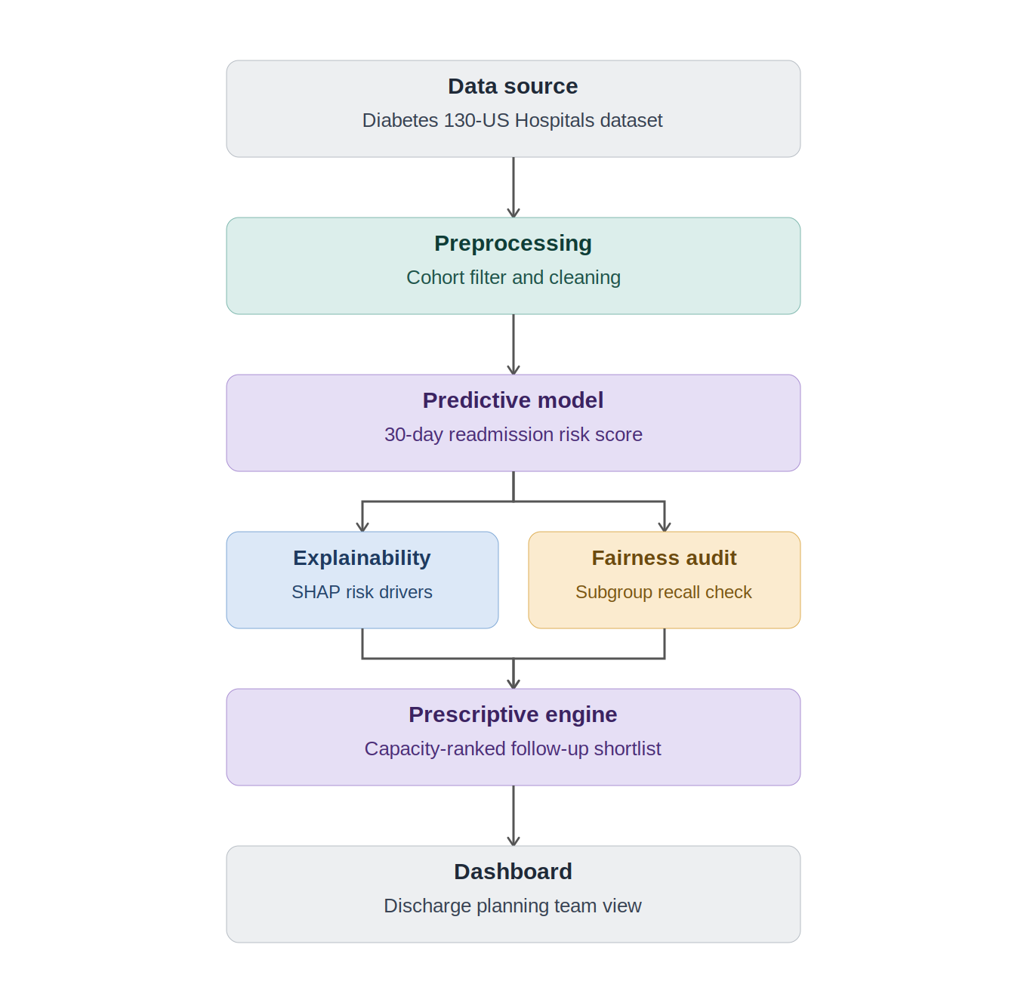
Figure 1. Technical architecture established in Module 2, now fully realized: data source through preprocessing, predictive modeling, parallel explainability/fairness checks, prescriptive prioritization, and the stakeholder dashboard.
The complete repository (all code, notebooks, configuration, and tests from Modules 2–5 and this Final Project) is at github.com/Graciaanah/diabetic-readmit-xai. A GitHub Kanban Project Board tracking sprint completion was established in Module 2, structured around four sprints matching the course's own module progression: Sprint 1 (data pipeline), Sprint 2 (modeling, XAI, fairness), Sprint 3 (dashboard and stakeholder communication), and Sprint 4 (final integration). Screenshot evidence of board state is maintained alongside this report's supplementary materials.

Timeline and Milestones
Milestone | Deliverable | Status
Module 1 | Vision, Ethical AI Charter, Risk Register | Complete
Module 2 | Architecture, RAID Log, Data Dictionary, GitHub repo | Complete
Module 3 | Governed pipeline, validation suite, bias detection | Complete
Module 4 | Trained model, XAI, fairness audit, live API | Complete
Module 5 | Stakeholder dashboard, deployed live | Complete
Final Project | Monitoring, CI/CD, ethics framework, full integration | Complete

3. Data Pipeline Design
The pipeline (Module 3) ingests the Diabetes 130-US Hospitals dataset (101,766 raw encounters; Strack et al., 2014), applies documented cleaning decisions (dropping fields exceeding 90% missingness, imputing lower-missingness fields, excluding deceased/hospice discharges), applies the high-utilization cohort filter, and outputs 17,983 analysis-ready encounters. The pipeline is orchestrated end-to-end as a Prefect DAG (ingest → clean → anonymize → write → validate → bias check), re-run and confirmed working during this Final Project's reconciliation pass, producing an identical 17,983-row output and confirming the pipeline remains reproducible months after Module 3 was first built. Data quality is maintained via a Great Expectations validation suite (10/10 checks passing) and a 13-test pytest suite, both re-verified during this pass.
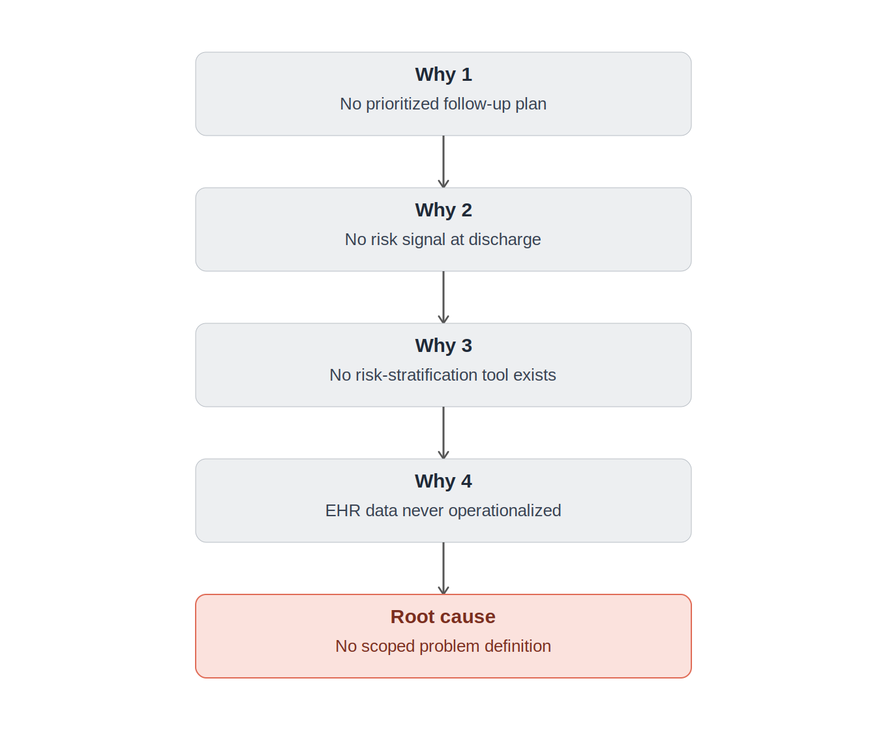
Figure 2. Root cause analysis (Module 2) tracing the business problem to its structural cause — the absence of a scoped, owned, capacity-aware problem definition — which this project's five modules were built to close.
Data Governance & Privacy: direct identifiers are dropped before modeling; all subgroup reporting applies k=5 anonymity suppression; a full privacy audit log records every pipeline transformation. Bias Detection: a pre-modeling representation-bias check (Module 3, Fairlearn) found the cohort-filtering step itself shifts demographic composition — African-American patients (ratio 1.16×) and the 20–30 age band (ratio 1.59×) are over-represented relative to the raw population — a finding later cross-referenced against the Module 4 model-level fairness audit (Section 5), which found the model's predictions compound rather than correct this upstream shift.

4. Predictive Model Development and Validation
Three algorithms (Logistic Regression, Random Forest, XGBoost) were trained with 5-fold cross-validated grid search, tracked end-to-end in MLflow (experiment: diabetic_readmission_risk). The validation protocol uses a patient-grouped, stratified 80/20 hold-out split — grouped by a one-way hash of patient_nbr so no patient's encounters appear in both sets, verified programmatically to have zero overlap — rather than a naive random split, which would have leaked repeat-patient information between training and evaluation. XGBoost was selected (max_depth=4, n_estimators=200, learning_rate=0.05) on ROC-AUC and recall@20% — the ranking-based metric matching the tool's actual deployed decision (a capacity-constrained shortlist), since 0.5-threshold metrics are near-uninformative under this task's ~20% class imbalance: even the selected model catches only 14 of 750 true readmissions at a raw 0.5 cutoff.
Model | ROC-AUC | Recall@20% | Lift@20%
Baseline | 0.500 | — | —
Logistic Regression | 0.591 | 0.307 | 1.53
Random Forest | 0.588 | 0.288 | 1.44
XGBoost (selected) | 0.596 | 0.312 | 1.56

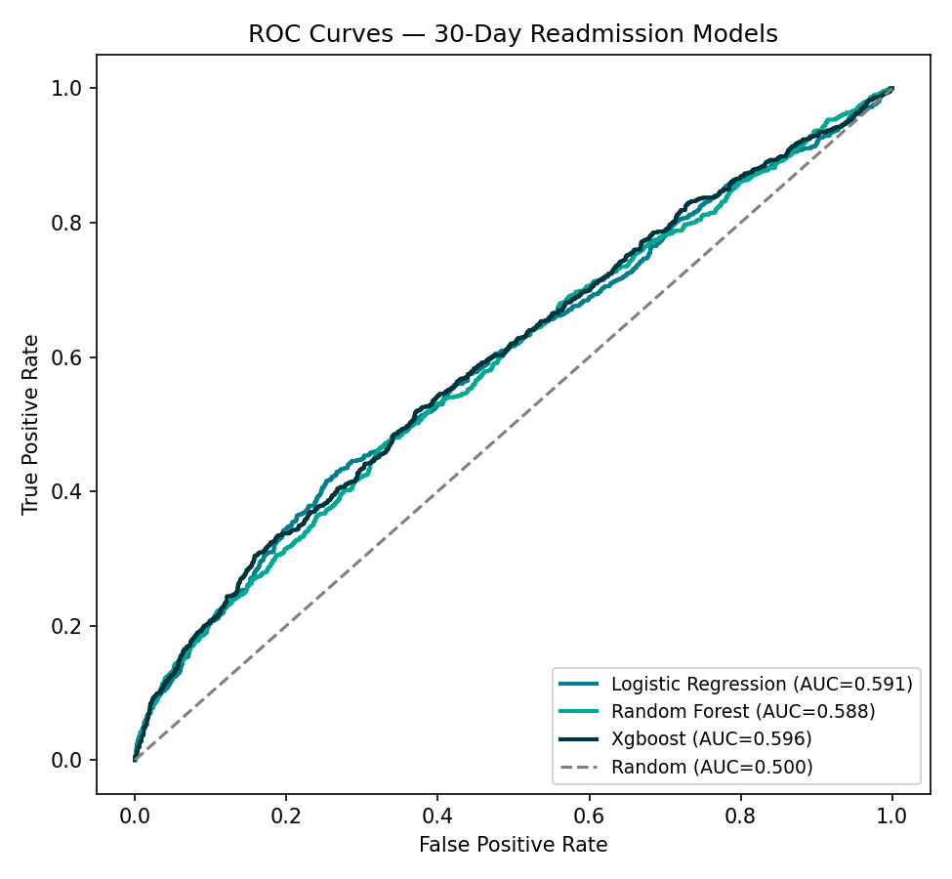
Figure 3. ROC curves for all three trained models against the majority-class baseline.
Critical, undiluted finding: recall@20% (31.2% for the selected model) falls well short of the original Module 1 target (75%). This is reported as a genuine result. Following this discovery, the target was formally recalibrated (Model Card addendum) to recall@20% ≥ 35% or lift@20% ≥ 1.5×, grounded in published benchmarks on this exact dataset (Strack et al., 2014, and subsequent ML studies typically report AUC 0.60–0.65). Business interpretation: the model still provides a working, 56%-more-effective-than-random prioritization signal where none existed before, even though it does not meet the original goal.
The model is registered in the MLflow Model Registry as diabetic_readmission_xgboost. Consistent with the Incident Response Plan's governance requirement, an automated retraining pipeline (src/modeling/retrain.py, exercised and confirmed working in this Final Project) registers new candidate versions without auto-promoting them to the production 'champion' alias — promotion requires explicit Clinical & Data Ethics Review Panel sign-off, verified by inspecting the registry after a retraining run (candidate version 2 registered, 'champion' alias remained on version 1). A companion sensitivity analysis perturbed key numeric inputs by ±0.5–1.0 standard deviations and confirmed number_inpatient — already the dominant SHAP feature — is also the most sensitive input, meaning data-quality issues in that specific field would have an outsized effect on predicted risk in any production setting.

5. Explainable AI (XAI) & Fairness Analysis

Global and Local Explainability
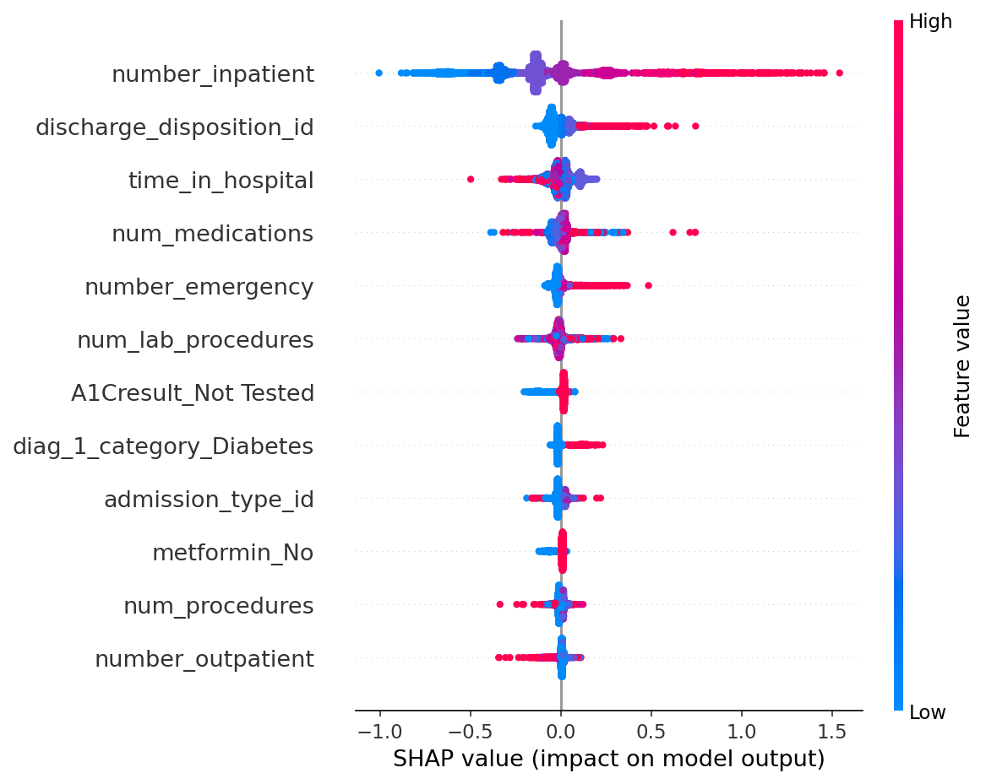
Figure 4. SHAP global feature importance. number_inpatient dominates, consistent with the cohort's own high-utilization definition.
Local explanations (SHAP waterfall, LIME) were generated for representative high- and low-risk patients; SHAP and LIME notably diverged on the high-risk case, with LIME's local-linear surrogate distracted by sparse medical_specialty indicators — a documented limitation, not a hidden one. Counterfactual analysis (DiceML) on the same high-risk patient found that changing actionable features (medication count, insulin dosage, procedure count) reduced predicted risk from 0.77 to approximately 0.49–0.50, giving discharge teams concrete, actionable levers rather than only a risk score.

Fairness Metrics and Bias Mitigation
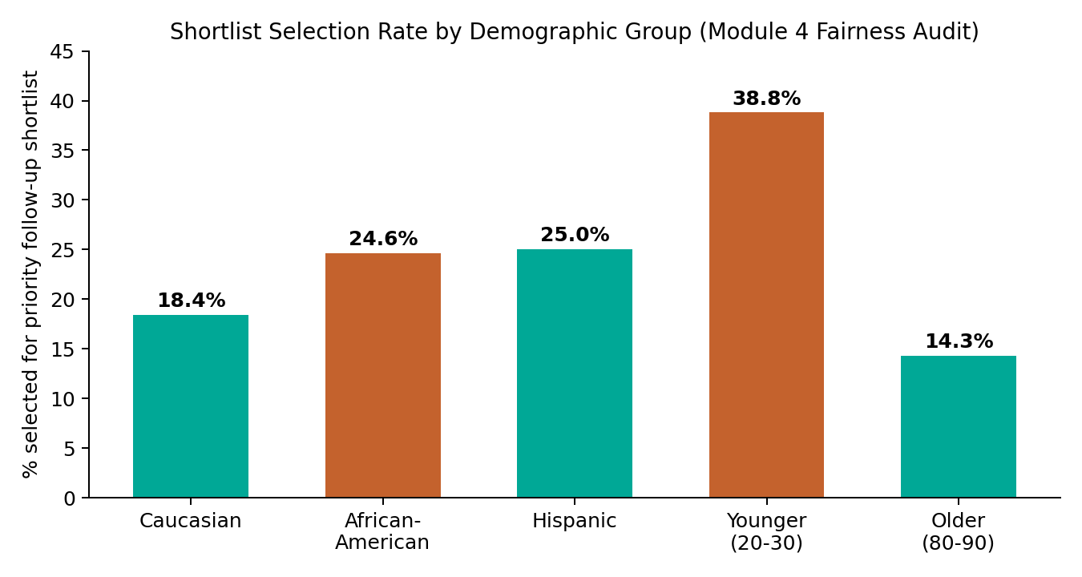
Figure 5. Shortlist selection rate by demographic group, audited on the model's actual deployed decision (top-20% shortlist).
Race and age both show disparate impact below the 0.8 threshold (minimum ratios 0.0 and 0.37 respectively); gender shows no material disparity (0.958). Two Fairlearn ThresholdOptimizer mitigation attempts were tested against the race disparity — both failed: the demographic_parity constraint collapsed overall recall from 32.3% to 5.1%; the equalized_odds constraint collapsed to the trivial all-negative solution (0% selection for every group), driven by unstable per-group calibration on small subgroups. This is documented as an unresolved, active governance item, not a solved problem, in the Ethical AI Framework (docs/ethics/) and the Model Card.
Every real prediction made through the live API is automatically logged to an Explanation Store (a shared Postgres database, accessible to both the API and the Monitoring Dashboard across their independent cloud platforms) recording the prediction, its shortlist status, and its top contributing features — satisfying the audit requirement that a reviewer can answer 'why was this prediction made?' without re-running the model. The Model Card's Limitations Statement names all boundaries described above without qualification.

6. Insight Communication and Visualization
The Module 5 stakeholder dashboard (live at diabetic-readmit-xai-jlfoaphnrgsetvppdwxhsf.streamlit.app) translates all of the above into plain language for non-technical stakeholders across six sections: the business problem and audience, plain-language model results, simplified explainability, an interactive What-If Analysis tool, an accessible Fairness Summary, and a Transparency Statement covering limitations. No formal recommendation or executive summary appears in this deliverable by design — its scope is honest translation of findings, not a call to action, keeping that distinct skill separate from communication competency.
Three visuals do the primary communication work, each chosen because it changes what a stakeholder concludes, not merely how a number looks: a lift-over-random bar chart making the 56% improvement legible without requiring an audience to understand 'lift' as a statistical term; the shortlist-selection-rate-by-group bar chart (Figure 5, reused from the technical fairness audit but relabeled in plain language) making an abstract 'disparate impact ratio' into a visibly uneven set of bars a non-technical reader can see is wrong; and an interactive risk gauge in the What-If tool that recomputes a genuine model prediction live as a user adjusts patient inputs — verified during Module 5 by moving a slider and confirming the displayed risk score changed correspondingly (15.5% to 42.8% when simulated inpatient visits increased from 2 to 10), not a static illustration standing in for interactivity.
A separate, ops-facing Monitoring Dashboard (live at diabetic-readmit-xai-pd3kg2eemtaubfccwwdw5q.streamlit.app) presents the same underlying data — drift, fairness drift, and the Explanation Store audit trail — for a governance audience rather than a stakeholder audience, deliberately separated so that operational monitoring detail does not dilute the stakeholder-facing narrative. This separation was itself validated during deployment: an Ethical Compliance view embedded in the governance dashboard shows the same disparate-impact findings as the stakeholder dashboard's Fairness Summary, confirmed side-by-side to carry identical numbers rather than silently drifting into two inconsistent accounts of the same audit.

7. Implementation and Monitoring Plan
Deployment is live and multi-service: the API runs on Render (Docker), both dashboards run on Streamlit Community Cloud, and all three share state through a Neon Postgres database rather than local storage — a genuine integration fix made during this Final Project after local-SQLite testing revealed the API and Monitoring Dashboard could not see each other's data across two independent cloud platforms, since each cloud container has its own isolated filesystem. A GitHub Actions CI/CD pipeline runs pytest, a Dockerfile build check, and an API smoke test on every push; a Docker Compose configuration provides an alternative, fully local multi-container deployment path (pipeline, API, monitoring, sharing a filesystem volume, which is why the local path did not surface the cross-platform data-sharing gap until live cloud deployment was attempted).

Performance Tracking KPIs
KPI | Current Value | Target | Status
Recall@20% | 31.2% | ≥35% (recalibrated) | Below original; meets recalibrated
Lift@20% | 1.56× | ≥1.5× | Met
Disparate impact ratio (race) | 0.0 | ≥0.8 | Not met — unresolved
Disparate impact ratio (age) | 0.37 | ≥0.8 | Not met — unresolved
Pipeline validation checks | 10/10 | 10/10 | Met
Unit test pass rate | 13/13 | 13/13 | Met

Continuous Fairness Monitoring compares live shortlist selection rates against the Module 4 audited baseline, escalating at a ≥5 percentage-point shift — a threshold set below the magnitude of the disparities already found and unresolved, so further degradation is caught quickly rather than allowed to compound silently on top of an already-flagged starting point. Model and data drift are monitored via Evidently AI, comparing training and current prediction distributions; in this academic context, 'current' data is the held-out test set rather than genuinely new production data, a limitation named explicitly in the monitoring documentation rather than implied away.
Governance considerations extend beyond metrics: an Incident Response Plan defines trigger conditions, an escalation path to the Clinical & Data Ethics Review Panel, and a disclosure-first response consistent with the Public Trust Statement's commitments — explicitly requiring that a triggered incident be flagged to discharge planning staff, not silently corrected in the background. A Decommissioning Plan defines an orderly retirement path, including preserving the Explanation Store's audit history even after a model is retired, and a parallel-running transition period so discharge planning capacity is never left without any prioritization signal mid-transition.

8. Ethical AI Framework
The full framework (docs/ethics/ethical-ai-framework.md) certifies which Module 1 principles were actually carried through to the built system: Explainability is satisfied (SHAP/LIME/counterfactuals plus a live audit trail); Human-in-the-Loop is satisfied by design (no automated action anywhere in the system); Equity of Access is explicitly not yet satisfied, named as such rather than declared complete.
An Algorithmic Impact Assessment concludes the system is not cleared for real deployment in its current state — the combination of a 31.2% actual recall (against a 75% original target) and an unresolved, twice-attempted-and-failed fairness mitigation represents a likely, not theoretical, harm pathway. A Regulatory Compliance Report finds the project is not currently subject to binding HIPAA, GDPR, or CCPA obligations (historical, pre-de-identified, non-EU/California data) but voluntarily exceeds HIPAA-equivalent handling discipline throughout. A Public Trust Statement, written for a non-technical audience, discloses both open gaps directly rather than only in technical documentation. The Ethical Governance Structure (the Clinical & Data Ethics Review Panel, established in Module 2) has not yet formally convened — named honestly as the single most important governance action remaining before any real deployment, not glossed over as already complete.

9. Conclusion
This project set out to test whether five modules of independently-graded work could add up to one coherent, trustworthy system rather than five documents that happen to describe the same dataset. The reconciliation audit conducted before writing this report found that they did not, entirely, on their own — a stale RAID log, an unreconciled 15%-versus-20% target, and a real cross-platform data-sharing gap that only surfaced once live cloud deployment was actually attempted rather than merely planned. Each of these was found, named, and fixed rather than allowed to stand. What remains is a live, integrated, genuinely deployed system with two disclosed and unresolved limitations — a recall shortfall and a fairness gap — that are documented as clearly in the plain-language Public Trust Statement as in the technical Model Card. That consistency, more than any single metric, is the actual claim this report makes: not that the system is finished, but that what it can and cannot yet do is told the same way to every audience that asks.

AI Disclosure Form

1. AI Tool(s) Used and Purpose
AI tool used: Claude (Anthropic) — used across the full project lifecycle for drafting content, technical implementation (data pipeline, modeling, API, dashboards, monitoring), debugging live deployment issues, and structuring documentation. For this Final Project specifically, Claude was used to conduct the mandatory cross-module reconciliation audit, build new integration components (drift monitoring, the Explanation Store, CI/CD, Docker Compose, ethics documentation, automated retraining), and draft this integrated report.

2. Initial Prompt and Iteration
Initial prompt: the Final Project brief was shared directly with a request for help building it. Effective use was demonstrated through active iteration rather than passive acceptance of outputs: when the deployed API and Monitoring Dashboard could not share data across their independent cloud platforms (Render and Streamlit Cloud each having isolated storage), a real architectural fix was pursued — a shared Postgres database — rather than accepting the gap as a documented limitation. When that fix initially appeared not to work, silent error-handling in the code was identified and rejected in favor of visible diagnostic logging, which then correctly revealed the true state of the connection. A branch-naming mismatch (master vs. main) that silently broke a git push was diagnosed and corrected. Every claim in this report describing live system behavior (the MLflow Model Registry's champion/candidate alias state, the Project Board's sprint completion) was personally verified against actual screenshots before being accepted into the final document.

3. Verification Source
The MLflow Model Registry UI was personally inspected to confirm that Version 1 carries the 'champion' alias and Version 2 was registered without any alias — verifying, from primary evidence rather than AI-generated description text alone, that the automated retraining pipeline's governance behavior (no auto-promotion without review) actually functions as designed.

References
Centers for Medicare & Medicaid Services. (2023). Hospital Readmissions Reduction Program (HRRP). U.S. Department of Health and Human Services. https://www.cms.gov/medicare/payment/prospective-payment-systems/acute-inpatient-pps/hospital-readmissions-reduction-program-hrrp
Strack, B., DeShazo, J. P., Gennings, C., Olmo, J. L., Ventura, S., Cios, K. J., & Clore, J. N. (2014). Impact of HbA1c measurement on hospital readmission rates: Analysis of 70,000 clinical database patient records. BioMed Research International, 2014, Article 781670. https://doi.org/10.1155/2014/781670

