Business Analytics Project Overview Report
Diabetic Readmission Risk Stratification: From Vision to Delivery Plan
Grace Sitienei
MSc Data Analytics — Nexford University
Module 2: Business Analytics Project Overview Report

1. Define the Business Problem
This project builds directly on the Module 1 Vision Document, carrying forward the same vertical, problem, and dataset. The core issue is that hospital discharge planning teams have no data-driven way to identify which diabetic patients, among those with a high prior-year utilization burden (two or more inpatient or emergency-department visits), are most likely to be readmitted within 30 days — and therefore cannot direct their limited weekly follow-up capacity toward the patients who need it most.
Applying the problem-identification framework: (define) the problem is scoped exactly as narrowed in Module 1 — a capacity-constrained, discharge-planning-owned risk-prioritization gap, not a general “reduce readmissions” goal; (gather data) the Diabetes 130-US Hospitals dataset (101,766 encounters, 130 U.S. hospitals, 1999–2008; Strack et al., 2014) supplies the demographic, admission, utilization, and clinical fields needed; (analyze) Section 2 traces the problem to its structural cause; (root cause) the absence of a scoped, owned decision-support tool; (objectives) the three SMART goals defined in Module 1 — recall@20% ≥ 75%, a capacity-sized shortlist with measurable lift over random selection, and a top-5 explainable driver set.
This alignment is intentional: every objective in this planning document maps to a goal already justified in Module 1, so nothing here re-argues the business case — it only makes that case executable by a technical team.
Scope is deliberately bounded to match Module 1: this is a retrospective, dataset-driven build using historical (1999–2008) data, not a live clinical integration. Expected deliverables from this planning phase are an initialized GitHub repository matching the Module 1 directory structure, a defined sprint board, a technical architecture diagram, a Technical RAID Log, and the privacy, fairness, and compliance requirements formalized in Section 6 — each of which a technical team could pick up tomorrow without needing to re-derive the vision or the ethical constraints from scratch.

2. Root Cause Analysis
A 5 Whys analysis was used to trace the readmission problem to its structural root cause (Figure 1).
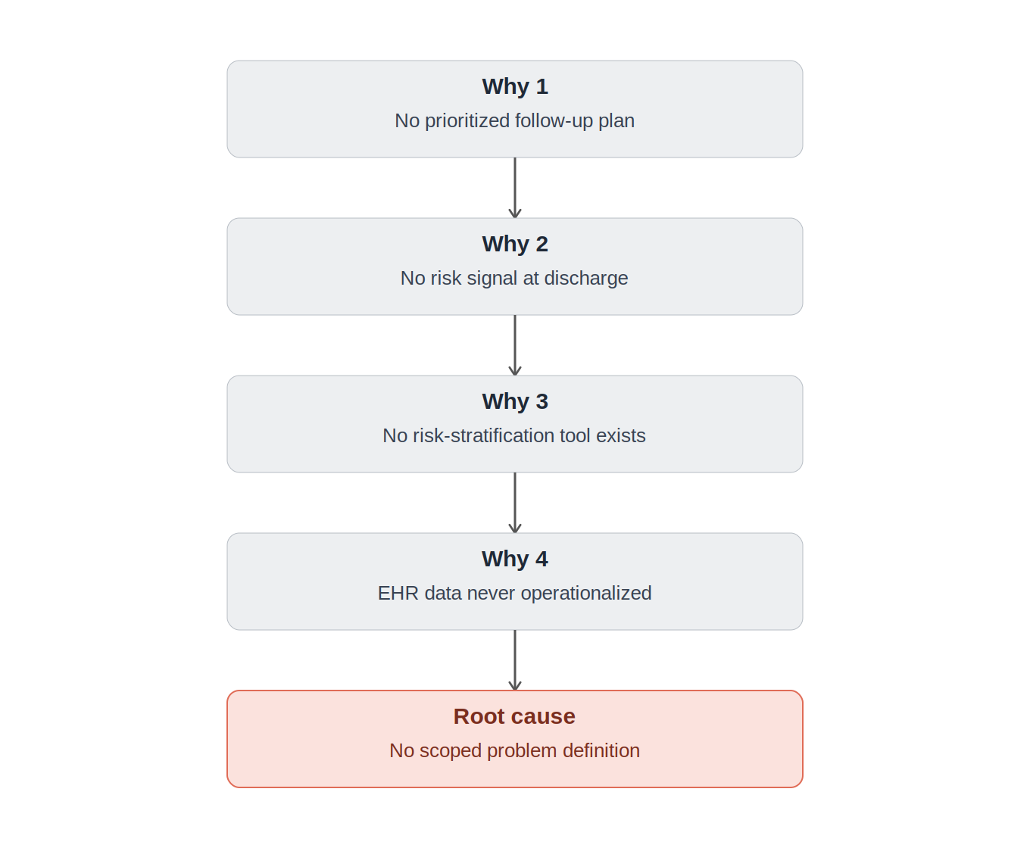
Figure 1. 5 Whys analysis tracing the readmission problem to its root cause.
The chain shows that patients are readmitted because follow-up is not matched to risk (Why 1–2), because no consistent risk signal exists at discharge (Why 3), because the EHR data needed to build one has never been operationalized for this purpose (Why 4). The root cause is the absence of a scoped, owned, capacity-aware problem definition — exactly the gap Module 1 closed and this document now makes buildable.
This root cause links directly to the project's KPIs: recall@20% (Goal 1) directly replaces the ad hoc judgment identified at Why 2 with a consistent signal; lift over random selection (Goal 2) addresses the capacity-matching gap at Why 3; and the explainability output (Goal 3) makes that signal actionable rather than a black-box number, addressing Why 4.

3. Business Analytics Project Overview
Objectives, scope, and deliverables carry forward unchanged from Module 1: build a risk-stratification tool for discharge planning teams that scores 30-day readmission risk for the high-utilization diabetic cohort and converts that score into a capacity-constrained, ranked follow-up shortlist. Required data types are demographic (race, gender, age band), admission context (type, source, length of stay), prior utilization (inpatient/ED/outpatient visit counts), clinical (labs, HbA1c, diagnoses), and medication fields, all drawn from the Diabetes 130-US Hospitals dataset (Strack et al., 2014).
Two analytical methods are integrated: a predictive model producing the 30-day readmission risk score, and a prescriptive layer that ranks and sizes the follow-up shortlist to real weekly staffing capacity. Figure 2 formalizes the technical architecture first proposed as a stack table in Module 1, now shown as an end-to-end system diagram.
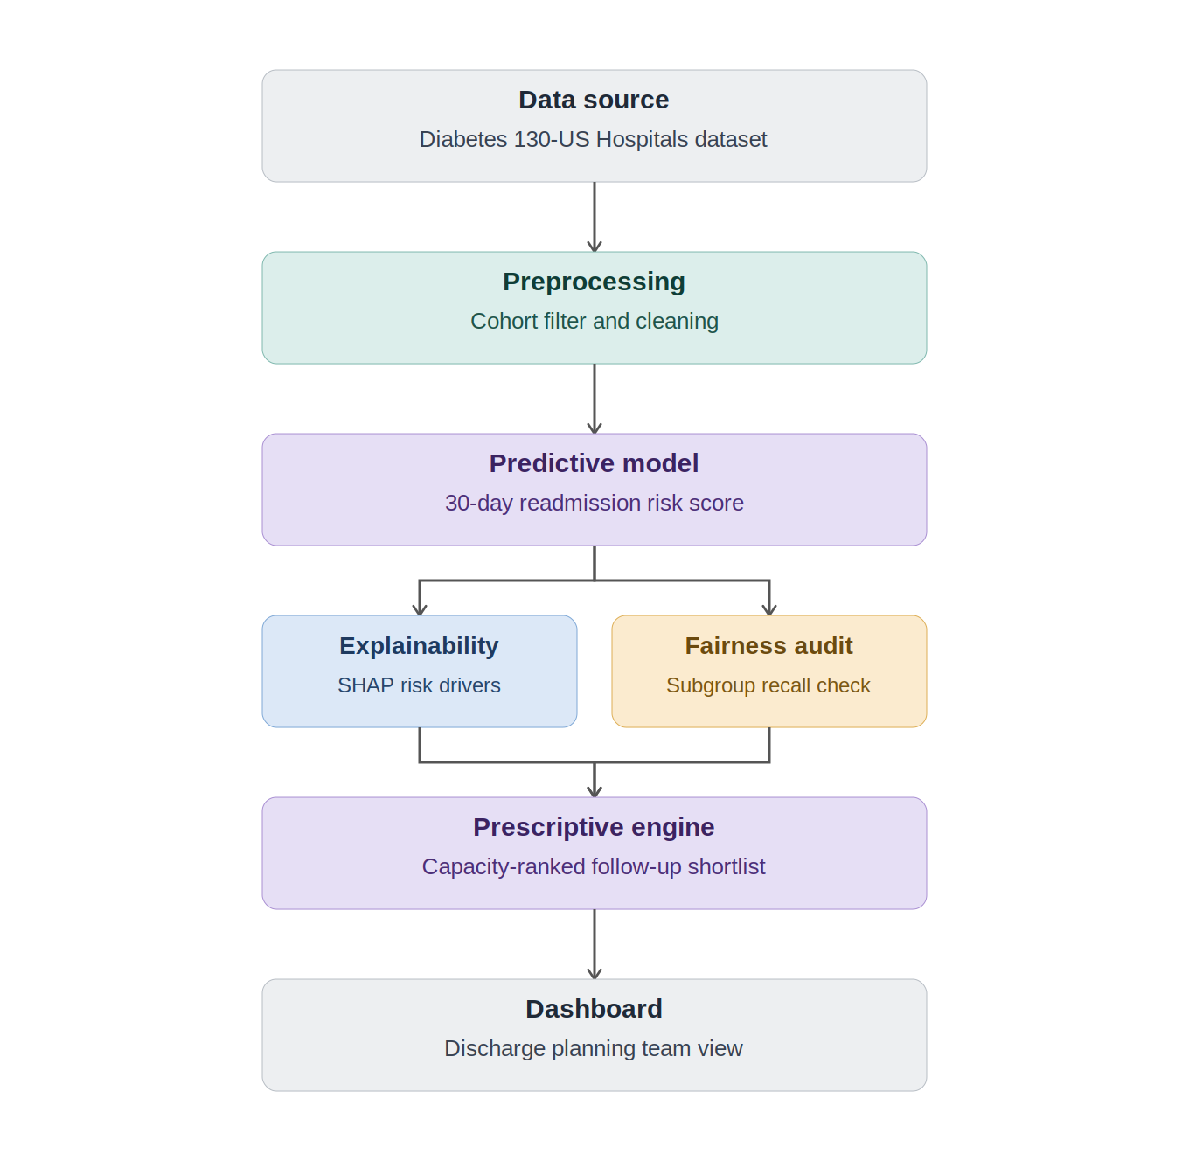
Figure 2. Technical architecture: data source through preprocessing, predictive modeling, parallel explainability/fairness checks, prescriptive prioritization, and the discharge-planning dashboard.
Each component in Figure 2 maps to a specific tool named in the Module 1 Technical Stack (pandas for preprocessing, scikit-learn/XGBoost for modeling, SHAP for explainability, Fairlearn for fairness auditing, Streamlit for the dashboard) and to a folder in the Module 1 repository structure (src/preprocessing/, src/modeling/, src/fairness/, dashboard/).

4. Agile Methodology
The project is delivered as four sprints, each corresponding to a course module, allowing iterative feedback (instructor and, conceptually, discharge-planning stakeholders) between stages rather than a single end-to-end build. This mirrors agile's core value of adapting the plan as each sprint surfaces new information — for example, if Sprint 1 data-quality findings change the viable cohort size, Sprint 2's modeling scope adjusts accordingly rather than proceeding on stale assumptions.
This iterative structure also protects value delivery under uncertainty: because Sprint 2's fairness audit could surface a subgroup disparity that requires revisiting feature choices, the plan treats that as an expected checkpoint rather than a failure state, consistent with the Human-in-the-Loop and Equity of Access principles from the Module 1 Ethical AI Charter. Each sprint closes with a defined output reviewed before the next begins, so scope changes are absorbed one sprint at a time instead of compounding silently across the whole build.
Sprint | Module | Focus | Key tickets
Sprint 1 | Module 3 | Data pipeline | Ingest data; drop high-missingness fields; cohort filter; patient-level split
Sprint 2 | Module 4 | Model, XAI, fairness | Train model; tune recall@20%; SHAP layer; Fairlearn audit; shortlist logic
Sprint 3 | Module 5 | Dashboard | Build dashboard; driver display; fairness report view; stakeholder deck
Sprint 4 | Final Project | Integration | End-to-end test; deploy; finalize documentation

A GitHub Project Board (Kanban) was created with Backlog, To Do, In Progress, In Review, and Done columns, with tickets from the table above entered as issues and labeled by sprint, directly referencing the Module 1 repository structure (each ticket links to the repo folder it produces work in).

5. Implementation and Communication Plan
Stakeholder roles carry forward from Module 1: discharge planning nurses and case managers consume the ranked shortlist and retain override authority; cardiology/endocrinology case managers consume SHAP driver explanations to shape follow-up content; hospital administrators consume the aggregate dashboard for HRRP penalty tracking; the Clinical & Data Ethics Review Panel reviews fairness results before each sprint's model is considered final. Communication flows sprint-to-sprint: each sprint's output (data quality report, model + fairness audit, dashboard) is reviewed before the next sprint begins, preventing downstream work from building on an unvalidated upstream stage.
Monitoring KPIs are the same three SMART metrics from Module 1 — recall@20% ≥ 75%, shortlist lift over random selection, and a documented top-5 driver set — tracked at the end of Sprint 2 and re-verified before Sprint 3 dashboard integration. If a KPI is not met at the Sprint 2 checkpoint, the plan calls for revisiting feature engineering or cohort scope before proceeding to Sprint 3, rather than shipping a dashboard built on an unvalidated model.

Technical RAID Log (Summary)
A full Technical RAID Log was developed as a companion spreadsheet, expanding the Module 1 Ethical Risk Register into Risks, Assumptions, Issues, and Dependencies tied to specific sprints. Key entries are summarized below.
Type | Item | Sprint | Mitigation
Risk | Algorithmic bias via demographic proxies | Sprint 2 | Fairlearn subgroup audit; Ethics Panel review
Risk | Data leakage from repeat patient encounters | Sprint 1 | Patient-level train/test split
Assumption | ~15% weekly follow-up capacity is realistic | Sprint 2 | Revisit shortlist size after lift results
Issue | NXU vs. APA citation format ambiguity | Module 1 (carried forward) | Confirm with instructor before submission
Dependency | Dashboard build depends on finalized SHAP/Fairlearn output | Sprint 2 → 3 | Freeze model version (SemVer tag) before integration

6. Privacy, Fairness & Compliance Requirements
This section operationalizes the Ethical AI Charter and Fairness Objectives from Module 1, converting stated principles into specific mechanisms a technical team can implement.

Data Privacy Plan
Patient and encounter identifiers are dropped before modeling; any subgroup breakdown in the fairness audit or dashboard suppresses or aggregates cells with fewer than five records (k-anonymity, k=5); no merging with external datasets is permitted at any stage; raw data remains isolated from processed, de-identified data used downstream; and all data is retained only for the course engagement, with a defined deletion point at close-out, per the Module 1 Data Governance Principles.

Fairness Metrics
Module 1's qualitative Fairness Objectives are operationalized here as two specific, Fairlearn-computed metrics: Demographic Parity (selection-rate difference into the high-risk shortlist across race, age band, and gender) and Equalized Odds (recall and false-positive rate parity across the same subgroups), both reported at every model iteration in Sprint 2, not only at final delivery.

Explainability Framework
SHAP is applied at two levels: globally, to produce the top-5 cohort-wide risk drivers required by Goal 3; and locally, to produce a per-patient explanation a discharge planner can act on. Output is rendered as plain-language driver labels rather than raw feature names or SHAP plots, consistent with the Explainability Over Black-Box Accuracy principle.

Regulatory Compliance Checklist
Regulation | Applicability | Status
HIPAA (current) | Source data de-identified; HIPAA-equivalent discipline applied voluntarily | Applied
HIPAA (future real-EHR use) | Would require data-use agreement and IRB review | Flagged, not yet applicable
GDPR | Not applicable — U.S.-sourced data, no EU subjects | N/A
CCPA | Not applicable — outside CCPA's scope | N/A

References
Centers for Medicare & Medicaid Services. (2023). Hospital Readmissions Reduction Program (HRRP). U.S. Department of Health and Human Services. https://www.cms.gov/medicare/payment/prospective-payment-systems/acute-inpatient-pps/hospital-readmissions-reduction-program-hrrp
Strack, B., DeShazo, J. P., Gennings, C., Olmo, J. L., Ventura, S., Cios, K. J., & Clore, J. N. (2014). Impact of HbA1c measurement on hospital readmission rates: Analysis of 70,000 clinical database patient records. BioMed Research International, 2014, Article 781670. https://doi.org/10.1155/2014/781670

