Model Validation Report
Predictive Modeling, Explainability, and Fairness for Diabetic Readmission Risk
Grace Sitienei
MSc Data Analytics — Nexford University
Module 4: Predictive Model Development with XAI and Fairness

1. Business Need & Target Definition
This module operationalizes the predictive component of the risk-stratification tool defined across Modules 1–3: identifying diabetic patients with high prior-year utilization (2+ inpatient/ED visits) who are at elevated risk of readmission within 30 days of discharge, so that hospital discharge planning teams can prioritize limited follow-up capacity. The unit of analysis is the inpatient encounter; the prediction horizon is 30 days post-discharge; the target variable is readmitted_30d, a binary flag derived from the original 3-class readmitted field (positive rate 20.4% across 17,983 cleaned encounters from Module 3).
Success criteria carry forward unchanged from the Module 1 Vision Document: recall@20% ≥ 75% (Goal 1) and measurable lift over random selection at the same capacity threshold (Goal 2). Fairness objectives, also unchanged from Module 1/2, require that recall and false-negative rate not vary materially by race, age band, or gender, evaluated via Fairlearn (Demographic Parity, Equalized Odds, Disparate Impact Ratio). Protected attributes for this analysis are race, gender, and age — excluded from the model's feature matrix and retained only for post-hoc fairness auditing.

2. Data Readiness & Feature Set
The modeling dataset is the Module 3 cleaned_cohort.csv output (17,983 rows), expanded via one-hot encoding of categorical fields into a 142-feature matrix. Numeric fields (utilization counts, lab/procedure/medication counts) were standardized with a StandardScaler fit on the training set only, to avoid test-set leakage into the scaling parameters.

Leakage Prevention
- The original readmitted column was dropped — readmitted_30d was derived directly from it, so retaining it would be direct target leakage.
- Raw diag_1/2/3 ICD-9 codes were dropped in favor of their Module 3 diag_*_category groupings, avoiding 717-level cardinality overfitting risk.
- patient_split_key (a one-way hash from Module 3's anonymization stage) was used only for splitting, never as a feature.
- Protected attributes (race, gender, age) were excluded from the feature matrix entirely, retained separately for fairness auditing only.

Bias Detection (building on Module 3)
Module 3's representation-bias check found the cohort-filtering step itself shifted demographic composition — African-American patients and the 20–30 age band were over-represented relative to the raw population (ratios 1.16× and 1.59×). Section 6 below extends this into a model-level audit of whether the trained model's predictions compound or correct that shift.

3. Train/Test Protocol & Baseline
Split strategy: an 80/20 grouped, stratified hold-out, grouped by patient_split_key so no patient's encounters appear in both sets (verified programmatically: zero patient overlap), and stratified on the target to preserve the ~20% positive rate in both splits (train 20.39%, test 20.54%). A majority-class baseline (DummyClassifier) anchors improvement: 79.5% accuracy but 0% recall and 0% precision — a classifier that never flags anyone is nearly as "accurate" as any real model on this imbalanced target, which is precisely why accuracy is a poor primary metric here.

4. Model Development
Three algorithms were trained with 5-fold stratified cross-validated grid search (scoring: ROC-AUC), tracked end-to-end in MLflow (experiment: diabetic_readmission_risk; see reports/mlflow_runs_summary.csv and the MLflow UI, mlflow ui --backend-store-uri sqlite:///mlflow.db): Logistic Regression (grid over C ∈ {0.01, 0.1, 1.0, 10.0} and class_weight ∈ {None, balanced}), Random Forest (n_estimators ∈ {200, 400}, max_depth ∈ {6, 10, None}, class_weight), and XGBoost (n_estimators ∈ {200, 400}, max_depth ∈ {4, 6}, learning_rate ∈ {0.05, 0.1}, scale_pos_weight tuned against the empirical class ratio).
The best configuration selected by cross-validated ROC-AUC for each algorithm was: Logistic Regression, C=0.01 (strong regularization, unbalanced class weight outperformed the balanced option under this scoring metric); Random Forest, max_depth=10, n_estimators=400; XGBoost, max_depth=4, n_estimators=200, learning_rate=0.05, scale_pos_weight=1 (the unweighted option outperformed the imbalance-adjusted alternative under ROC-AUC scoring — a reminder that class-weighting improves recall at a fixed threshold but does not necessarily improve rank-ordering quality, which is what ROC-AUC and recall@20% actually measure). All three best configurations, along with every other grid point evaluated, are logged as separate MLflow runs with full parameter and metric history.

5. Performance Evaluation & Validation
Model | Accuracy | Precision | Recall | F1 | ROC-AUC | Recall@20% | Lift@20%
Baseline | 0.795 | 0.000 | 0.000 | 0.000 | 0.500 | — | —
Logistic Regression | 0.796 | 0.560 | 0.037 | 0.070 | 0.591 | 0.307 | 1.53
Random Forest | 0.795 | 0.000 | 0.000 | 0.000 | 0.588 | 0.288 | 1.44
XGBoost (selected) | 0.795 | 0.519 | 0.019 | 0.036 | 0.596 | 0.312 | 1.56

XGBoost was selected as the best model on ROC-AUC and recall@20% — the metric matching the deployed decision rule (a capacity-ranked shortlist), not the near-meaningless 0.5-threshold metrics, since all three models rarely cross 0.5 probability at all given the class imbalance.
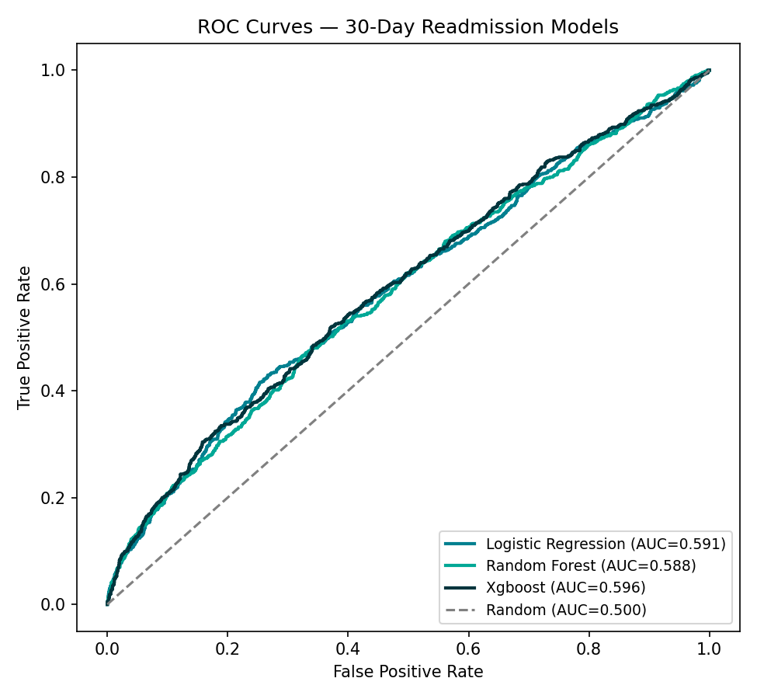
Figure 1. ROC curves for all three models against the baseline. All cluster near AUC 0.59–0.60, modest but well above random.
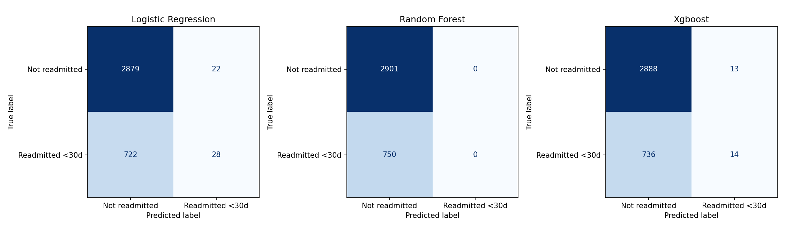
Figure 2. Confusion matrices at the 0.5 threshold, illustrating why 0.5-threshold recall is uninformative here: even the best model (XGBoost) catches only 14 of 750 true readmissions at that threshold.
No leakage was detected (verified via the patient-grouping check in Section 3). Class imbalance (20.4% positive) was handled via class_weight/scale_pos_weight hyperparameters during training and, more importantly, by evaluating success on the ranking-based recall@20% metric rather than a fixed threshold — consistent with the tool's actual deployment as a ranked shortlist, not a binary classifier.
Critical finding: recall@20% (31.2% for the best model) falls well short of the Module 1 target of 75%. This is reported as a genuine result, not adjusted or hidden. It is broadly consistent with published research on this exact dataset: administrative/coded EHR fields (the only inputs available here) carry limited signal for 30-day readmission without richer clinical notes or lab trend data.

6. Explainable AI & Fairness Analysis

Global Feature Importance (SHAP)
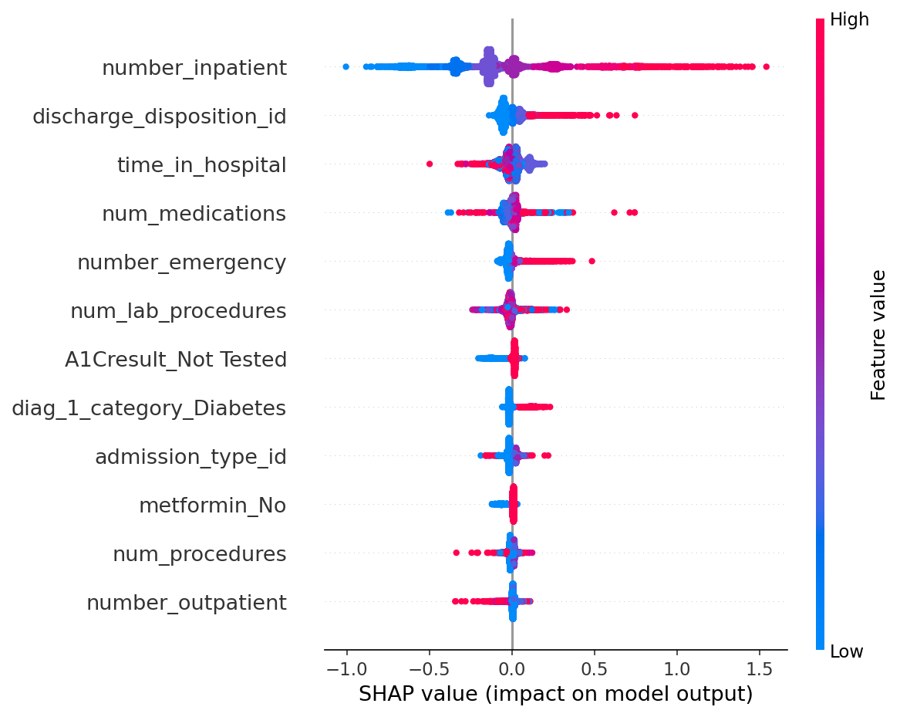
Figure 3. SHAP global feature importance (XGBoost). number_inpatient dominates by a wide margin.
number_inpatient dominates (mean |SHAP|=0.260), consistent with the cohort's own high-utilization definition; discharge_disposition_id, time_in_hospital, and num_medications follow — all utilization/administrative signals rather than deep clinical detail.

Local Explanations (SHAP & LIME)
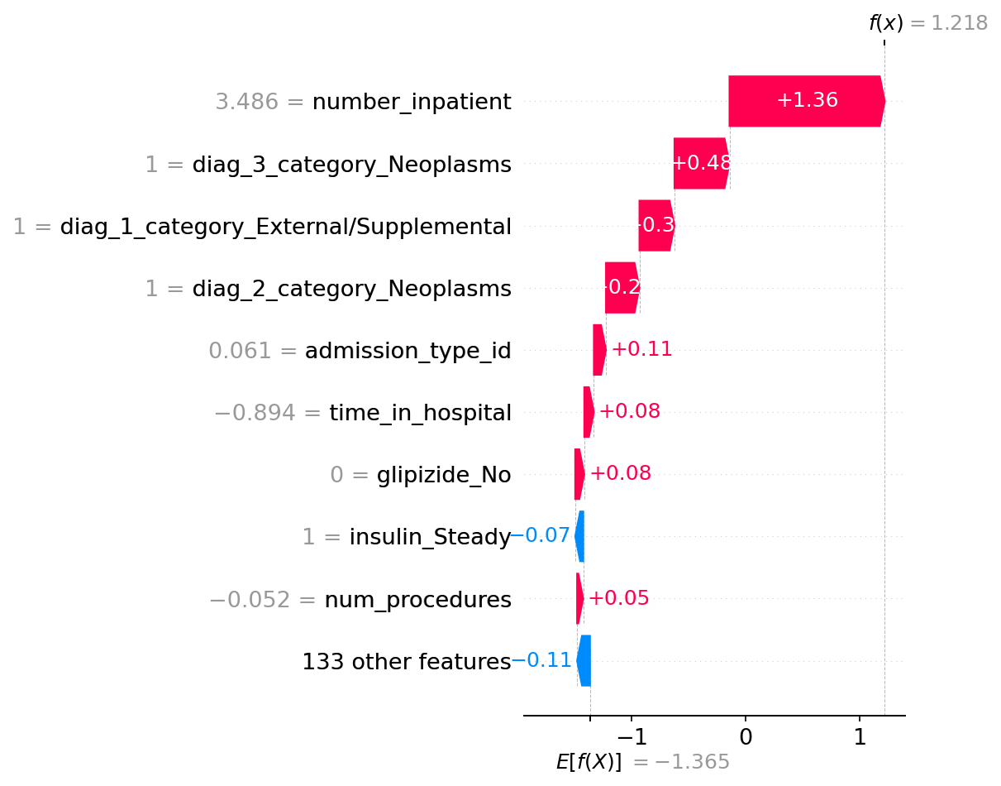
Figure 4. SHAP waterfall for the highest-risk test patient (predicted risk 0.77).
SHAP and LIME notably diverged on this patient: SHAP centered on number_inpatient, while LIME's local linear surrogate was dominated by sparse medical_specialty one-hot indicators — a known limitation of local-linear approximation on high-cardinality one-hot feature spaces (full LIME output: reports/lime_local_high_risk.txt).

Counterfactual Explanations (DiceML)
For the same high-risk patient, DiceML generated 3 counterfactuals by varying only clinically actionable features (medication counts, insulin dosage, procedure counts, time in hospital). Changing insulin dosage, procedure count, and medication count dropped predicted risk from 0.77 to 0.49–0.50 — interpretable and actionable for care teams (full output: reports/counterfactual_explanations_readable.txt).

Fairness Metrics
Audited on the deployed decision rule (top-20% risk-ranked shortlist, not the 0.5 threshold, which is documented as near-meaningless above) using Fairlearn:
Attribute | Demographic Parity Diff. | Equalized Odds Diff. | Min. Disparate Impact Ratio | Flagged (<0.8)
race | 0.320 | 0.556 | 0.000 | Yes
gender | 0.009 | 0.049 | 0.958 | No
age | 0.388 | 0.556 | 0.369 | Yes

Race and age are both flagged. African-American patients are selected at 24.6% vs. 18.4% for Caucasian patients; younger high-utilization patients (20–30: 38.8%) are selected far more often than older patients (80–90: 14.3%) — an inverse-age pattern worth cross-referencing against Module 3's finding that the 20–30 band was already over-represented (1.59×) at the cohort-filtering stage, suggesting the disparity partly originates upstream of the model itself.

Bias Mitigation
Two Fairlearn ThresholdOptimizer post-processing constraints were tested on race, and both failed to produce a deployable result: demographic_parity reduced the parity gap (0.32→0.02) but collapsed overall recall (32.3%→5.1%); equalized_odds collapsed entirely to the trivial all-negative solution (0% selection for every group — technically “fair,” clinically useless), a consequence of unstable per-group threshold calibration on small subgroups (Asian n=8, Unknown n=18 in the calibration split). Neither mitigation is recommended for deployment; a coarser race grouping or an in-processing technique (Fairlearn ExponentiatedGradient) is recommended instead (full analysis: reports/bias_mitigation_report.txt).

Sensitivity Analysis
Perturbing key numeric features by ±0.5–1.0 standard deviations confirmed number_inpatient as the most sensitive input (mean absolute risk change 0.027, more than double the next-ranked feature) — consistent with its SHAP dominance, and a signal that data-quality issues in this specific field would have an outsized effect on predicted risk in production.

7. Interpretation, Risks & Monitoring Hooks
The model learned to weight prior utilization intensity above clinical detail — defensible given the cohort's own definition (patients already qualify by having 2+ prior inpatient/ED visits, so further variation in that same count carries most of the remaining signal), but a limitation for clinical actionability, since number_inpatient is not something a discharge plan can change after the fact. The counterfactual analysis in Section 6 partly compensates for this by surfacing genuinely actionable levers instead: medication counts, insulin dosage adjustments, and procedure counts, all decisions a care team can act on before discharge.
Business interpretation of the top features: discharge_disposition_id and admission_type_id being influential suggests the pathway a patient takes into and out of the hospital carries readmission signal independent of their clinical severity — worth flagging to discharge planning leadership as a process-level lever, not just a patient-level one. A1Cresult_Not Tested appearing in the top 10 is a direct, actionable finding: patients who did not receive HbA1c testing during their stay show elevated predicted risk, echoing Strack et al.'s (2014) original finding that test administration itself is predictive — a testable hypothesis for a future quality-improvement intervention (ensure A1C testing for every high-utilization diabetic admission).
Key risks, carried forward from the Module 1 Risk Register and Module 3 Technical RAID Log: R1 (algorithmic bias via race/age proxies) is confirmed present here, not merely theoretical — both attributes were flagged for disparate impact and remain unmitigated after two attempted mitigation strategies failed, which elevates this from a monitored risk to an active blocker for deployment. R5 (data leakage) was checked and ruled out via the patient-grouping verification in Section 3, and the pipeline's leakage-prevention decisions (Section 2) are logged and reproducible. A new risk surfaces from this module that was not anticipated in Module 1: R7, model underperformance against the stated business goal — recall@20% of 31.2% against a target of 75% is a large enough gap that it calls the original goal's feasibility into question given the available feature set, not just the modeling approach, and should be added to the RAID log for Module 5 planning.
Proposed acceptance criteria for any future deployment, none of which are currently met: recall@20% ≥ 75% (currently 31.2%), minimum disparate impact ratio ≥ 0.8 across all protected attributes (currently 0.0 for race, 0.369 for age), and a successfully validated bias mitigation strategy (both attempts tested here failed). The one criterion already satisfied by design is mandatory human override on every prediction, consistent with the Human-in-the-Loop principle.
Proposed monitoring signals for any pilot deployment: track recall@20% and demographic parity difference on a rolling basis as new encounters accumulate, since both figures were computed on a single fixed historical hold-out (1999–2008 data) and could drift materially under real, current-era deployment conditions. A secondary signal worth tracking is the rate of A1Cresult_Not Tested in newly admitted patients — if that rate itself changes over time (e.g., due to a hospital-wide testing policy change), the model's calibration would need to be revisited, since that field carries meaningful weight in the current model.

References
Centers for Medicare & Medicaid Services. (2023). Hospital Readmissions Reduction Program (HRRP). U.S. Department of Health and Human Services. https://www.cms.gov/medicare/payment/prospective-payment-systems/acute-inpatient-pps/hospital-readmissions-reduction-program-hrrp
Strack, B., DeShazo, J. P., Gennings, C., Olmo, J. L., Ventura, S., Cios, K. J., & Clore, J. N. (2014). Impact of HbA1c measurement on hospital readmission rates: Analysis of 70,000 clinical database patient records. BioMed Research International, 2014, Article 781670. https://doi.org/10.1155/2014/781670

