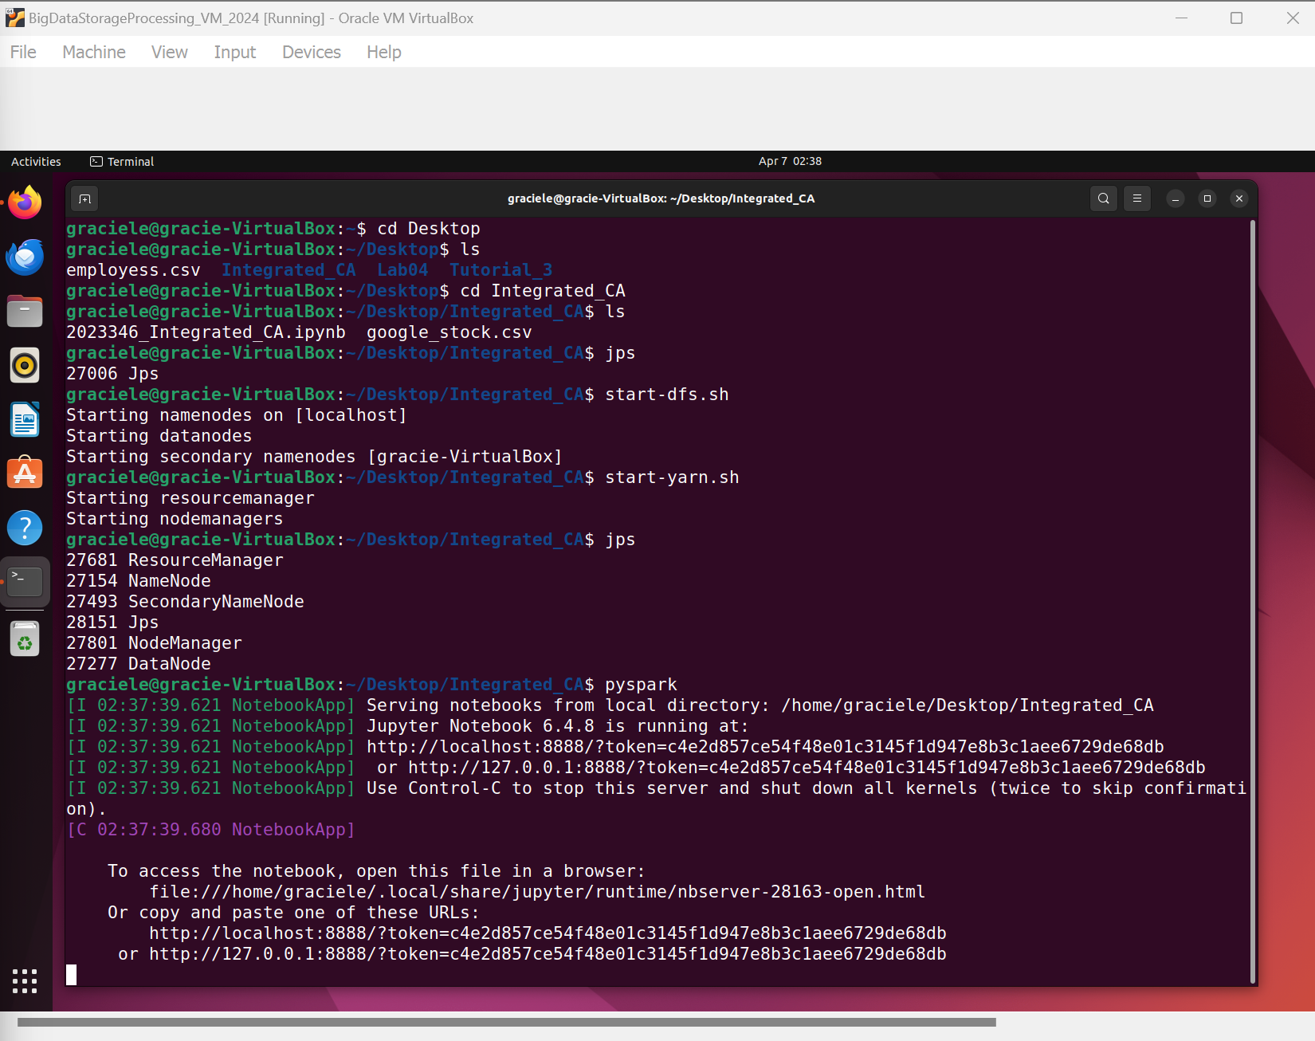

References
https://www.kaggle.com/datasets/shreenidhihipparagi/google-stock-prediction?resource=download my dataset
https://opendatacommons.org/licenses/dbcl/1-0/ dataset License

