HOUSE PRICE PREDICTION SYSTEM USING MACHINE LEARNING
MINI PROJECT REPORT
OF INTERNSHIP
BACHELOR OF TECHNOLOGY
COMPUTER SCIENCE AND ENGINEERING
Submitted
To

Dr. A.P.J. ABDUL KALAM TECHNICAL UNIVERSITY
LUCKNOW
SUBMITTED BY
Gracy Srivastava
University Roll No. 2400100100196
UNDER THE SUPERVISION OF
Mr. ____________
Assistant Professor

UNITED COLLEGE OF ENGINEERING & RESEARCH,
PRAYAGRAJ, 2026-27

Certificate
This is to certify that the mini project report entitled "House Price Prediction System Using Machine Learning", submitted by Gracy Srivastava (University Roll No. 2400100100196) to the Department of Computer Science and Engineering, United College of Engineering & Research, Prayagraj, in partial fulfilment of the requirements for the award of the degree of Bachelor of Technology in Computer Science and Engineering of Dr. A.P.J. Abdul Kalam Technical University, Lucknow, is a record of bonafide work carried out during the internship under my supervision.
To the best of my knowledge, the work reported in this report has not been submitted elsewhere for the award of any other degree or diploma.

Signature of Supervisor:
Name: Mr. ____________
Designation: Assistant Professor
Date:

Head of Department:
Date:
Declaration
We hereby declare that this submission is our own work and that, to the best of our knowledge and belief, it contains no material previously published or written by another person nor material which to a substantial extent has been accepted for the award of any other degree or diploma of the university or other institute of higher learning, except where due acknowledgment has been made in the text.

Signature:

Name: Gracy Srivastava
Roll No: 2400100100196
Date:
Acknowledgement
I would like to express my sincere gratitude to my project supervisor, Mr. ____________, Assistant Professor, Department of Computer Science and Engineering, for his valuable guidance, constant encouragement and constructive feedback throughout this internship project.
I am also thankful to the Head of the Department and the faculty members of United College of Engineering & Research, Prayagraj, for providing the academic environment and resources needed to complete this work. I acknowledge the Kaggle community for making the House Prices dataset publicly available, and the developers of the open-source libraries used in this project.
Finally, I thank my family and friends for their support and motivation.

Signature:

Name: Gracy Srivastava
Roll No.: 2400100100196
Date:
Abstract
Accurate estimation of house prices is important for buyers, sellers, real estate agents and financial institutions, yet traditional valuation relies on manual comparison and expert judgement, which is slow and subjective. This project develops a machine learning system that predicts the sale price of a residential property from its characteristics.
The Kaggle House Prices: Advanced Regression Techniques dataset, containing 1,460 training records and 81 features of houses in Ames, Iowa, was used. The data was cleaned by dropping sparse columns, imputing missing values, removing price outliers with the IQR method and encoding categorical variables. New features such as TotalSF, HouseAge and TotalBath were engineered and the 20 most relevant features were selected.
Three models, namely Linear Regression, Random Forest and XGBoost, were trained on a log-transformed target and compared using MAE, RMSE and R² Score. XGBoost performed best, with an R² Score of 0.8395, an MAE of 0.0934 and an RMSE of 0.1362 on the hold-out test set. The model was deployed as an interactive Streamlit web application that returns an instant price prediction with a confidence range. The report also discusses the limitations of the work and directions for future improvement.
Table of Content
Index Page No
Certificate i
Declaration ii
Acknowledgement iii
Abstract iv
List of Abbreviations vi
Chapter 1: Objectives 1
Chapter 2: Tools and Technologies Used 4
Chapter 3: System Functionality 6
Chapter 4: Model Workflow 8
Chapter 5: Key Features 12
Chapter 6: Performance and Evaluation 14
Chapter 7: Limitations 17
Chapter 8: Conclusion and Future Work 19
References 21
Appendix 22
List of Abbreviations
Abbreviation | Full form
AI | Artificial Intelligence
CSV | Comma-Separated Values
DFD | Data Flow Diagram
EDA | Exploratory Data Analysis
IQR | Interquartile Range
MAE | Mean Absolute Error
ML | Machine Learning
OLS | Ordinary Least Squares
R² | Coefficient of Determination
RMSE | Root Mean Squared Error
RSS | Residual Sum of Squares
SF | Square Feet
USD | United States Dollar

Chapter 1: Objectives

1.1 Background
The real estate market is one of the most significant economic sectors globally, with housing prices influenced by a wide range of factors including location, property size, number of rooms, age of the building and available amenities. Accurate prediction of house prices is of great importance to buyers, sellers, real estate agents and financial institutions. Traditional methods of price estimation often rely on expert knowledge and manual comparison of similar properties, which can be time-consuming and inconsistent.
With the rapid advancement of Artificial Intelligence (AI) and Machine Learning (ML) techniques, it has become possible to build automated systems that analyse large datasets and make accurate predictions. Machine learning models can capture complex non-linear relationships between features and house prices, providing more consistent and reliable estimates than traditional approaches.

1.2 Problem Statement
The primary challenge in the real estate domain is to estimate accurately the price of a residential property from its characteristics. Manual price estimation is subjective and prone to human bias. There is a need for an automated, data-driven system that can:
- process large volumes of historical property sale data;
- identify the key factors that significantly influence house prices;
- build a predictive model that generalises well to unseen data; and
- provide an easy-to-use interface for real-time price prediction.

1.3 Objectives
The main objectives of this project are:
- to collect and preprocess the Kaggle House Prices dataset for machine learning;
- to perform exploratory data analysis (EDA) and understand the key features affecting house prices;
- to engineer meaningful features that improve model performance;
- to train and compare three machine learning models: Linear Regression, Random Forest and XGBoost;
- to evaluate model performance using the MAE, RMSE and R² Score metrics; and
- to deploy the best-performing model as an interactive web application using Streamlit.

1.4 Scope of the Project
This project focuses on predicting residential house sale prices using the Kaggle House Prices: Advanced Regression Techniques dataset [5]. The dataset contains 1,460 training samples with 81 features describing various aspects of residential properties in Ames, Iowa, USA. The project covers the complete machine learning lifecycle, from data collection to model deployment.

1.5 Literature Survey
House price prediction has been an active research area in both economics and computer science. Early approaches used hedonic pricing models, which are statistical regression techniques that decompose the price of a property according to its individual characteristics. Limsombunchai [4] demonstrated that hedonic models based on Ordinary Least Squares (OLS) regression provide a baseline for house price prediction. Later work introduced regularisation techniques such as Ridge and Lasso regression to reduce overfitting in high-dimensional feature spaces. These methods are easy to interpret but struggle with non-linear patterns.
Ensemble methods have emerged as powerful alternatives. Breiman [1] introduced the Random Forest algorithm, which applies ensemble learning through bagging. Antipov and Pokryshevskaya [3] applied ensemble methods to the Russian real estate market and found that Random Forest significantly outperformed classical hedonic models because of its ability to handle non-linear relationships and variable interactions. XGBoost, introduced by Chen and Guestrin [2], uses gradient boosting with regularisation to build an ensemble of weak learners sequentially, and XGBoost-based solutions consistently rank among the top performers in the Kaggle House Prices competition.
Several studies also highlight the importance of feature engineering. Composite features such as total square footage, age of the property and renovation status can significantly improve model performance by providing more informative inputs to the learning algorithm.

1.6 Research Gap
While numerous studies have applied machine learning to house price prediction, most focus on a single model or on specific geographic regions. This project provides a comparative analysis of multiple models on the standard Kaggle benchmark dataset, together with a practical deployment that makes the predictions accessible to end users through a web interface.

Chapter 2: Tools and Technologies Used

2.1 Programming Language and Libraries
The system was implemented in Python using open-source data science libraries. Table 2.1 lists the tools used and the purpose of each.
Table 2.1: Tools and technologies used
Tool / Library | Purpose in the project
Python | Core programming language used for the complete project
Pandas [8] | Loading, cleaning and manipulating the tabular dataset
NumPy | Numerical operations, including the log1p and expm1 transformations of the target variable
Scikit-learn [6] | SimpleImputer, LabelEncoder, StandardScaler, train_test_split, model training and evaluation metrics
XGBoost [2] | Gradient boosting regressor used as the final model
Streamlit [7] | Interactive web application for entering house details and viewing the predicted price
Pickle | Serialising the trained model to the file xgboost_model.pkl

2.2 Machine Learning Algorithms

2.2.1 Linear Regression
Linear Regression is a fundamental supervised learning algorithm that models the relationship between the features and the target variable as a linear function. It minimises the Residual Sum of Squares (RSS) between observed and predicted values. While simple and interpretable, it assumes a linear relationship between the features and the target.

2.2.2 Random Forest Regressor
Random Forest [1] is an ensemble learning method that builds multiple decision trees and combines their outputs through averaging. Each tree is trained on a random subset of the data (bagging) and a random subset of the features, which reduces variance and prevents overfitting. The model used 100 estimators with default hyperparameters.

2.2.3 XGBoost Regressor
XGBoost (Extreme Gradient Boosting) [2] is an optimised gradient boosting algorithm that builds trees sequentially, where each tree corrects the errors of the previous one. It includes L1 and L2 regularisation to prevent overfitting. The model was trained with 200 estimators, a learning rate of 0.05 and a maximum depth of 6.

2.3 Dataset Description
The dataset used in this project is the Kaggle House Prices: Advanced Regression Techniques dataset [5]. It consists of 1,460 training records and 1,459 test records, with 81 columns (features) describing residential properties in Ames, Iowa, USA. Table 2.2 summarises the dataset.
Table 2.2: Summary of the dataset
Attribute | Details
Source | Kaggle: House Prices: Advanced Regression Techniques
Training samples | 1,460 rows
Test samples | 1,459 rows
Total features | 81 columns (including the target)
Target variable | SalePrice (continuous; house sale price in USD)
Feature types | Numerical (38), Categorical (43)

Key features in the dataset include OverallQual (overall material and finish quality), GrLivArea (above grade living area), GarageArea (size of the garage), TotalBsmtSF (total basement area) and YearBuilt (year of construction). The target variable SalePrice ranges from USD 34,900 to USD 755,000, with a mean of about USD 180,921.

Chapter 3: System Functionality

3.1 Overview of the System
The House Price Prediction System takes the characteristics of a residential property as input and returns an estimate of its sale price. The system has two parts. The first is the offline part, in which the dataset is prepared and the models are trained and evaluated. The second is the online part, in which the best model, XGBoost, is loaded into a Streamlit web application that serves predictions to the user.

3.2 Functional Requirements
The system performs the following functions:
- accepts the property characteristics from the user through an interactive form;
- passes the entered details to the trained XGBoost model, which is loaded from the saved file xgboost_model.pkl;
- converts the model output, which is on the log scale, back to a price in US dollars using the expm1 function;
- displays the predicted price together with a confidence range of ±8% of the predicted value; and
- returns the result instantly, without the user having to run any code.

3.3 Data Flow
Figure 3.1 shows the Level 0 data flow diagram (context diagram) of the system. The whole project is shown as one process. The user supplies the house details and receives the predicted sale price, while the data sources, namely the Kaggle CSV dataset and the trained model, supply past sales data and features.
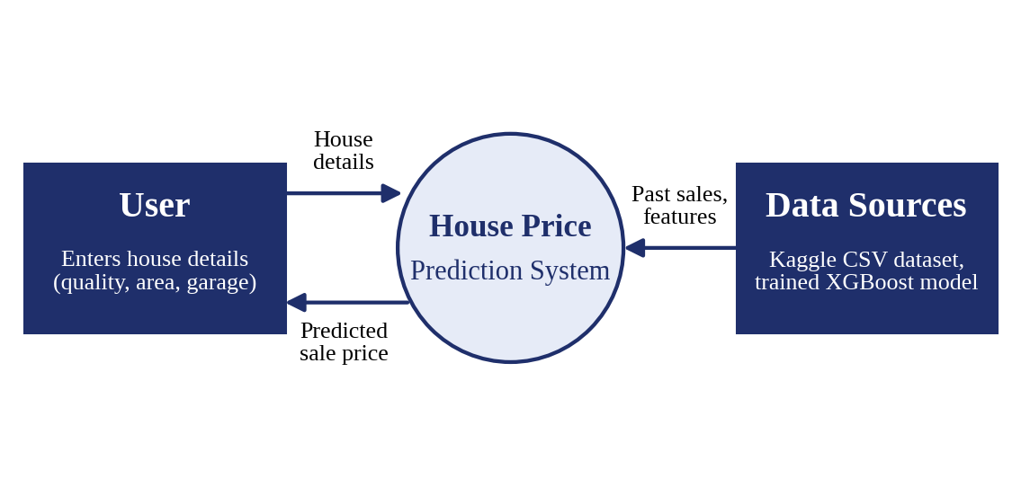
Figure 3.1: Level 0 data flow diagram of the system
At Level 1, the system is divided into four processes and three data stores:
- 1.0 Data Cleaning: fills missing values and removes outliers in the data taken from D1, the Kaggle dataset (CSV);
- 2.0 Feature Engineering: adds the TotalSF, HouseAge and TotalBath features and prepares the selected features, which are held in D3 (top 20 features);
- 3.0 XGBoost Prediction: predicts the price from the features using D2, the trained model with its scaler; and
- 4.0 Price Output: shows the predicted price to the user in the Streamlit application.

3.4 User Interaction
The Streamlit application loads the saved model when it starts and shows a message that the model has been loaded successfully, together with the R² Score of the model (0.8395). During development the application was run locally on port 8501. The user enters the property details in the form and the application immediately displays the predicted price and its confidence range.

Chapter 4: Model Workflow

4.1 Overview of the Workflow
The project followed the complete machine learning lifecycle in eight phases, shown in Figure 4.1: problem understanding, data collection, data preprocessing, exploratory data analysis, feature engineering, model building, model evaluation and deployment.
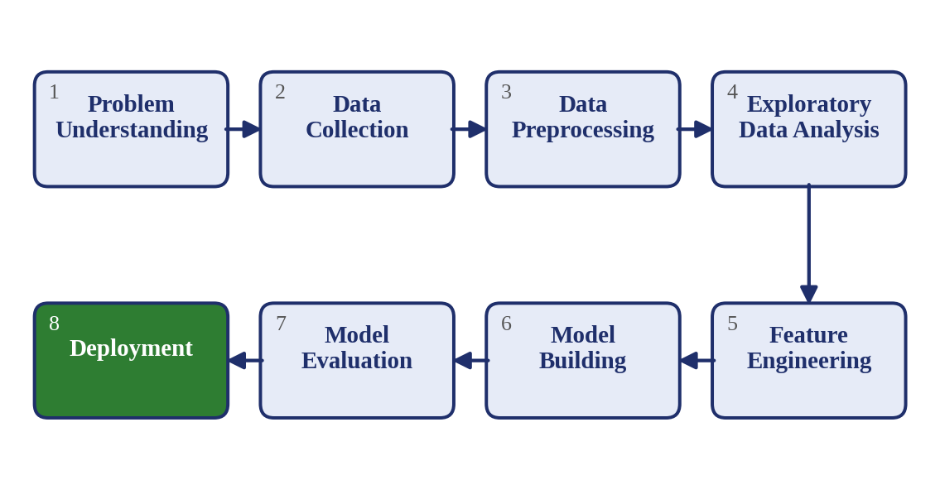
Figure 4.1: Machine learning workflow followed in the project

4.2 Data Preprocessing

4.2.1 Handling Missing Values
Columns with more than 45% missing values were dropped entirely (for example Alley, PoolQC, Fence and MiscFeature). For the remaining numerical columns, missing values were filled using median imputation with the SimpleImputer of Scikit-learn [6]. For categorical columns, missing values were filled with the most frequent value (mode imputation).

4.2.2 Outlier Treatment
Outliers in the target variable SalePrice were treated using the Interquartile Range (IQR) method. Records in which SalePrice fell outside the range [Q1 - 1.5 × IQR, Q3 + 1.5 × IQR] were removed. This reduced the dataset from 1,460 to 1,399 clean records.

4.2.3 Categorical Encoding
All 43 categorical features were encoded using Label Encoding (LabelEncoder from Scikit-learn), which converts each unique category into an integer value. This approach is compatible with tree-based models such as Random Forest and XGBoost.

4.2.4 Feature Scaling
Numerical features were standardised using StandardScaler (zero mean and unit variance) before training the Linear Regression model, to ensure that all features contribute equally to the cost function of the model.

4.3 Exploratory Data Analysis

4.3.1 Univariate Analysis: SalePrice Distribution
The target variable SalePrice shows a right-skewed distribution, which is typical of real estate data. Most houses are priced between USD 100,000 and USD 250,000, with a few high-value outliers. A log transformation of SalePrice produces a near-normal distribution, which is beneficial for regression models. The log-transformed target (log1p) was therefore used during model training to improve prediction accuracy.

4.3.2 Bivariate Analysis
Scatter plots were created to visualise the relationship between key features and SalePrice. Strong positive relationships were observed between SalePrice and GrLivArea (above ground living area), TotalBsmtSF (total basement area), GarageArea and OverallQual. Properties with higher overall quality ratings (8 to 10) command significantly higher prices than lower quality properties (1 to 5).

4.3.3 Correlation Analysis
A correlation heatmap was generated for the top 10 numerical features. The features with the highest positive correlation with SalePrice are:
- OverallQual: 0.79 (strongest predictor);
- TotalSF (engineered): 0.76;
- GrLivArea: 0.71;
- GarageCars: 0.64;
- GarageArea: 0.62; and
- TotalBsmtSF: 0.61.

4.4 Feature Engineering
The new features listed in Table 4.1 were created to enhance model performance.
Table 4.1: Engineered features
Feature | Formula | Description
HouseAge | YrSold - YearBuilt | Age of the house at the time of sale
RemodAge | YrSold - YearRemodAdd | Years since the last renovation
TotalSF | TotalBsmtSF + 1stFlrSF + 2ndFlrSF | Total usable square footage
TotalBath | FullBath + 0.5 × HalfBath + BsmtFullBath + 0.5 × BsmtHalfBath | Weighted total number of bathrooms
HasGarage | 1 if GarageArea > 0, else 0 | Binary flag: garage present or not

After feature engineering, the top 20 features were selected on the basis of their absolute correlation with SalePrice. Features of lower relevance, such as GarageYrBlt and MSSubClass, were excluded from model training.

4.5 Model Development

4.5.1 Data Splitting
The dataset was split into a training set (80%) and a testing set (20%) using the train_test_split function of Scikit-learn with random_state=42 for reproducibility. This resulted in approximately 1,119 training samples and 280 testing samples.

4.5.2 Target Transformation
The target variable SalePrice was log-transformed using the log1p function of NumPy before training. This stabilises the variance and makes the target distribution more symmetric, which is beneficial for all regression models. Predictions were inverse-transformed using expm1 to obtain actual price values.

4.5.3 Model Training
Three models were trained on the preprocessed data:
- Linear Regression, trained on StandardScaler-normalised features;
- Random Forest Regressor with 100 trees and default hyperparameters, trained on the raw features; and
- XGBoost Regressor with 200 estimators, learning_rate=0.05 and max_depth=6, trained on the raw features.

4.5.4 Streamlit Deployment
The best-performing model (XGBoost) was serialised using the pickle module of Python and saved as xgboost_model.pkl. A Streamlit web application [7] was then developed that loads the saved model and allows users to enter property characteristics through an interactive form. The application displays the predicted price along with a confidence range of ±8% of the predicted value.

Chapter 5: Key Features

5.1 Key Features of the System
- Complete machine learning lifecycle: the project covers all eight phases, from problem understanding to deployment.
- Robust data preparation: sparse columns are dropped, missing values are imputed, price outliers are removed with the IQR method and categorical variables are encoded.
- Log-transformed target: training on log1p(SalePrice) reduces the effect of the right skew and of high-priced outliers.
- Engineered features: HouseAge, RemodAge, TotalSF, TotalBath and HasGarage give the models more informative inputs, and the top 20 features are selected by correlation.
- Comparison of three models: Linear Regression, Random Forest and XGBoost are evaluated on the same hold-out test set using MAE, RMSE and R² Score.
- Interactive prediction: the Streamlit application returns an instant price prediction with a ±8% confidence range.

5.2 Most Influential Features
Figure 5.1 shows the six features with the highest correlation with SalePrice. OverallQual has the highest correlation (0.79), and the engineered feature TotalSF is second (0.76). The feature importance analysis of the Random Forest model also showed that OverallQual, TotalSF and GrLivArea are the three most important predictors. Quality matters more than size alone: houses with higher quality ratings command a price premium of two to three times.
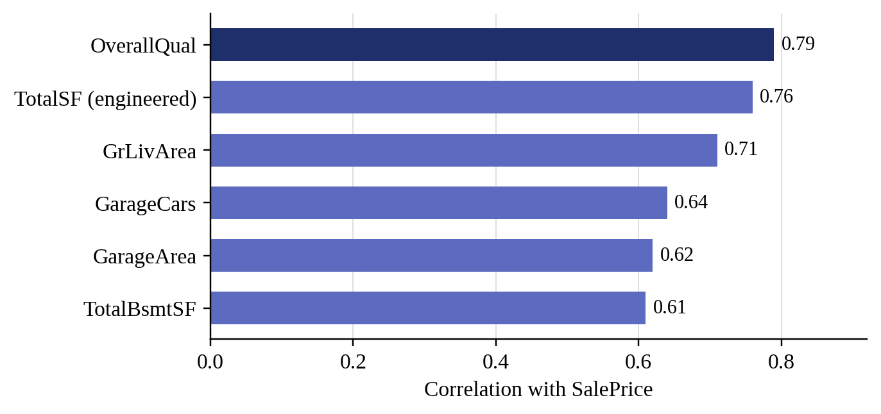
Figure 5.1: Features most strongly correlated with SalePrice

5.3 Key Findings
- OverallQual (overall material and finish quality) is the single most important predictor of house price.
- TotalSF (engineered total square footage) ranks as the second most important feature, confirming that size is a primary price driver.
- XGBoost consistently outperforms both Linear Regression and Random Forest across all three metrics.
- Log transformation of the target variable (SalePrice) significantly improved model performance by reducing the impact of price outliers.
- Feature engineering (HouseAge, TotalSF, TotalBath) improved model accuracy compared with using the raw features alone.

Chapter 6: Performance and Evaluation

6.1 Evaluation Metrics
All three models were evaluated on the hold-out test set (20% of the data) using three regression metrics:
- Mean Absolute Error (MAE): the average absolute difference between the actual and the predicted values;
- Root Mean Squared Error (RMSE): the square root of the average squared difference, which penalises large errors more heavily; and
- R² Score: the coefficient of determination, which gives the proportion of the variance in the target explained by the model (1 is the best value).
Since the models were trained on log-transformed prices, the metrics are computed on log-scale values. The formulae are given in Appendix C.

6.2 Performance Results
Table 6.1 compares the three models. The same results are shown graphically in Figure 6.1 and Figure 6.2.
Table 6.1: Performance of the models on the test set
Model | MAE | RMSE | R² Score
Linear Regression | 0.1023 | 0.1403 | 0.8297
Random Forest | 0.0955 | 0.1376 | 0.8362
XGBoost (best) | 0.0934 | 0.1362 | 0.8395

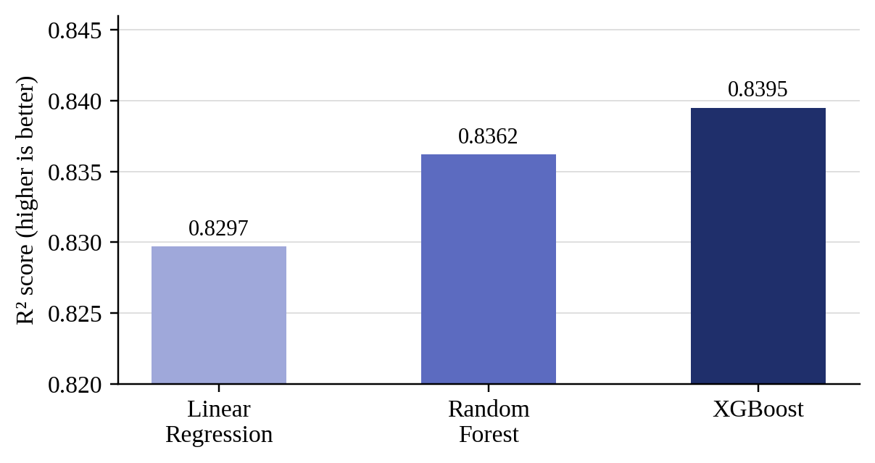
Figure 6.1: R² Score of the three models (vertical axis starts at 0.82)
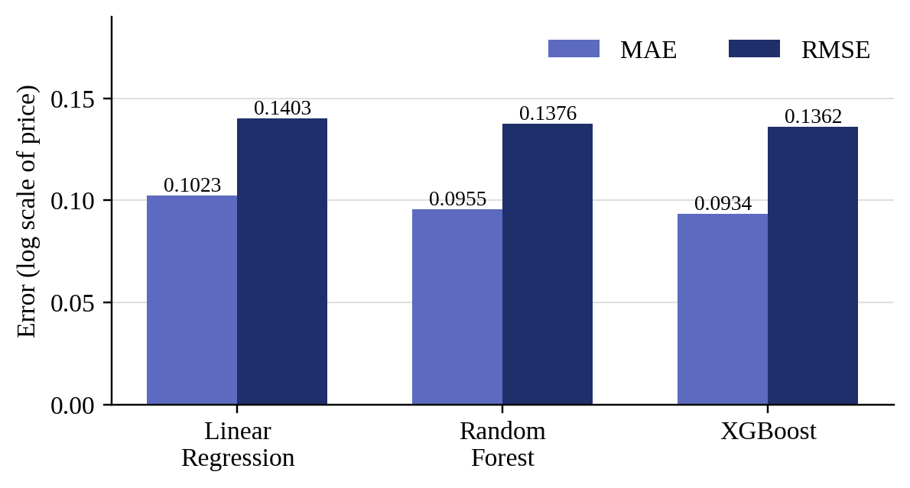
Figure 6.2: MAE and RMSE of the three models

6.3 Comparative Analysis

6.3.1 Linear Regression
Linear Regression achieved an R² Score of 0.8297, which means that it explains approximately 82.97% of the variance in house prices. While this is a reasonable baseline, the assumption of linearity limits its ability to capture complex feature interactions. The MAE of 0.1023 on the log scale corresponds to prediction errors of approximately 10 to 11% of the actual price.

6.3.2 Random Forest Regressor
Random Forest improved upon Linear Regression with an R² Score of 0.8362 and a lower MAE (0.0955) and RMSE (0.1376). The ensemble nature of Random Forest allows it to capture non-linear relationships and feature interactions, which accounts for its better performance.

6.3.3 XGBoost Regressor: Best Model
XGBoost achieved the best performance, with an R² Score of 0.8395, an MAE of 0.0934 and an RMSE of 0.1362. The sequential boosting mechanism allows XGBoost to correct residual errors iteratively, resulting in better generalisation. The built-in L1 and L2 regularisation helps to prevent overfitting, which explains why XGBoost outperforms Random Forest even though both are tree-based ensemble methods.

6.4 Discussion
The results confirm that ensemble tree-based methods are more suitable than linear models for house price prediction. The R² Score of 0.8395 achieved by XGBoost indicates strong predictive power, although there is still room for improvement. Potential areas for improvement include hyperparameter tuning using GridSearchCV or Bayesian optimisation, more advanced feature engineering and the use of more sophisticated models such as LightGBM or neural networks.

Chapter 7: Limitations
Although the system achieves good accuracy, the following limitations should be kept in mind when interpreting its results.

7.1 Limitations of the Data
- The dataset describes houses in a single city, Ames in Iowa, USA, and contains only 1,460 training records. The model may therefore not transfer to other cities or markets without retraining on local data.
- The data is a historical snapshot, so the model does not account for changes in market conditions over time.
- Removing price outliers with the IQR method reduced the dataset from 1,460 to 1,399 records. Very expensive houses outside the retained range are therefore not represented in training, and the model is likely to be less reliable for them.

7.2 Limitations of the Models
- The best R² Score is 0.8395, so a considerable part of the variation in house prices is still not explained by the model.
- The hyperparameters of the models were not systematically tuned; tuning with GridSearchCV or similar methods may improve accuracy.
- Label Encoding assigns integer codes to categories and so implies an order between categories that may not exist. This suits tree-based models better than Linear Regression.
- The reported errors are measured on the log scale of the price, so they are not directly expressed in US dollars.

7.3 Limitations of the Application
- The confidence range of ±8% is a fixed margin around the prediction and is not a statistically derived prediction interval.
- The application was run locally during development and has not yet been deployed on a cloud platform for wider access.
- The model is static and does not update itself with new market data, and the application does not explain why a particular price was predicted.

Chapter 8: Conclusion and Future Work

8.1 Conclusion
This project successfully demonstrated the application of machine learning techniques to the real-world problem of house price prediction. By following the complete machine learning lifecycle, from data collection and preprocessing, through exploratory data analysis and feature engineering, to model training, evaluation and deployment, a robust and accurate prediction system was developed.
Three machine learning models were trained and compared: Linear Regression, Random Forest Regressor and XGBoost Regressor. XGBoost emerged as the best-performing model, with an R² Score of 0.8395, an MAE of 0.0934 and an RMSE of 0.1362 on the test set. The model was deployed as an interactive Streamlit web application that allows users to enter property details and receive instant price predictions.
The project provided valuable hands-on experience with the entire data science workflow, including handling missing values, encoding categorical features, engineering new features, comparing multiple machine learning algorithms and building a user-friendly prediction interface.

8.2 Future Work
Several improvements and extensions can be explored in future work:
- Hyperparameter tuning: applying GridSearchCV or RandomizedSearchCV to optimise the XGBoost parameters (n_estimators, max_depth, learning_rate and subsample) could further improve accuracy.
- Advanced ensemble methods: stacking Linear Regression, Random Forest and XGBoost with a meta-learner could achieve higher accuracy than any individual model.
- Deep learning approaches: neural networks with embedding layers for categorical features could capture more complex patterns in the data.
- Geospatial features: adding geographic data such as proximity to schools, public transport and hospitals could improve prediction quality.
- Real-time data: integrating live real estate APIs to update the model continuously with new market data would make the system more practical and current.
- Model explainability: SHAP (SHapley Additive exPlanations) values would give better insight into individual predictions and make the model more transparent and trustworthy.
- Cloud deployment: hosting the Streamlit application on a cloud platform such as Heroku, AWS or Streamlit Community Cloud would make it accessible to a wider audience.

References
[1] Breiman, L. (2001). Random Forests. Machine Learning, 45(1), 5-32.
[2] Chen, T., & Guestrin, C. (2016). XGBoost: A Scalable Tree Boosting System. In Proceedings of the 22nd ACM SIGKDD International Conference on Knowledge Discovery and Data Mining (pp. 785-794).
[3] Antipov, E. A., & Pokryshevskaya, E. B. (2012). Mass appraisal of residential apartments: An application of Random forest for valuation and a CART-based approach for model diagnostics. Expert Systems with Applications, 39(2), 1772-1778.
[4] Limsombunchai, V. (2004). House price prediction: Hedonic price model vs. artificial neural network. In New Zealand Agricultural and Resource Economics Society Conference.
[5] Kaggle. (2016). House Prices: Advanced Regression Techniques. Retrieved from https://www.kaggle.com/competitions/house-prices-advanced-regression-techniques
[6] Pedregosa, F., et al. (2011). Scikit-learn: Machine Learning in Python. Journal of Machine Learning Research, 12, 2825-2830.
[7] Streamlit Inc. (2023). Streamlit: The fastest way to build and share data apps. Retrieved from https://streamlit.io
[8] McKinney, W. (2010). Data Structures for Statistical Computing in Python. In Proceedings of the 9th Python in Science Conference (pp. 51-56).

Appendix

Appendix A: Model Configuration
Table A.1: Configuration of the models
Model | Configuration | Input features
Linear Regression | Minimises the Residual Sum of Squares | StandardScaler-normalised
Random Forest | 100 estimators, default hyperparameters | Raw features
XGBoost | 200 estimators, learning rate 0.05, maximum depth 6, L1 and L2 regularisation | Raw features

Appendix B: Key Dataset Features
Table A.2: Description of key dataset features
Feature | Description
OverallQual | Overall material and finish quality (scale of 1 to 10)
GrLivArea | Above ground living area (square feet)
TotalBsmtSF | Total basement area (square feet)
GarageArea | Size of the garage (square feet)
YearBuilt | Year of construction
SalePrice | Target variable: house sale price (USD)

Appendix C: Evaluation Metrics
Let y be the actual value, ŷ the predicted value and n the number of test samples. SS_res is the sum of (y - ŷ)² over all samples and SS_tot is the sum of the squared differences between y and the mean of the actual values.
- MAE = (1 / n) × Σ |y - ŷ|
- RMSE = √[(1 / n) × Σ (y - ŷ)²]
- R² = 1 - (SS_res / SS_tot)

