# **TRAVELGRAM**

S.E. Mini-Project 1A project report submitted in partial fulfilment of the requirements of the degree of

**Bachelor of Engineering (B.E.)**

in

**COMPUTER SCIENCE AND ENGINEERING (DATA SCIENCE)**

by

|  |  |
| --- | --- |
| **CHSMPANEKAR HITEN** | **EU1228001** |
| **MORE VRATESH** | **EU1228031** |
| **YADAV GRACY** | **EU1228023** |

Under the guidance of

|  |
| --- |
| **Mr. VIVIAN LOBO** |
| Assistant Professor |



**Department of Computer Science and Engineering (Data Science)**

**St. John College of Engineering and Management, Palghar**

**University of Mumbai**

2023–2024

**CERTIFICATE**

This is to certify that the S.E. Mini-Project 1A entitled **“TRAVELGRAM”** is a bonafide work of **“Champanekar Hiten” (EU1228001), “More Vratesh” (EU1228031),** and **“Yadav Gracy” (EU1228023)** submitted to University of Mumbai in partial fulfilment of the requirement for the award of the degree of **“Bachelor of Engineering”** in **“Computer Science and Engineering (Data Science)”** during the academic year 2023–2024.

|  |
| --- |
| **Mr. Vivian Lobo** |
| Project Guide |

|  |  |
| --- | --- |
| **Mr. Vivian Lobo** | **Dr. G.V. Mulgund** |
| Head of Department | Principal |

# **S.E. Mini-Project 1A Report Approval**

This project report entitled ***TRAVELGRAM*** by ***Hiten Champanekar, Vratesh More, Gracy Yadav*** is approved for the degree of ***Bachelor of Engineering*** in ***Computer Science and Engineering (Data Science)*** from ***University of Mumbai***.

###### **Examiners**

1.---------------------------------------------

2.---------------------------------------------

Date: Place:

# **Declaration**

###### We declare that this written submission represents our ideas in our own words and where others’ ideas or words have been included, we have adequately cited and referenced the original sources. We also declare that we have adhered to all principles of academic honesty and integrity and have not misrepresented or fabricated or falsified any idea/data/fact/source in our submission. We understand that any violation of the above will be cause for disciplinary action by the Institute and can also evoke penal action from the sources which have thus not been properly cited or from whom proper permission has not been taken when needed.

---------------------------------------

Signature

Hiten Champanekar (EU1228001)

---------------------------------------

Signature

Vratesh More (EU1228031)

---------------------------------------

Signature

Gracy Yadav (EU1228023)

Date:

**Abstract**

In the age of digital comfort, travellers look for personalized travelling planning solutions. This project leverages travelling maps with OpenCV, an open source library and build a web-based map for travel plans. TRAVELGRAM’s intuitive mapping system further enhances your travel experience. Explore the area, discover nearby point of interest , and chart out your itinerary ease. Whether you’re a seasoned globetrotter or a first-time traveller. TRAVELGRAM equips you with knowledge and explore like pro.

This abstract provides an overview of the project’s objectives, technology stack, and its potential to enhance the tour planning for users.

**Table of Contents**

|  |  |  |
| --- | --- | --- |
|  | **Abstract** | **v** |
|  | **List of Figures** | **vii** |
|  | **List of Tables** | **viii** |
|  | **List of Abbreviations** | **ix** |
| **Chapter 1** | **Introduction** | **1** |
|  | 1.1 Motivation | 3 |
|  | 1.2 Problem Statement | 4 |
|  | 1.3 Objectives | 5 |
|  | 1.4 Scope | 6 |
| **Chapter 2** | **Literature Review** | **7** |
|  | 2.1 Literature Review Table |  |
| **Chapter 3** | **Report on Present Investigation** | **9** |
|  | 3.1 Proposed System | 10 |
|  | 3.1.1 Flow diagram of Proposed System | 11 |
|  | 3.2 Implementation | 12 |
|  | 3.2.1 Algorithm/Flowchart | 13 |
|  | 3.2.2 Pseudo code | 15 |
|  | 3.2.3 Screenshots of the output | 16 |
| **Chapter 4** | **Technologies Used** |  |
| **Chapter 5** | **Results** | **20** |
| **Chapter 6** | **Conclusion and Future Work** | **21** |
|  | **References** |  |
|  | **Acknowledgments** | **22** |

***V,,***

**List of Figures**

|  |  |  |
| --- | --- | --- |
| **Figure No.** | **Figure Name** | **Page No.** |
| 1 | Proposed System Block Diagram | 9 |
| 2 | Data Flow Diagram(a) | 11 |
| 3 | Data Flow Diagram(b) | 12 |
| 4 | Pseudo code(a) | 13 |
| 5 | Pseudo code(b) | 14 |
| 6 | Pseudo code(c) | 14 |
| 7 | Login Page | 16 |
| 8 | Register Page | 17 |
| 9 | Home Page | 17 |

**List of Tables**

|  |  |  |
| --- | --- | --- |
| **Table No.** | **Table Name** | **Page No.** |
| 1 | Literature Review | 6 |

**Chapter 1**

**Introduction**

A website which helps user before visiting any place, users can have a view of the location, enabling them to determine the crowd and inspect the condition of place through images posted by other users. It helps to gain the better understanding of the related area they wish to visit.

* 1. **Motivation**
* To visit a place without any previous knowledge of it, we may encounter failure, as there is sometimes too much crowd or the condition of the place is not good.
* Sometimes, people waste their time in queue just because they don’t have an image or idea of the place.
* Sometimes, due to poor condition at a place, people may face accidents or receive proper service because of it.
  1. **Problem Statement**

* To visit a place without any previous knowledge of the location, including details about the crowd, conditions, facilities, traffic, waterlogging management during the rainy season, etc., users can determine the specifications of the location with the help of the images in this website.
  1. **Objectives**

The objectives are as follows :-

* To help the user become aware of the traffic.
* To plan the trip according to the user’s requirements while being aware of the potential problems that may be encountered during the journey.
* To determine which route will be perfect for travelling.
  1. **Scope**
* To help people know the condition of the location with the help of the image.
* To help people to figure out the place they want to visit.
* To help user to figure out the traffic on the route they are travelling.
* To get familiar with the place’s locality using images.

**Chapter 2**

**Literature Review**

|  |  |  |  |  |  |  |
| --- | --- | --- | --- | --- | --- | --- |
| Sr. no​ | Title​ | Year​ | Author​ | Limitations​ | Outcome​ | Dataset ​ |
| 1​ | **[1]Quantifying Tourist Behavior Patterns by Travel Motifs and Geo-Tagged Photos from Flickr**​ | 2017​ | Lun wu, yu liu,chaogui kang ​ | Didn't describe much about the location ​ | erving as the prerequisite to travel recommender systems, detecting and visualizing tourists’ frequent travel patterns is of great importance for effective travel itinerary planning​ | <https://webscope.sandbox.yahoo.com/catalog.php?datatype=i&did=67.>​ |
| 2​ | **[2]A Practical Cross-View Image Matching Method between UAV and Satellite for UAV-Based Geo-Localization**​ | 2020​ | Pattiasnia, timothy john and  setyoadi , eddy triwanto and wijayanto,david ​ | Soucre informing about the traffic is very slow and delayed comparativily​ | a method for solving distribution route problem for the company to be able to deliver goods or product to customers ​ | GOOGLE MAPS APPLICATION PROGRAMMING INTERFACE ​ |
| 3​ | **[3]The Verification of Land Cover Datasets with the Geo-Tagged Natural Scene Images**​ | 2022​ | Liu cui,hui yang,liang chu,fei xu,​ | In this paper, only three land cover types were used to validate and discuss the land cover data. In the future, the training of models in more detailed categories will be needed to adapt the verification of land cover maps in more fields​ | The automatic classification model of natural scene images is the key under this framework, which will directly determine the reliability of the land cover data verification results.​ | <https://ec.europa.eu/eurostat/web/lucas/data>​ |
| 4​ | **[4]A Novel Popular Tourist Attraction Discovering Approach Based on Geo-Tagged Social Media Big Data**​ | 2017​ | Xia peng,zhaou ​ | Result illustrates that the proposed approach is adaptive to the scenes of uneven density distribution in the clustering region​ | Through spatial clustering of the original user locations, both the ‘natural’ boundaries and the human activity information of the tourist attractions are generated​ | Data Pre-Processing , Class Mergence​ |

|  |  |  |  |  |  |  |
| --- | --- | --- | --- | --- | --- | --- |
| 5 | **[4]A Novel Popular Tourist Attraction Discovering Approach Based on Geo-Tagged Social Media Big Data**​ | 2017​ | Xia peng,zhaou ​ | Result illustrates that the proposed approach is adaptive to the scenes of uneven density distribution in the clustering region​ | Through spatial clustering of the original user locations, both the ‘natural’ boundaries and the human activity information of the tourist attractions are generated​ | Data Pre-Processing,Class Mergence​ |
| 6​ | **[5]Location update accuracy in human tracking system using zigbee modules**​ | 2020​ | B amutha ,m. Ponnavaikko​ | There is image available of the location to know the exact view of the location which certainlt don't help the user.​ | This system can be applied outdoors especially for avoiding accidents ,GPS asthe soucres of loaction data.​ | ZIGBEE MODULES​ |
| 7​ | **[6]A Practical Cross-View Image Matching Method between UAV and Satellite for UAV-Based Geo-Localization**​ | 2020​ | Lirong ding, ji zhou,zhiyong long​ | The localization of uav images without geo-tags and uav navigation without geographic coordinates are crucial for users​ | the images of different views from location (the left column, the middle column, and the right column are satellite-view images, unmanned aerial vehicle (UAV)-view images, and street-view images, respectively).​ | Matching Accuracy of LCM’s Baseline Model​ |
| 8​ | **[7]Exploring Land Use and Land Cover of Geotagged Social-Sensing Images Using Naive Bayes Classifier**​ ​ | 2016​ | Masahiko nagai,matthew dailey,asamaporn sitthi​ | Did not specify must about the coward or the people present int hat location to the user.​ | how effectively LULC types can be predicted using geotagged ground level images from Flickr. We used independent training and testing datasets as described in the previous section​ | Crowdsourced Data , Landsat TM5 Data​ |
| 9​ | **Mining Travel Patterns from Geotagged Photos​** | 2021​ | Yan-Tao Zheng, Zheng-Jun Zha,Tat-Seng Chua​ | it does not have any pictorial representation of the location due to which it is difficult for the user to clearify of the scenario​ | The photos, together with their time- and geo-references, become the digital footprints of photo takers and implicitly document their spatiotemporal movements.​ | not available​ |

|  |  |  |  |  |  |  |
| --- | --- | --- | --- | --- | --- | --- |
| 10​ | **​ Travel route recommendation using geotagged photos​** | 2021​ | Takeshi kurashima, Tomoharu Iwata,Golire​ | This application only showcase the route which are suitable not the image of the place at the  present time​ | By following their location sequences, we can find representative and diverse travel routes that link key landmarks.​ | dataset held by Flickr ​ |
| 11​ | **Automatic analysis of geotagged photos for intelligent tourist services  (conference paper)​** | 2020​ | Marco Mamei, Alberto Rosi, Franco Zambonelli ​ | it only define the location condition note specified it with image​ | Web communities are making available an increasing volume of free, fresh, detailed and powerful information about living people.​ | dataset of several geotagged pictures ​ |
| 12​ | **Using geotagged photographs and GIS analysis to estimate visitor flows in natural areas​** | 2020​ | Francesco Orsi,Davide Geneletti​ | it didn't gave much justice to the traffic of the location in the map​ | Protected area management requires detailed information about visitors’ travel patterns.​ | GPS tracks​ |
| 13​ | **Landmark-based pedestrian navigation from collection of geotagged photos​** | 2018​ | Harlan Hile,Ramakrishna Vedantham,Alan Liu,Gregory Cuellar​ | present a user study that indicates these generated directions are beneficial to users and suggest areas for future improvement.​ | These are presented to the user as a sequence of images of landmarks augmented with directional instructions.​ | landmark-based pedestrian navigation systems​ |
| 14​ | **Extracting and understanding urban areas of interest using geotagged photos​** | 2019​ | Yu, Bailang,Wenwen L,Yingjie Hu​ | it does not have any pictorial representation of the location due to which it is difficult for the user to clearify of the scenario​ | Urban areas of interest (AOI) refer to the areas within an urban environment which attract people's attention. Such areas may contain city landmarks, commercial centers, and recreational zones, or may simply provide a scenic view of the city.​ | <https://www.flickr.com/services/api/>​ |

**Chapter 3**

**Report on Present Investigation**

**3.1 Proposed System**

**3.1.1** Flow diagram of Proposed System

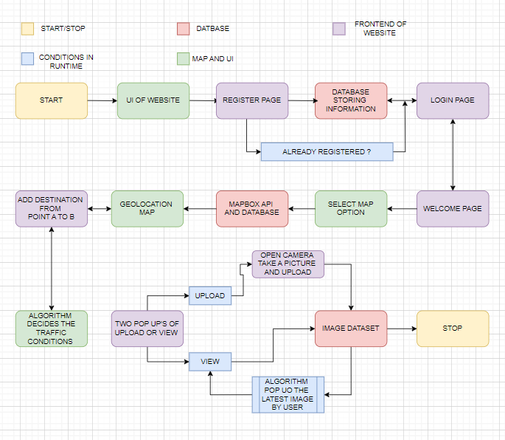

Fig 1

**3.2 Implementation**

**3.2.1 Algorithm/Flowchart**

* **Algorithm & Approach** 
  1. Data from users
  2. Processing data:
* Using Stack Data structure for photos as it follows Last In First Out (LIFO) pattern.
* Using Convolutional Neural Network for traffic analysis
  1. Displaying the Picture or traffic analysis to the user.
* **Model**
* The system we are building will be used to enable users to plan their travel destinations according to their preferences. The design we will be implementing is user-friendly, allowing individual users to upload images and view the images of other users, which can be helpful for them in deciding and planning their travel destinations. The database for the web application is PostgreSQL, a powerful open-source relational database management system that offers a wide range of features and benefits, providing various tools for applications. PostgreSQL allows you to define custom data types, operators, functions, and procedural languages.
* We are also using MapboxAPI for this web application to enhance its interactivity, empowering developers to create engaging and feature-rich web applications with robust mapping and geospatial capabilities. This enhances the user experience and functionality of location-based services.

**3.2.2 Data Flow Diagram**

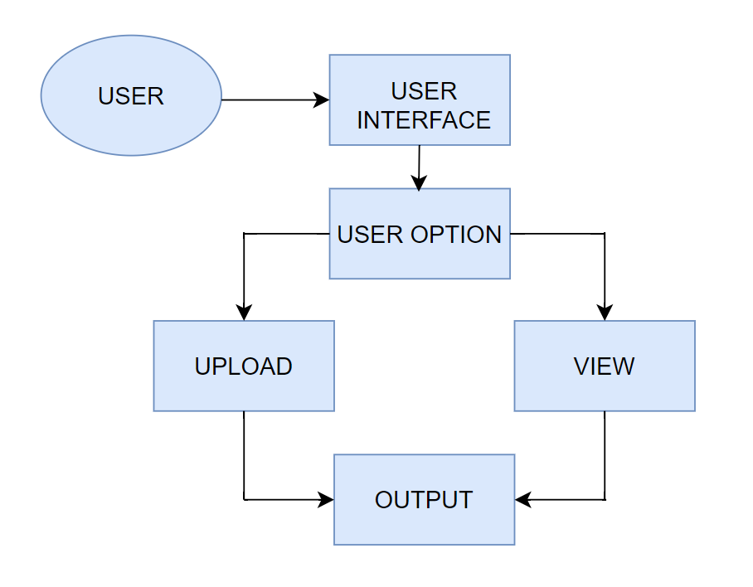

Fig 2: Data Flow Diagram (a)

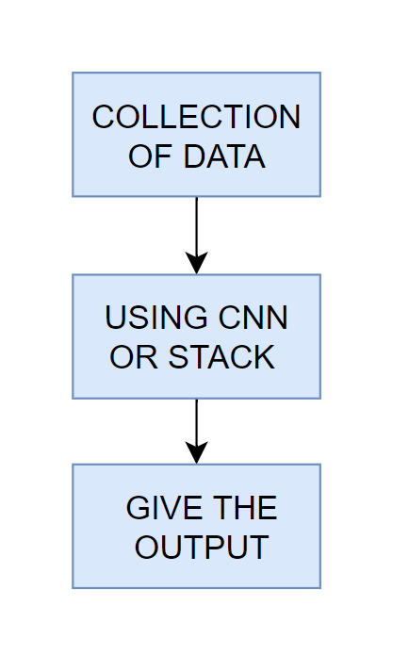

Fig 3: Data Flow Diagram (b)

**3.2.3 Pseudo code**

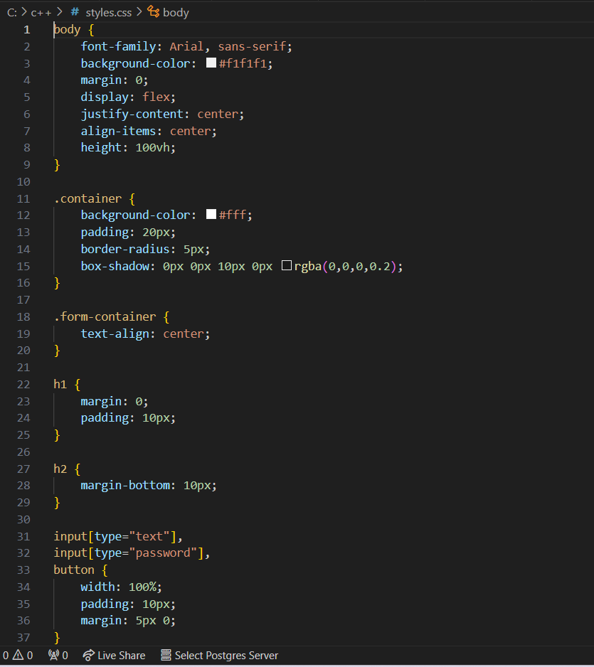

Fig 4: Pseudo code(a)

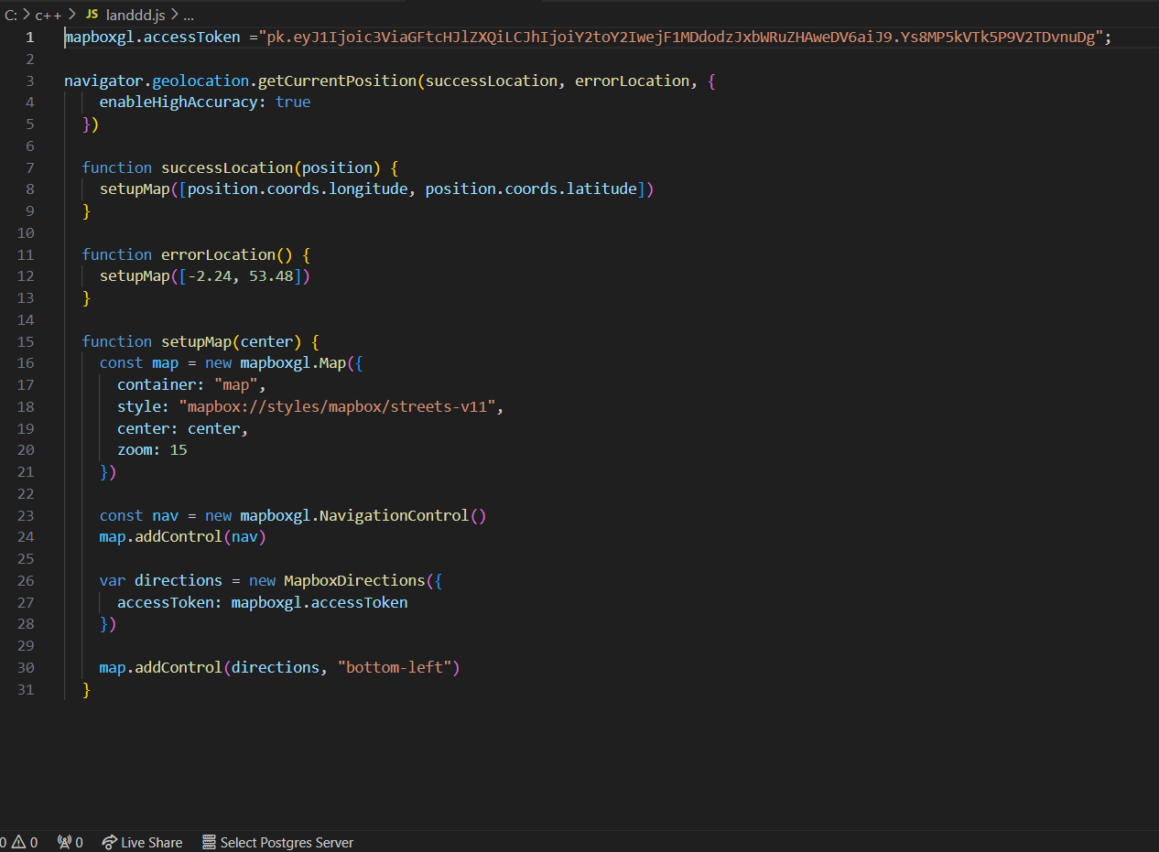

Fig 5: Pseudo code(b)

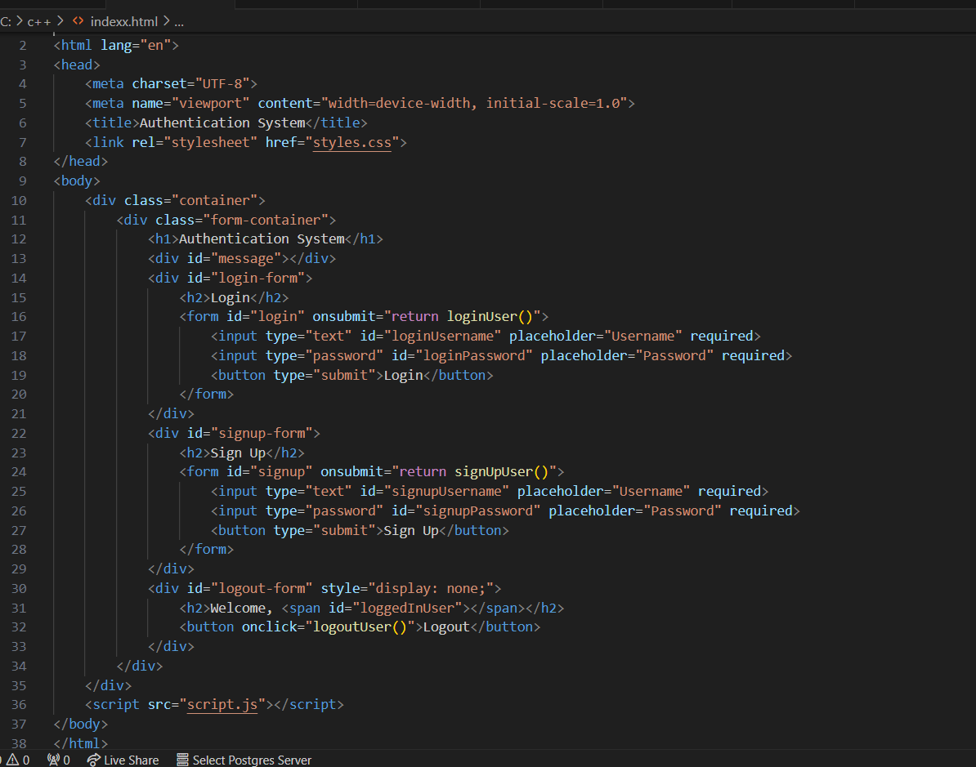

Fig 6: Pseudo code(c)

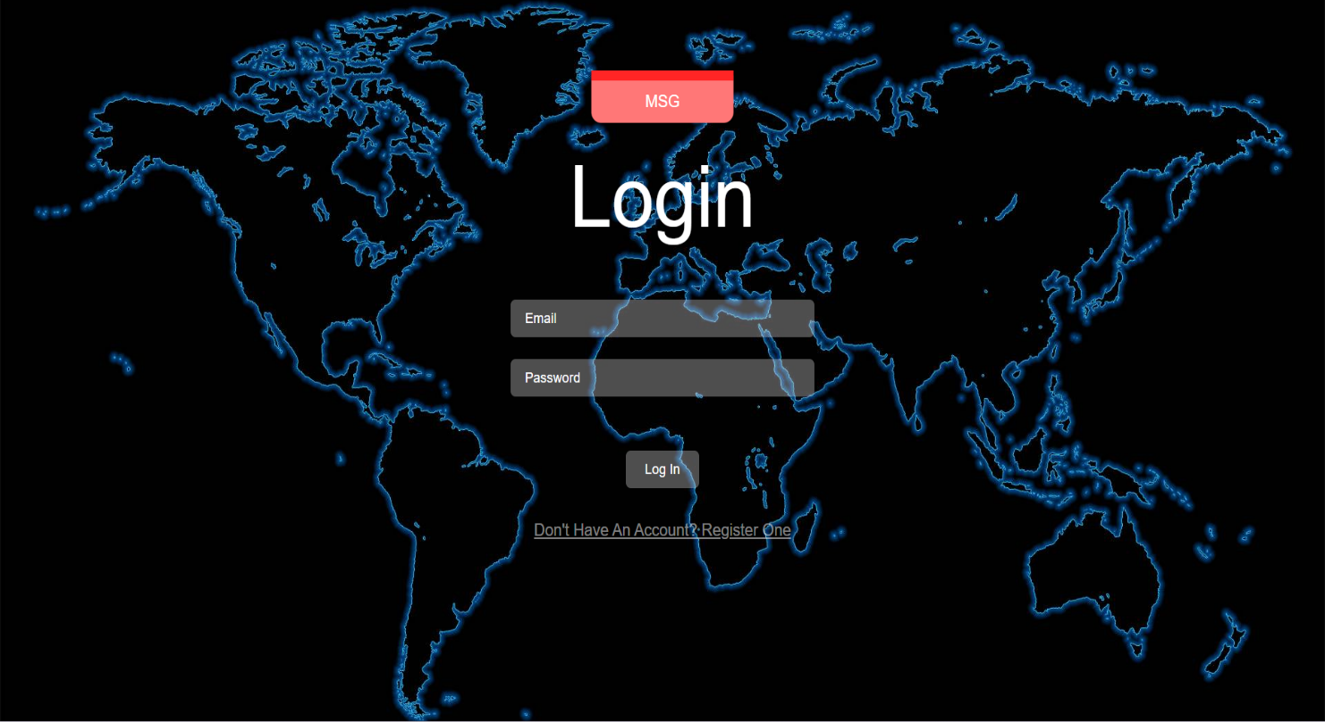

Fig 7: Login Page

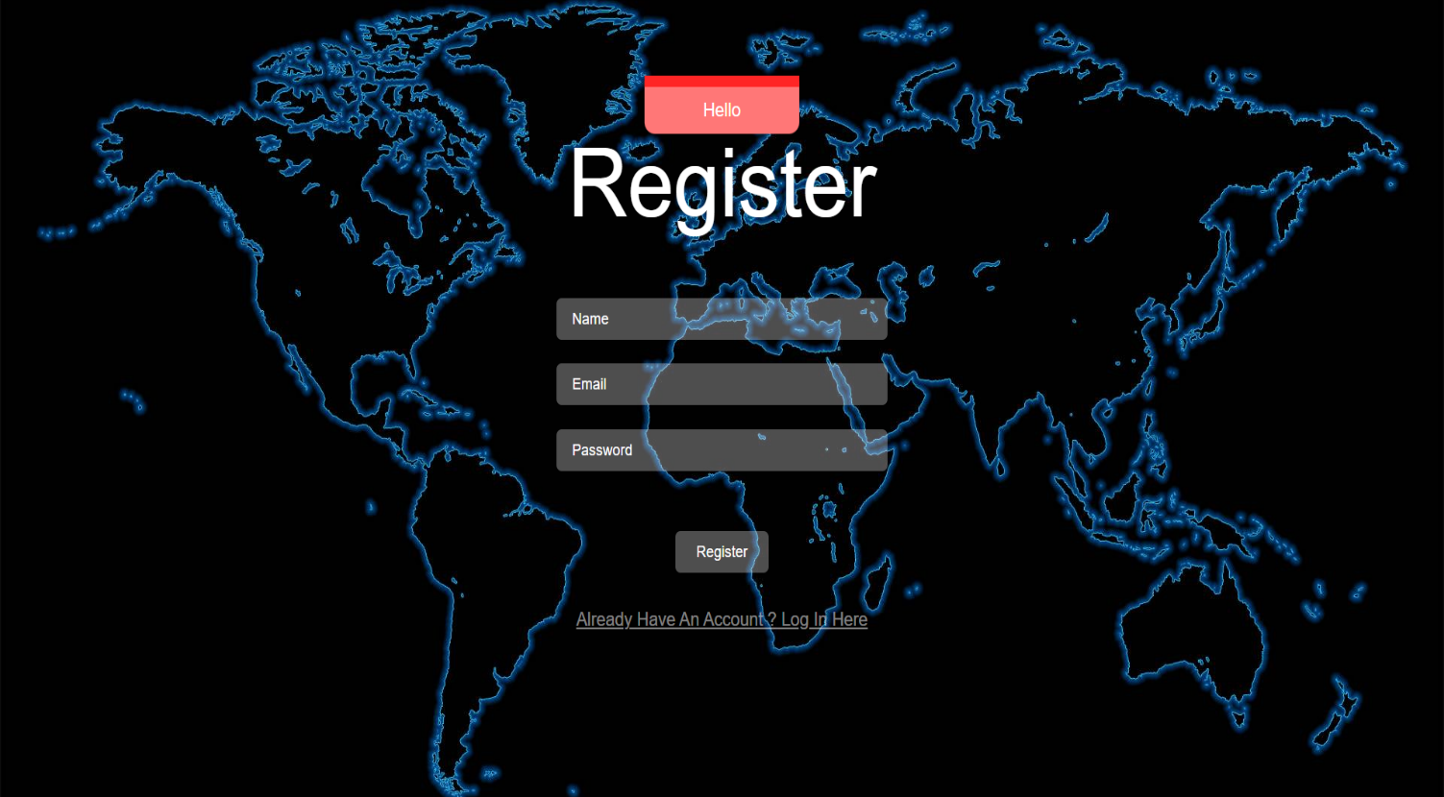

Fig 8: Register Page

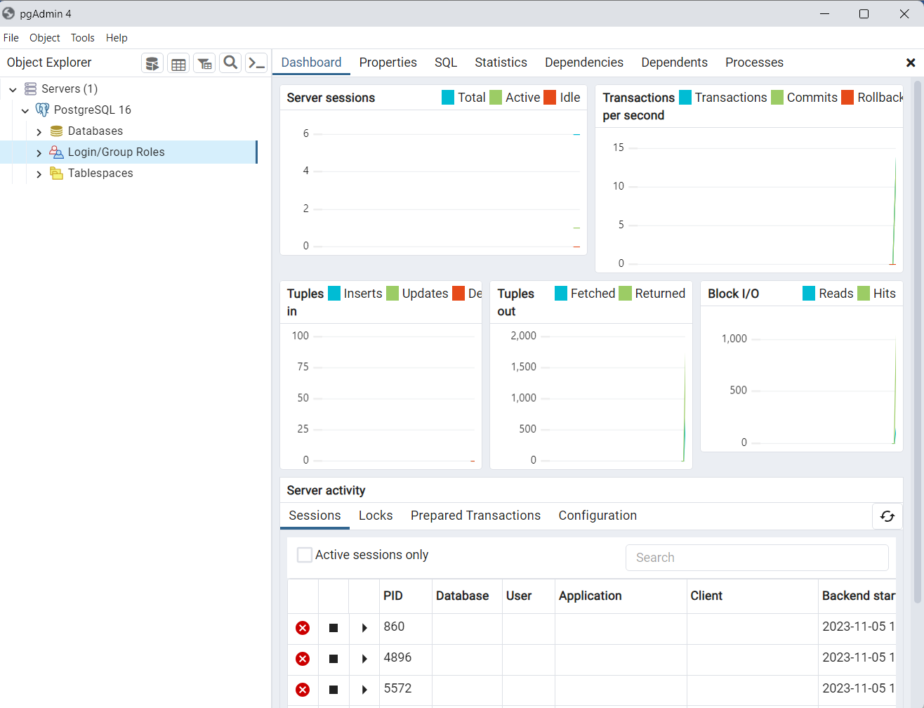

Fig 9: DATABASE

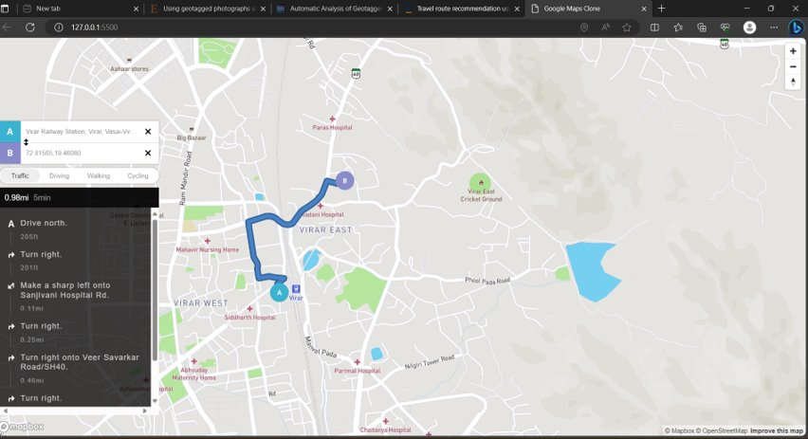

Fig 10: MAP

**Chapter 4**

**Technologies Used**

* + 1. **Hardware Requirement**
* Window 7 or above
* 2 GB ram and more
* 256 GB SSD
* Minimum 8 MP camera
  + 1. **Software Requirement**
* VS Code
* pgAdmin4
* OpenCV
* Mapbox API
  + 1. **Technologies and Libraries Used**
* HTML
* CSS
* JAVASCRIPT
* PostgreSQ

**Chapter 5**

**Result**

The accuracy of the model will be tested by the train and test dataset from the system. From this web-application we can help the users to know the crowd of the location and know the condition of the location. Additionally information related to the traffic will be given to the user they can also know about the routes to the particular location with the help of this web-application.

**Chapter 6**

**Conclusion and Future Work**

**CONCLUSION**

In conclusion, we can say that TRAVELGRAM will be helpful for the user to plan their trips and visiting spots . With the combination of a user-friendly interface and an intelligent , the way trips are planned by travelers is aimed to be revolutionized, making it a more enjoyable and efficient process.. Further developments in this project are looked forward to, and a commitment is made to create a valuable tool that simplifies and enhances the tour planning experience for users.

**References**

* + - * Millonig, A., Schechtner, K.: Developing Landmark-Based Pedestrian-Navigation Systems. Intelligent Transportation Systems, IEEE Transactions
      * D. J. Crandall, L. Backstrom, D. Huttenlocher, J. Kleinberg and C. J. Kaufman, "Mapping the world's photos", *Proceedings of the 18th international Conference on World Wide Web.*
      * L. Chen and A. Roy, "Event detection from flickr data through wavelet-based spatial analysis", *Proceeding of the 18th ACM Conference on information and Knowledge Management.*
      * J. Hays and A. Efros, "IM2GPS: estimating geographic information from a single image", *Proceedings of the IEEE Conf. on Computer Vision and Pattern Recognition (CVPR)*.
      * R. Ji, X. Xie, H. Yao and W. Ma, "Mining city landmarks from blogs by graph modelling", Proceedings of the Seventeen ACM international Conference on Multimedia.
    - J. Kleban, E. Moxley, J. Xu and B. S. Manjunath, "Global annotation on georeferenced photographs", *Proceeding of the ACM international Conference on Image and Video Retrieval (Santorini Fira Greece July 08–10 2009).* ​
    - Beeharee, A. K., Steed, A.: A Natural Wayfinding Exploiting Photos in Pedestrian Navigation Systems. In: MobileHCI '06: Proceedings of the 8th Conference on Human-Computer Interaction with Mobile Devices and Services.
    - [Tong S](https://dl.acm.org/author/Tong%2C+Song), [Duan J](https://dl.acm.org/author/Duan%2C+Jingyi), [Liang X](https://dl.acm.org/author/Liang%2C+Xuefeng), [Kumada T](https://dl.acm.org/author/Kumada%2C+Takatsune), [Peng K](https://dl.acm.org/author/Peng%2C+Kaiping) and [Nakashima R](https://dl.acm.org/author/Nakashima%2C+Ryoichi). (2023). Inferring Affective Experience from the Big Picture Metaphor: A Two-dimensional Visual Breadth Model 2023 IEEE/CVF Conference on Computer Vision and Pattern Recognition Workshops (CVPRW). ​
    - Ahern S,Naaman M, Nair R et al (2007) World explorer: visualizing aggregate todata from unstructured text in geo-referenced collections.
    - Ashbrook D, Starner T (2003) Using GPS to learn significant locations and predict movement across multiple users.
    - Blei DM, Ng AY, Jordan MI (2003) Latent dirichlet allocation. J Mach Learn. ​
    - Cao L, Yu J, Luo J et al (2009) Enhancing semantic and geographic annotation of web images via logistic canonical correlation regression. In: Proceedings of 17th international conference on multimedia.

**Acknowledgments**

We owe our deepest gratitude and regards towards the ones who offered their valuable guidance in the hour of need. We thank our guide **Mr. Vivian Lobo** (Assistant Professor, Department of Artificial Intelligence and Machine Learning, St. John College of Engineering and Management) for his guidance and precious insights. His useful comments and feedbacks during the discussions we had and the encouragement to question every technical detail that we came across while partially completing this S.E. Mini-project 1A helped us to a great extent.

We also take the opportunity to thank **Mr. Vivian Lobo** (S.E. Mini-Project 1A Co-ordinator and Head of Department) who has always rendered his support and assistance in the best possible way.

We would also like to thank **Dr. G. V. Mulgund** (Principal, St. John College of Engineering and Management) and the **members of Aldel Education Trust** who have given us the background to conduct this S.E Mini-project 1A.