**Intoduction**

In the recent period, the phenomenon of suicide has increased a lot. In fact, many indicators and statistics indicate that suicide incidents have increased significantly in our societies, but this is without these incidents occurring as an actual phenomenon as is happening in the Arab world. We offer you all the information related to suicide.

The phenomenon of suicide has reasons that suicide bombers call for, including: the bad economic situation that people go through at a certain stage of their lives; The difficult economic situation may put pressure on people, especially when they find themselves unable to make ends meet and to secure the maintenance of their families. They fall prey to weakness and mental illness that lead them to think about suicide and get rid of life. Weakness of religious faith. There is no doubt that the religious motive protects a person from contemplating suicide, regardless of the reasons, because he knows that God is forbidden and forbidden. Some researchers have put some statistics recently, which showed that: - About 35% of suicide cases are due to psychological and mental illnesses such as depression, schizophrenia and addiction.

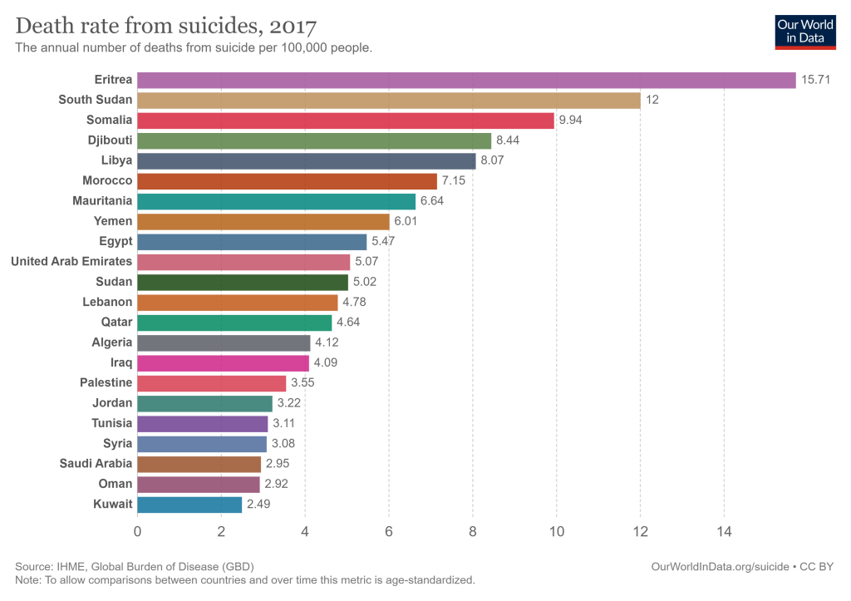

And 65% is due to multiple factors such as education, community culture, family or emotional problems, academic failure, pain and physical illness, avoiding shame, or believing in an idea or principle such as committing suicide operations. According to the statistics of the World Health Organization, which indicated that

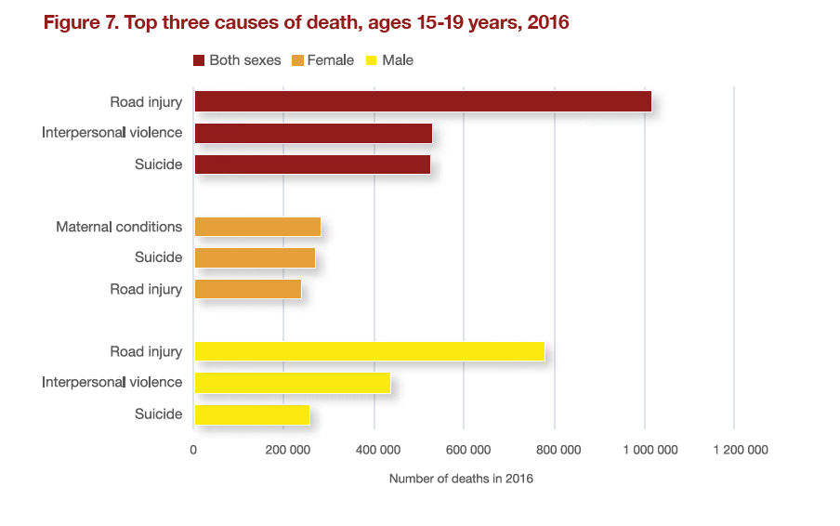  
1- More than 700,000 people commit suicide every year.

2- Each suicide case corresponds to several other suicide attempts. And the attempt to commit suicide before is the single most important factor that increases the likelihood of committing suicide again for suicides.

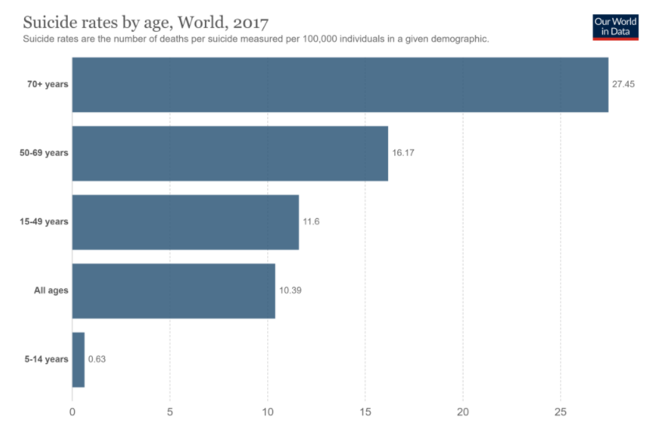

3- Suicide is the fourth cause of death in people aged 15-19 years.

4- 77% of suicides in the world occur in low- and middle-income countries.

5- Ingestion of pesticides, hanging and firearms are among the most common methods of suicide globally.

6- Every year 703,000 people end their lives, but the numbers of suicide attempts are much higher. Every suicide leaves a tragedy that affects families, communities and entire countries and has long-lasting effects on the person's family. Suicide occurs at any stage of life, and in 2019 it was ranked the fourth leading cause of death among 15-29-year-olds globally.

7- Suicide does not occur only in high-income countries, but is a phenomenon that occurs in all regions of the world. In fact, more than 79% of global suicides in 2019 occurred in low- and middle-income countries.

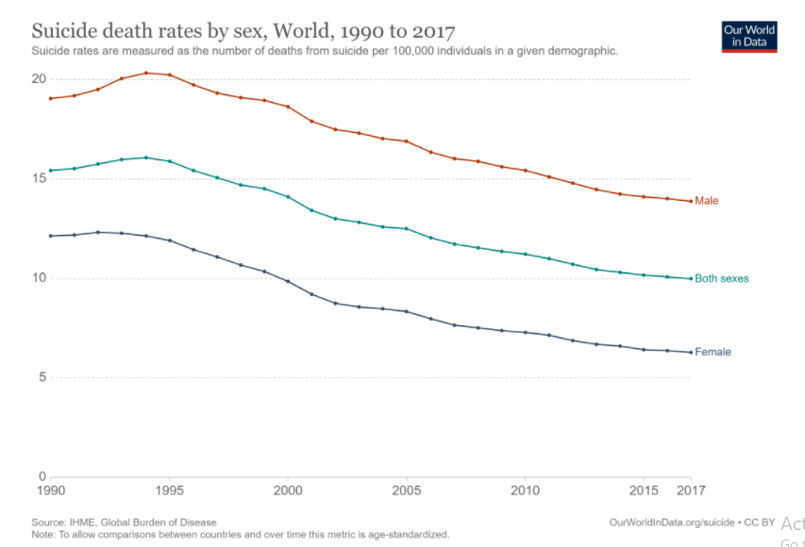

Suicide is a serious public health problem, but it can be avoided through timely, evidence-based interventions that are usually low-cost. To ensure the effectiveness of the national response, a comprehensive multisectoral suicide prevention strategy is required.