Cristian Gradinaru

Database Project

For this project our task was to create a database and management interface for a given subject. I was handed a bicycle shop to manage, and I decided to proceed with C#, as I wasn’t quite sure what I wanted to do yet, and I thought I might as well expose myself to something new.

The result I ended up with was this : 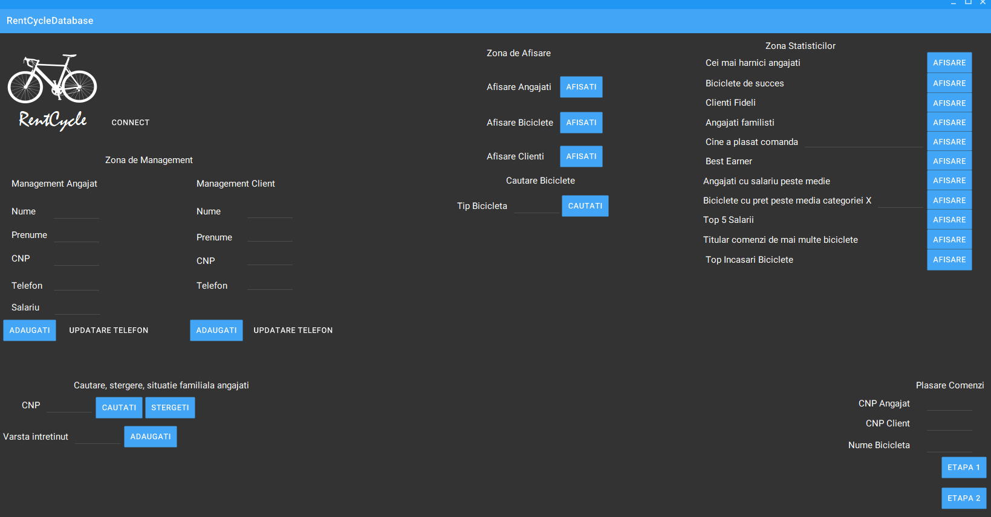

A fully functional( if a bit simplistic) interface, that can be used to add delete and update clients, employees( on the left side of the interface panel) as well as a set of queries to be used for statistical and display purposes. Things like displaying the current employees, the bicycles we have in our inventory as well as a set of statistical rankings of the employees, bicycles and clients, because more information is ALWAYS useful.