Question 01:

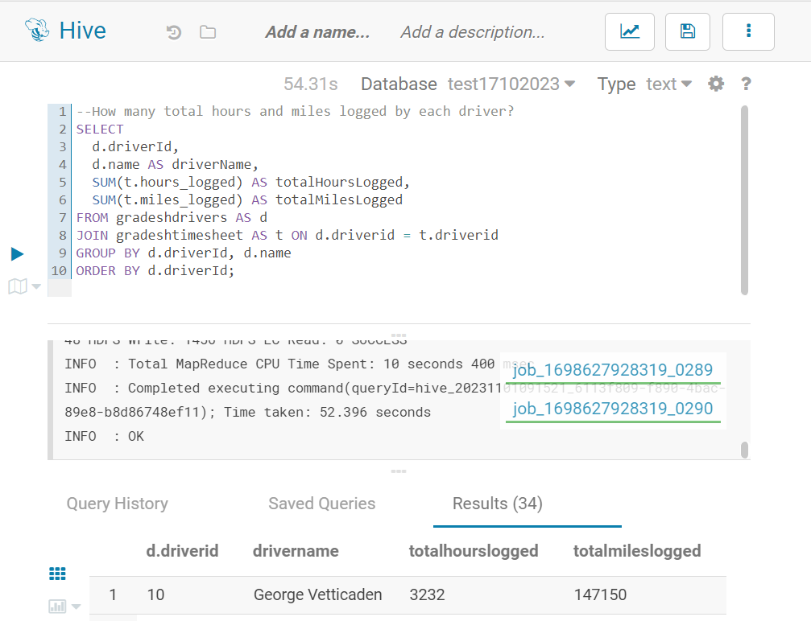

Question 2:

SELECT

d.driverId,

d.name AS driverName,

SUM(t.hours_logged) AS totalHoursLogged,

SUM(t.miles_logged) AS totalMilesLogged

FROM gradeshdrivers AS d

JOIN gradeshtimesheet AS t ON d.driverid = t.driverid

GROUP BY d.driverId, d.name

ORDER BY d.driverId;

Question 3:

