Step 1:

Step 2:

Step 4:

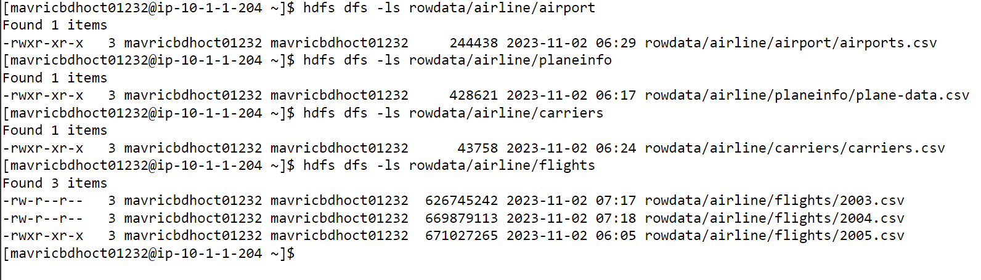



Step:

Step: What is the average arrival delay and average departure delay in each month of the year 2004?

--flights,

select month,avg(arrdelay) as Avg_Arr_Delay,

avg(depdelay) as Avg_Dep_delay

from flights_stg where year= 2004

group by month

order by month

;

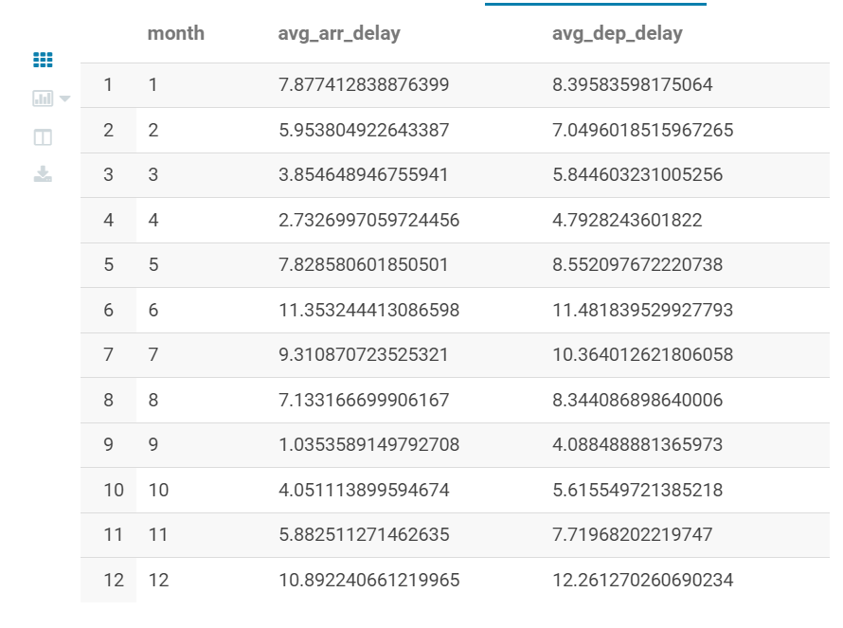

Step: Is there a difference between the response times for the queries(2 and 3)

Time Taken by Avg_ Query :

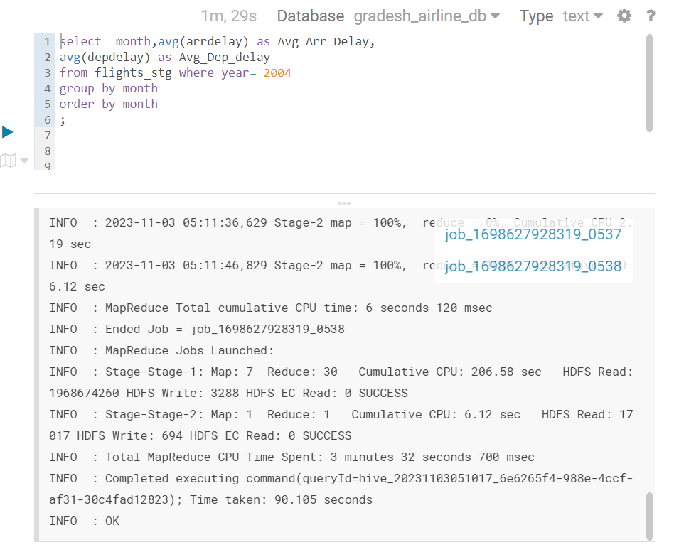



Time Taken By Parquet Table Query:

