Input City Data format/Layout

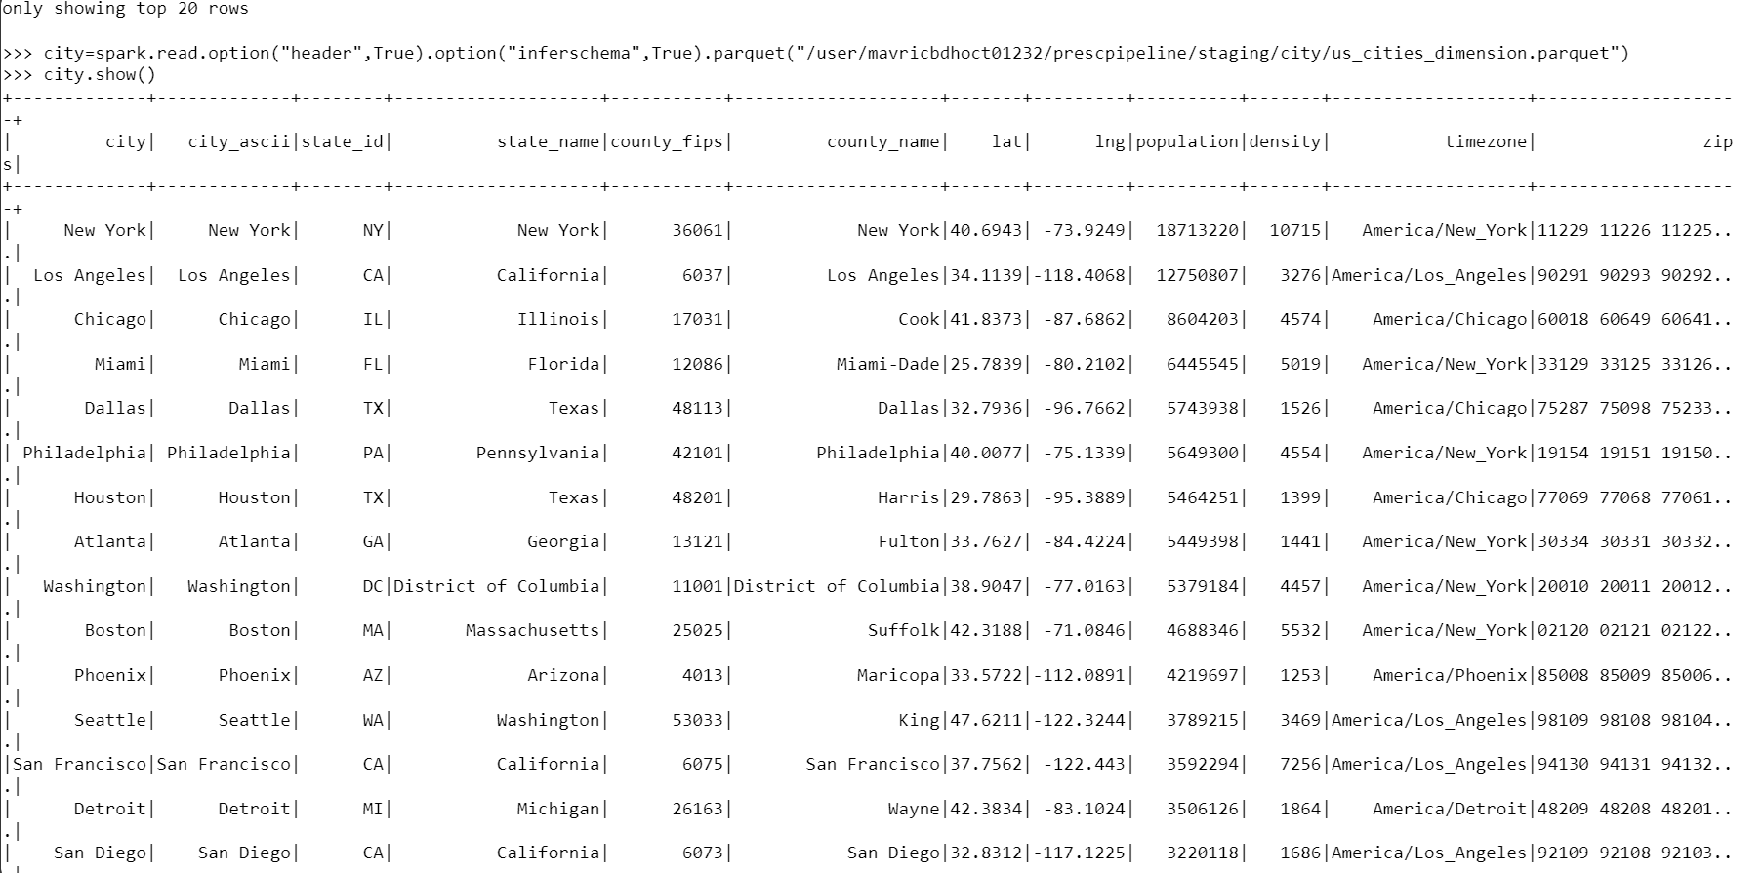

Input Prescriber Data Layout

Output data layout (City)

df = spark.read.table("city")

num_splits = 1

output_format = "JSON"

compression = "Bzip2"

spark.conf.set("mapreduce.input.fileinputformat.split.maxsize", f"{df.rdd.getNumPartitions() * num_splits}")

spark.sql("SET hive.exec.orc.default.compress=SNAPPY")

df.write.format(output_format).mode("overwrite").option("compression",compression).saveAsTable("Gradesh_Db_Airline.city")

Output data layout (Prescriber)

df = spark.read.table("pres1")

num_splits = 2

output_format = "orc"

compression = "snappy"

spark.conf.set("mapreduce.input.fileinputformat.split.maxsize", f"{df.rdd.getNumPartitions() * num_splits}")

spark.sql("SET hive.exec.orc.default.compress=SNAPPY")

df.write.format(output_format).mode("overwrite").option("compression", compression).saveAsTable("Gradesh_Db_Airline.pres")

For City

df = spark.read.table("data")

num_splits = 1

output_format = "JSON"

compression = "Bzip2"

spark.conf.set("mapreduce.input.fileinputformat.split.maxsize", f"{df.rdd.getNumPartitions() * num_splits}")

spark.sql("SET hive.exec.orc.default.compress=SNAPPY")

df.write.format(output_format).mode("overwrite").option("compression", compression).saveAsTable("Hivecity ")

For Prescriber

df = spark.read.table("pres1")

num_splits = 2

output_format = "orc"

compression = "snappy"

spark.conf.set("mapreduce.input.fileinputformat.split.maxsize", f"{df.rdd.getNumPartitions() * num_splits}")

spark.sql("SET hive.exec.orc.default.compress=SNAPPY")

df.write.format(output_format).mode("overwrite").option("compression", compression).saveAsTable("airline_db.pres")

for Cleansing (City)

**cityDF1=cityDF.select('city','state_id','state_name','county_name','population','zips')**

**cityDF1.show(4)**

**cityDF1.printSchema()**

For Prescriber ()

**Converting the required fields to upper case** For City

import pyspark.sql.functions as F  
city=spark.read.option("header",True).option("inferschema",True).parquet('prescpipeline/staging/city/us_cities_dimension.parquet')  
cityDF = city.select('city','state_id','state_name','county_name','population','zips')  
cityDF = city.select(F.upper(city.city).alias("city"),'state_id',F.upper(city.state_name).alias("state_name"),F.upper(city.county_name).alias("county_name"),'population','zips')  
from pyspark.sql.functions import size  
from pyspark.sql.functions import split  
df2 = cityDF.withColumn('zips',size(split(cityDF['zips']," ")))   
cityDF.createOrReplaceTempView("city_data")

**For Prescriber**

prescriberDF=spark.read.option("header",True).option("inferschema",True).csv("prescpipeline/staging/prescriber/USA_Presc_Medicare_Data_12021.csv")   
prescriberDF.show(10)  
prescriberDF.printSchema()  
df1=prescriberDF.select('npi','nppes_provider_last_org_name','nppes_provider_first_name','nppes_provider_city','nppes_provider_state','specialty_description','drug_name','total_claim_count','total_day_supply','total_drug_cost')     
df1=prescriberDF.select('npi',(prescriberDF.nppes_provider_last_org_name).alias ('np_Lname'),(prescriberDF.nppes_provider_first_name).alias ('np_Fname'),(prescriberDF.nppes_provider_city).alias ('np_city'),(prescriberDF.nppes_provider_state).alias ('np_state'),(prescriberDF.specialty_description).alias ('speciality_desc'),(prescriberDF.drug_name).alias ('drug_nm'),(prescriberDF.total_claim_count).alias ('tot_clm_count'),(prescriberDF.total_day_supply).alias ('tot_day_supp'),(prescriberDF.total_drug_cost) .alias ('tot_drug_cst'))      
from pyspark.sql.functions import col, lit  
df1=df1.withColumn("Country", lit("USA"))   
PrescriberDF1.show(3)  
df1=prescriberDF.select('npi',(prescriberDF.nppes_provider_last_org_name).alias ('np_Lname'),(prescriberDF.nppes_provider_first_name).alias ('np_Fname'),  
(prescriberDF.nppes_provider_city).alias ('np_city'),(prescriberDF.nppes_provider_state).alias ('np_state'),(prescriberDF.specialty_description).alias ('speciality_desc'),  
(prescriberDF.drug_name).alias ('drug_nm'),(prescriberDF.total_claim_count).alias ('tot_clm_count'),(prescriberDF.total_day_supply).alias ('tot_day_supp'),  
(prescriberDF.total_drug_cost) .alias ('tot_drug_cst'),'years_of_exp')     
import pyspark.sql.functions as F  
df1= df1.withColumn("years_of_exp", F.regexp_replace("years_of_exp", "=", ""))                                       
df1= df1.withColumn("years_of_exp", F.regexp_replace("years_of_exp", "\.0", ""))  
df1= df1.withColumn("years_of_exp", F.regexp_replace("years_of_exp", " ", ""))                                                                                                    
from pyspark.sql.functions import concat, concat_ws,col, lit    
df1 = df1.withColumn("years_of_exp",col("years_of_exp").cast("Integer"))       
from pyspark.sql.functions import concat, concat_ws,col, lit                                                                             
df1 = df1.withColumn("presc_fullname",concat_ws(" ", "np_Fname", "np_Lname"))                                        
df1 = df1.drop("np_Fname", "np_Lname")                                                                                  
from pyspark.sql.functions import col,isnan, when, count    
df1 = df1.dropna(subset = 'npi')                                                                                                     
df1 = df1.dropna(subset = 'drug_nm')  
df1 = df1.dropna(subset = 'tot_clm_count')                                                                                                 
df1.select([count(F.when(isnan(c) | col(c).isNull(),c)).alias(c) for c in df1.columns]).show()  
df1.createOrReplaceTempView("pres")

**Transform Logic: City Report**

**from pyspark.sql.functions import col, lit**

**from pyspark.sql.functions import split, explode , size**

**split_col=split(cityDF1['ZIPS'],' ')**

**df_split = cityDF1.withColumn('Zip_Split_cnt',size(split_col))**

**df_split.createOrReplaceTempView("City_split_df")**

**Calculate the number of distinct Prescribers assigned for each City.**

**prescriber1_df = spark.sql("SELECT count(distinct npi) as Prescriber_Counts,np_city from prescriber group by np_city").show()**

**Calculate total total_claim_count prescribed for each city.**

**prescriber1_df = spark.sql("SELECT sum(tot_claim_cnt) as total_claim_counts, np_state from prescriber group by np_state") .show()**

**Do not report a city in the final report if no prescriber is assigned to it.**

prescriber1_df.createOrReplaceTempView("prescriber1")

df_split.createOrReplaceTempView("City_split_df")

spark.sql( "SELECT CITY as City_Name,STATE_NAME as State_Name,COUNTY_NAME as County_Name ,POPULATION as City_Population,Zip_Split_cnt as Number_of_Zips,p.Prescriber_Counts,p.total_claim_counts FROM City_split_df c inner join prescriber1 p on upper(c.CITY) = p.np_city and c.STATE_ID = p.np_state").show()

spark.sql( "SELECT CITY as City_Name,STATE_NAME as State_Name,COUNTY_NAME as County_Name ,POPULATION as City_Population,Zip_Split_cnt as Number_of_Zips,p.Prescriber_Counts,p.total_claim_counts FROM City_split_df c inner join prescriber1 p on upper(c.CITY) = p.np_city and c.STATE_ID = p.np_state where p.Prescriber_Counts != 0").show(),

**Checking if any city having no prescriber :**

spark.sql( "SELECT CITY as City_Name,STATE_NAME as State_Name,COUNTY_NAME as County_Name ,POPULATION as City_Population,Zip_Split_cnt as Number_of_Zips,p.Prescriber_Counts,p.total_claim_counts FROM City_split_df c inner join prescriber1 p on upper(c.CITY) = p.np_city and c.STATE_ID = p.np_state where p.Prescriber_Counts = 0").show()

**Writing the City Report outputs in to Hive/HDFS:**

from pyspark.sql import SparkSession

spark=SparkSession.builder.appName("SparkHive").enableHiveSupport().config("spark.sql.warehouse.dir","/user/hive/warehouse").getOrCreate()

spark.sparkContext.setLogLevel("ERROR")

City_report_df = spark.sql( "SELECT CITY as City_Name,STATE_NAME as State_Name,COUNTY_NAME as County_Name ,POPULATION as

City_Population,Zip_Split_cnt as Number_of_Zips,p.Prescriber_Counts,p.total_claim_counts FROM City_split_df c inner join prescriber1 p on upper(c.CITY) = p.np_city and c.STATE_ID = p.np_state where p.Prescriber_Counts != 0")

**No of splits: 1**

repart_df = prescriber_report_DF.repartition(1)

repart_df.write.mode("overwrite").option("compression","bzip2").json("/user/mavricbdhoct07/prescpipeline/output/city")



**City output In HDFS**

**Select * from City_Final_Report limit 10;**

**select count(*) from City_Final_Report;**

